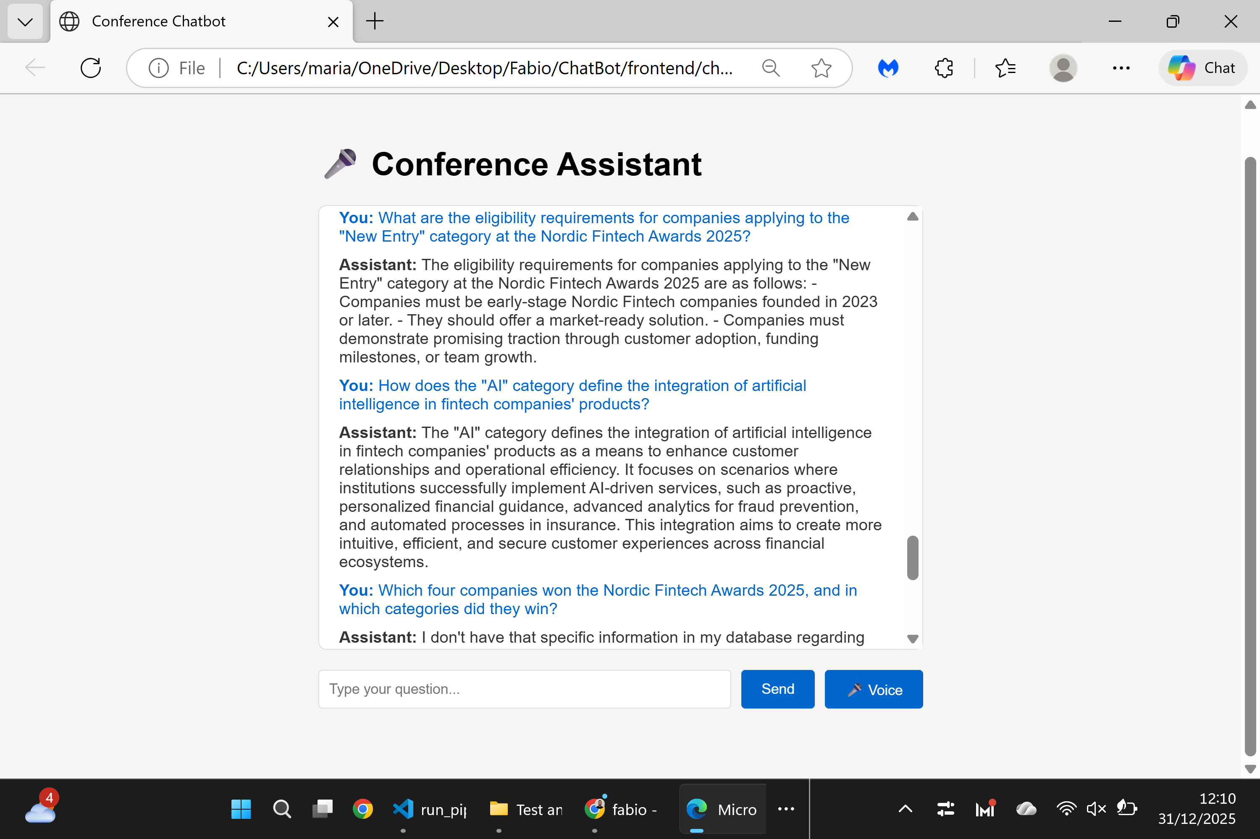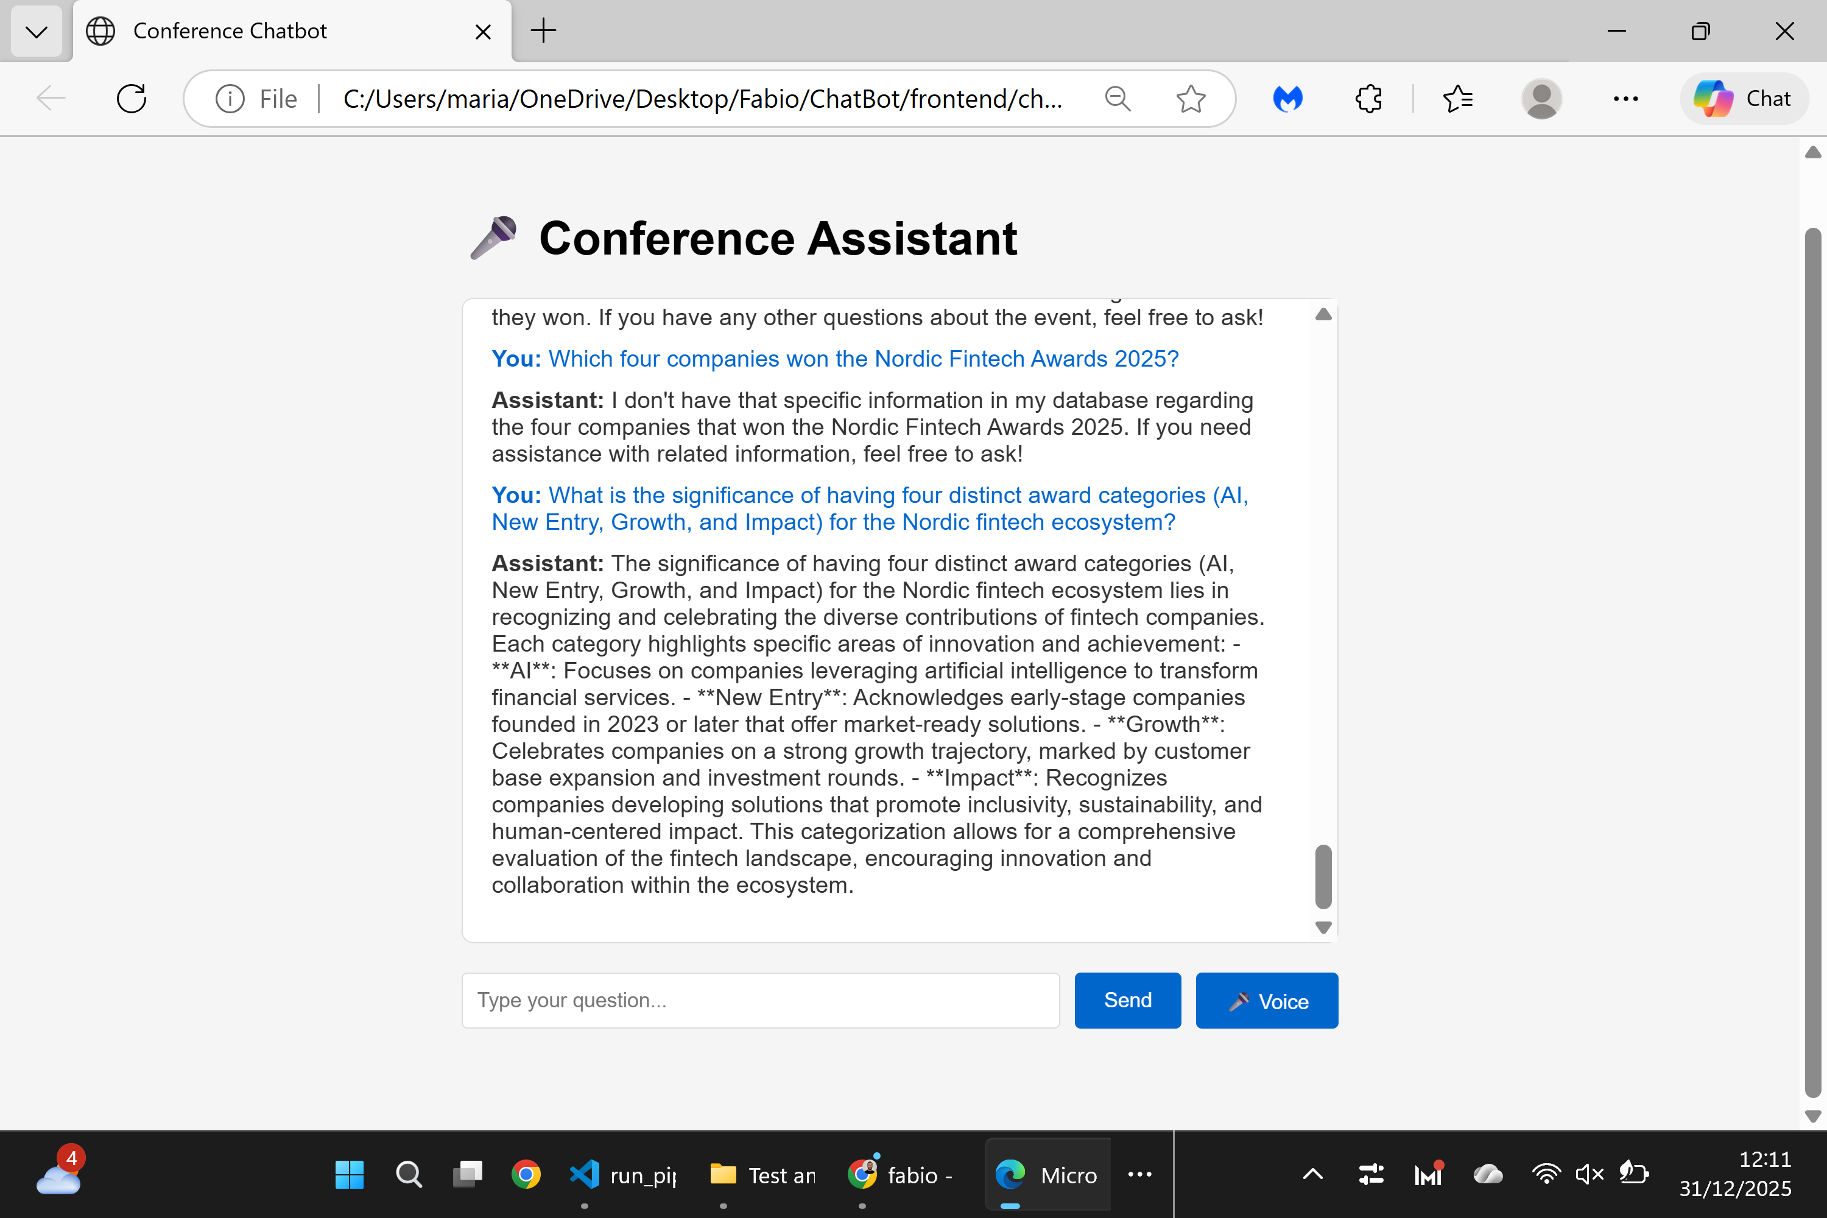

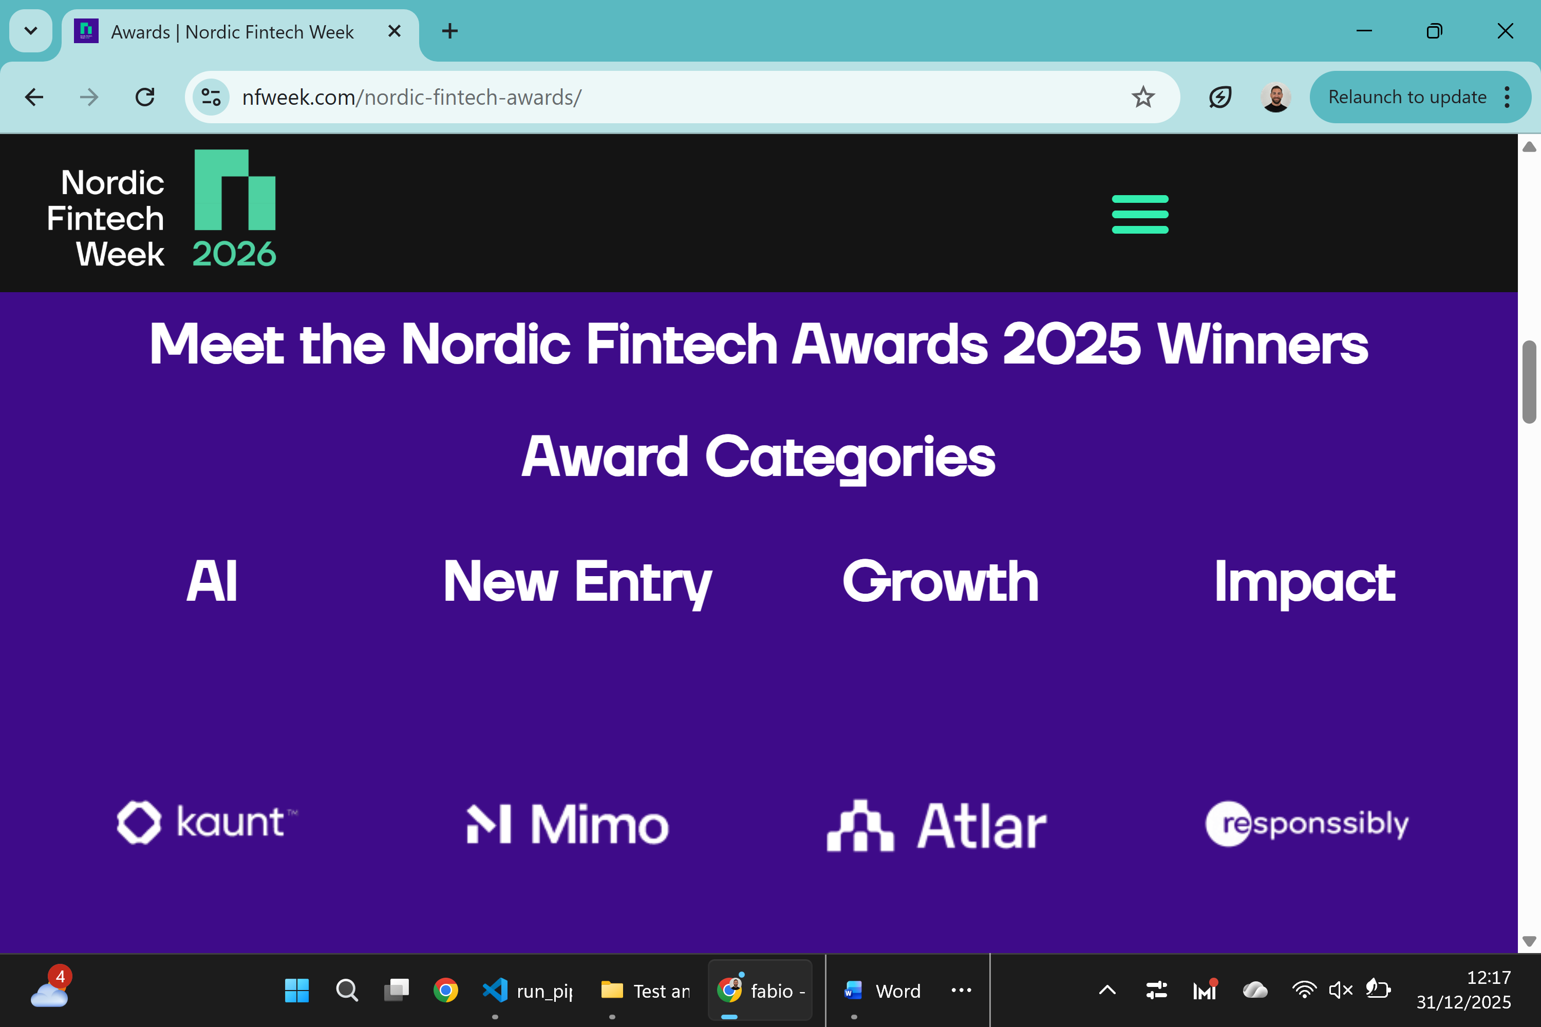

Nordic Fintech Awards 2025 - Test Report
Website: nfweek.com/nordic-fintech-awards/
Questions:
- What are the eligibility requirements for the "New Entry" category?
- How does the "AI" category define AI integration in products?
- Which four companies won awards and in which categories?
- What is the significance of having four distinct award categories?
- Which major organizations were on the evaluation jury?
Result: Semi-successful - Only one answer couldn't be answered (question 3 - specific winning companies not fully visible in images).

