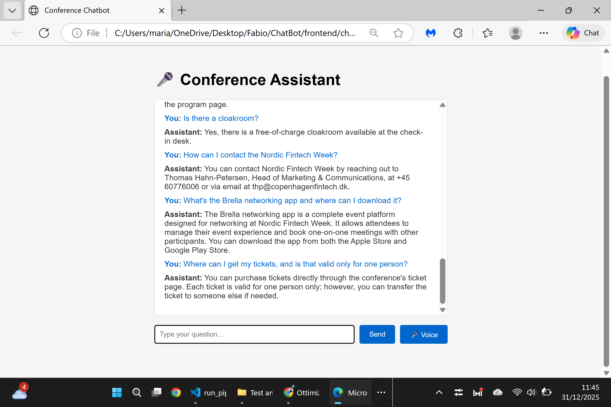

Page Tested: FAQ
https://nfweek.com/faqs/
Test Scope:
FAQ page content validation.
Tested Questions:
Multiple representative FAQ questions related to event information, program, venue, and logistics.
Result:
✅ All tested questions returned correct and accurate answers.
✅ No inconsistencies or missing information detected.
Status:
Successful

