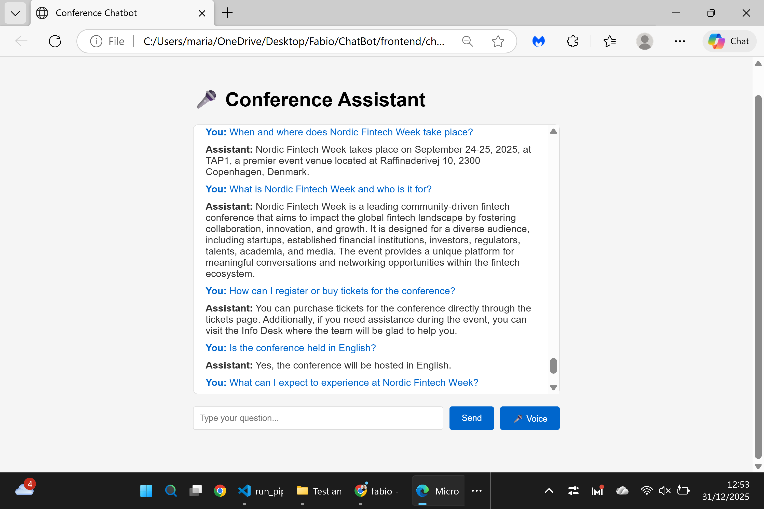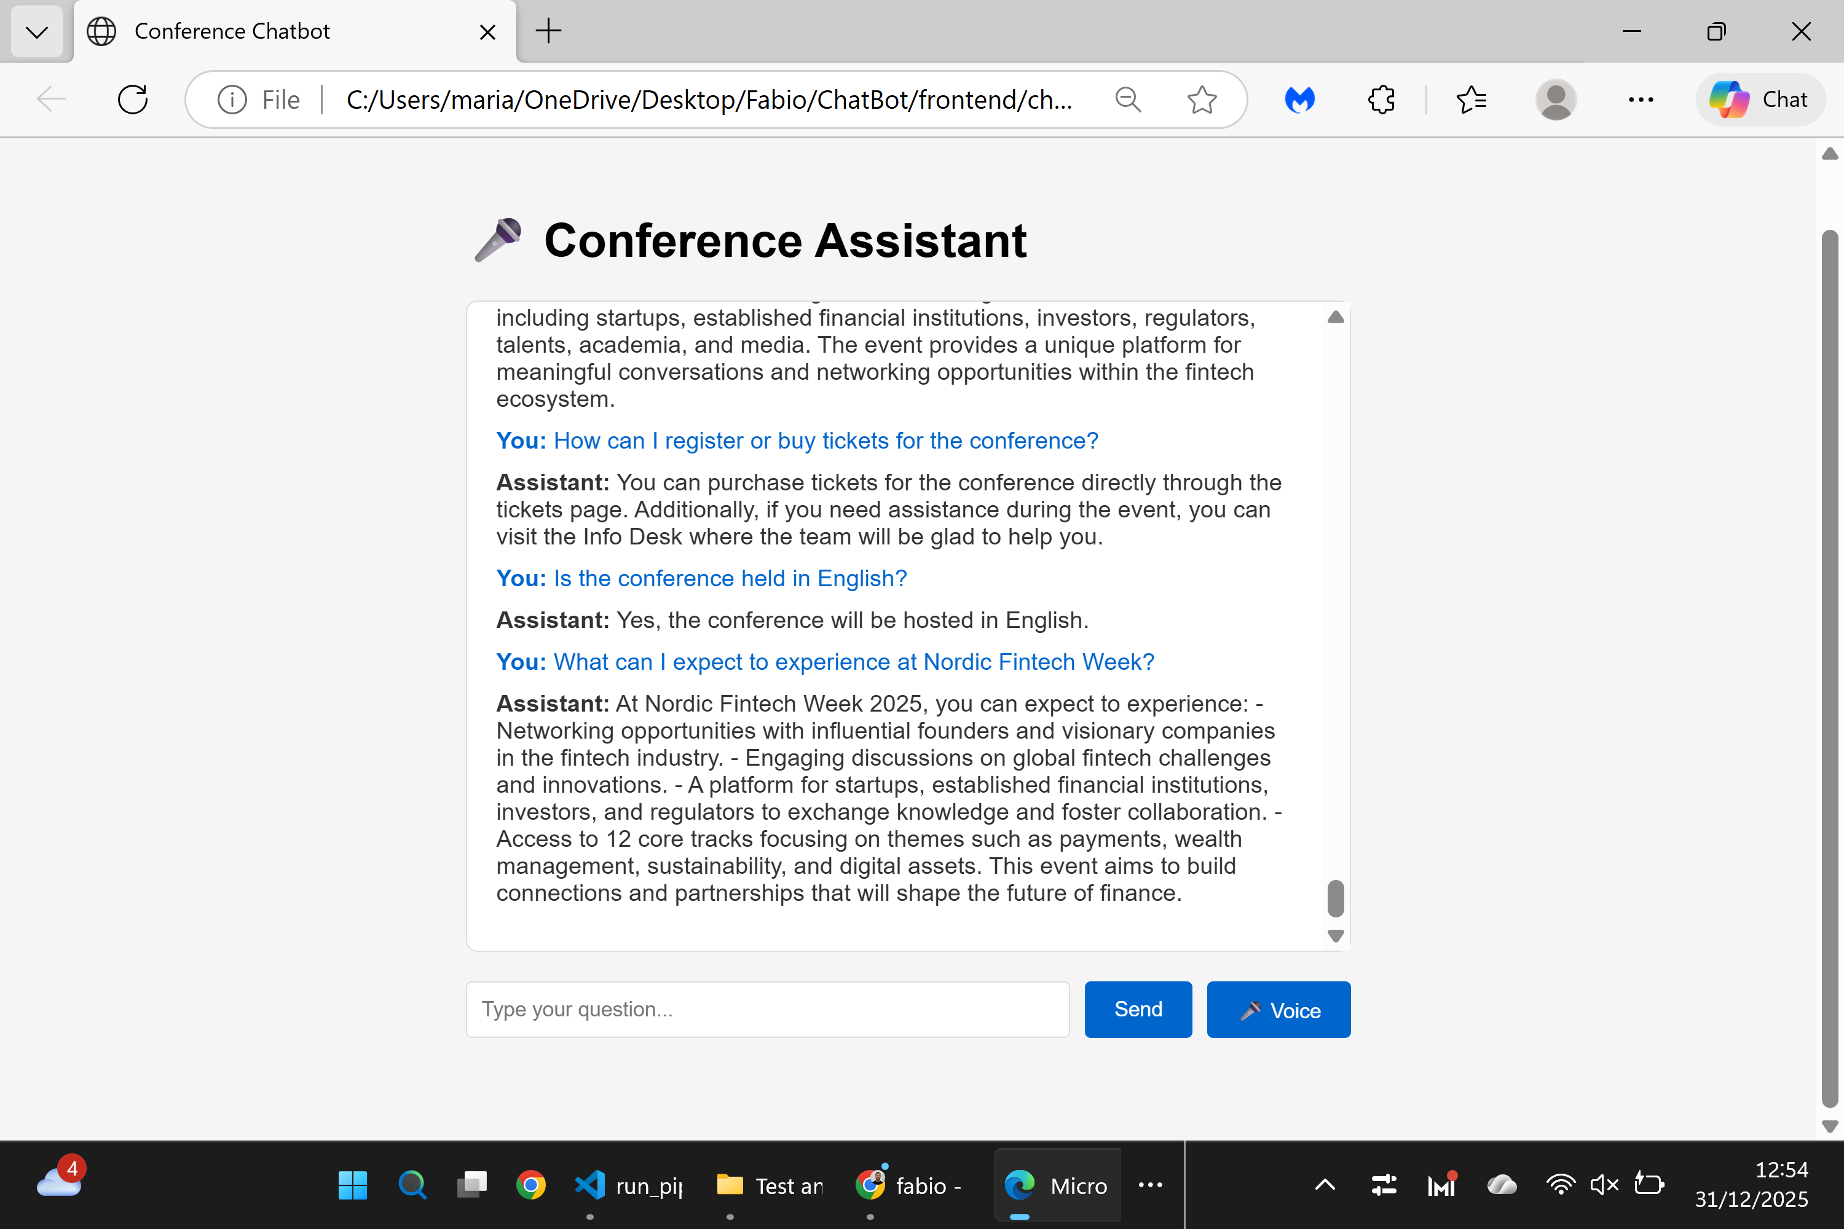

Test Report – General Questions
Page tested:
https://nfweek.com/
Test scope:
Validation of general, first-time user questions via the Conference Assistant.
Questions tested:
- When does the conference take place?
- Where is Nordic Fintech Week held?
- How long does the conference last?
- Who is the conference for?
- Is the event held in English?
Result:
✅ Successful
All general questions were answered correctly and consistently by the assistant.
Status:
Completed successfully.

