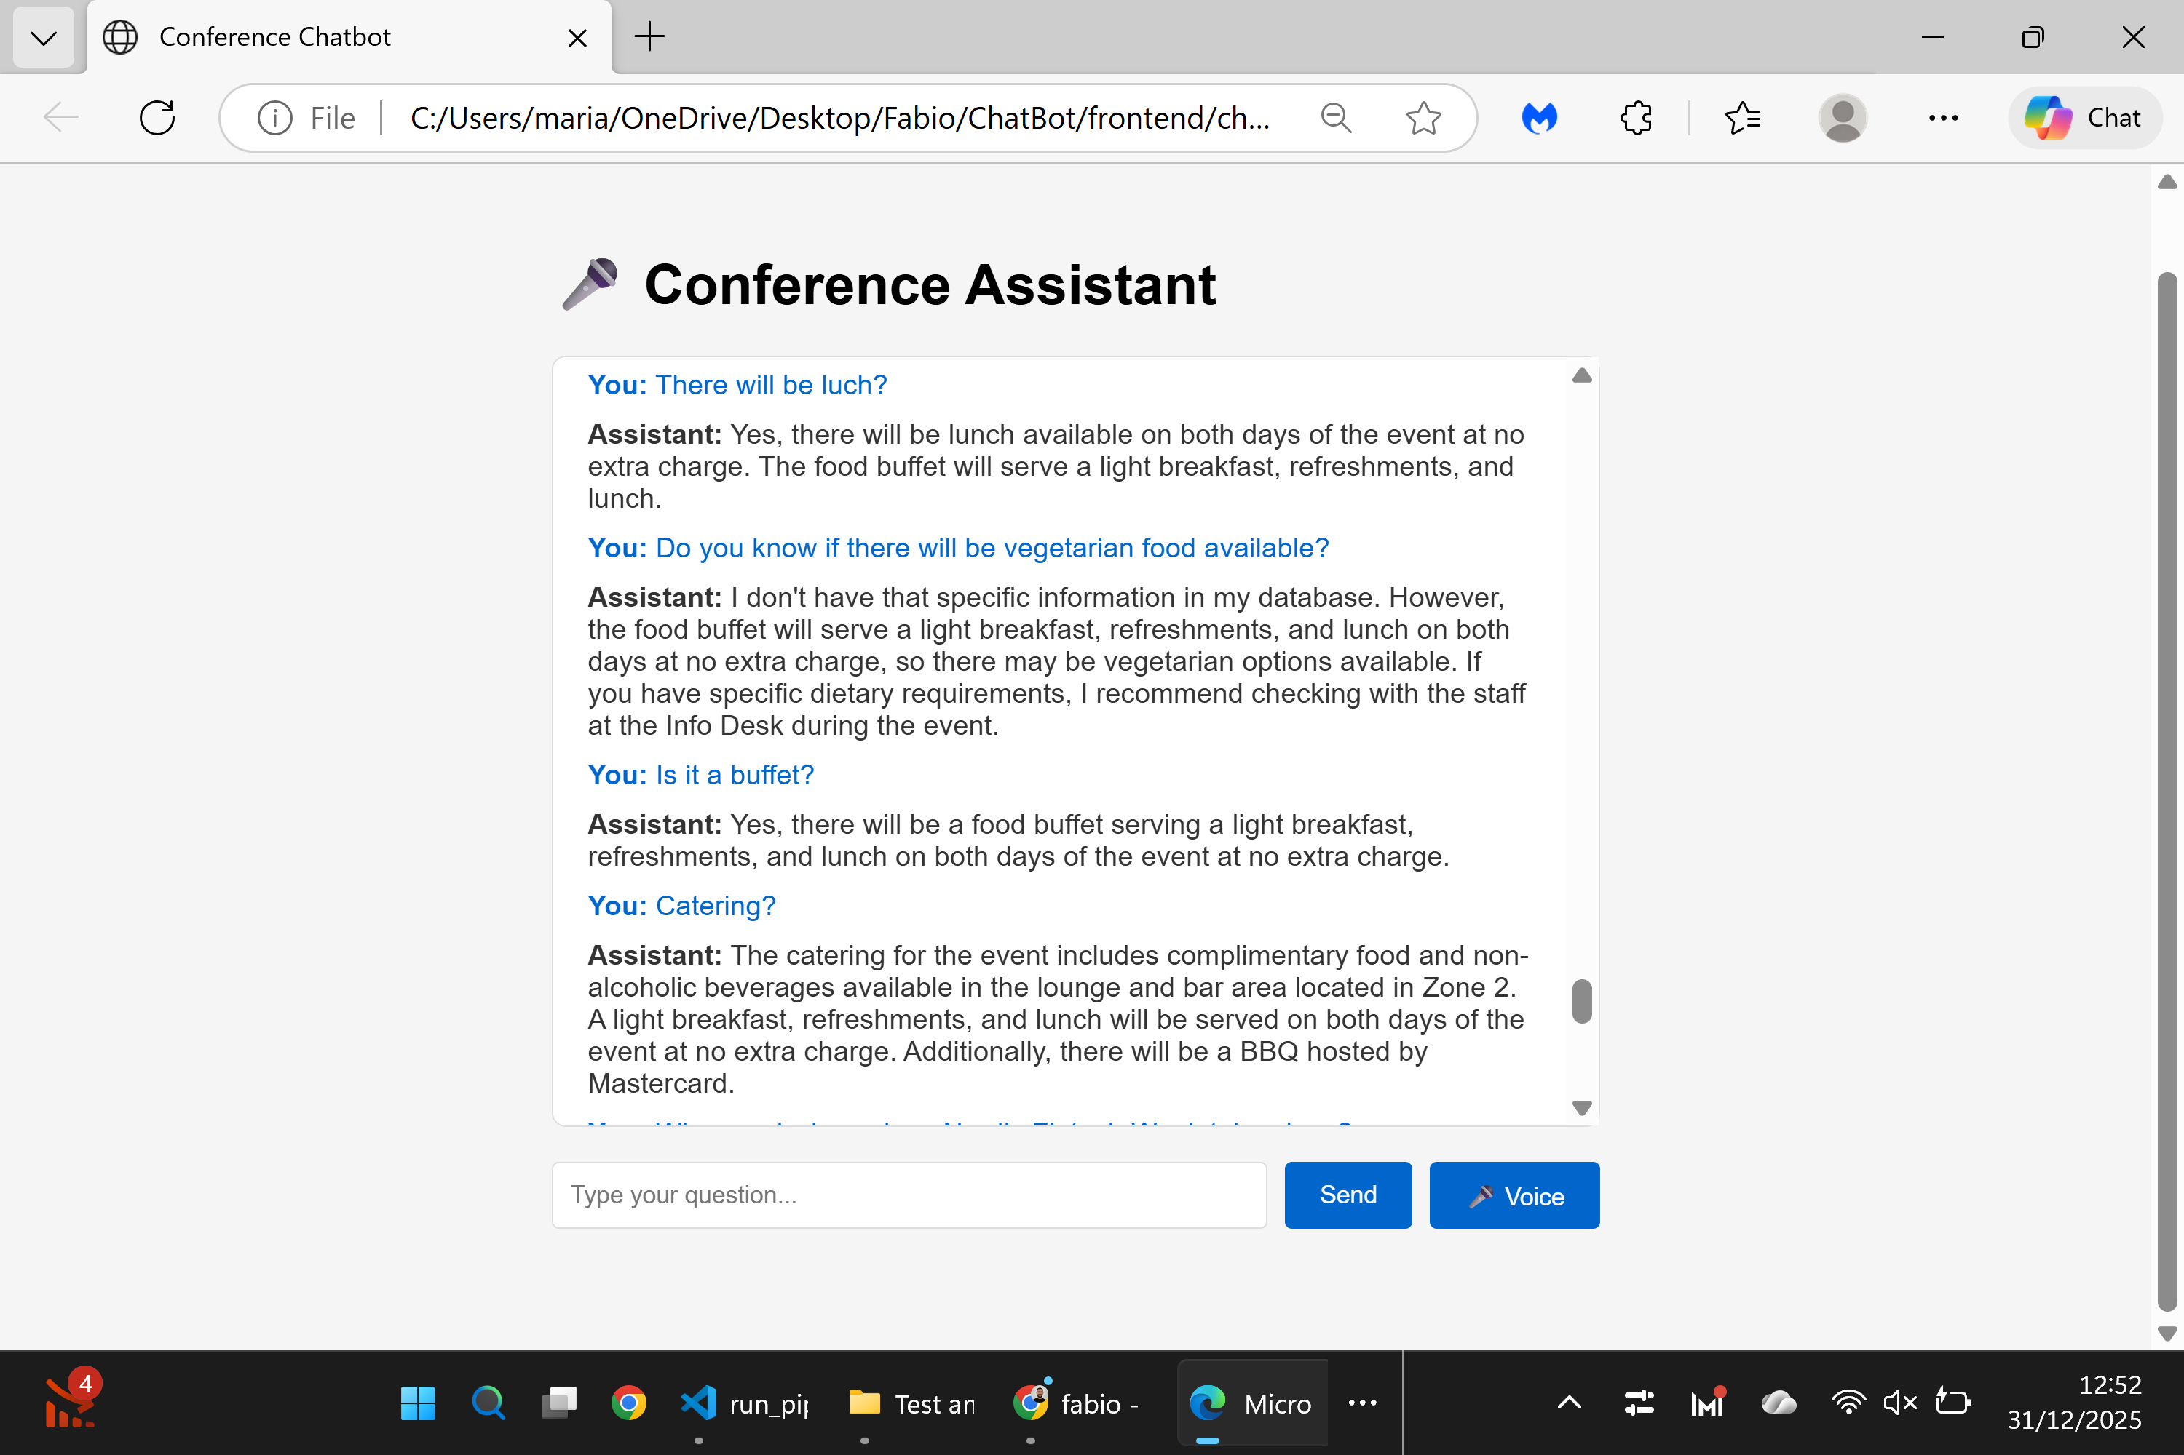
Test Report – Catering & Food Information
Page tested:
https://nfweek.com/startups/
Test scope:
Validation of food, catering, and meal-related information through the Conference Assistant.
Questions tested:
- Is lunch available during the conference?
- Is vegetarian food available?
- Is food served as a buffet?
- What catering is included?
- Are refreshments provided during the event?
Result:
✅ Successful
All tested questions returned consistent, clear, and accurate answers aligned with the information available on the website. The assistant correctly explained lunch availability, buffet format, refreshments, and catering details.
Status:
Completed successfully.

