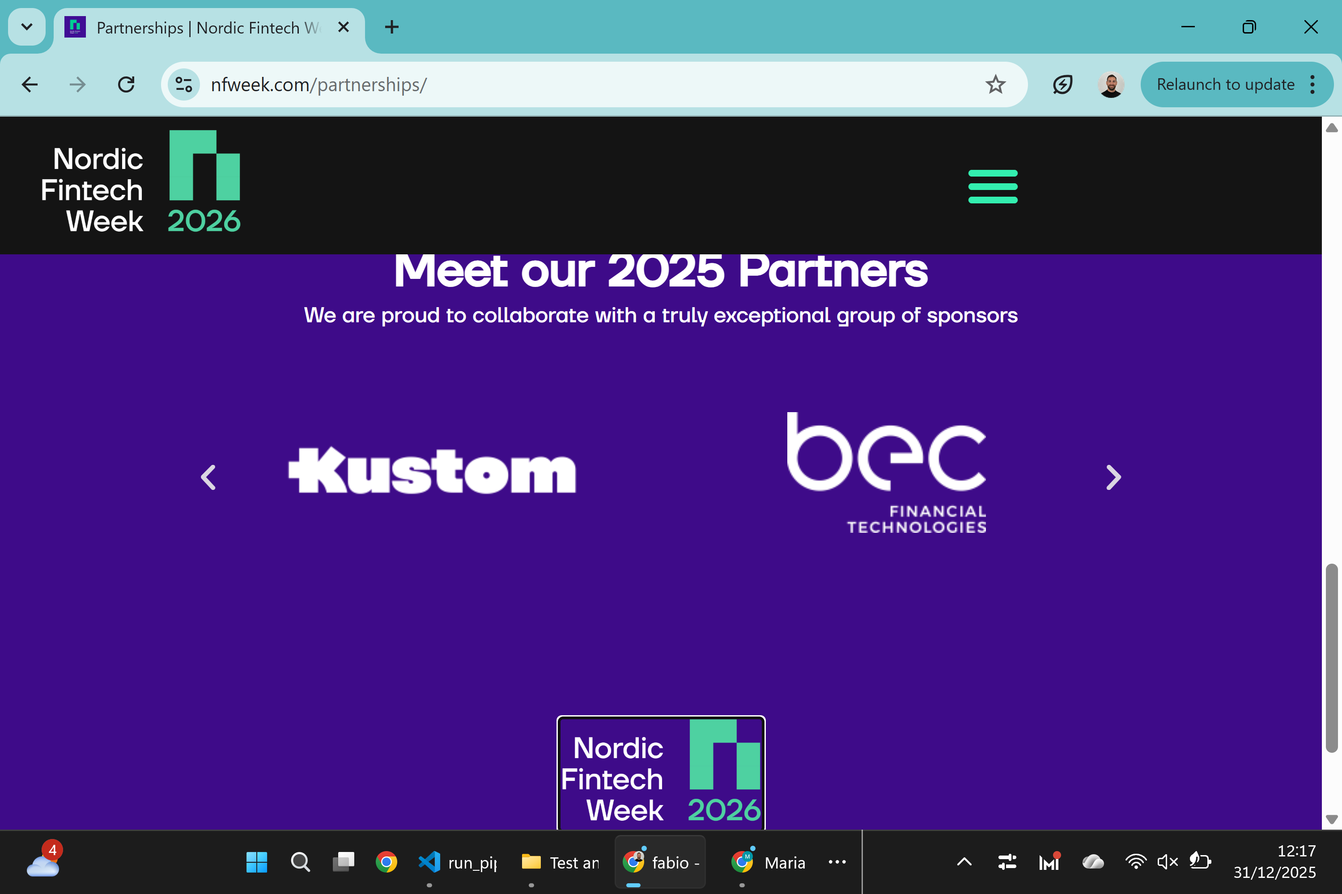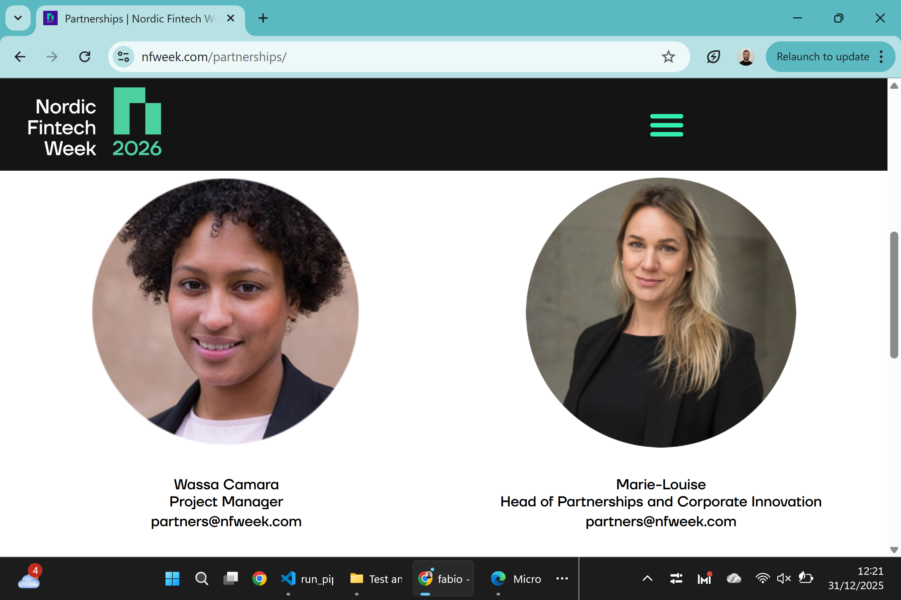

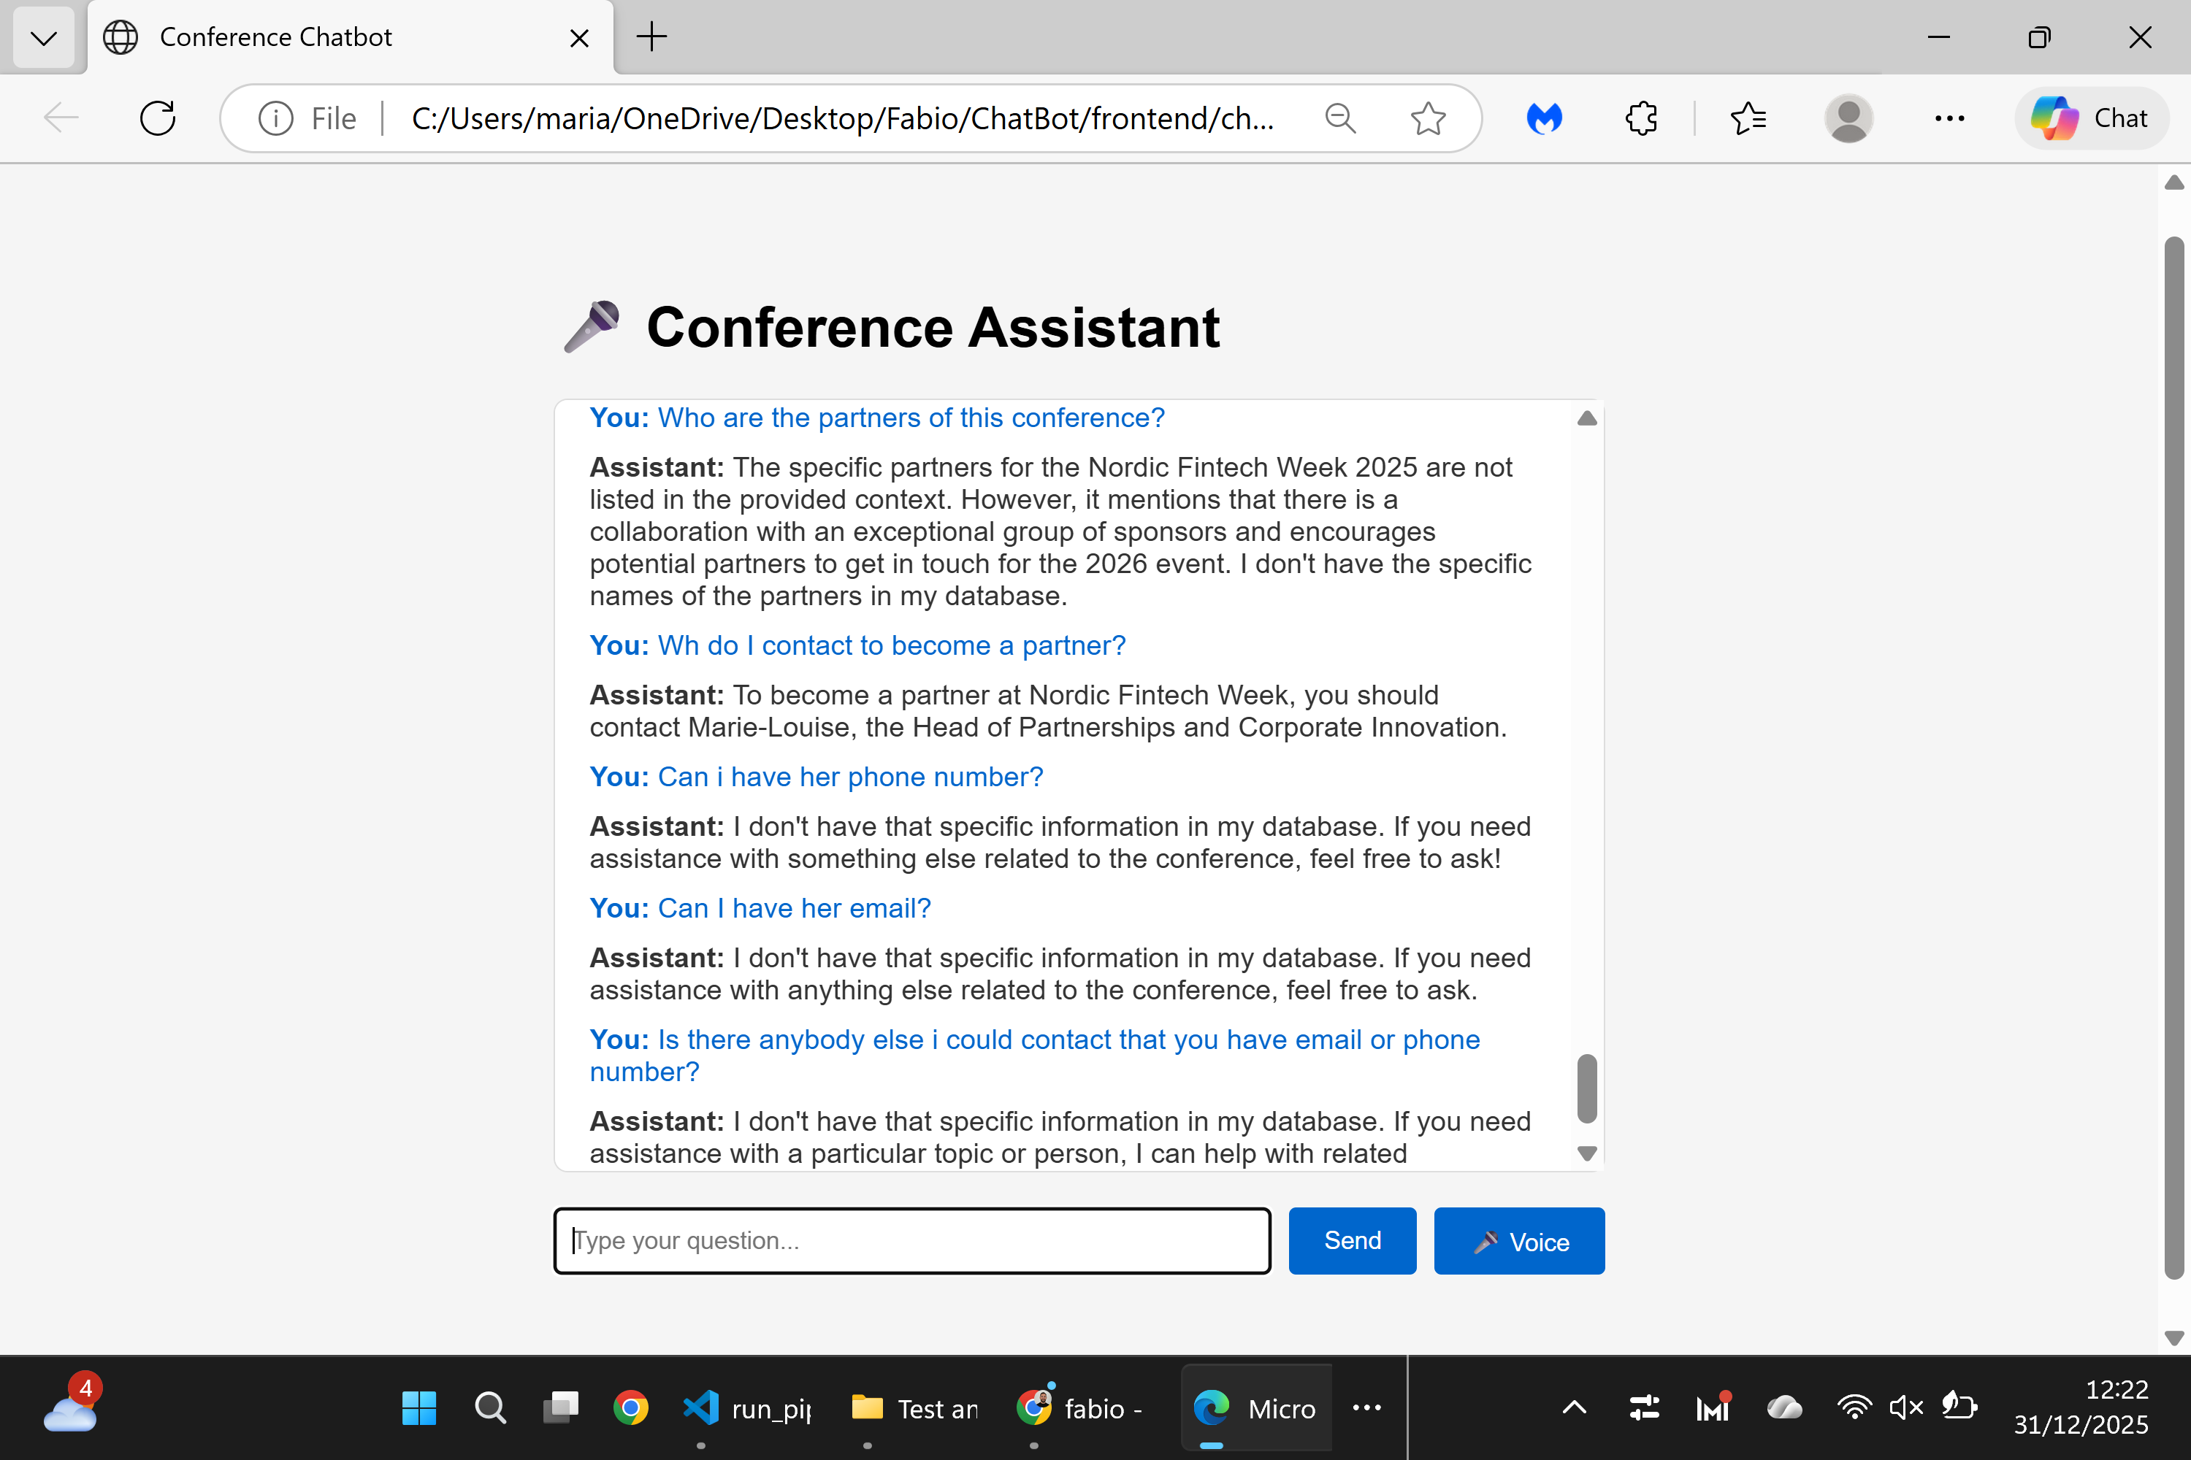
Nordic Fintech Week 2025 - Partners Page Test Report
Website: nfweek.com/nordic-fintech-awards/ (Partners section)
Questions:
- Who are the official partners of Nordic Fintech Week 2025?
- How can I contact someone to become a partner?
- What is Marie-Louise's phone number (Head of Partnerships)?
- What is Marie-Louise's email address?
- Is there any other contact person with available email or phone number?
Result: Unsuccessful - The chatbot could not provide specific information for any of the questions. All responses indicated that the information was not available in the database.
Suggestion: Hardcode essential partnership contact information (at minimum Marie-Louise's email and/or phone number) into the chatbot's knowledge base to enable basic partnership inquiries.

