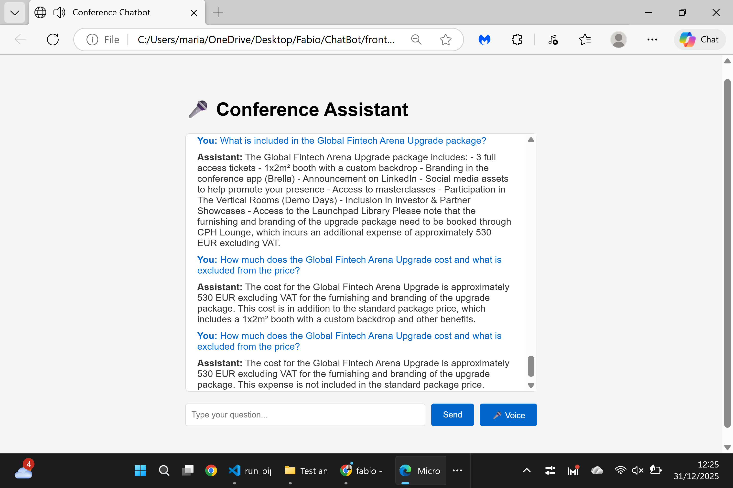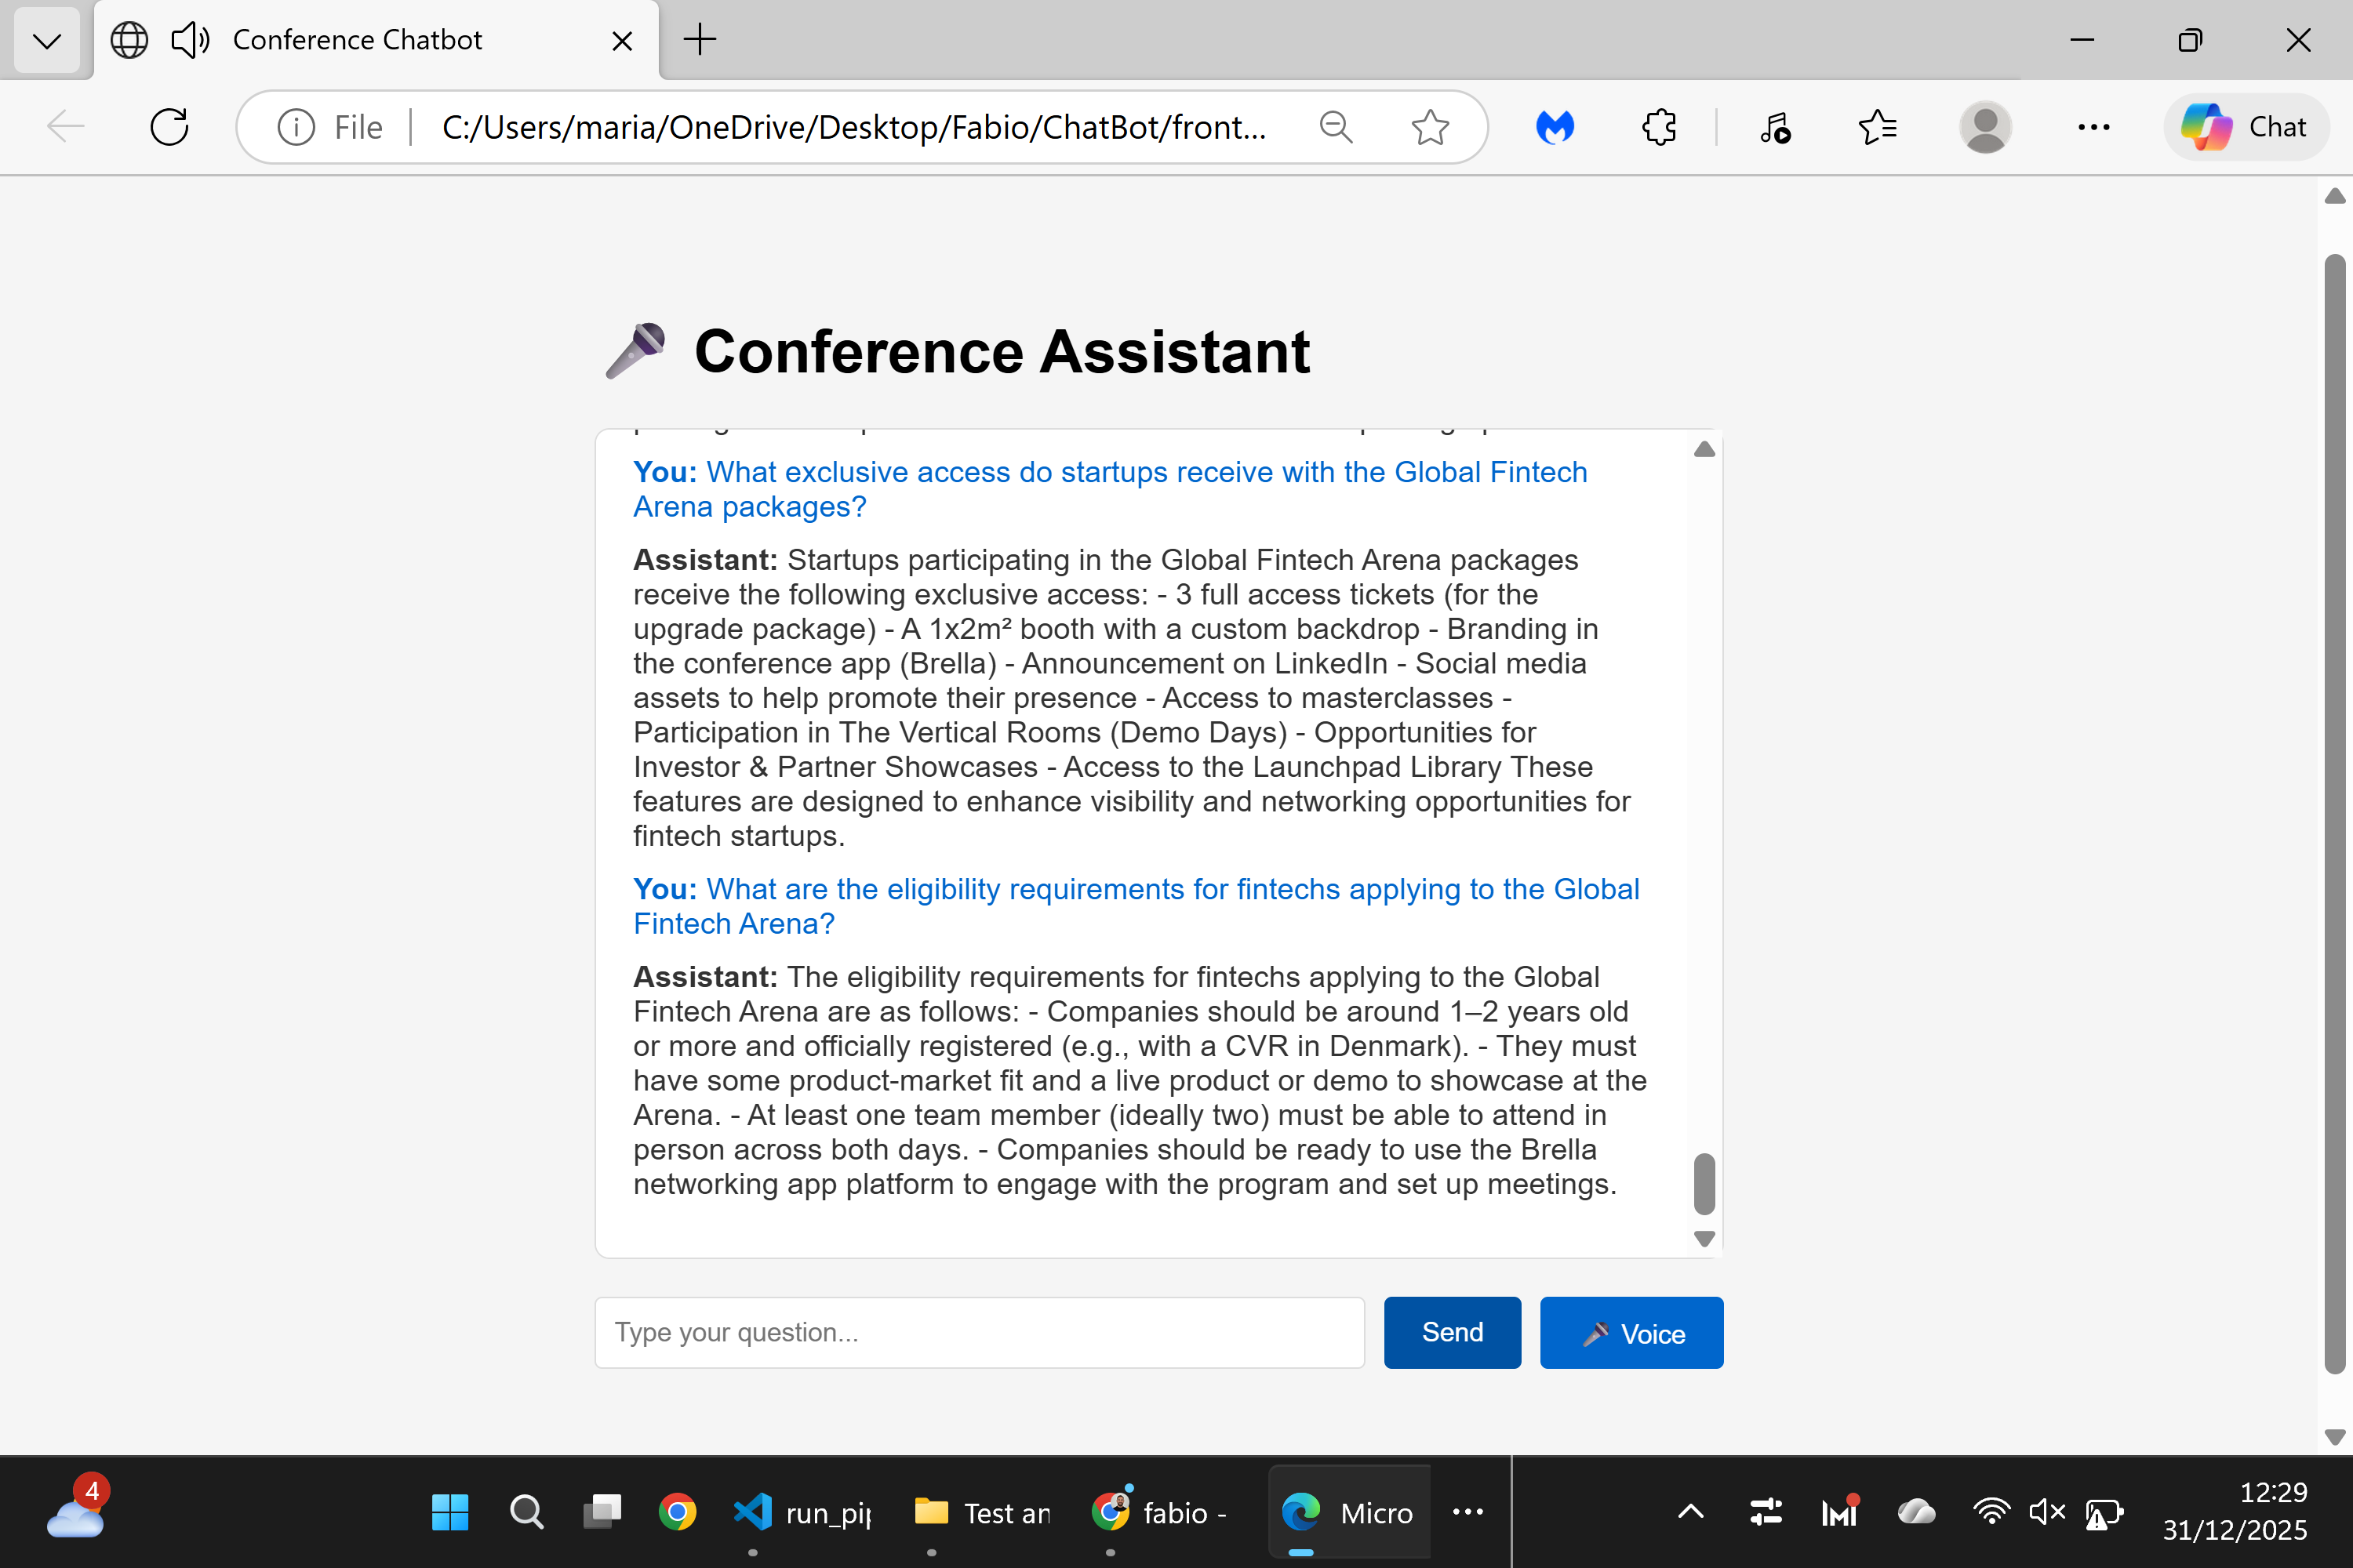

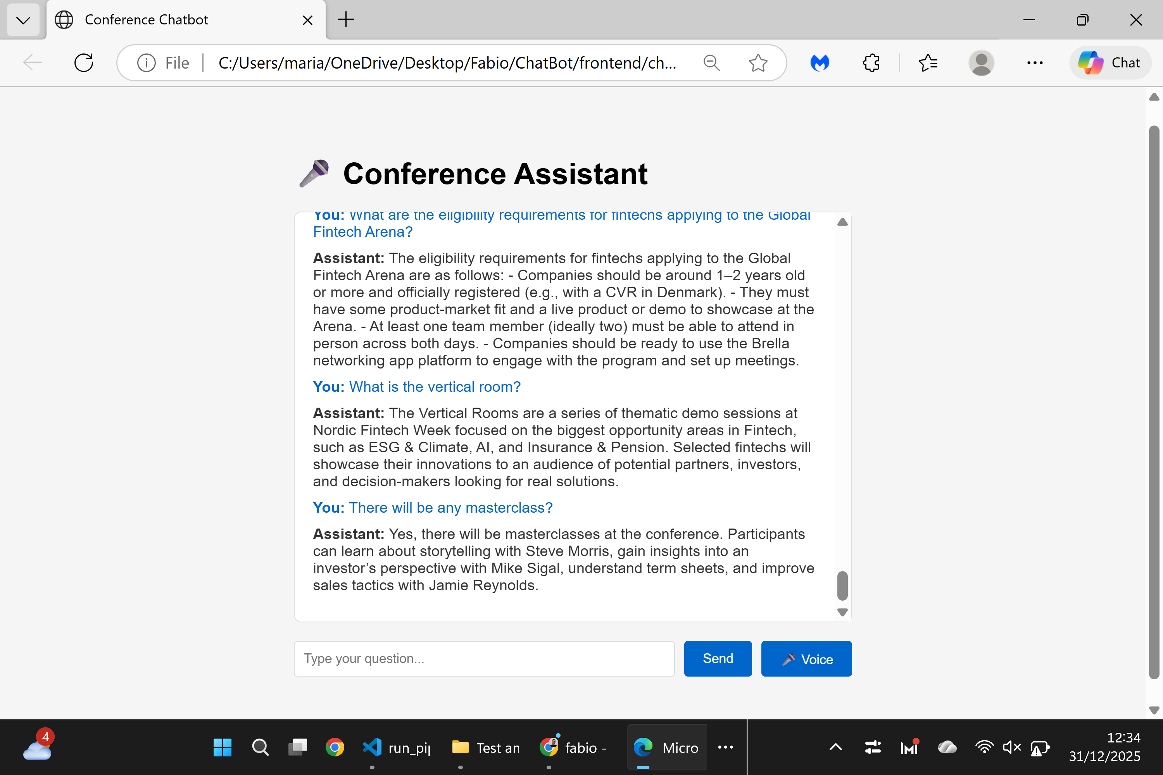

Page Tested: Pricing – Global Fintech Arena
URL: https://nfweek.com/startups/
Tested Questions:
- What is included in the Global Fintech Arena Upgrade package?
- How much does the Global Fintech Arena Upgrade cost and what is excluded from the price?
- What is the difference between the Global Fintech Arena Upgrade and the standard Global Fintech Arena package?
- What exclusive access do startups receive with the Global Fintech Arena packages?
- What are the eligibility requirements for fintechs applying to the Global Fintech Arena?
- What is the vertical room?
- There will be any masterclass?
Result:
✅ All tested questions returned clear, accurate, and pricing-consistent answers based on the page content.
Status:
Successful

