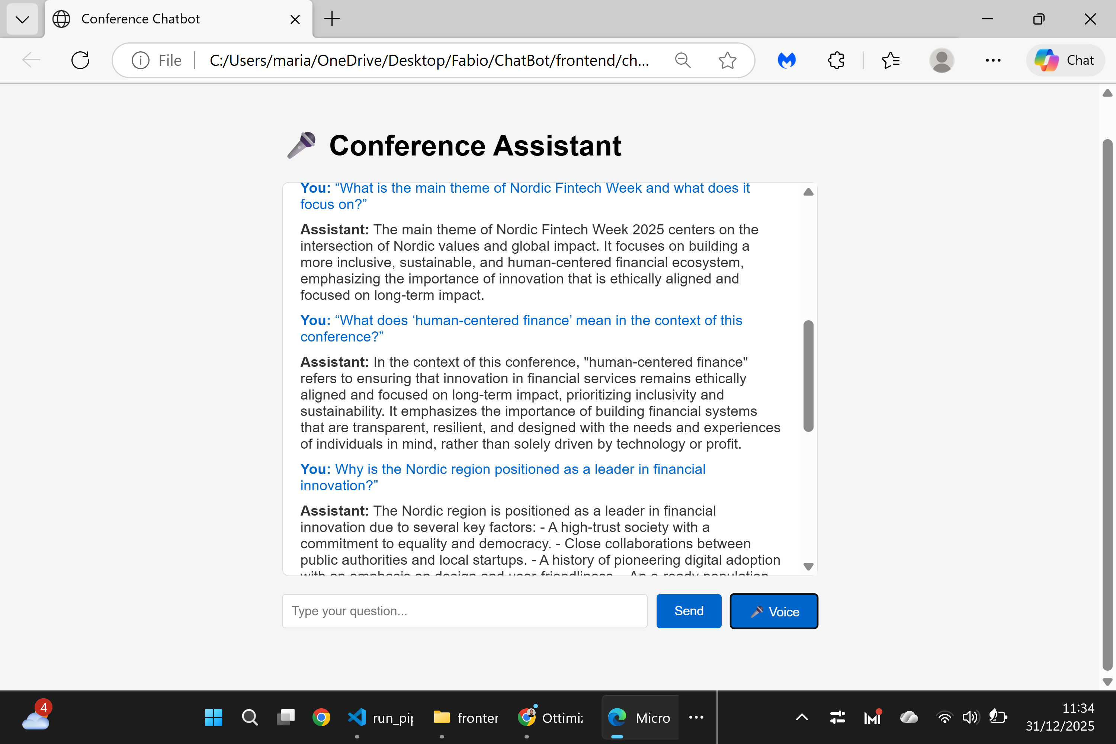

Program Page – Test Summary
Page name: Program
URL: https://nfweek.com/program-2/
Questions Tested
- What is the main theme of Nordic Fintech Week?
- How does the conference connect sustainability and finance?
- What does “human-centered finance” mean in this context?
- Which key topics will be discussed during the event?
- Why is the Nordic region positioned as a fintech leader?
- How does this theme differ from traditional fintech conferences?
- How does the program address long-term societal impact?
- Who would benefit most from attending this program?
Result
Status: ✅ Successful
All questions were answered correctly and coherently based on the page content.

