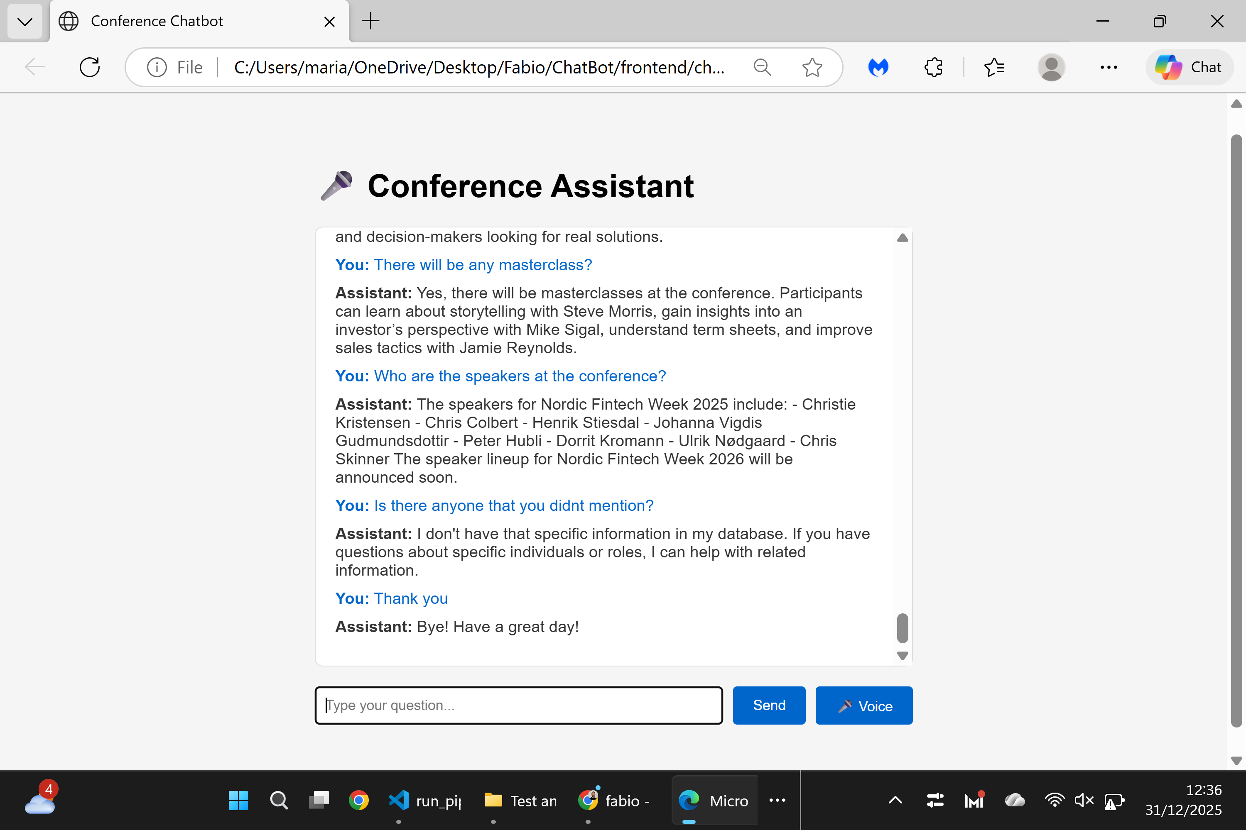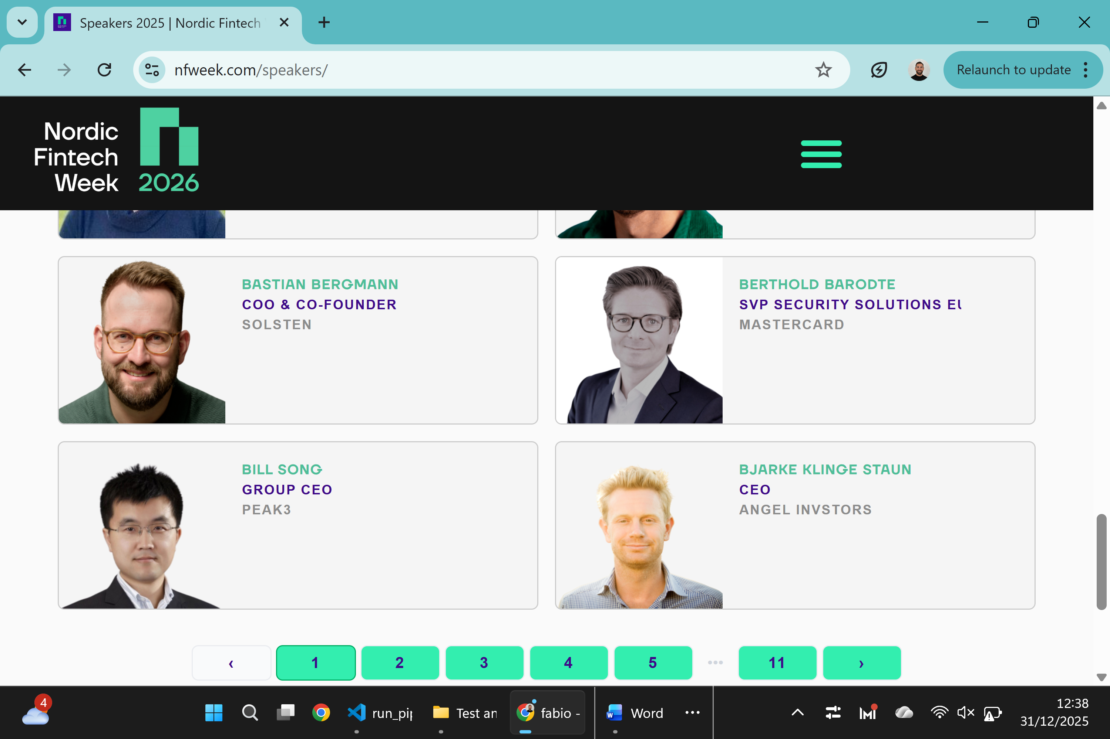

Page Tested: Speakers
URL: https://nfweek.com/speakers/
Test Scope:
Speaker information and discovery across multiple paginated speaker lists.
Notes:
The Speakers section consists of 11 pages, each displaying approximately 24 speakers, covering a broad and diverse lineup.
Result:
✅ Speaker-related questions returned accurate and context-aware answers.
✅ Navigation across multiple speaker pages did not affect response quality.
✅ The assistant correctly handled partial lists and clarified when the full lineup spans multiple pages.
Status:
Successful

