**Tidyverse: How R Should be Used**

*Zane Murphy*

*(567)-868-5658*

*zanemurphy1996@gmail.com*

**What is the Tidyverse?**

The Tidyverse is a collection of R packages that enable easy manipulation of data frames, the most important data structure in R. They share a similar design, philosophy, and grammar, and are intended to be as user friendly as possible. The Tidyverse was developed by Hadley Wickham, Chief Scientist at RStudio and is now maintained by several contributors.

**What prior knowledge is required?**

Essentially none. I will try to cover as much as possible in this packet to get you started with R, but you shouldn’t need any prior knowledge of R to participate in this workshop. I will walk through the steps of installing R and RStudio, along with the Tidyverse. These should be installed prior to coming to the workshop so that we can jump right into the material.

**Installing the necessary software**

Installing R

Navigate to the following URL: <https://cran.rstudio.com/>

Then click one of the following links at the top of the page, depending on your operating system:

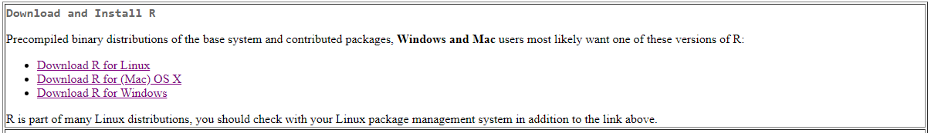

**Windows**

Click the “Download R for Windows” link, then click the “Install R for the first time” link on the next page. Finally, click the “Download R 4.0.3 for Windows” link and run the downloaded .exe file.

**Mac**

Click the “Download R for (Mac) OS X” link, then click the “R-4.0.3.pkg” link on the next page. Run the downloaded .pkg file.

**Linux**

Follow these instructions:

<https://www.jason-french.com/blog/2013/03/11/installing-r-in-linux/>

I am not a Linux user, but I will help with this install as much as possible if you contact me by email or phone before the workshop.

Installing RStudio

Once you have R installed, you will need to install RStudio. This is an IDE designed and maintained specifically for R. We will be working in an R Notebook, which works seamlessly in RStudio.

Start by navigating to the following link: <https://rstudio.com/products/rstudio/download/#download>

Then Download RStudio by clicking on the button that shows your OS:

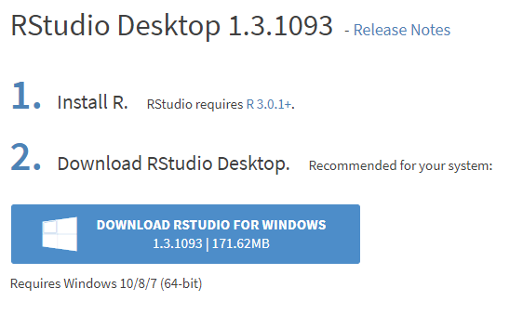

Run the downloaded .exe file. Note that we already completed Step 1 of this picture, so you are simply doing what step 2 tells you here.

Testing

To test that you have properly installed R and RStudio, open up RStudio and navigate to the Console at the bottom of the screen. Type “mtcars” and press enter. You should see a dataset pop up like in the picture below:

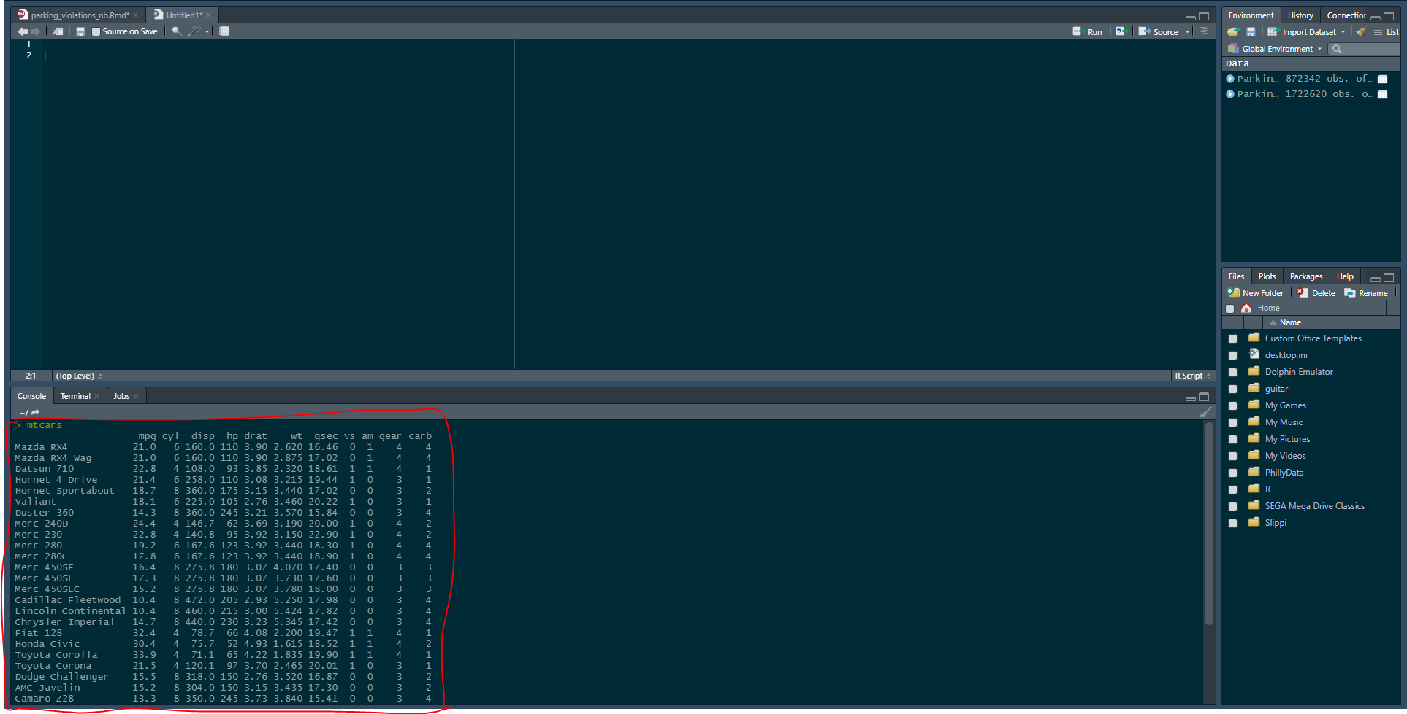

This data comes from the 1974 Motor Trend magazine and includes various statistics about the top selling car brands at that time. If you want to get a head start on the workshop, you can start trying to manipulate the data by following the attached dplyr cheat sheet.

Installing Packages

To install the Tidyverse, simply navigate to the console as you did before, then type:

install.packages(“tidyverse”)

Press enter and you should see a confirmation message in the console output telling you that the package has been installed. To load and use the package just type:

library(tidyverse)

Notice that there are no quotation marks here.

For more information about the Tidyverse, you can visit [www.tidyverse.org](http://www.tidyverse.org) to see what packages are included in the Tidyverse along with cheat sheets on how to use them. For this workshop, we will mostly be covering dplyr and ggplot2.