Dataset: 55 agents and 34103 calls.

Methodology:

Step I:

As a first step I will analyze data. Data analysis involves many steps like:

1. how many debtors paid their bill.
2. On the agents side, I will focus on how many agents could successfully persuade clients pay the debt.
3. An exploratory data analysis for agents delivering success and failure will be an important step.
4. If success rate is high for particular agents, that implies the agents could adapt to environment in a betters way compared to their peers.
5. An analysis on communication pattern of agents with higher success rate.
6. Are they using same patter? Or, they are changing depending on the situation of client.

Step 2:

Any machine learning algorithm will work best if the data has many features or attributes. In this regard, some more information from client side would be beneficial to predict the success rate. Information like

1. Age
2. Sex
3. Health condition
4. Employment condition
5. Geographical location
6. Past payment history
7. Credit score
8. Members in family

Step 3:

This is the most important step. Analysis of calls. Kind of phrase or words used that result in payment from the debtor end. Few things to extract from these calls are:

1. Sense of urgency
2. tone of conversation
3. provide customer variety of payment option like by cheque or wire transfer.
4. Providing extension in payment timeline

Below a work flow diagram is presented that describes steps involved in modeling dataset

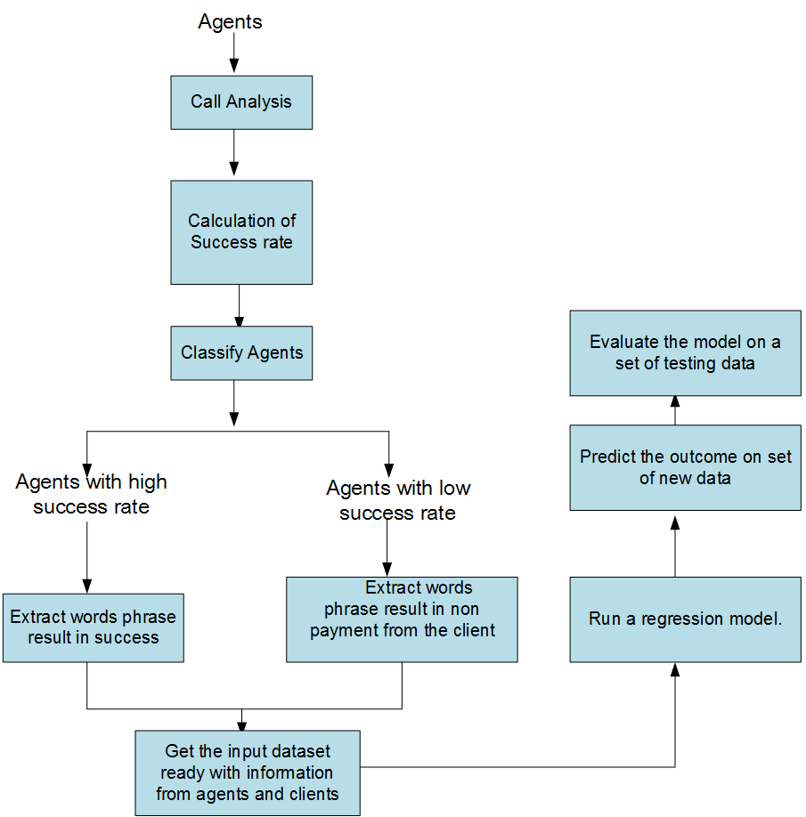

Fig.1 Steps involved in modeling dataset