### **50-12 Income Tax Reconciliation using Percentages**

A number of companies have used a negative tax rate for the statutory tax rate element. EffectiveIncomeTaxRateReconciliationAtFederalStatutoryIncomeTaxRate. This element represents the percentage of domestic federal statutory tax rate applicable to pretax income (loss). Typically in the United states this will be 34% or 35%. Companies will sometimes make the value for the statutory tax rate item negative when they have a pretax loss. For example in the disclosure below:

**Table 1 - 740-10-Effective Tax Rate Reconciliation**

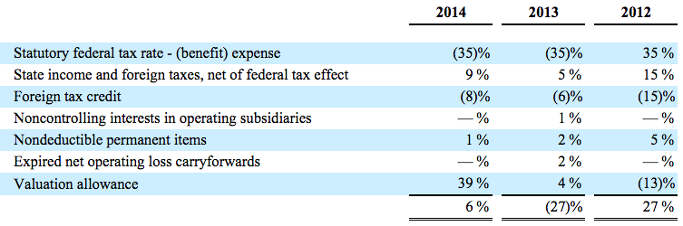

In this example the company has a pretax loss of $62,750 and a provision for income tax of $3,912 in 2014 as shown in the table below:

**Table 2 - 740-10-Net Income (Loss)**

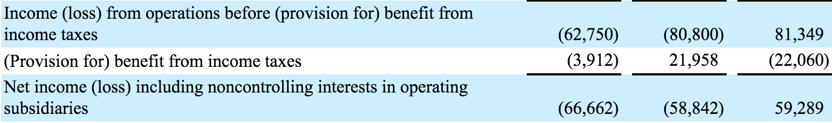

The percentage table is generated by taking the tax expense or tax credit and dividing it by the net income (loss) before tax. For example the effective tax rate is calculated as follows: 

or

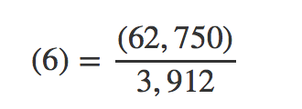

The company has reported the value as positive 6%. Given that the calculated value is -6 then the filer might consider using the negated label. However, this gives an erroneous result for the 2012 year with a value of 27% which calculates to a positive amount. In 2013, the company has entered a value as -27%. In this case the company has a loss and a tax benefit. A negative divided by a negative should in this case be a positive value and not a negative value.

To make the calculations work the company has changed the statutory federal tax rate to a negative value. The federal statutory tax rate represents the statutory tax rate applicable to the pre tax income or loss. (See definition). This amount should be a constant across all companies with the same tax jurisdiction and should not change if the company has made a profit or a loss. The 35% can be multiplied by the pretax amount to determine the fact value of the element IncomeTaxReconciliationIncomeTaxExpenseBenefitAtFederalStatutoryIncomeTaxRate. In fact the following relationships should hold.

IncomeLossFromContinuingOperationsBeforeIncomeTaxes… * EffectiveIncomeTaxRateReconciliationAtFederalStatutoryIncomeTaxRate = IncomeTaxReconciliationIncomeTaxExpenseBenefitAtFederalStatutoryIncomeTaxRate

and

IncomeLossFromContinuingOperationsBeforeIncomeTaxes…* EffectiveIncomeTaxRateContinuingOperations = IncomeTaxExpenseBenefit

Given that the starting point will always be approximately 35% for US based companies the percentages used to calculate the effective tax rate should follow the same principle. For example a foreign tax credit will always reduce the tax liability when expressed as a monetary value. In the example in table 1 the tax credit represents 8% of pre tax income. We can calculate foreign tax credit as follows:

EffectiveIncomeTaxRateReconciliationTaxCreditsForeign * IncomeLossFromContinuingOperationsBeforeIncomeTaxes… =

IncomeTaxReconciliationTaxCreditsForeign

So in this case it would be :

(8%) X ($62,750) = $5,020

If the above table was recast following the logic defined above it would be shown as below in Table 3.

**Table 3 - 740-10-Effective Tax Rate Reconciliation Percentage**

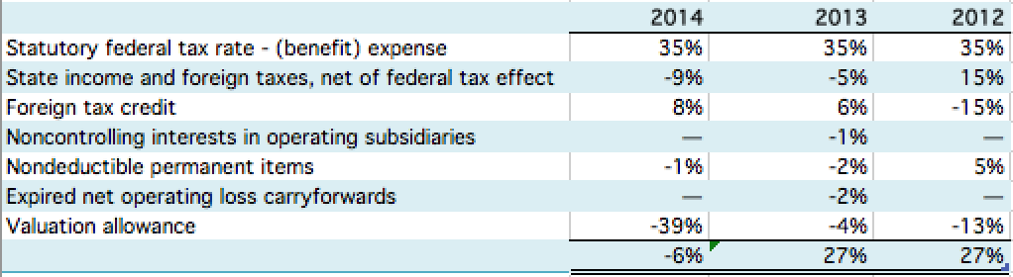

The equivalent monetary amounts can then be easily calculated by multiplying the rates in table 3 for each cell by the pretax income for each period to get the results shown in table 4.

For example 35% X (62,750) = (21,962.5)

**Table 4 - 740-10-Effective Tax Rate Reconciliation Monetary**

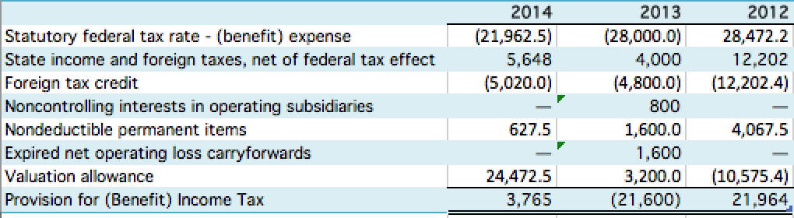

If table 4 was generated using the percentages defined in the actual disclosure the monetary equivalents would have the opposite sign in years 2014 and 2013. To get compatibility across filings it is important that the effective rates can be multiplied by the pre tax income or loss amount to get the equivalent monetary values.

When the tax rate reconciliation is prepared in an XBRL format using rates as opposed to dollar amounts the statutory rate should always be positive and the reconciling rates should equal the monetary amount of the reconciling item divided by pre tax income or loss. The sign of the resulting rate should reflect that derived from the calculation. This means a tax credit rate could be positive in one year and negative in another if the company had a pretax loss.

#### Rules

The element EffectiveIncomeTaxRateReconciliationAtFederalStatutoryIncomeTaxRate should always be positive. (See Nonneg rule DQC_0015)

The percentage income tax reconciliation elements that are not two way elements should have positive values unless the net income loss before tax is negative or a loss. When the net income loss before tax is negative then these values should be negative and not positive. (See Nonneg rule DQC_0013)