**Guidance on Tagging Designated Hedges and Non-Designated Hedges**

XBRL US Data Quality Committee

The US GAAP taxonomy contains a number of taxonomy structures to support disclosures related to hedging positions. The axis *HedgingDesignationAxis* is used to disaggregate hedges into those hedges designated as a hedge and those hedges not designated as a hedge.  This axis can be used in combination with the Hedging Relationship axis which allows a filer to disaggregate between cash flow, fair value and net investment hedges.  The relationship between these axis and the members they contain is as follows:

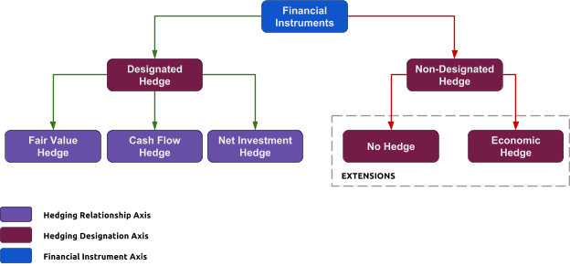

Companies will often disaggregate derivative positions into those categories of derivatives that are designated as hedges and those that are not.

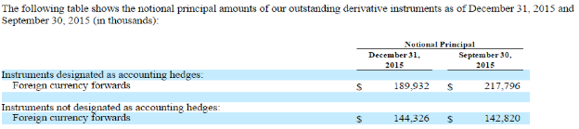

In this example the company has disaggregated the notional value of their foreign currency forwards into categories that are designated as hedges or not designated as hedges.  To disaggregate these two amounts for any given reporting period the *HedgingDesignationAxis* should be used with the members *DesignatedAsHedgingInstrumentMember* and *NondesignatedMember.*

In other situations companies further disaggregate the non-designated hedge amounts into economic hedges and derivatives used for non hedging purposes.  The following extension members[1] can be used to identify the amounts disaggregated into these categories:

***Economic Hedge Component***

|  |  |
| --- | --- |
| *NotDesignatedAsHedgingInstrumentEconomicHedgesMember* | https://lh6.googleusercontent.com/UBan5slW0yqp4E45jmMNVHnYxmzV1LMP-7R-nNJn0Kh3UP0M6MP16zKzE6W6n3QC5ZMxXCIXSsAUx2cHdbhB-s4dEqC_ot9zvR2mgbbb1u8Ee55SU_BL-Q0d-xzut9kMtSEg1JB3 |

***Non Hedge Component***

|  |  |
| --- | --- |
| *NotDesignatedAsHedgingInstrumentTradingMember* | https://lh6.googleusercontent.com/UBan5slW0yqp4E45jmMNVHnYxmzV1LMP-7R-nNJn0Kh3UP0M6MP16zKzE6W6n3QC5ZMxXCIXSsAUx2cHdbhB-s4dEqC_ot9zvR2mgbbb1u8Ee55SU_BL-Q0d-xzut9kMtSEg1JB3 |

In the following example the company has reported the notional amounts for both economic (Management) hedges and trading derivatives.

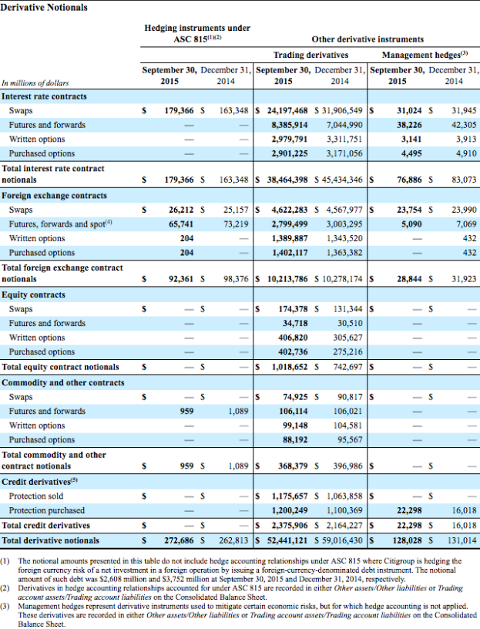

The data in the first column would use the member *DesignatedAsHedgingInstrumentMember,* the second column would use the member *NotDesignatedAsHedgingInstrumentTradingMember* and the third colum would use the member *NotDesignatedAsHedgingInstrumentEconomicHedgesMember.* The management hedges are in effect economic hedges as described in footnote 3 of the disclosure. All of the values in the disclosure would use the element *DerivativeNotionalAmount.*

Axis Redundancy

If a derivative is identified as a cash flow hedge, fair value hedge or Net Investment hedge the hedging designation axis should not be used. If any of these members are used the value must be a designated hedge and the addition of the hedging designation axis is redundant. See the section on net investment hedges in section 470.

De-Designation of a Hedge

In many cases companies will report the fact that a hedge was de designated as a hedge. This means that in a prior period an amount was hedged and in the current period it was not.  The company will often disclose the value of the notional or fair value that was de-designated as a hedge. Because this is a movement from one member on the *HedgingDesignationAxis* to another member on the axis it makes little sense to use this axis to distinguish this amount. Using the member not designated as a hedge with these values creates ambiguities in the filing as consumers of the data could misinterpret the amount to be the value of designated hedges as opposed to the change during the period. In the following disclosure the company reports the value of forward currency contracts that we de-designated of $4,879.

[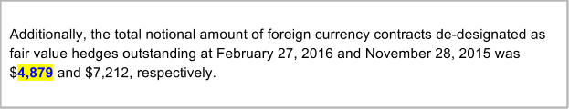](http://csuite.xbrl.us/php/dispatch.php?Task=htmlExport&FactID=122274725&searchText=%224,879%22)

This disclosure should be reported using an extension element called *DerivativeNotionalAmountDeDesignatedHedge* with the member representing that the amount relates to foreign currency contracts and the member indicating that it is a fair value hedge.

The following extension elements  can be used when defining the changes in the notional amounts due to de-designated hedges during a period:

|  |  |
| --- | --- |
| ***Change in Notional Amounts*** |  |
| *DerivativeNotionalAmountDeDesignatedHedge - Duration* | https://lh6.googleusercontent.com/UBan5slW0yqp4E45jmMNVHnYxmzV1LMP-7R-nNJn0Kh3UP0M6MP16zKzE6W6n3QC5ZMxXCIXSsAUx2cHdbhB-s4dEqC_ot9zvR2mgbbb1u8Ee55SU_BL-Q0d-xzut9kMtSEg1JB3 |

***Change in Derivative Asset Amounts***

|  |  |
| --- | --- |
| *DerivativeAssetsDeDesignatedHedge - Duration* | https://lh6.googleusercontent.com/UBan5slW0yqp4E45jmMNVHnYxmzV1LMP-7R-nNJn0Kh3UP0M6MP16zKzE6W6n3QC5ZMxXCIXSsAUx2cHdbhB-s4dEqC_ot9zvR2mgbbb1u8Ee55SU_BL-Q0d-xzut9kMtSEg1JB3 |

***Change in Derivative Liability Amounts***

|  |  |
| --- | --- |
| *DerivativeLiabillitiesDeDesignatedHedge - Duration* | https://lh6.googleusercontent.com/UBan5slW0yqp4E45jmMNVHnYxmzV1LMP-7R-nNJn0Kh3UP0M6MP16zKzE6W6n3QC5ZMxXCIXSsAUx2cHdbhB-s4dEqC_ot9zvR2mgbbb1u8Ee55SU_BL-Q0d-xzut9kMtSEg1JB3 |

The US GAAP taxonomy currently does not have elements that reflect the change in notional and derivative fair market values that reflect the movement in the notional or derivative value during the period. If reporting the the amount de designated for a Fair Value, Cash Flow or Net Investment hedge then qualify the values using the hedging Relationship [Axis].

1. https://lh6.googleusercontent.com/UBan5slW0yqp4E45jmMNVHnYxmzV1LMP-7R-nNJn0Kh3UP0M6MP16zKzE6W6n3QC5ZMxXCIXSsAUx2cHdbhB-s4dEqC_ot9zvR2mgbbb1u8Ee55SU_BL-Q0d-xzut9kMtSEg1JB3When the FASB icon is shown in this document it means that a request has been made (or should be made) to the FASB to update the taxonomy for the specific area discussed.