**Guidance on Tagging Other Than Temporary Impairment**

XBRL US Data Quality Committee

When booking other than temporary impairments the journals shown below are typically booked. To recognize the impairment the company will debit Other Comprehensive Income and credit the value of the investment, for example held to maturity securities.  The amount representing the credit loss portion does not go to AOCI rather this goes to earnings.  If a security is impaired and a portion goes to earnings and a portion to AOCI the journal entry will be as follows:

**Dr**     Impairment Expense

**Dr**     OTTI expense (AOCI)

**Cr**     Investment (Held to Maturity Security)

The XBRL equivalent elements associated with this journal are as follows:

**Dr**     Impairment Expense

|  |
| --- |
| 1. *OtherThanTemporaryImpairmentLossesInvestmentsPortionRecognizedInEarningsNetAvailableforsaleSecurities* 2. *OtherThanTemporaryImpairmentLossesInvestmentsPortionRecognizedInEarningsNetHeldtomaturitySecurities* 3. *OtherThanTemporaryImpairmentLossesInvestmentsPortionRecognizedInEarningsNet* |

**Dr**     OTTI expense to AOCI

1. *OtherThanTemporaryImpairmentLossesInvestmentsPortionInOtherComprehensiveIncomeLossNetOfTaxPortionAttributableToParent*
2. *OtherThanTemporaryImpairmentLossesInvestmentsPortionInOtherComprehensiveIncomeLossNetOfTaxPortionAttributableToParentHeldtomaturitySecurities*
3. *OtherThanTemporaryImpairmentLossesInvestmentsPortionInOtherComprehensiveIncomeLossNetOfTaxPortionAttributableToParentAvailableforsaleSecurities*
4. *OtherThanTemporaryImpairmentLossesInvestmentsPortionInOtherComprehensiveIncomeLossBeforeTaxPortionAttributableToParent*
5. *OtherThanTemporaryImpairmentLossesInvestmentsPortionInOtherComprehensiveIncomeLossBeforeTaxIncludingPortionAttributableToNoncontrollingInterestAvailableforsaleSecurities*
6. *OtherThanTemporaryImpairmentLossesInvestmentsPortionInOtherComprehensiveIncomeLossTaxPortionAttributableToParent*
7. *OtherThanTemporaryImpairmentLossesInvestmentsPortionInOtherComprehensiveIncomeLossNetOfTaxIncludingPortionAttributableToNoncontrollingInterestAvailableforsaleSecurities*
8. *OtherThanTemporaryImpairmentLossesInvestmentsPortionInOtherComprehensiveIncomeLossNetOfTaxPortionAttributableToParent*
9. *OtherThanTemporaryImpairmentLossesInvestmentsPortionInOtherComprehensiveIncomeLossBeforeTaxPortionAttributableToParentAvailableforsaleSecurities*
10. *OtherThanTemporaryImpairmentLossesInvestmentsPortionInOtherComprehensiveIncomeLossNetOfTaxIncludingPortionAttributableToNoncontrollingInterestAvailableforsaleSecurities*
11. *OtherThanTemporaryImpairmentLossesInvestmentsPortionInOtherComprehensiveIncomeLossTaxPortionAttributableToParentAvailableforsaleSecurities*
12. *OtherThanTemporaryImpairmentLossesInvestmentsPortionInOtherComprehensiveIncomeLossNetOfTaxIncludingPortionAttributableToNoncontrollingInterest*
13. *OtherThanTemporaryImpairmentLossesInvestmentsPortionInOtherComprehensiveIncomeLossBeforeTaxPortionAttributableToParentHeldtomaturitySecurities*
14. *OtherThanTemporaryImpairmentLossesInvestmentsPortionInOtherComprehensiveIncomeLossNetOfTaxPortionAttributableToParentHeldtomaturitySecurities*
15. *OtherThanTemporaryImpairmentLossesInvestmentsPortionInOtherComprehensiveIncomeLossTaxIncludingPortionAttributableToNoncontrollingInterestAvailableforsaleSecurities*
16. *OtherThanTemporaryImpairmentLossesInvestmentsPortionInOtherComprehensiveIncomeLossTaxIncludingPortionAttributableToNoncontrollingInterest*

**Cr**     Investment (HTM Security)

***Rules***

1. *All of the values listed above should be entered with a positive value.  If the value is negative the accretion extension elements discussed below should be used.  See rule* [*DQC_001*](http://xbrl.us/DQC_0015)*5*

Once a loss in the value of the security is recorded any subsequent accretions applicable to AOCI are usually recorded with the following Journal:

**Dr**    Investment (HTM Security)

**Cr** Accretion of Non Credit Portion OTTI out of AOCI

The elements in the taxonomy which represent this journal is restricted to the debit to Investment held to maturity securities. No elements exist in the taxonomy representing the credit to comprehensive income that specifically identifies the amount that was accreted.

**Dr**    Investment (HTM Security)

*OtherThanTemporaryImpairmentLossesInvestmentsAccretionOfNoncreditPortionHeldtomaturitySecuritiesBeforeTax*

**Cr** Accretion of Non Credit Portion OTTI out of AOCI

*No specific* *XBRL Element*

The taxonomy does however have the element: *OtherThanTemporaryImpairmentLossesInvestmentsReclassificationAdjustmentOfNoncreditPortionIncludedInNetIncomeHeldtomaturitySecuritiesBeforeTax*

This element is a credit to AOCI to reverse a temporary impairment. This element encompasses the following:

* Accretion of the non credit portion
* Reversal of the impairment associated with selling the held to maturity security
* Reversal  of the impairment associated with transferring the held to maturity security to available for sale

The taxonomy addresses some of these items from the perspective of the investment disclosure but not from the impact on AOCI. The taxonomy includes the element *OtherThanTemporaryImpairmentLossesInvestmentsAccretionOfNoncreditPortionHeldtomaturitySecuritiesBeforeTax* which is debit element because it increases the value of the investment. There is no corresponding credit item for the impact on AOCI.

In addition the taxonomy includes an element for the reversal of the impairment associated with transferring the held to maturity security to available for sale securities. The element OtherThanTemporaryImpairmentLossesInvestmentsReclassificationAdjustmentOfNoncreditPortionFromHeldtomaturityToAvailableforsaleSecuritiesBeforeTax is a debit element which represents the impact on the AFS component of OCI for the OTTI amount as shown in the journal below:

**Dr**    Transfer of OTTI Loss to AFS component of AOCI

OtherThanTemporaryImpairmentLossesInvestmentsReclassificationAdjustmentOfNoncreditPortionFromHeldtomaturityToAvailableforsaleSecuritiesBeforeTax

**Cr** Transfer of Non Credit Portion out of OTTI to AFS component of OCI

No specific XBRL Element

To specifically report an amount that relates to the accretion of the noncredit portion, the preparer should create an extension[1] element for each of the following applicable Gross, Tax and Net items depending on what values are reported.

|  |  |
| --- | --- |
| *OtherComprehensiveIncomeLossAccretionOfNoncreditPortionHeldtomaturitySecuritiesBeforeTax* | https://lh6.googleusercontent.com/UBan5slW0yqp4E45jmMNVHnYxmzV1LMP-7R-nNJn0Kh3UP0M6MP16zKzE6W6n3QC5ZMxXCIXSsAUx2cHdbhB-s4dEqC_ot9zvR2mgbbb1u8Ee55SU_BL-Q0d-xzut9kMtSEg1JB3 |

|  |  |
| --- | --- |
| *OtherComprehensiveIncomeLossAccretionOfNoncreditPortionHeldtomaturitySecuritiesTax* | https://lh6.googleusercontent.com/UBan5slW0yqp4E45jmMNVHnYxmzV1LMP-7R-nNJn0Kh3UP0M6MP16zKzE6W6n3QC5ZMxXCIXSsAUx2cHdbhB-s4dEqC_ot9zvR2mgbbb1u8Ee55SU_BL-Q0d-xzut9kMtSEg1JB3 |

|  |  |
| --- | --- |
| *OtherComprehensiveIncomeLossAccretionOfNoncreditPortionHeldtomaturitySecuritiesNetofTax* | https://lh6.googleusercontent.com/UBan5slW0yqp4E45jmMNVHnYxmzV1LMP-7R-nNJn0Kh3UP0M6MP16zKzE6W6n3QC5ZMxXCIXSsAUx2cHdbhB-s4dEqC_ot9zvR2mgbbb1u8Ee55SU_BL-Q0d-xzut9kMtSEg1JB3 |

In the disclosure below the company has recorded an accretion on the debt securities through AOCI. In the disclosure the gross amount is increasing the value of Other Comprehensive income as this will offset the OTTI recognized in prior periods. The three extension elements listed above should be used to record the values for $1,478, $(604) and $874.All of these amounts will be entered with positive values.

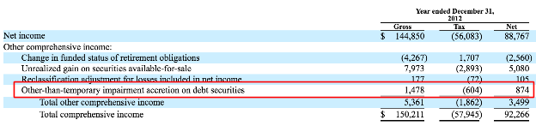

In addition in some cases companies have taken the accretion amount and expense amount and have netted them together. We have suggested the FASB add an element for this. In the disclosure below the second line has positive and negative values that indicates the value has been netted.

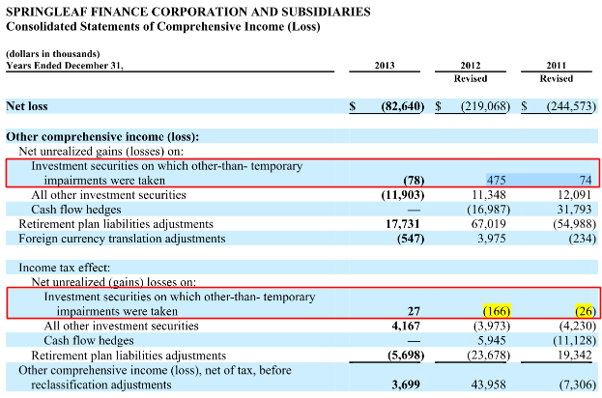

|  |  |
| --- | --- |
| OtherComprehensiveIncomeLossAdjustmentFromAOCIOn*OtherThanTemporaryImpairmentCreditLosses*BeforeTax | https://lh6.googleusercontent.com/UBan5slW0yqp4E45jmMNVHnYxmzV1LMP-7R-nNJn0Kh3UP0M6MP16zKzE6W6n3QC5ZMxXCIXSsAUx2cHdbhB-s4dEqC_ot9zvR2mgbbb1u8Ee55SU_BL-Q0d-xzut9kMtSEg1JB3 |

|  |  |
| --- | --- |
| OtherComprehensiveIncomeLossAdjustmentFromAOCIOn*OtherThanTemporaryImpairmentCreditLosses*Tax | https://lh6.googleusercontent.com/UBan5slW0yqp4E45jmMNVHnYxmzV1LMP-7R-nNJn0Kh3UP0M6MP16zKzE6W6n3QC5ZMxXCIXSsAUx2cHdbhB-s4dEqC_ot9zvR2mgbbb1u8Ee55SU_BL-Q0d-xzut9kMtSEg1JB3 |

|  |  |
| --- | --- |
| OtherComprehensiveIncomeLossAdjustmentFromAOCIOn*OtherThanTemporaryImpairmentCreditLosses*AfterTax  (FASB to add additional elements for attributable to parent and attributable to non-controlling interest) | https://lh6.googleusercontent.com/UBan5slW0yqp4E45jmMNVHnYxmzV1LMP-7R-nNJn0Kh3UP0M6MP16zKzE6W6n3QC5ZMxXCIXSsAUx2cHdbhB-s4dEqC_ot9zvR2mgbbb1u8Ee55SU_BL-Q0d-xzut9kMtSEg1JB3 |

**Sale of Security**

When an impaired security is sold for more than its book value the journal entered depends if the impairment was recorded in earnings or in OCI.

If the security sold had impairment losses that were recognized in earnings then the journal would be as follows:

**Dr**     Cash

**Cr**     Investment (HTM Security)

**Cr** Gain on Sale

*OtherThanTemporaryImpairmentCreditLossesRecognizedInEarningsReductionsSecuritiesSold*

The gain on sale is the reversal of the previous credit losses recognized in earnings. This item represents reductions in the cumulative amount of credit losses recognized in earnings for an other than temporary impairment (OTTI) of a debt security because of the sale of impaired securities during the period.  This element typically appears in the roll forward of credit losses for OTTI. (See below)

If the impairment was recognized in OCI then the journal would be as follows:

**Dr**     Cash

**Cr**     Investment (HTM Security)

**Cr** Reversal of OTTI in AOCI

The element representing the credit to AOCI to reverses the loss for the sale is not defined in the US-GAAP Taxonomy.  The extension element

|  |  |
| --- | --- |
| *OtherThanTemporaryImpairmentLossesInvestmentsPortionInOtherComprehensiveIncomeLossBeforeTaxReductionsSecuritiesSold* | https://lh6.googleusercontent.com/UBan5slW0yqp4E45jmMNVHnYxmzV1LMP-7R-nNJn0Kh3UP0M6MP16zKzE6W6n3QC5ZMxXCIXSsAUx2cHdbhB-s4dEqC_ot9zvR2mgbbb1u8Ee55SU_BL-Q0d-xzut9kMtSEg1JB3 |

**Roll -Forward of the Balance of Credit Related Impairment Losses**

The disclosure below is an example of the roll forward of a credit impairment where a portion of OTTI is recognized in OCI. In the example below the opening and closing balances are tagged with the element:

*OtherThanTemporaryImpairmentCreditLossesRecognizedInEarningsCreditLossesOnDebtSecuritiesHeld*

The movement for reductions in securities is tagged with the element:

*OtherThanTemporaryImpairmentCreditLossesRecognizedInEarningsReductionsSecuritiesSold*

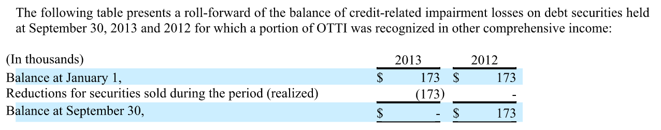

This example shows one item in the rollforward. There are a number of items which affect the movement which are shown in the roll forward in the taxonomy including elements that show the impact on OTTI for securities sold and securities with a change in status.

1. https://lh6.googleusercontent.com/UBan5slW0yqp4E45jmMNVHnYxmzV1LMP-7R-nNJn0Kh3UP0M6MP16zKzE6W6n3QC5ZMxXCIXSsAUx2cHdbhB-s4dEqC_ot9zvR2mgbbb1u8Ee55SU_BL-Q0d-xzut9kMtSEg1JB3When the FASB icon is shown in this document it means that a request has been made (or should be made) to the FASB to update the taxonomy for the specific area discussed.