**Project Title: Human Resources Analyst**

**Domain: Business Analyst**

**Project Difficulties level: intermediate**

Project Report  
Prepared by: Ritika Roy  
Date: 21/05/2025

# 1. Project Overview

This HR Analytics project focuses on employee data insights to aid strategic decision-making in areas like employee retention, performance management, diversity hiring, and overall workforce planning.  
  
Objectives of the project include:  
• Understanding employee demographics and diversity.  
• Analyzing performance and satisfaction scores.  
• Identifying trends in termination and absences.  
• Assessing the effectiveness of recruitment sources.  
• Providing HR with actionable insights through a clear and interactive Power BI dashboard.

# 2. Data Source and Importance

The dataset 'HRDataset_v14.csv' contains historical employee information such as performance review scores, engagement and satisfaction metrics, absence frequency, and hiring source. It includes details on departments, positions, marital status, gender, citizenship, and race. The data spans both active and terminated employees and includes key dates such as hire and termination.

|  |  |
| --- | --- |
| **Column Name** | **Description** |
| Employee_Name | Full name of the employee (format: Last, First) |
| EmpID | Unique employee identifier |
| MarriedID | Binary flag (1 = Married, 0 = Not Married) |
| MaritalStatusID | Numeric ID representing marital status (redundant if MaritalDesc exists) |
| GenderID | Numeric ID representing gender (typically "1" for Male and "0" for female (linked to Sex)) |
| EmpStatusID | Numeric status ID |
| DeptID | Numeric identifier for department (linked to Department) |
| PerfScoreID | Numeric code for performance score (linked to PerformanceScore) |
| FromDiversityJobFairID | Binary flag (1 = Yes, 0 = No) — indicates if employee came from a diversity job fair |
| Salary | Base annual salary in USD |
| Termd | Flag: 1 = Employee terminated, 0 = Still active |
| PositionID | Numeric ID for the employee’s position (linked to Position) |
| Position | Job title of the employee |
| State | U.S. state where the employee works |
| Zip | ZIP/postal code for the work location |
| DOB | Date of Birth — used to calculate employee age |
| Sex | Gender of the employee (typically "M" or "F") |
| MaritalDesc | Full marital status description (e.g., Married, Single) |
| CitizenDesc | Citizenship status (e.g., US Citizen, Eligible Non-Citizen) |
| HispanicLatino | Flag: "Yes" or "No" — identifies if employee is Hispanic or Latino |
| RaceDesc | Racial identity (e.g., White, Black, Asian, Two or more races) |
| DateofHire | Date the employee was hired |
| DateofTermination | Date the employee was terminated (null if still active) |
| TermReason | Reason for termination (e.g., Resigned, Retirement, Layoff) |
| EmploymentStatus | Text status: Active, Terminated, Voluntarily Resigned, etc. |
| Department | Name of the department (e.g., IT, Sales, Admin) |
| ManagerName | Full name of the employee's direct manager |
| ManagerID | Numeric ID for the manager |
| RecruitmentSource | Source of hire (e.g., Indeed, LinkedIn, Referral) |
| PerformanceScore | Descriptive score from performance review (e.g., Exceeds, Meets, Needs Improvement) |
| EngagementSurvey | Numeric score from employee engagement survey (usually 1.0 to 5.0) |
| EmpSatisfaction | Satisfaction rating on a scale (typically 1–5) |
| SpecialProjectsCount | Number of special projects the employee has been assigned |
| LastPerformanceReview_Date | Date of the last performance review |
| DaysLateLast30 | Number of days the employee was late in the last 30 days |
| Absences | Total number of full days absent in the past year |

# 3. Data Cleaning Process

To ensure accurate and meaningful analysis, the following data cleaning tasks were performed:  
  
• Removed redundant columns: Zip, EmpStatusID, Gender (mapped to Sex), PositionID, DepartmentID.  
• Standardized state names to full form (e.g., 'MA' to 'Massachusetts').  
• Cleaned names (removed comma from Employee_Name).  
• Replaced numeric identifiers with readable text:  
 - MaritalStatusID → MaritalDesc  
 - DeptID → Department  
 - PositionID → Position  
• Replaced 0/1 in MarriedID to 'Unmarried'/'Married'.  
• Removed Zip codes and other non-analytical columns.

# 4. Data Transformation Steps

Custom columns and transformations:  
• Created a corrected department column for anomalies (e.g., EmpID 10131 = 'Admin Offices').  
• Added column Agetill2020, calculating age as of Jan 1, 2020 using DOB.  
• Cleaned Sex column and renamed it to Gender ('M' → Male, 'F' → Female).  
• Converted various categorical fields (e.g., RaceDesc, Citizenship) for visualization purposes.

# 5. Dashboard Design

The Power BI dashboard includes the following visualizations for HR stakeholders:  
  
• Employee Demographics:  
 - Age distribution  
 - Gender ratio  
 - Racial diversity  
 - Marital status overview  
  
• Employment Trends:  
 - Department-wise employee count  
 - Status (Active vs Terminated)  
 - Termination reasons  
  
• Performance & Satisfaction:  
 - Average performance score by department  
 - Engagement survey vs. satisfaction comparison  
 - Correlation between late days and performance  
  
• Recruitment & Source Effectiveness:  
 - Recruitment sources and their success rate  
 - Impact of Diversity Job Fair  
 - Source-wise performance distribution  
  
• Absenteeism Insights:  
 - Number of absences by department  
 - Days late in the last 30 days (trend and outliers)

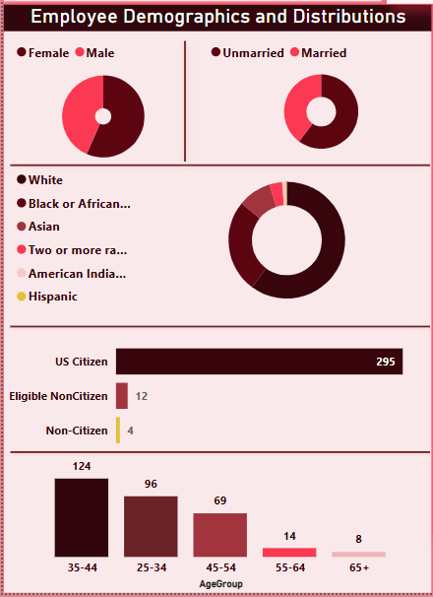

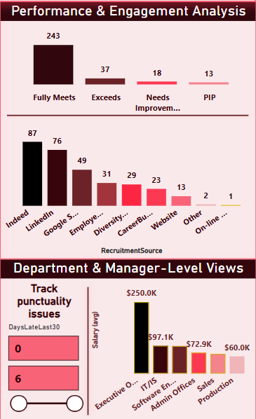



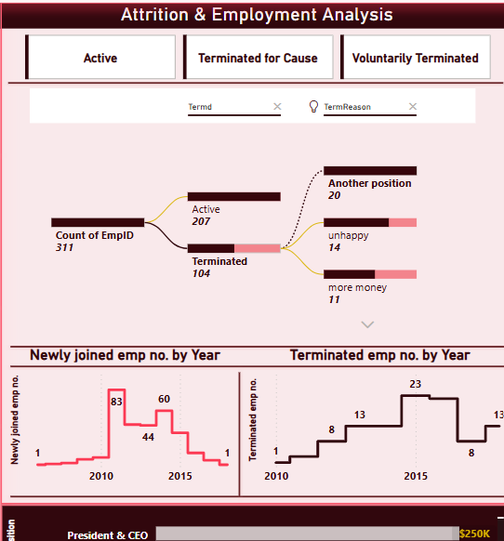

# 6. Data Storytelling

**✅ 1. Workforce Snapshot**

|  |  |  |
| --- | --- | --- |
| **Metric** | **Value** | **Insight** |
| Workforce Size | **311** | A medium-sized organization |
| Avg Job Satisfaction | **3.89** | Generally **positive satisfaction** |
| Median Salary | **$62,810** | Suggests a mid-level salary structure |
| Diversity Hires | **29** | Efforts are being made toward **diverse hiring** |

**👥 2. Employee Demographics**

|  |  |
| --- | --- |
| **Attribute** | **Insight** |
| **Gender** | Close balance between **male and female** employees |
| **Marital Status** | Balanced distribution of **married vs. unmarried** |
| **Race/Ethnicity** | Predominantly **White**, followed by **Black or African American**, **Asian** |
| **Citizenship** | Most are **US Citizens (295)**; only **16 non-citizens** |
| **Age Group** | Dominant age group: **35–44 years**, followed by **25–34 years** |

**🔄 Attrition & Termination Analysis**

|  |  |
| --- | --- |
| **Insight** | **Detail** |
| **Active Employees** | **207** currently working |
| **Terminated Employees** | **104** have left |

**Top Voluntary Termination Reasons**:

* "Another position" (20)
* "Unhappy" (14)
* "More money" (11)  
  | Suggests: Need for **better compensation, engagement, or career growth** options

**📈 Hiring & Termination Trends Over Time**

|  |  |
| --- | --- |
| **Trend** | **Insight** |
| **New Joins** | Spike around **2010–2015**, then drop |
| **Terminations** | Increasing around **2013–2015**, peaking in **2013** |
| Suggests: A **reorganization or strategic shift** may have occurred |  |

**📊 Performance & Engagement**

|  |  |
| --- | --- |
| **Metric** | **Insight** |
| **Performance Score**: |  |

* Most employees "**Fully Meet Expectations (243)**"
* Very few on **PIP (13)** or **Need Improvement (18)**  
  | Indicates overall **healthy performance management** |  
  | **Engagement Survey**: Can be further analyzed vs. EmpSatisfaction (already attempted via scatter plot)

**🌐 Recruitment Source Effectiveness**

|  |  |
| --- | --- |
| **Source** | **Hires** |
| Indeed | 87 |
| LinkedIn | 76 |
| Google Search | 49 |
| Employee Referral, Website, Others | Lower |
| **Insight**: **Job boards perform best**, but **employee referrals** could be improved |  |

**🕑 Punctuality / Behavioral Metrics**

|  |  |
| --- | --- |
| **Metric** | **Insight** |
| Days Late (Last 30 Days) | Most are **within 0–6 days** |
| Suggests: **Good attendance discipline** overall |  |

**💼 Department-Level Salary Distribution**

|  |  |
| --- | --- |
| **Department** | **Avg Salary** |
| Executive Office | **$250K** |
| Software / IT | **$97.1K** |
| Admin | **$72.9K** |
| Sales, Production | **$60K or below** |
| Insight: Strong pay **hierarchy and role-based segmentation** |  |

# 7. Reporting & Deliverables

The final deliverables to the client include:  
• Cleaned and transformed dataset with calculated metrics.  
• Interactive Power BI Dashboard (.pbix) file.  
• Documentation detailing data preparation, insights, and decisions.  
• Recommendations for HR strategy based on the findings.  
  
Key Takeaways:  
• Highlighted performance trends and potential flight risks.  
• Identified departments with higher absenteeism.  
• Demonstrated diversity hiring impact.  
• Visual storytelling for business-friendly interpretation.  
This project equips HR with actionable, real-time insights and supports data-driven decision making.