# Inorganic Arsenic: Susceptibility Factors for Bladder Cancer

The toxicity of inorganic arsenic that leads to bladder cancer is primarily mediated through reactive oxygen species (ROS). Cells become more susceptible to ROS as inorganic arsenic depletes pools of oxidative scavengers such as glutathione, s-adenosylmethionine (SAMe), and thioredoxin. This means that any agent, stressor, or disease state that interferes with oxidative radical scavenger pools will likely be a susceptibility factor for those with inorganic arsenic exposure to develop bladder cancer.

Network analysis was used to identify potentially important key events. For instance, we know that the formation of monomethylarsonous acid (MMA(III)) is critical for toxicity. By focusing on nodes in proximity to MMA(III) and dimethylarsonous acid (DMA(III)), we can identify those nodes which are most likely to interact directly, and thus less likely to be controlled through other homeostatic mechanisms. In other words, the nodes proximal to MMA(III) and DMA(III) production and their immediate effects are the ones that are most likely to be directly impactful in susceptibility.

Following is a list of potential or known susceptibility factors that may interact with inorganic arsenic exposure to modulate bladder cancer risk. These factors may be used to identify and characterize potentially susceptible populations. Each of these factors will be discussed in further detail below.

* Cigarette smokers
* Single nucleotide polymorphism (SNP) rs11191439 in the arsenite methyltransferase (As3MT) gene
* Polymorphism rs8175347 in the UDP glucuronosyltransferase family 1 member A1 (UGT1A1) gene
* SNP rs4925 in the glutathione S-transferase omega 1 (GSTO1) gene

## Cigarette Smokers

Current and ever cigarette smokers are at a significantly higher risk of bladder cancer than never smokers (Freedman *et al.*, 2011). The mode of action includes the reactivation of arylamines in the urinary bladder, due largely to acidic urine (Kadlubar *et al.*, 1977; Alguacil *et al.*, 2011). If bladder cells fail to decrease the pro-oxidant reactivity of the arylamines, this can lead to oxidative stress, decreases in reduced glutathione (GSH), and DNA damage (Siraki *et al.*, 2002). This is depicted in Figure X1 with the thick arrows.

Inorganic arsenic’s interaction with the arylamines from cigarette smoke occurs through GSH and oxidative stress (Figure X1). Specifically, inorganic arsenic leads to the production of reactive oxygen species (ROS), and conversion from As(V) to As(III), both of which deplete intracellular GSH pools (Jomova *et al.*, 2011; Gamble *et al.*, 2006). In addition, arsenical metabolism and resulting oxidative stress also lead to the depletion of thioredoxin pools. Depletion of the intracellular GSH pool makes cells more susceptible to oxidative stress.

Thus, cigarette smokers are likely to be even more susceptible to bladder cancer when co-exposed to inorganic arsenic through the environment. As both activities deplete the intracellular anti-oxidant pools, cells become even more susceptible oxidative stress, cellular and tissue injury, and potential tumor initiation and progression.

## As3MT SNP rs11191439

As3MT is responsible for the formation of MMA and DMA (Gamble *et al.*, 2006), making it a key enzyme in the toxicity and detoxification of inorganic arsenic. The SNP rs11191439 encodes a M287T (methionine-to-threonine subtitution at amino acid position 287). This SNP leads to an increase in DMA production, and thus increased potential for toxicity. This suggests that individuals with the SNP rs11191439 may be at an increased risk of toxicity, including bladder cancer, due to the enhanced production of MMA(III) and DMA(III) (Kitchin, 2001).

When cellular GSH levels are low (e.g., 1mM), SNP rs11191439 produces even more DMA(III) than wildtype As3MT (Ding *et al.*, 2012). In a study of a Mexican population, people with the rs11191439 SNP not only had higher urinary DMA(III) concentrations, but they also exhibited increased toxicity through an increased incidence of diabetes mellitus type 2 (Drobná *et al.*, 2013).

SNP rs11191439 has a relatively low occurrence in human populations. Individuals of Chinese heritage have the lowest frequency of occurrence, at 2.0%, within the 1000 Genomes Project. The group with the highest frequency, at 17.8%, is Puerto Ricans from Puerto Rico (<http://www.ncbi.nlm.nih.gov/variation/tools/1000genomes/?q=rs11191439>; accessed 10 August 2016).

## UGT1A1 rs8175347

UGT1A1 is responsible for the glucoronidation of lipophyllic compounds, a part of Phase II drug/chemical metabolism. The rs8174347 is a TA(7) polymorphism in the TATA box of the gene’s promoter. The normal allele is the TA(6) state, where the TATA box has 6 TAs. The TA(7) polymorphism leads to decreased expression of UGT1A1 by approximately 70% (Tukey *et al.*, 2002; Bosma *et al.*, 1995).

Among smokers, the polymorphism rs9175347 is associated with a 4.95 risk of recurrence of non-muscle-invasive bladder cancers (Lacombe *et al.*, 2016). With respect to smoking, this polymorphism likely decreases the ability of UGT1A1 to glucoronidate activated arylamines. Thus, a combination of this polymorphism, in ever smokers, who have exposure to inorganic arsenic, may see an increased risk of bladder cancer.

According to PharmGKB (https://www.pharmgkb.org/variant/rs8175347#tabview=tab3&subtab=), the TA(7) polymorphism occurs with the highest frequency in African Americans (42-56%), between 26-31% in Caucasians, and at the lowest frequency in Asian populations (9-16%) (Hall *et al.*, 1999; Beutler *et al.*, 1998).

## GSTO1 SNP rs4925

Glutathione s-transferase omega 1 (GSTO1) is involved in the methylation of inorganic arsenic, along with As3MT. GSTO1 is involved in the conversion from MMA(V) to MMA(III) (Schmuck *et al.*, 2005). The SNP rs4925 has been shown to decrease thioltransferase activity by 75%; however, in the same study there was no noticeable difference in the kinetic parameters for MMA(V) to MMA(III) reduction (Tanaka-Kagawa *et al.*, 2003). Likely, any enhancement in arsenic toxicity due to this SNP may have to do with the thioltransferase activity, and is likely associated with a decrease in arsenic excretion into the urine (Rodrigues *et al.*, 2012). It is also possible that there may be genetic linkage between this SNP and others that also contribute to the enhanced toxicity. Individuals from a Southwestern Taiwanese population who were homozygous for SNP rs4925 had a hazard ratio of 4.79 for developing urothelial carcinomas only when their cumulative arsenic exposure was greater than or equal to 20mg/L*year (Hsu *et al.*, 2011).

Overall, rs4925 has an average frequency of 18% in the human population. The populations with the highest frequency are Utah residents with northern and western European ancestry and Toscani from Italy, each at 36%. The population with the lowest frequency is the Mende population in Sierra Leone at 3.5%.

# References

Alguacil, J. *et al.* (2011) Urinary pH, cigarette smoking and bladder cancer risk. *Carcinogenesis*, **32**, 843–847.

Beutler, E. *et al.* (1998) Racial variability in the UDP-glucuronosyltransferase 1 (UGT1A1) promoter: a balanced polymorphism for regulation of bilirubin metabolism? *Proc. Natl. Acad. Sci. U. S. A.*, **95**, 8170–8174.

Bosma, P.J. *et al.* (1995) The genetic basis of the reduced expression of bilirubin UDP-glucuronosyltransferase 1 in Gilbert’s syndrome. *N. Engl. J. Med.*, **333**, 1171–1175.

Ding, L. *et al.* (2012) Methylation of Arsenic by Recombinant Human Wild-Type Arsenic (+3 Oxidation State) Methyltransferase and its Methionine 287 Threonine (M287T) Polymorph: Role of Glutathione. *Toxicol. Appl. Pharmacol.*, **264**, 121–130.

Drobná, Z. *et al.* (2013) Environmental exposure to arsenic, AS3MT polymorphism and prevalence of diabetes in Mexico. *J. Expo. Sci. Environ. Epidemiol.*, **23**, 151–155.

Freedman, N.D. *et al.* (2011) Association between smoking and risk of bladder cancer among men and women. *JAMA*, **306**, 737–745.

Gamble, M.V. *et al.* (2006) Folate and arsenic metabolism: a double-blind, placebo-controlled folic acid–supplementation trial in Bangladesh. *Am. J. Clin. Nutr.*, **84**, 1093–1101.

Hall, D. *et al.* (1999) Variability at the uridine diphosphate glucuronosyltransferase 1A1 promoter in human populations and primates. *Pharmacogenetics*, **9**, 591–599.

Hsu, L.-I. *et al.* (2011) Genetic polymorphisms in glutathione S-transferase (GST) superfamily and risk of arsenic-induced urothelial carcinoma in residents of southwestern Taiwan. *J. Biomed. Sci.*, **18**, 51.

Jomova, K. *et al.* (2011) Arsenic: toxicity, oxidative stress and human disease. *J. Appl. Toxicol. JAT*, **31**, 95–107.

Kadlubar, F.F. *et al.* (1977) Hepatic Microsomal N-Glucuronidation and Nucleic Acid Binding of N-Hydroxy Arylamines in Relation to Urinary Bladder Carcinogenesis. *Cancer Res.*, **37**, 805–814.

Kitchin, K.T. (2001) Recent Advances in Arsenic Carcinogenesis: Modes of Action, Animal Model Systems, and Methylated Arsenic Metabolites. *Toxicol. Appl. Pharmacol.*, **172**, 249–261.

Lacombe, L. *et al.* (2016) Phase II Drug-Metabolizing Polymorphisms and Smoking Predict Recurrence of Non-Muscle-Invasive Bladder Cancer: A Gene-Smoking Interaction. *Cancer Prev. Res. Phila. Pa*, **9**, 189–195.

Rodrigues, E.G. *et al.* (2012) GSTO and AS3MT genetic polymorphisms and differences in urinary arsenic concentrations among residents in Bangladesh. *Biomarkers*, **17**, 240–247.

Schmuck, E.M. *et al.* (2005) Characterization of the monomethylarsonate reductase and dehydroascorbate reductase activities of Omega class glutathione transferase variants: implications for arsenic metabolism and the age-at-onset of Alzheimer’s and Parkinson’s diseases. *Pharmacogenet. Genomics*, **15**, 493–501.

Siraki, A.G. *et al.* (2002) N-oxidation of aromatic amines by intracellular oxidases. *Drug Metab. Rev.*, **34**, 549–564.

Tanaka-Kagawa, T. *et al.* (2003) Functional characterization of two variant human GSTO 1-1s (Ala140Asp and Thr217Asn). *Biochem. Biophys. Res. Commun.*, **301**, 516–520.

Tukey, R.H. *et al.* (2002) Pharmacogenomics of human UDP-glucuronosyltransferases and irinotecan toxicity. *Mol. Pharmacol.*, **62**, 446–450.

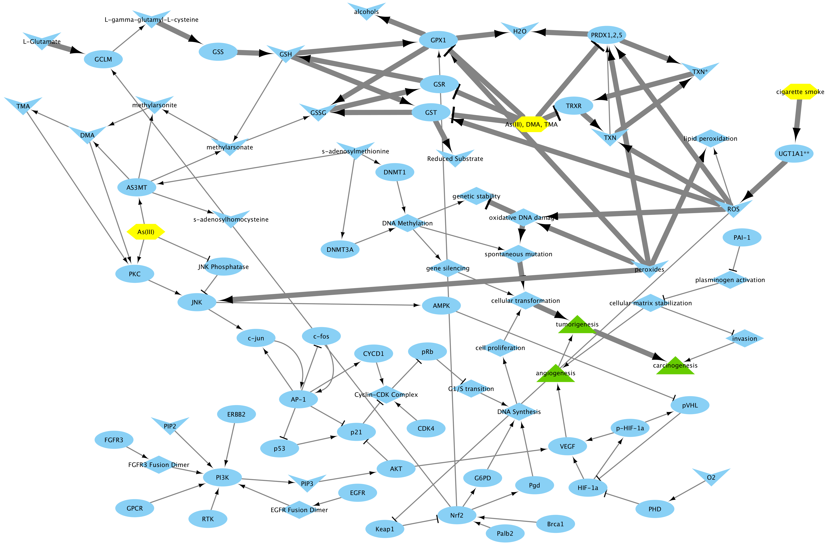

Figure X1