

Macroeconomic report -- November 2019

This reports summarizes recent development in macroeconomic figures affecting the Norwegian econonomy. Particullary focusing on data from the National Account,interest rates, exchange rates and prices of consumer goods and housing.

# The real economy

This paragraph discusses data from the National Accounts ..

## Few signs of slower economic growth in Norway this autumn

Figures for the Norwegian econonomy is still strong...

### Private and public growth, Investments and Net Exports in fixed 2017-prices

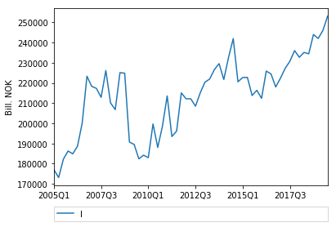

### GDP-gap for the Norwegian economy

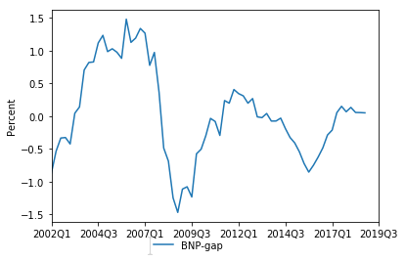

Measured by the GDP-gap the Norwegian economy is now growing with the a growth rate equal to the average growth rate for the last decades...The Table below shows figures for the last four quarter...

### Macroecomic figures, Bill. NOK. Fixed prices

|  |  |  |  |  |
| --- | --- | --- | --- | --- |
|  | I | G | NX | G |
| 2018Q3 | 234459 | 248948 | 303073 | 248948 |
| 2018Q4 | 244030 | 248795 | 298701 | 248795 |
| 2019Q1 | 242045 | 248756 | 304699 | 248756 |
| 2019Q2 | 246056 | 253820 | 303818 | 253820 |
| 2019Q3 | 253135 | 258967 | 297102 | 258967 |

# Exchange rates and interest rates

## The Norwegian continue to weaken

The Norwegian krone (NOK) continues to depresiate. As shown in the figure below we see that measured againts both the Euro and the US Dollarthe NOK is record weak.

### Exchange rates, NOK againts, GBP, USD, EUR

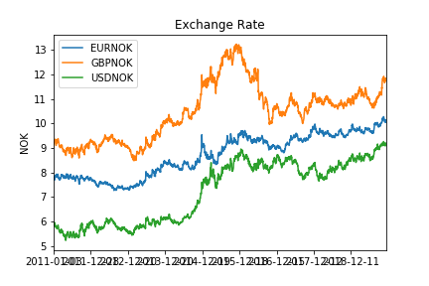

**Data sources:** Statitics Norway and Bank of Norway  
**Author:** Joakim Blix Prestmo   
**Source code:** makeWordReport.ipynb   
**Updated:** 2019-11-22