**Title One: Pairs Trading Analysis**

**Abstract**

**Introduction**

“The stock price is random walk” Eugen Fama said. The movie inside jobs tells story of 2008 financial crisis. People lost jobs and companies went down. Lehman brothers which was found in 1850 filed bankruptcy in 2008, and government tired to save AIG. The examples above describe a sophisticated market with potential risk. However, many hedge fund companies perform exceedingly impressive. John Pualson who is a HBS graduate and a also hedge fund industry tycoon donated 400 million dollars to School of Engineering and Applied Science in 2015. All the examples above relate to the movement of stocks. Many analysis and researches try to find the rules or trend in the stock market.

Pairs trading applies the concept of time series stationary process. Mean reverting of the spread between two stocks price. Since the individual stock price movement is random walk AR1 model which means beta1 equals to 1. The price today is price yesterday plus noise. Thereby, we could not really do something about predicting individual stock’s price. However, by applying pairs trading strategy, we can trade successfully by applying understanding mean reverting concept.

*S*  *Xt* *Yt*

We then say X(t) and Y(t) are cointegrated if we can find a  that makes

this spread stationary (so it will be mean-reverting).

We would then go long 1 share of X and short  shares of Y.

(Professor Michael Parzen, 12/2016, slides of stats 107, Harvard University)

To do pairs trading, we have two questions. First of all, which pair we should choose? The second is when to initiate and to close the trade. Besides, two correlated stocks price might be not a good pair to trade.

**Methods**

1. Pairs trading

“Pairs trading is a market-neutral trading strategy that matches a long position with a short position in a pair of highly correlated instruments such as two stocks, exchange-traded funds (ETFs), currencies, commodities or options. Pairs traders wait for weakness in the correlation, and then go long on the under-performer while simultaneously going short on the over-performer, closing the positions as the relationship returns to its statistical norm. The strategy’s profit is derived from the difference in price change between the two instruments, rather than from the direction in which each moves.”

(Investopedia, http://www.investopedia.com/university/guide-pairs trading/#ixzz4RuWmYmu2 )

When a market allows short sell(some markets do not), we can take advantage a reverting mean of difference between two stocks prices. The stocks prices might split far at this moment but they will be back gather again. Traders use this movement to bring the profit and reduce losses.

1. How to choose a pair

* ACF & Random Walk of individual stock price

Correlation is a single number that describes the degree of relationship between two variables. Thereby, we might consider correlation is a benchmark to select a pair of stock to trade. However, correlation does not work well for pairs trading. The formulas below explain that stock price today is yesterday price plus noise since the beta1 of AR1 model equals to 1. When beta1 equals to 1, the mean of time series is blowing away. Most of stocks price follow AR1 model with beta1 equal to 1. The individual stock price movement is independent and so there is no correlation between stocks ‘price. Therefore, correlation coefficient should not be used. Stock price is random walk with positive drift.

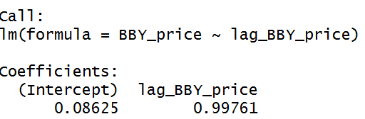

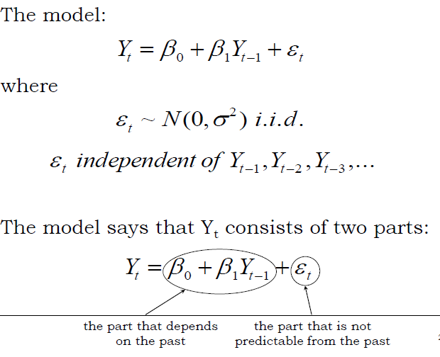

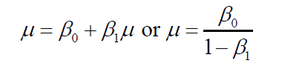

(Professor Michael Parzen, 12/2016, slides of stats 107, Harvard University)

* Understanding cointegration

Correlation might not be the choice to select a good pair to trade. We need two stock conintegrated. The definition of cointegration shows below.

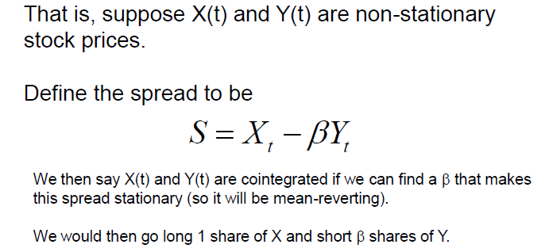

(Professor Michael Parzen, 12/2016, slides of stats 107, Harvard University)

We need to find a pair of stocks whose beta’s value satisfy smaller than one. If beta equals to 1, the series is called nonstationary. No mean level exists, and they are not a good to trade. If beta smaller than 1, the series is called stationary and means the spread S above is mean level and variance do not change over time.

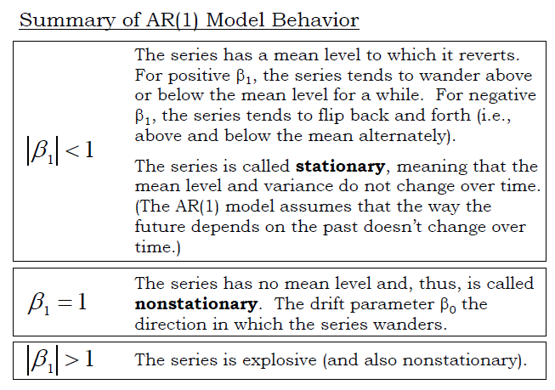

(Professor Michael Parzen, 12/2016, slides of stats 107, Harvard University)

To check if the spread S is stationary, we first find Beta. Then, we long one share stock one and short beta share stock two. After that, we if the spread is stationary by running The Dickey-Fuller Test. The null hypothesis is nonstationary, and the alternative hypothesis is stationary. If we get smaller p value, that means the spread is stationary, we could choose the stocks to do pairs trading.

1. Measures of making transactions.

By using cointegration method, we can choose a pair of stocks to trade. The next question is the time of making a trade and closing the trade. I will analyze three ways of trading strategy.

1. “Brazilian method”

* Normalize both stock prices

Like the idea of z-score, we take both stocks price normalized.

First of all, we have two stock price, calculate moving mean of 14 days interval, and compute the standard deviation of 14 days interval. Then, we get the formula below:

Normalized stock price 1= (stock price – moving mean of 14 dyas)/(moving standard deviation of 14 days)

Normalized stock price 2= (stock price – moving mean of 14 dyas)/(moving standard deviation of 14 days)

Difference = Normalized stock price 1- Normalized stock price 2

* Trade when the absolute value of difference of the normalized

value is larger than some cut-off value

When difference < -2, we go long stock1 and short stock2 in equal

dollar amounts(10,000 dollars)

When difference > 2, we short stock1 and go long

stock2 in equal dollar amounts(10,000 dollars)

* Close out the trades when the difference crosses 0.

(Marcelo Scherer Perlin , Evaluation of Pairs Trading Strategy at the Brazilian Financial Market)

1. “Ratio method” from Pairslog.com

This rule is similar to Brazilian method but take ratio of stock price first and then normalized the ratio. Making a trade(10,000 dollars) when the ratio is beyond the threshold value, and close the trade when ratio cross zero.

1. “Log Ratio method” from Pairslog.com

This rule is similar to Pairslog method but take log ratio of stock price first and then normalized the ratio. Also, it takes 130 days moving window instead of 14 days. Making a trade(10,000 dollars) when the ratio is beyond the threshold value, and close the trade when ratio cross zero.

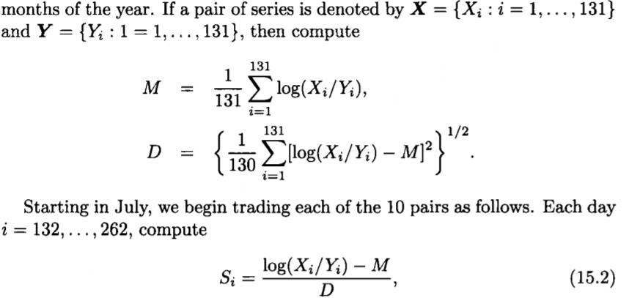

(Ngai Hang Chan, Oct 5, 2010, Time Series: Applications to Finance with R and S-Plus, Wiley)

**Results**

I am going to choose three pairs of stocks to do pairs trading by applying cointegration method and those three strategies to test.

1. 'SINA' and 'BABA'

BABA represents Alibaba Group Holding Limited is a Chinese e-commerce company that provides consumer-to-consumer, business-to-consumer and business-to-business sales services via web portals.

SINA stands for Sina is a Chinese online media company. Sina operates four major business lines: Sina Weibo, Sina Mobile, Sina Online, and Sina.net. Sina has over 100 million registered users worldwide.

We choose the data from 01/01/2015, and use adjusted stock price.

First of all, we can see the average trading volume and average trading volume. BABA has more volumes than SINA, and also enjoys higher stock price. We might a little concern about liquidity of SINA.

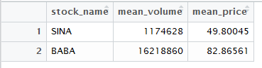

Secondly, we run the adf test to check cointegration. The p value is 6.9% and is close to 5%. So we can reject the null hypothesis, and conclude the spread of the pair is stationary. Also, we can see the correlation between two stocks is quite high.



I run the exponential moving average for both correlation and cointegration. I can see that recently the cointegration of two stock goes down and correlation of two stocks goes up.

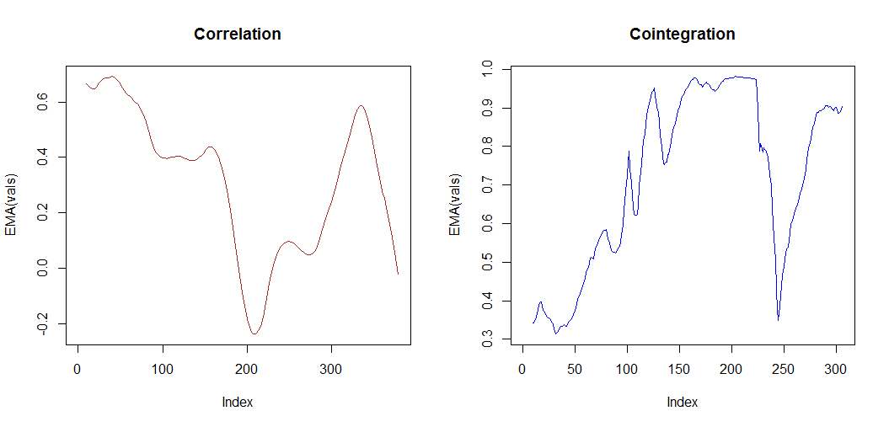

Thirdly, we can compare three trading strategies and check their performances. The difference method is the best with highest profit of 6608.108, max profit of 1567.71. The ratio method is the worst. It lost 903.078, and min profit is 1972.289. The log ratio is pretty interesting. It wins 1231.058 but never lost. So it dose not lose anything! Overall, the pairs trading strategy works exceedingly well. The pair is cointegrated. By using appropriate trading strategy we could generate 6608.108 profit if we invest 10,000.

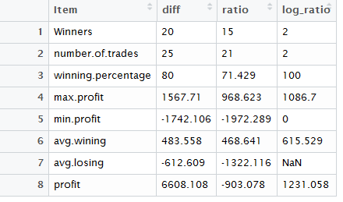

From the plots, Difference method performance is lot better than ratio for this pair.

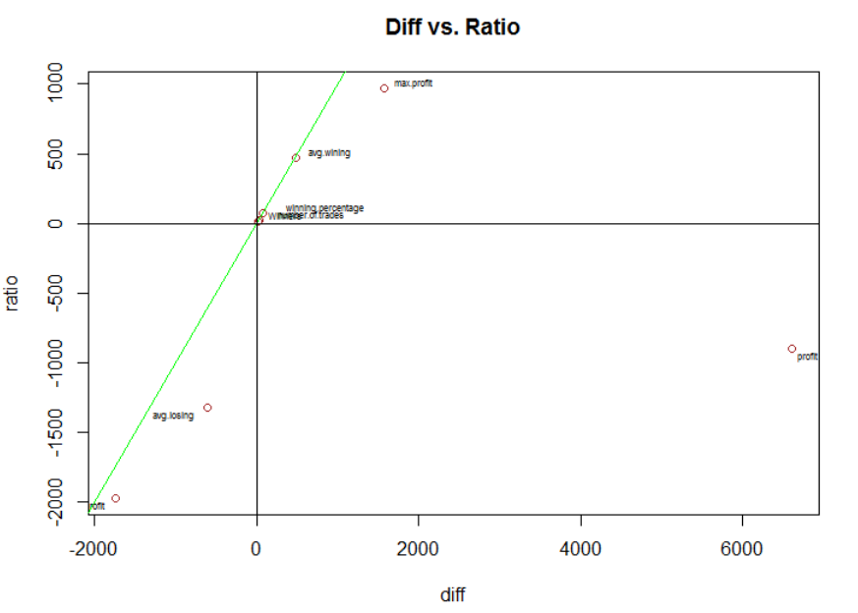

The below chart is closer view to the origin

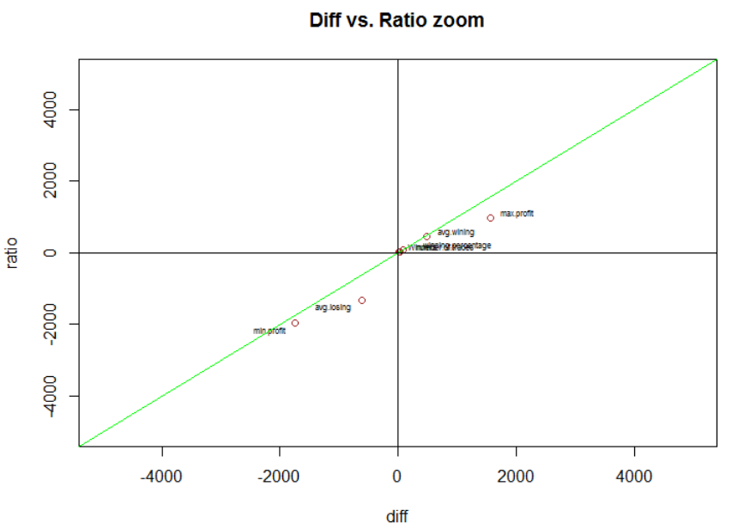

1. ‘TXN’ and ‘QCOM’

TXN is Texas Instruments Inc. is an American technology company that designs and manufactures semiconductors, which it sells to electronics designers and manufacturers globally.

QCOM stands for Qualcomm is an American multinational semiconductor and telecommunications equipment company that designs and markets wireless telecommunications products and services.

We choose the data from 01/01/2015, and use adjusted stock price.

First of all, we can see the average trading volume and average trading volume. QCOM has more volumes than TXN, and also has slightly higher stock price. I think both stock’s are easy to trade for this liquidity level.

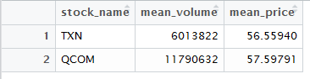

Secondly, we run the adf test to check cointegration. The p value is 9.3% and is close to 10%. We might reject the null hypothesis, and conclude the spread of the pair is stationary. Also, we can see the correlation between two stocks is quite high.



I run the exponential moving average for both correlation and cointegration. I can see that recently the cointegration of two stock goes down and correlation of two stocks goes up. Furthermore, the cointegration and correlation fluctuate over time.

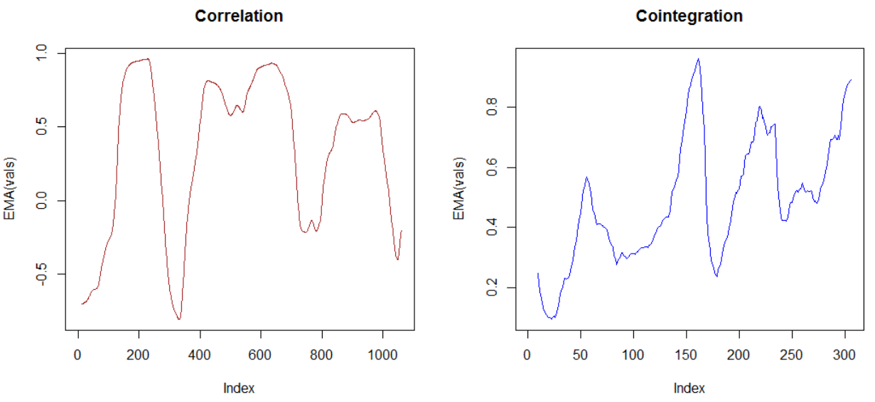

Thirdly, we can compare three trading strategies and check their performances. The difference method is the best with highest profit of 4090.914, max profit of 979.465. The ratio method has max profit of 1374.317, and min profit is -1307.21. The log ratio is pretty dam this time. Overall, the pairs trading strategy works well. The pair is cointegrated. By using appropriate trading strategy we could generate 6608.108 profit if we invest 10,000.

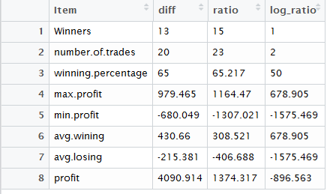

The plot below shows the difference method is a lot better than ratio one.

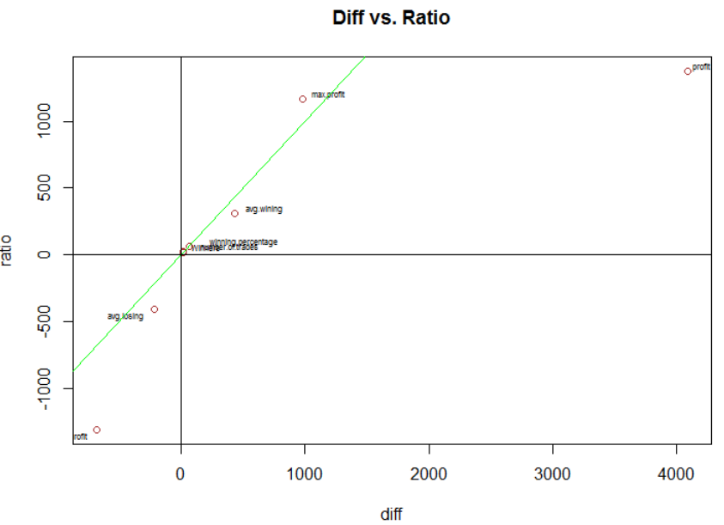

1. 'AMZN' and 'T'

AMZN represents Amazon.com, often simply Amazon, is an American electronic commerce and cloud computing company, founded in July 5, 1994 by Jeff Bezos and based in Seattle, Washington.

T stands for AT&T Inc. is an American multinational telecommunications conglomerate, headquartered at Whitacre Tower in downtown Dallas, Texas.

We choose the data from 01/01/2015, and use adjusted stock price.

First of all, we can see the average trading volume and average trading volume. T has more volumes than AMZN, and also AMZN has much higher stock price. I think both stock’s are easy to trade for this liquidity level.

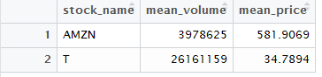

Secondly, we run the adf test to check cointegration. The p value is 9.3% and is close to 70%. We cannot reject the null hypothesis, and conclude the spread of the pair is not stationary. Also, we can see the correlation between two stocks low.



I run the exponential moving average for both correlation and cointegration. I can see that recently the cointegration of two stock goes up and so does correlation of two stocks.

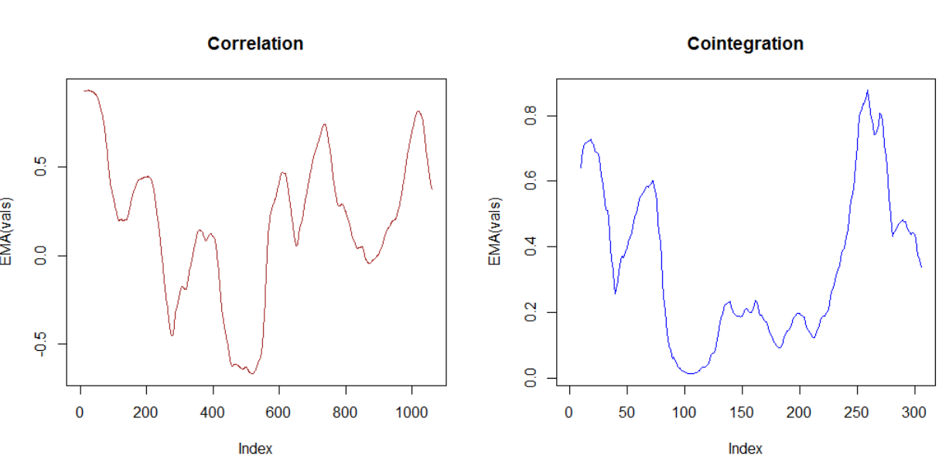

Thirdly, we can compare three trading strategies and check their performances. The log ratio method is the with highest profit of 1756.767, max profit of 2885.568. The ratio method has profit of -5492.065, and min profit is -1812.795. The difference method has lost of 3226.156. Overall, the pairs trading strategy does not work since the high cointegration value. The pair is not cointegrated and the mean level is not reverted.

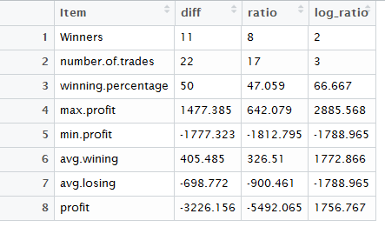

The plot below shows the difference method is a lot better than ratio one.

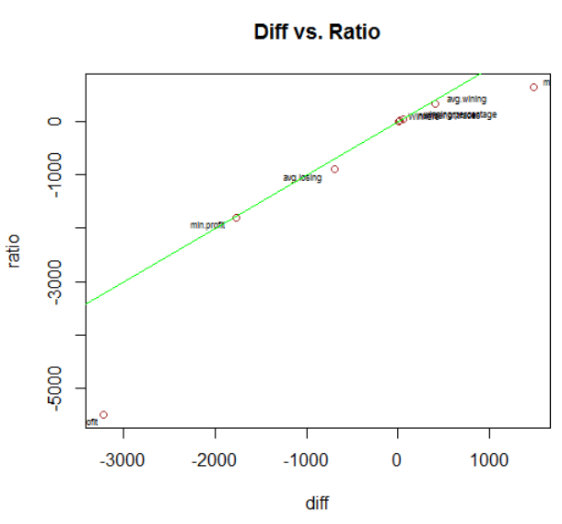

**Reference**

Professor Michael Parzen, Dec, 2016, slides of stats 107, Harvard University

Investopedia, http://www.investopedia.com/university/guide-pairs trading/#ixzz4RuWmYmu2

Ngai Hang Chan, Oct 5, 2010, Time Series: Applications to Finance with R and S-Plus, Wiley

Marcelo Scherer Perlin , Evaluation of Pairs Trading Strategy at the Brazilian Financial Market