Dataset Link : [https://www.kaggle.com/datasets/amitabhajoy/bengaluru-house-price-data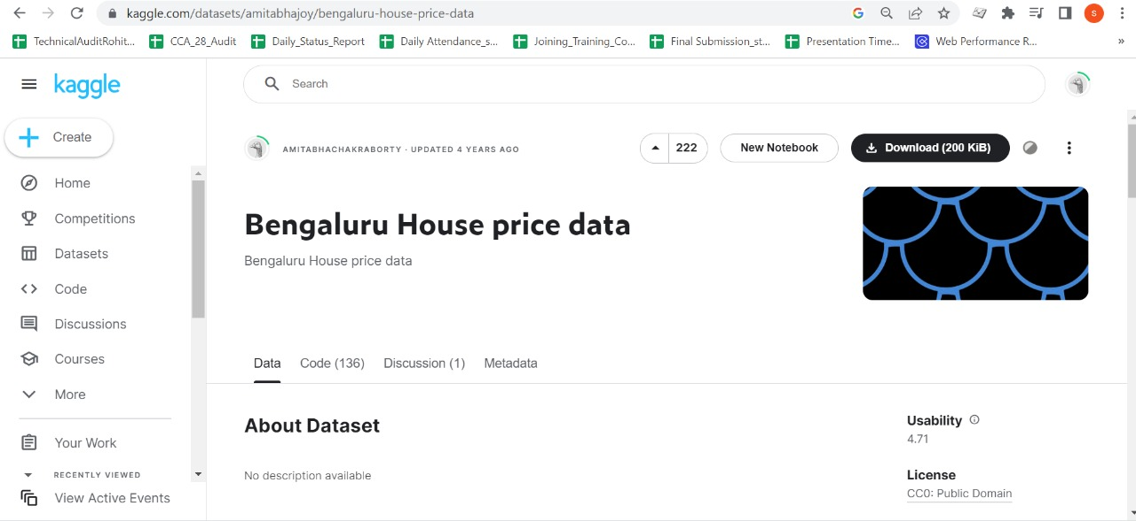](https://www.kaggle.com/datasets/amitabhajoy/bengaluru-house-price-data#)