Survey results of frontline workforce in Scotland’s alcohol and drug services

## 1. Introduction

Scottish Government announced a National Mission on drug-related deaths in January 2021[1] to address Scotland’s record numbers of drug-related deaths. Similarly Scotland’s alcohol death rates are also consistently higher than those of England and Wales, as well as the rest of Europe. In addressing these challenges the Scottish Government is committed to building a resilient and skilled workforce in the drug and alcohol treatment sector.

To support this work Health and Social Care Analysis (HSCA) have undertaken a programme of work to better understand the drug and alcohol workforce. This includes both collecting and analysing existing datasets, and generating new data. This paper specifically reports the key findings of a survey of drug/alcohol services conducted in Autumn 2021. The results of this survey provide a rich evidence base across a variety of topics including service type, staff numbers in clinical/non-clinical/non-medical prescribing roles, vacancy rates and caseloads. These quantitative and qualitative data provide crucial insights about the state of Scotland’s workforce, and will inform further work in how to support and empower individuals working in frontline settings.

## 2. Methods

The first step of designing this survey was developing a sampling plan. It was decided that leveraging the Drug & Alcohol Information System[2] (DAISy) would be the most effective way of reaching potential respondents. DAISy is maintained by Public Health Scotland (PHS), and is a national database used to collect a wealth of information relating to problematic substance abuse in Scotland. This includes contact information for alcohol and drug partnerships (ADPs) as well as specialist treatment services, comprising a range of organisation types (NHS, third sector, integrated, etc) from all health boards across the country. In fact, DAISy obviated the need to devise a representative sampling strategy because the database includes every (or nearly every) service currently delivering on behalf of ADPs in Scotland. In other words the survey would be sent to the entire ‘population’ rather than a sample. Granted respondents would self-select, likely introducing some bias to the results. Nevertheless, DAISy is by far the best source of information for collecting data about frontline services, and therefore deriving sector-wide estimates about the drug and alcohol workforce.

In terms of the survey instrument, Dame Carol Black’s independent review of drugs was released in July 2021[3]. One element of this report was a survey of treatment providers conducted to explore reductions in substance abuse prevention and treatment in England. In the interests of reducing duplication and expediting survey design, HSCA worked with colleagues in Public Health England and the UK Department of Health and Social Care to acquire these survey materials. A working group comprising Scottish Government analytical and policy colleagues was then convened to tailor the survey to the Scottish context. This principally involved modifying job titles to reflect roles found in Scottish services under five main headings: nursing, medical, psychology, non-clinical, and ‘other’ (that is, roles not mentioned elsewhere). Other questions germane to the research around non-medical prescribers and voluntary posts were also added. The survey thus included both closed and open-ended questions, which working group members signed off once finalised. The risks associated with COVID necessitated distributing this survey digitally rather than face-to-face. However this approach was advantageous because written surveys are best suited to eliciting confidential information across a wide geographical area[4]. As[5] a final layer of quality assurance, the survey was then field-tested with select colleagues working in ADPs to ensure the survey questions and format overall were fit for purpose.

Finally, the survey launched on 22 November 2021 and was distributed to the 206 services on DAISy. The covering email included text ensuring respondent confidentiality and compliance with EU General Data Protection Regulations. The survey remained open until 20 December 2021, during which time four reminder emails were sent (Figure 1). 89 responses were received in this period, only one of which was discarded due to incompleteness. Consequently the final dataset contained 88 responses, or 43% of all Scotland’s alcohol and drug services. These were then analysed using both descriptive and inferential statistical techniques.

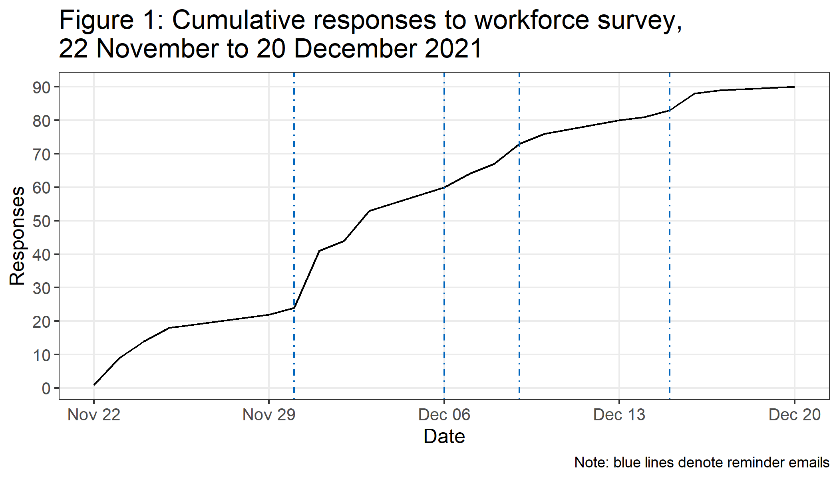

## 3. Findings

## 3.1 Overview

Figure 2 shows the number of services that responded to the survey compared to the total number of services on DAISy from that Health Board. In proportional terms, Orkney, Ayrshire & Arran and Grampian had the highest response rates, while Lothian, Fife and Lanarkshire had the lowest – excepting Shetland and Borders Health Boards where no services responded. Although responses from Greater Glasgow & Clyde and Lothian Health Boards were amongst the lowest percent-wise – 36.1% and 31.7% respectively – they (along with Highland Health Board) featured the greatest *absolute* number of responses.

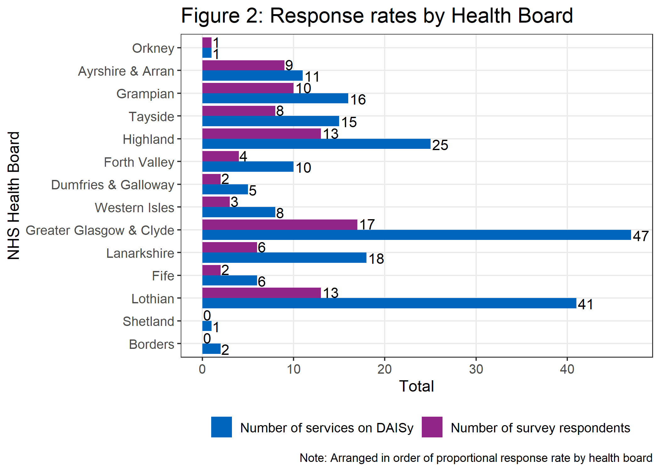

In addition to this geographic heterogeneity, services of every type responded to this survey (Figure 3). Third sector organisations represented the greatest share, numbering nearly 4 in 10.

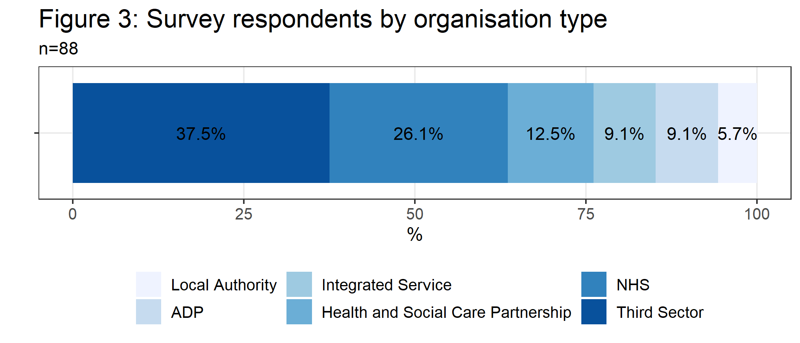

NHS organisations also accounted for over a quarter of the respondent totals. Furthermore, several ADP coordinators themselves also responded. They are ideally positioned to provide key insights from a strategic perspective given their roles in commissioning services as well as coordinating efforts between local partners (health boards, local authorities, police and voluntary agencies).

Overall, Figures 2 and 3 demonstrate that the survey responses not only cover a vast geographical area, but also comprise services spanning both rural and urban settings. Moreover, the respondent profile includes organisations of every type and working in every area of frontline substance abuse treatment. The results therefore constitute a representative sample of the drug and alcohol services ecosystem.

## 3.2 Vacancy rates

The capacity issues plaguing health and social care services in Scotland have been extensively documented[6]. However, knowledge around staffing specifically in drug and alcohol services is not well-known, either in terms of those currently employed nor vacancies. Workforce composition may also vary depending on service type and location.

A substantial portion of the survey was thus devoted to measuring vacancy rates. NHS Education Scotland’s (NES) definition of ‘vacancy rate’ was adopted for this research, which entails dividing the number of vacancies by the sum of staff in post plus vacancies per service[7]. Survey respondents were instructed to provide figures on their extant staffing compliment as well as vacancies in each section as of 1 November 2021. To maintain consistency with NES’s definition, these were to be submitted in whole-time equivalents (WTEs). These totals were then summed and divided to calculate vacancy rates.

Using this methodology produced an aggregated total of 2,107.19 WTEs employed across all drug and alcohol services as of 1 November 2021. Total vacancies numbered 152.16 WTEs. Using these figures gives a sector-wide vacancy rate of **6.7%**. The following sections outline how these figures break down by geography, organisation type and job role.

### 3.2.1 Vacancy rates by geography

Reported employment and vacancy WTE totals grouped by NHS Health Board are shown in Table 1. These figures show that vacancy rates varied widely across the sector. The highest rates belonged to Forth Valley (17.9%), Tayside (13.7%) and Highland (13.2%), while Fife and Orkney reported no vacancies whatsoever[8]. However these figures must be contextualised with the response rates found in Figure 1; Orkney had a 100% response rate – the highest in the sector – while Fife’s response rate was amongst the lowest at 33.3%. Meanwhile, Greater Glasgow & Clyde reported the highest *absolute* number of vacancies, but given the number of services in that region the vacancy rate amounted to 4%.

**TALK ABOUT THE DUNDEE EXAMPLE?**

| **Table 1: Vacancy rates by NHS Health Board (as of 1 November 2021)** | | | | |
| --- | --- | --- | --- | --- |
| **NHS Health Board** | **Reported employment** | **Reported vacancies** | **Reported total capacity** | **Vacancy rate** |
| Forth Valley | 114.7 | 25.0 | 139.7 | **17.9%** |
| Tayside | 96.6 | 15.3 | 111.9 | **13.7%** |
| Highland | 122.9 | 18.7 | 141.6 | **13.2%** |
| Lothian | 221.5 | 22.3 | 243.8 | **9.2%** |
| Ayrshire & Arran | 185.3 | 12.8 | 198.1 | **6.5%** |
| Western Isles | 16.0 | 1.0 | 17.0 | **5.9%** |
| Grampian | 182.1 | 10.3 | 192.4 | **5.4%** |
| Greater Glasgow & Clyde | 980.7 | 41.0 | 1,021.7 | **4%** |
| Lanarkshire | 113.7 | 4.7 | 118.4 | **4%** |
| Dumfries & Galloway | 27.8 | 1.0 | 28.8 | **3.5%** |
| Fife | 41.0 | 0.0 | 41.0 | **0%** |
| Orkney | 5.0 | 0.0 | 5.0 | **0%** |

Myriad factors influence geographic patterns in vacancy rates. In particular, health and social care services in remote, rural and island areas have distinct staffing issues[9]. However, the vacancy rates from this survey suggest that recruitment to roles in frontline substance misuse is an issue facing both rural and urban areas. For example, qualitative data suggested that relatively low pay for recovery workers – especially in third sector settings – as well as the increasing cost of living in the central belt, were potential deterrents for people taking up frontline roles. Sustainable workforce planning must therefore account for the specific challenges to recruitment and retention that services in these respective areas.

### 3.2.2 Vacancy rates by service type

Employment and vacancy figures also varied by service type, as shown in Figure 4. Third sector organisations reported the highest absolute totals for employment (1,111.7) and vacancies (49.1), which was to be expected given their high survey response rates as shown in Figure 3. Conversely, ADPs reported the lowest totals for each, followed closely by Local Authority organisations. Caution must be exercised when calculating vacancy rates for categories with small numbers. This explains why ADPs, despite repoting the lowest absolute numbers, reported the highest vacancy rates.

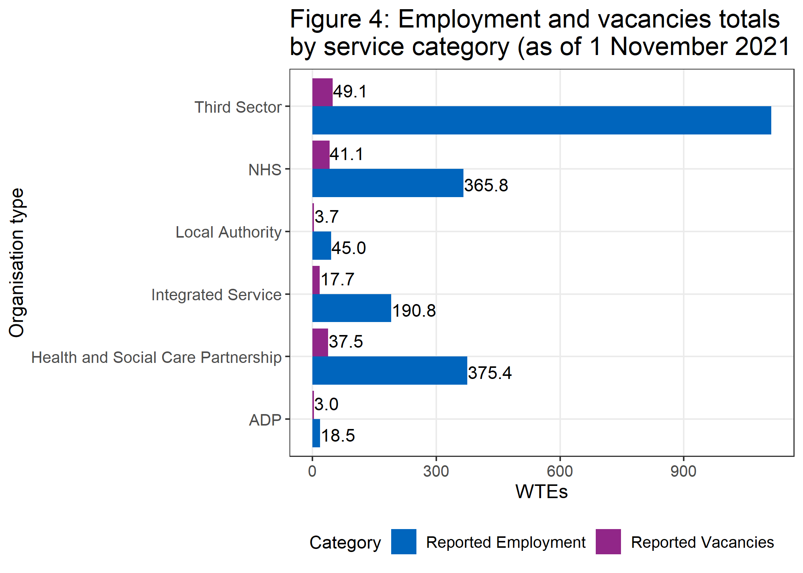

Interestingly, vacancy totals amongst NHS and Health and Social Care Partnership organisations were nearly equal to that of the third sector, while their total capacity (employment plus vacancies) was well under half. This is reflected in the vacancy rates, shown in Table 2 below. NHS organisations boasted vacancy rates of 10.1%, with HSCPs close behind at 9.1% While third sector reported the highest absolute number of vacancies, their vacancy rate was the lowest of all organisation types at 4.2%.

Vacancy rates have important implications irrespective of organisation type, and the qualitative responses suggested the effect that excessive vacancies have on e.g. capacity, delivery and staff well-being. This response, from an NHS organisation, exemplifies such issues:

“Have 3 band 6 nursing vacancies with one of those being maternity leave. At one point in summer 2021 the team only had one >registered nurse and team lead covering caseload for a team of 8. Team lead is not supposed yo[sic] have a casleoas[sic]. >Most of their work was not completed ans[sic] they are also supposed to support another team tooo.. This then lead to >burnout of one team members[sic]. The team has always been sitting with vacancies or long term sick since may[sic] 2019 with >between 2-6 staff short… It is very stressful at times”.

In addition, a number of responses noted, or implied, that they required more staff. Yet it is not clear if this meant they had unfilled vacancies or thought that having more staff overall would benefit their service. The qualitative data supported the quantitative findings, as those organisations highlighting vacancy issues were predominantly health service-oriented (i.e. NHS, Integrated Service and HSCPs). Meanwhile only one third sector organisation identified this as an issue.

| **Table 2: Vacancy rates by organisation type (as of 1 November 2021)** | | | | |
| --- | --- | --- | --- | --- |
| **Organisation Type** | **Reported employment** | **Reported vacancies** | **Reported total capacity** | **Vacancy rate** |
| ADP | 18.5 | 3.00 | 21.5 | **14%** |
| NHS | 365.8 | 41.07 | 406.9 | **10.1%** |
| Health and Social Care Partnership | 375.4 | 37.50 | 412.9 | **9.1%** |
| Integrated Service | 190.8 | 17.70 | 208.5 | **8.5%** |
| Local Authority | 45.0 | 3.74 | 48.8 | **7.7%** |
| Third Sector | 1,111.7 | 49.15 | 1,160.8 | **4.2%** |

### 3.2.3 Vacancy rates by role type

The 2,107.19 employed WTEs reported across all respondents was comprised of the following staff:

* 616.9 nursing
* 77.9 medical
* 53.9 psychology
* 1,280.2 non-clinical
* 78.49 ‘other’ (i.e. not listed elsewhere)

On the clinical side, the roles with the highest employment totals were in nursing, for band 5 (293 WTEs) and band 6 (228.7). Other proportionally prevalent roles included clinical psychologists (35.7), staff/specialty doctors (27.8) and consultant psychiatrists (26.3). For non-clinical roles, the greatest employment numbers were for ‘drug/alcohhol/recovery workers not included above’ (325.3), however services did not specify what these roles were. There were also high reported totals of admin/support staff (280.3) and team leaders (275.1). A breakdown of the individual job types under each of these headings can be found in Annex 1, although note that the y-axis is scaled differently in each chart.

However, these figures must once again be examined in the context of their vacancies. Table 3 shows figures for role type. Medical roles had the highest vacancy rates across the sector (14.6%), followed by psychology (11.8%). There was a substantial gap in vacancy rate between these two role types and nursing (6.7%), however nursing positions comprise by far the greatest employment totals amongst clinical roles

| **Table 3: Vacancy rates by role type (as of 1 November 2021)** | | | | |
| --- | --- | --- | --- | --- |
| **Category** | **Reported employment** | **Reported vacancies** | **Reported total capacity** | **Vacancy rate** |
| Medical | 77.910 | 13.29 | 91.200 | **14.6%** |
| Psychology | 53.710 | 7.20 | 60.910 | **11.8%** |
| Nursing | 616.900 | 44.56 | 661.460 | **6.7%** |
| Non-clinical | 1280.201 | 87.11 | 1367.311 | **6.4%** |

Breaking these numbers down by individual role can be misleading given the small numbers in particular areas (a full table can be found in Annex 2). Of those roles with a reported capacity over 5 WTEs, the greatest vacancy rates were in psychological therapists (38.9%), locum doctors (22.9%) and consultant psychologists (22.7%). However several roles in non-clinical, medical and psychology roles had vacancy rates exceeding 10%. The greatest vacancy rates in nursing was a tie between band 5 and band 6 nurses (7.7%). This is despite these two roles having the highest clinical employment numbers in the sector (see Annex 1), underscoring the crucial role that nursing personnel play in deliveringfrontline services.

No vacancies were reported for family support workers, councelling psychologists, clinical associates in applied psychology, band 8 nurses, or ‘other’ nurses. Interestingly, amongst the lowest reported vacancy rates were service managers (1.5%) and team leaders (3.2%). This is especially notable given how many WTEs are employed in these roles (see Annex 1). This suggests that there are few opportunities for upward progression within frontline services, which may well contribute to the retention issues reported in the qualitative data and the literature here.

### 3.2.4 Recruitment and retention

One major theme emerging from the qualitative responses concerned the way in which services are funded, and the impact this has on recruitment. A number of responses noted that short-term funding for services could lead to fixed term contracts. This made these posts less attractive for potential staff due to their precarious nature, and thus more difficult to recruit. Examples of responses include:

 “…lengthy or permanent funding is preferable due to difficulty recruiting to 6 month or 1 year posts and development and embedding of practice.”

 “Funding being permanent or for longer fixed terms rather than non-recurring which makes recruitment challenging.”

Staff salaries were also extensively commented upon:

 “It is still incredibly difficult to recruit skilled and experienced staff as our salary scales cannot match those of statutory organisations such as local authority and NHS. Therefore, there is a need to increase budgets for contracts to allow organisations like ours to increase salary and competitively recruit staff.”

 “Higher pay scales all round. We work closely with the housing sector (housing officers) and the pay gap is very disproportionate for the type of work we comparatively do.”

HSCPs, NHS, ADPs and third sector organisations all separately expressed these sentiments. This indicates that better pay and conditions are necessary across the entire drug and alcohol workforce, rather one particular service type.

However, respondents highlighted that the difficulties of recruiting and retaining staff were not simply matters of remuneration. There is a strong need for the drugs and alcohol workforce to be able to access continuing professional development and training opportunities. However this poses several challenges, one of which is a matter of geography. For example:

 “…training is not delivered locally so I have to travel if I want to access training.”

However, perhaps a more important consideration is the access and funding to undertake specialist courses in higher education institutions. This was highlighted especially in terms of career progression for staff in non-clinical roles:

 “Increase bursaries to allow more staff to do post graduate study to retain them not just SVQ health and Social care but specialist courses at University of Stirling and West of Scotland around addiction and harm reduction… As non clinical staff the staff group are not always valued or seen as less professional than clinical staff. SVQ not valued by other professions in same way as a degree.”

Finally, it was noted that more needed to be done to showcase the valuable jobs that are done by people in this sector. This was directly related to a call for more recognition for people that have opted to work work in settings as challenging as frontline drug and alcohol services. For example:

 “Strategically, the workforce in our services could be improved if they were given recognition as a specialist professional role. Drug and alcohol services are marginalised and often stigmatised as our service users are, the work that we do, the care and support that we provide is not always understood or appreciated by wider health and social care.”

In sum, the recruitment and retention issues facing the sector are diverse and multifaceted, and differ by organisation type. Funding and compensation remain major issues, as is the case across the entire health and social care workforce. However, respondents also highlighted shortcomings in career development and progression, as well as a general lack of appreciation/understanding of what working in frontline services entails. This underscores the need for more ££ as well as a cultural shift in perceptions.

## 3.3 Caseloads

In addition to operational considerations, this survey also asked respondents to speak to their caseloads. This included caseloads by staff as well as overall. Figure 5 shows box and whisker plots of average caseloads by WTE employee broken down by service type. Staff at HCSPs and NHS organisations reported the highest median caseloads per WTE employee, at 46 and 28 respectively. This is especially interesting given that these two organisation types had amongst the highest vacancy rates, as shown in Table 2. These charts also speak to the diversity of service size, as evidenced by the rather wide inter-quartile ranges of both NHS and integrated services. There are also several outliers in average caseload amongst third sector organisations.

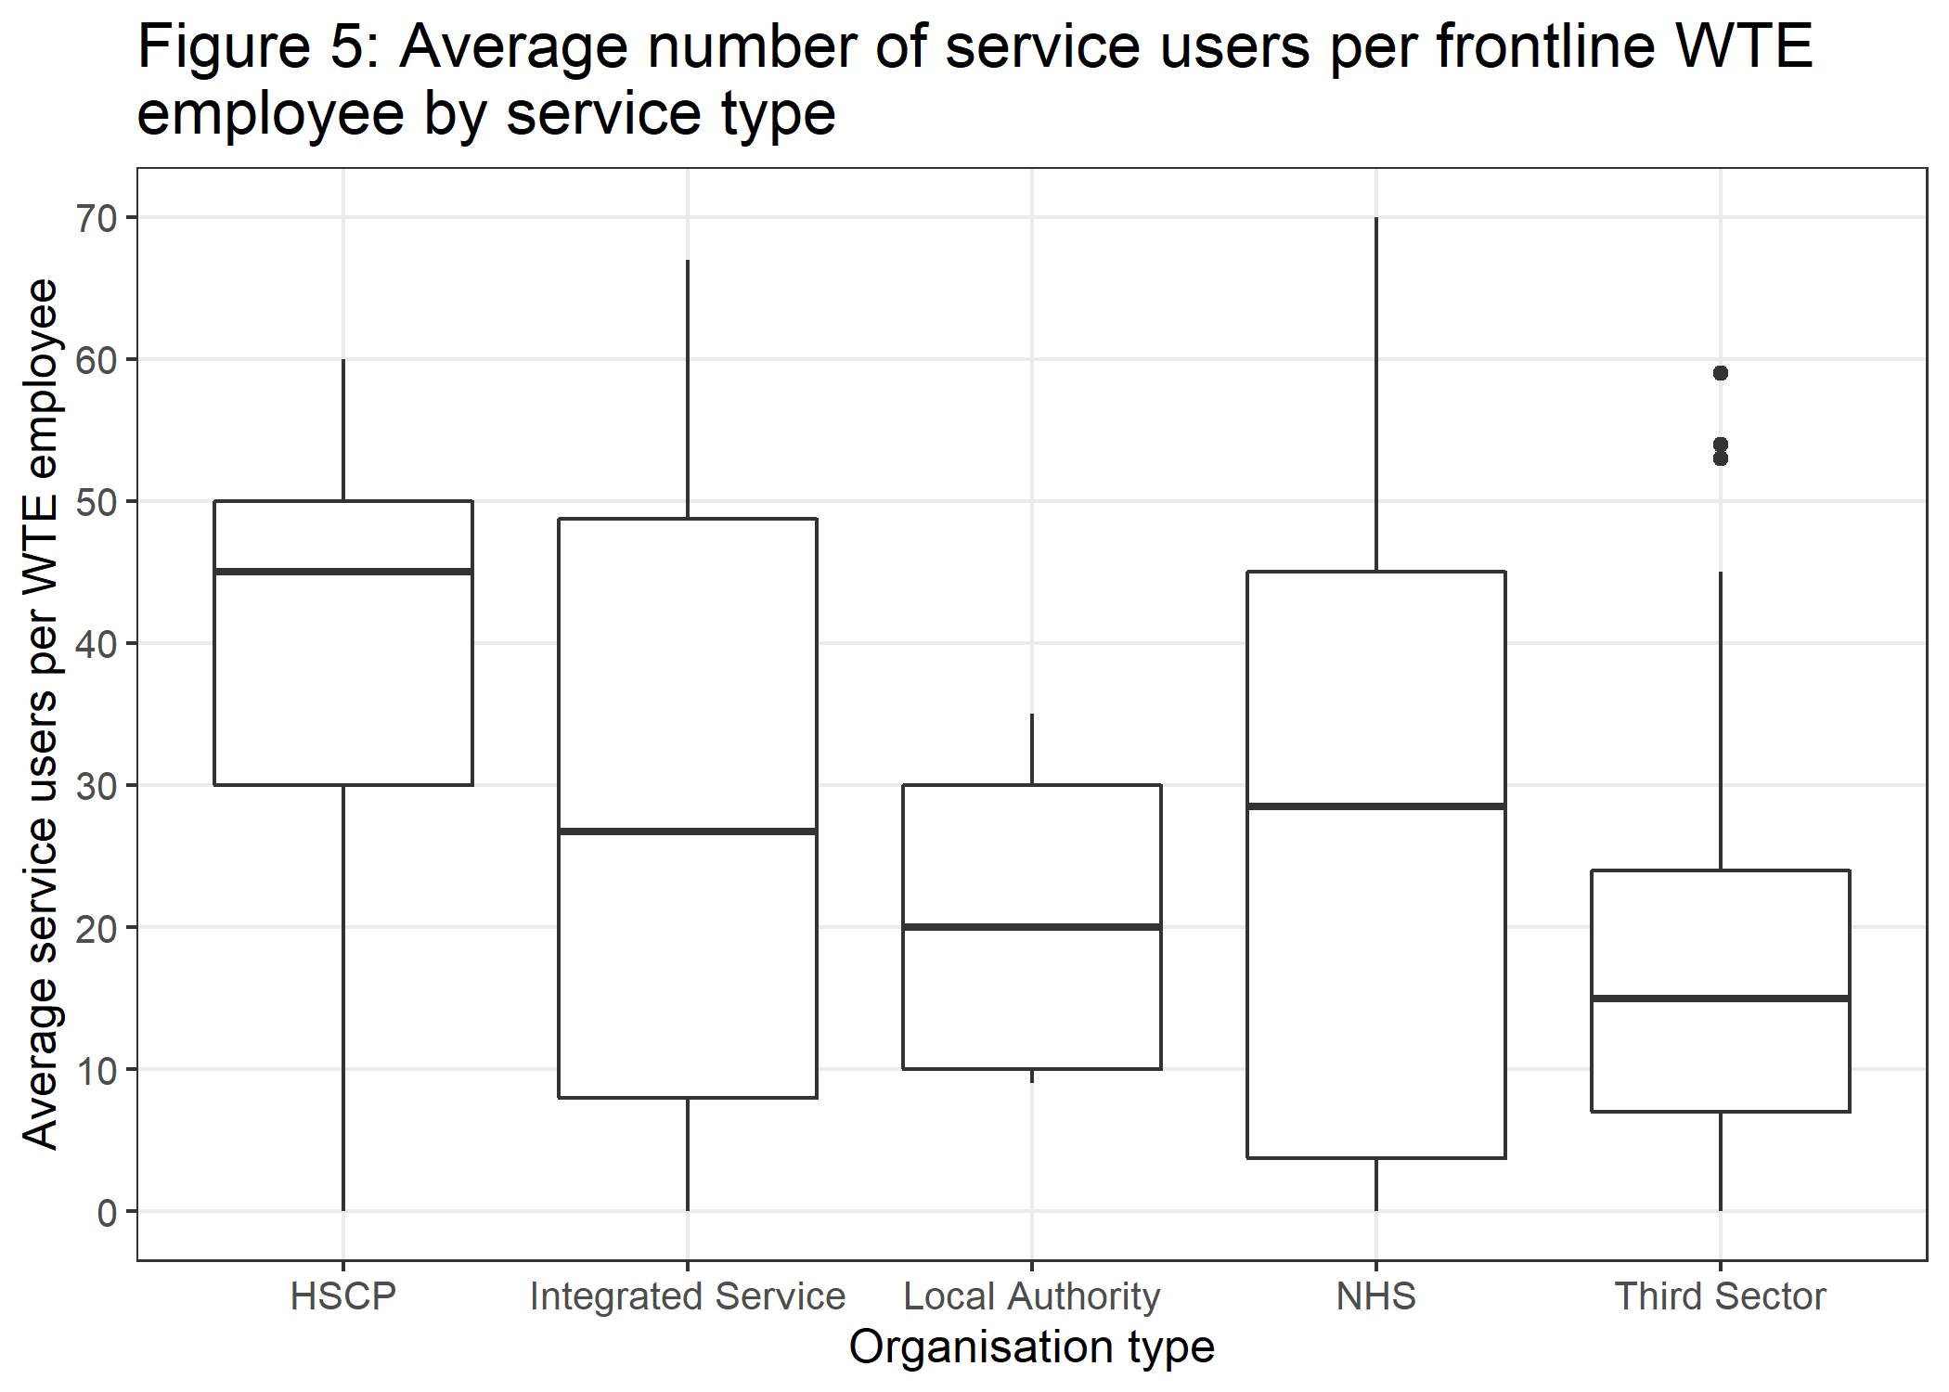

## 3.4 Sick days

Though employee wellbeing was not explicitly within the remit of this survey, information about absences was sought. Services were therefore asked how many days had been lost to sickness amongst paid employees over the past six months (1 May to 1 November 2021). The results of this are shown in figure six. The distribution of sick days is skewed right, with a median reported rate of 34 sick days per service (as denoted by the dashed line. However there were some notable outliers, with six organisations reporting over 200 sick days over that six month period.

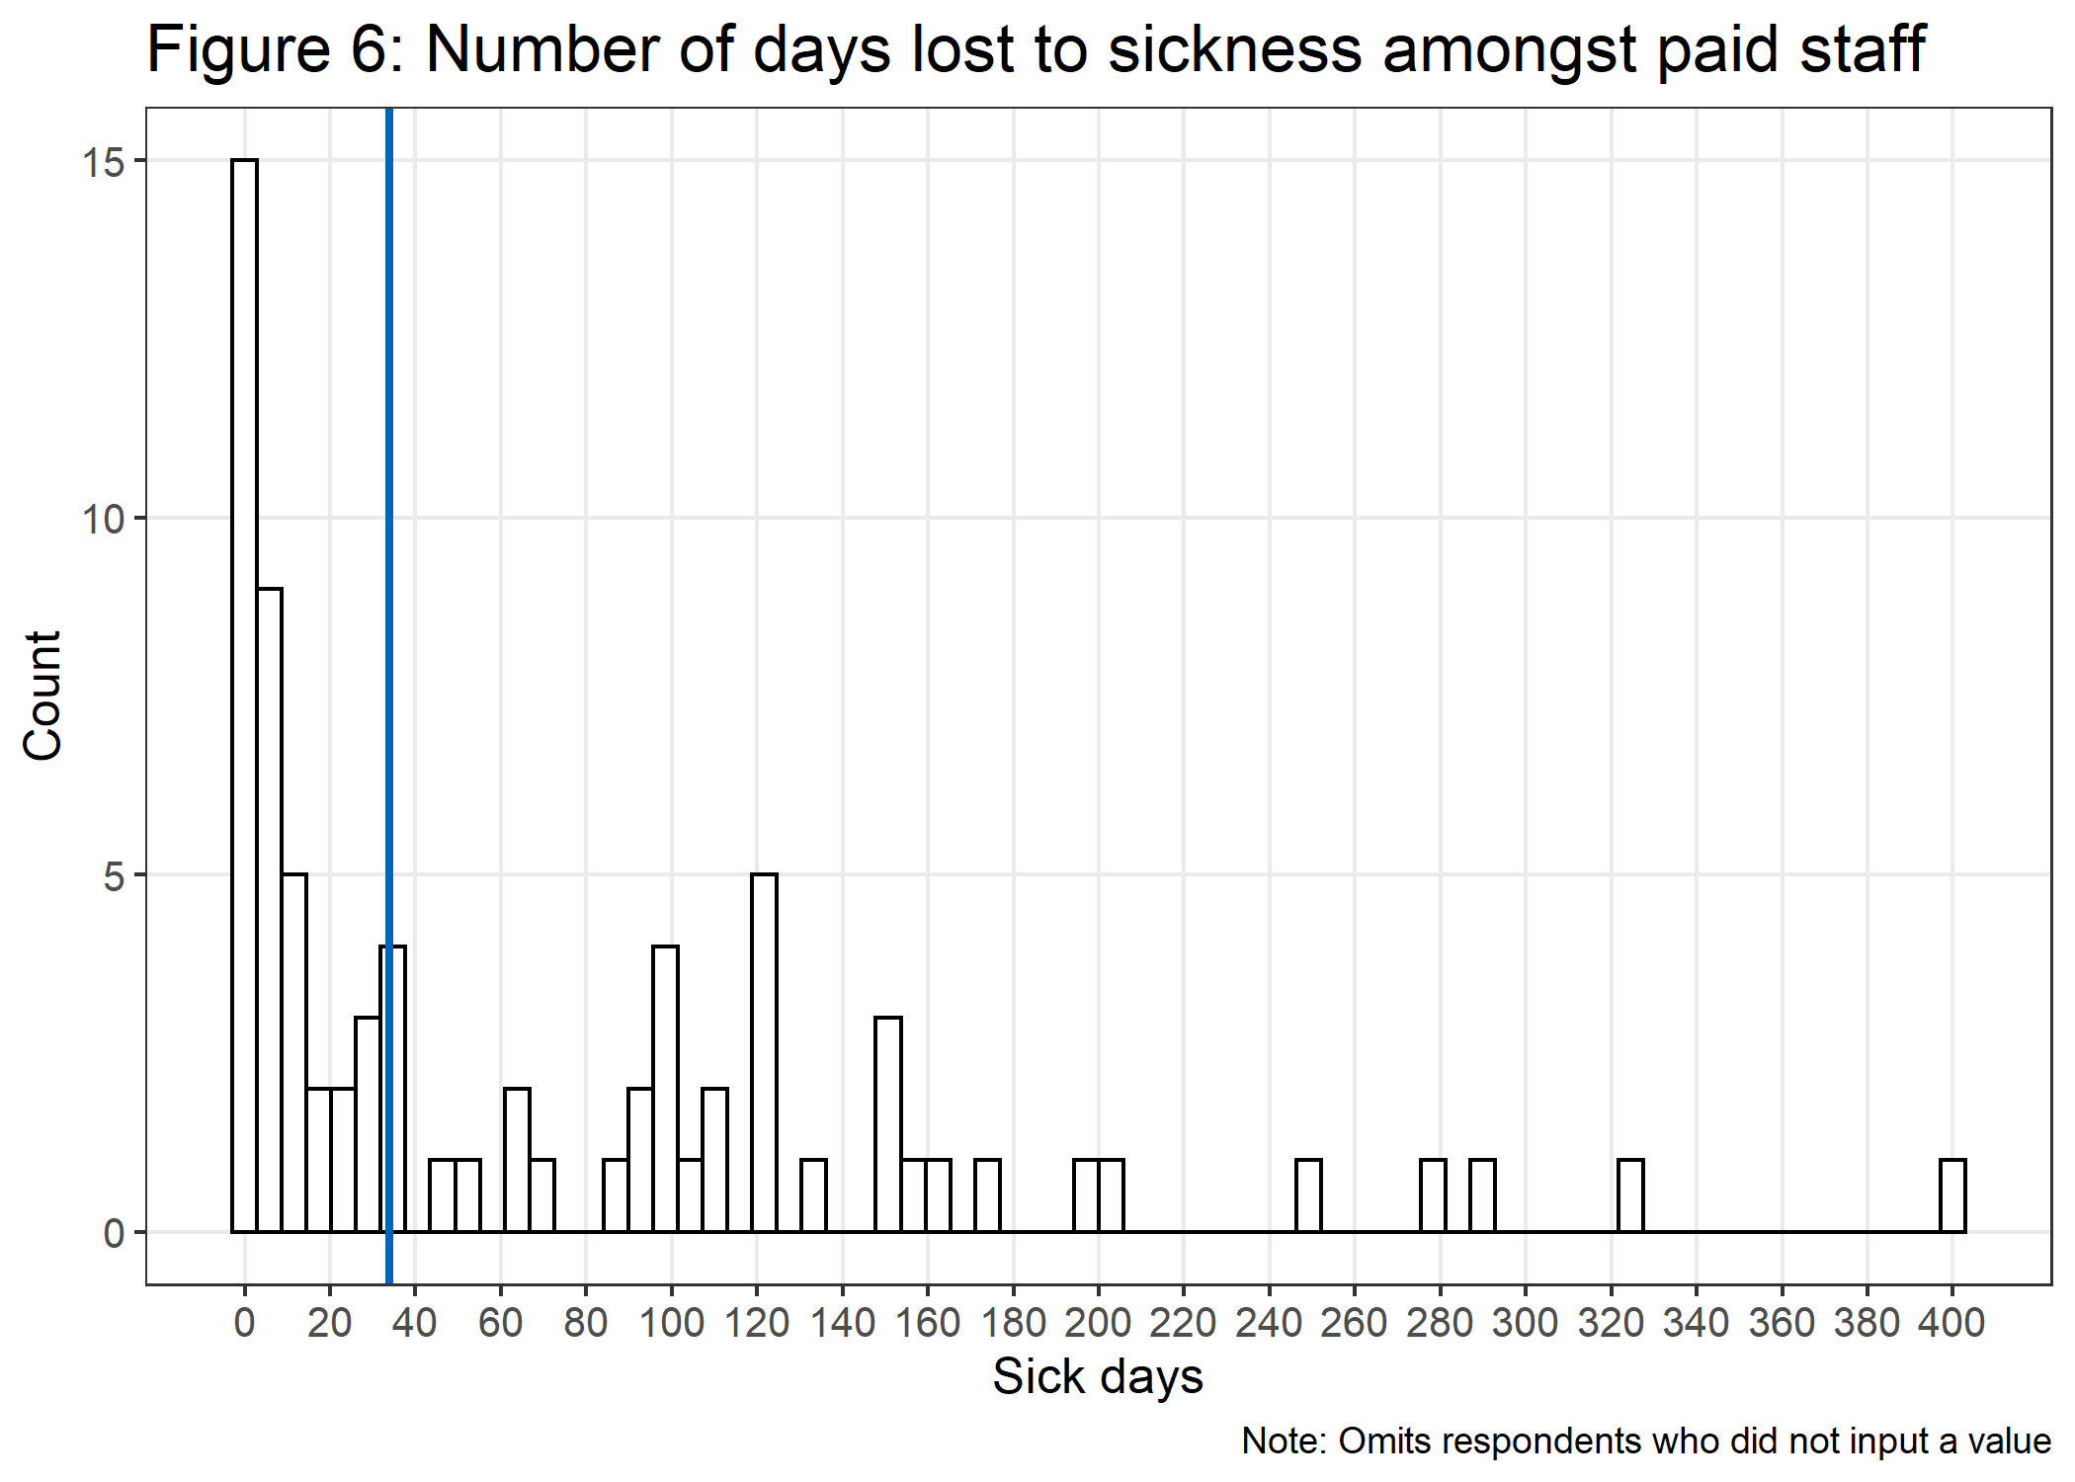

It is therefore worth quantifying the relationships between these variables

**SECTION TO BE POPULATED**

## X. Limitations

* self-selected (i.e. biased)
* small population and small sample size
* 1 time snapshot rather than longitudinal

## Annex 1: Employment and vacancy totals of frontline staff by category (WTEs)

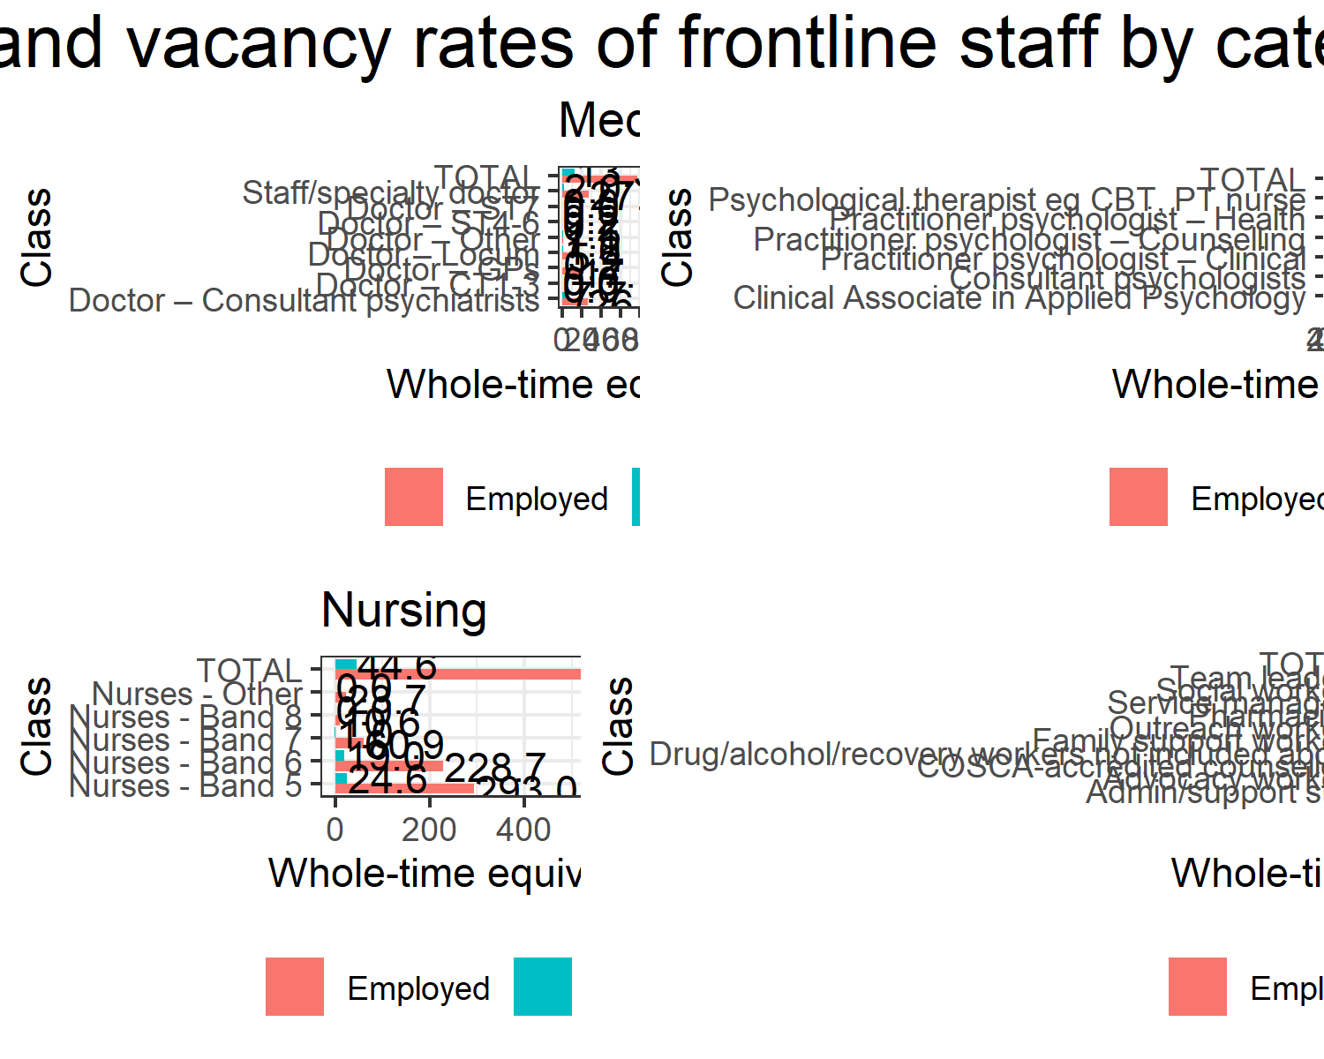

## Annex 2: Vacancy rates of frontline staff by category (WTEs)

| **Category** | **Job Type** | **Reported employment** | **Reported vacancies** | **Reported total capacity** | **Vacancy rate** |
| --- | --- | --- | --- | --- | --- |
| Non-clinical | Advocacy workers | 1.000 | 3.00 | 4.000 | **75%** |
| Medical | Doctor – Other | 1.100 | 1.50 | 2.600 | **57.7%** |
| Medical | Doctor – ST4-6 | 0.240 | 0.24 | 0.480 | **50%** |
| Psychology | Psychological therapist eg CBT, PT nurse | 4.710 | 3.00 | 7.710 | **38.9%** |
| Medical | Doctor – Locum | 5.400 | 1.60 | 7.000 | **22.9%** |
| Medical | Doctor – Consultant psychiatrists | 26.260 | 7.70 | 33.960 | **22.7%** |
| Psychology | Consultant psychologists | 4.500 | 1.00 | 5.500 | **18.2%** |
| **Medical** | **TOTAL** | **77.910** | **13.29** | **91.200** | **14.6%** |
| Non-clinical | Outreach workers | 46.500 | 6.75 | 53.250 | **12.7%** |
| **Psychology** | **TOTAL** | **53.710** | **7.20** | **60.910** | **11.8%** |
| Non-clinical | Drug/alcohol/recovery workers not included above | 325.300 | 40.00 | 365.300 | **10.9%** |
| Non-clinical | Social workers | 66.500 | 7.00 | 73.500 | **9.5%** |
| Non-clinical | COSCA-accredited counsellors | 35.381 | 3.20 | 38.581 | **8.3%** |
| Non-clinical | Pharmacists | 22.050 | 2.00 | 24.050 | **8.3%** |
| Psychology | Practitioner psychologist – Clinical | 35.700 | 3.00 | 38.700 | **7.8%** |
| Nursing | Nurses - Band 5 | 293.020 | 24.56 | 317.580 | **7.7%** |
| Nursing | Nurses - Band 6 | 228.740 | 19.00 | 247.740 | **7.7%** |
| **Nursing** | **TOTAL** | **616.900** | **44.56** | **661.460** | **6.7%** |
| Medical | Staff/specialty doctor | 27.800 | 2.00 | 29.800 | **6.7%** |
| **Non-clinical** | **TOTAL** | **1280.201** | **87.11** | **1367.311** | **6.4%** |
| Psychology | Practitioner psychologist – Health | 3.800 | 0.20 | 4.000 | **5%** |
| Non-clinical | Admin/support staff | 280.320 | 14.16 | 294.480 | **4.8%** |
| Non-clinical | Team leaders | 275.100 | 9.00 | 284.100 | **3.2%** |
| Nursing | Nurses - Band 7 | 60.900 | 1.00 | 61.900 | **1.6%** |
| Non-clinical | Service managers | 128.050 | 2.00 | 130.050 | **1.5%** |
| Medical | Doctor – GPs | 17.110 | 0.25 | 17.360 | **1.4%** |
| Nursing | Nurses - Band 8 | 10.560 | 0.00 | 10.560 | **0%** |
| Nursing | Nurses - Other | 23.680 | 0.00 | 23.680 | **0%** |
| Psychology | Clinical Associate in Applied Psychology | 2.000 | 0.00 | 2.000 | **0%** |
| Psychology | Practitioner psychologist – Counselling | 3.000 | 0.00 | 3.000 | **0%** |
| Non-clinical | Family support workers | 100.000 | 0.00 | 100.000 | **0%** |

1. <https://www.gov.scot/policies/alcohol-and-drugs/national-mission/>
2. <https://www.isdscotland.org/Health-Topics/Drugs-and-Alcohol-Misuse/Drug-Alcohol-Information-System/>
3. <https://www.gov.uk/government/publications/review-of-drugs-phase-two-report>
4. <https://www.mitre.org/sites/default/files/pdf/05_0638.pdf>
5. Hewson, C., Vogel, C. and Laurent D. (2015), Internet Research Methods, Sage
6. see e.g. <https://www.bbc.co.uk/news/uk-scotland-58641817>, <https://www.gov.scot/news/increasing-nhs-capacity-2/>, <https://www.audit-scotland.gov.uk/uploads/docs/report/2021/nr_210117_nhs_overview.pdf>
7. <https://turasdata.nes.nhs.scot/about-our-data-and-reports/data-sources-and-quality-assurance/vacancy-surveys/>
8. note that Borders and Shetland are omitted here because no services from those Health Boards responded to the survey
9. <https://www.gov.scot/publications/national-health-social-care-integrated-workforce-plan/pages/5/>