Create a folder in c drive and inside that folder create another folder called “static” and copy selected

Items.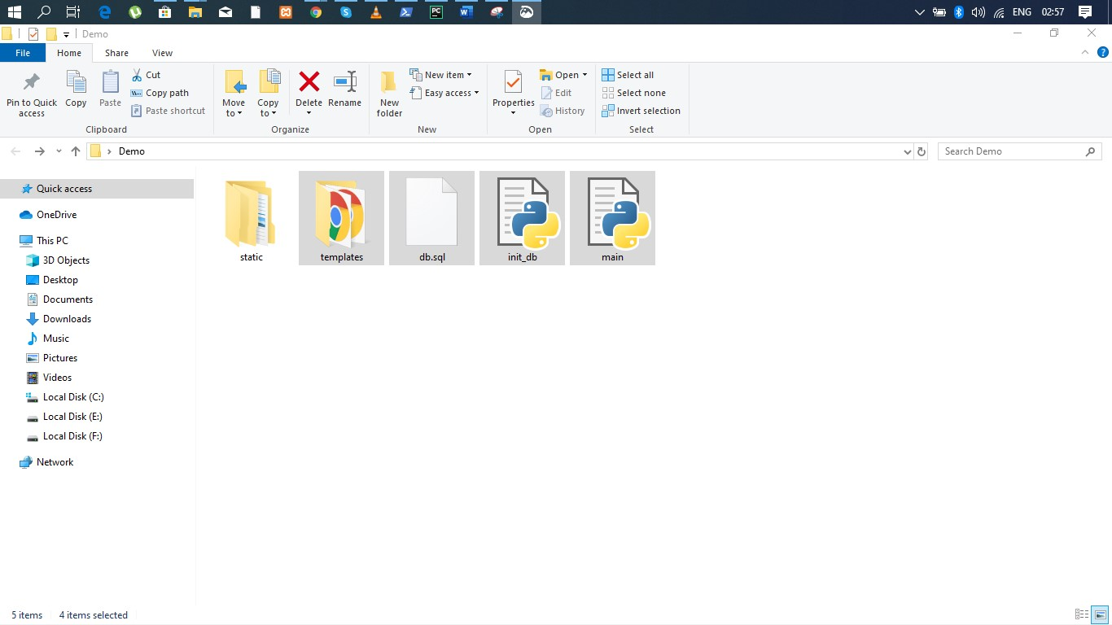

Inside the “Static” folder copy these files.

