PROJECT HOLIDAY-APPROACH PROPOSAL

A data engineering pipeline that processes tourism POI data with PySpark, stores it in PostgreSQL with geographic indexing.
GOAL: Predict the popularity of a region according to number of POI, the presence on the internet, number of reviews and certificates, amenities and themes.
Understanding and manipulation of data

Framework
- Which set(s) of data(s) did you use to achieve the objectives of your project?
DATAtourisme API (/catalog endpoint)
- Are these data freely available? If not, who owns the data?
Yes, the French government has open license but a free API is required on request
- Describe the volume of your dataset?
The main objects count approx. 476k entities but the database is in continuous update
*the data has been collected through the get method and is limited to the 99% of the data available at that time. For the purpose of having constantly updated data I build the function update_datatourisme that fetches only the updated data.
*the outcome is in json format, as semistructured data,loaded in batches for easier handling, updating and flexibility
Example of semistructured data:
{
"hasBeenCreatedBy": {
"legalName": "Haute Maurienne Vanoise Tourisme",
"identifier": "582",
"email": [
"laurent.sevenier@hautemaurienne.com",
"elisabeth.palmier@hautemaurienne.com",
"apidae1@hautemaurienne.com"
],
"homepage": [
"https://www.haute-maurienne-vanoise.com/"
]
},
"isLocatedAt": [
{
"geo": {
"elevation": 2002,
"latitude": 45.233402,
"longitude": 6.722158
},
"address": [
{
"hasAddressCity": {
"insee": "73026",
"label": {
"@en": "Avrieux",
"@fr": "Avrieux"
}
},
"postalCode": "73500",
"addressLocality": "Avrieux"
}
]
}
],
"lastUpdate": "2025-10-01",
"hasDescription": [
{
"shortDescription": {
"@en": "Chappe telegraphy, the forerunner of modern telecommunications, was invented at the end of the 18th century. The Courberon station, located at 2002 meters above sea level in the commune of Avrieux, was part of a communication line running from Paris to Venice.",
"@fr": "La télégraphie Chappe, ancêtre de nos télécommunications modernes, a vu le jour à la fin du 18ème siècle. Le poste de Courberon, implanté à 2002 mètres sur la commune d’Avrieux, faisait partie d’une ligne de communication allant de Paris à Venise."
}
}
],
"label": {
"@ru": "Télégraphe Chappe de Courberon",
"@en": "Chappe de Courberon telegraph",
"@fr": "Télégraphe Chappe de Courberon",
"@zh": "Télégraphe Chappe de Courberon"
},
"type": [
"PointOfInterest",
"CulturalSite",
"PlaceOfInterest"
],
"lastUpdateDatatourisme": "2025-10-02T06:20:17.926Z",
"hasContact": [
{
"telephone": [
"+33 6 87 74 31 54"
],
"email": [
"marie-annick.blondon@wanadoo.fr"
],
"homepage": [
"https://avrieux.com/telegraphe-chappe/"
]
}
],
"uri": "https://data.datatourisme.fr/13/2c29c0aa-bb2f-3dac-9f93-76f39f06bbc5",
"uuid": "000016ad-998e-3b6a-80b7-25531604fc11"
},
{
"hasMainRepresentation": [
{
"hasAnnotation": [
{
"credits": [
"©CAPPONI Elisabeth"
],
"isCoveredBy": "By-NC-ND 4.0",
"title": {
"@en": "montignac de lauzun-roulotte chateau de lescaut-roulotte et terrasse 3",
"@fr": "montignac de lauzun-roulotte chateau de lescaut-roulotte et terrasse 3"
}
}
],
"hasRelatedResource": [
{
"hasMimeType": [
{
"label": {
"@en": "image/jpeg",
"@fr": "image/jpeg"
}
}
],
"locator": [
"https://cdt64.media.tourinsoft.eu/upload/montignac-de-lauzun-roulotte-chateau-de-lescaut-roulotte-et-terrasse-3.jpg"
]
}
]
}
],
ANALYSIS OF COLLECTED DATA
Relevance
- Which variables seem most relevant to you in regard to your objectives?
The purpose of the project is to collect and process the data in order to create statistics and graphs, my approach towards the relevant variables is categorizing them like the following:
-geographic: latitude, longitude, city, postal_code for graphic approach
-classification: type_name, theme
-descriptive: description_fr, amenities for a clustering analysis using text mining
-contact: telephone, email, homepage for the presence on the paltform
-quality: rating_label, number of certificates for the connection with the consumer
- What is the target variable?
I define a variable called popularity_score that combines the informations from the platform and will help me classify the regions.
According to turism international platforms as tripadvisor, we can calculate the popularity score using this formula:
20% in the number of POI counted per region
15% in the number of reviews per POI
15% number of positive reviews and certificates
10% number of visual information added to location
10% the presence on the platform as reachable contact
10% amenities per POI
10% the themes per each POI
10% safety measures in case of health hazard.

The desired outcome:
Result: A score from 0 to 100, where:
- 0-33 = Low popularity (underperforming region)
- 34-66 = Medium popularity (average region)
- 67-100 = High popularity (tourist hotspot region)
*is defined both for a regression or classification prediction

- What features of your dataset can you highlight?
geographic: latitude, longitude
different language description
media content
quality index
track of the updates through timestamps:
- Are you limited by some of your data?
Yes, the data suffers from incomplete informations.
-missing data
-different standards
-the real data doesn t match the thesaurus
-language bias: the english info is limited, the french special characters are hard to read

Pre-processing and feature engineering
- Did you have to clean and process the data? If yes, describe your treatment process.
YES, extensive cleaning required:
flattening: Nested JSON → relational structure
missing values: Restricting the data to the thesaurus approved terms
*the lack of english labels, decided to leave it like it is for understanding purposes but I will not use it in my analysis
data types: Float, datetime, string conversions
text cleaning: Encoding *needs to be done , whitespace
null handling: for the purpose of this analysis, the null remains as it is for the columns that are not relevant for the location and for identifying a POI.
Cleaning process:
Mandatory fields: uuid, region_id, latitude, longitude cannot be NULL
Coordinate Validity: Latitude: -90 to 90, Longitude: -180 to 180
Unique UUIDs
Region Assignment: each uuid has to belong to a region
Data modeling and storage:
Proposal for data model: STAR SCHEMA
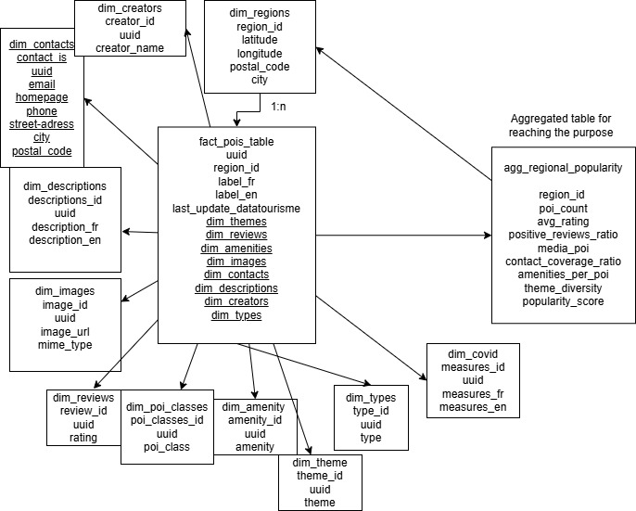

ETL DATA FLOW
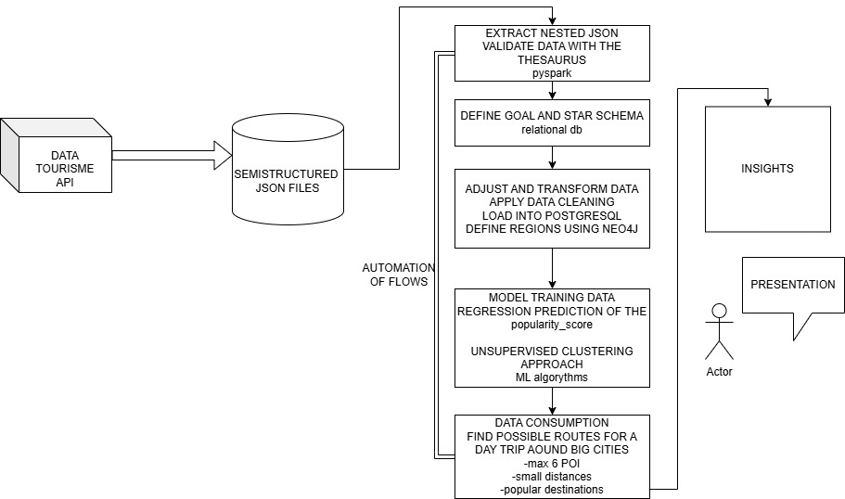

Next steps:
Loading data into Potsgres according to the Star Scheme
Define the Aggregation table to reach the purpose of the project
Define the regions table using the latitude and longitude
Model training data for the prediction of the popularity_score using regression/ classification
Model training data for clustering
Data consumption
Automation of flows
Organising presentation

