- Needed import:
  - import pandas as pd
  - import numpy as np
  - import seaborn as sns
  - import matplotlib.pyplot as plt
  - import re
  - import os
- Reading all files
  - issues.csv
  - issues_snapshot.csv
  - sample_utterances.csv
  - issues_snapshot_sample.xlsx
  - issues_change_history.csv
- Cleaning file issues.csv
  - Fillna for issue_assignee -> ‚unassigned‘
  - Drop several columns:
    - 'wf_in_review','wf_deployment','wf_resolved','wf_monitoring','wf_done','wf_pending_customer_approval','wf_rejected','wf_testing_monitoring', 'wf_in_progress', 'wf_reopened', 'wf_to_do', 'wf_validation', 'wf_resolved_under_monitoring','wf_closed','wf_waiting', 'wf_cancelled','wf_under_review','wf_approved','wf_pending_deployment'
  - Correction of data types

  - Decoding ‚issue_proj‘ and split to new columns (default: ‚internal‘)
    - ‚proj_type‘
    - ‚country_code‘
    - ‚client_product‘
  - First correlation matrix with quantities variables
    - Plot:
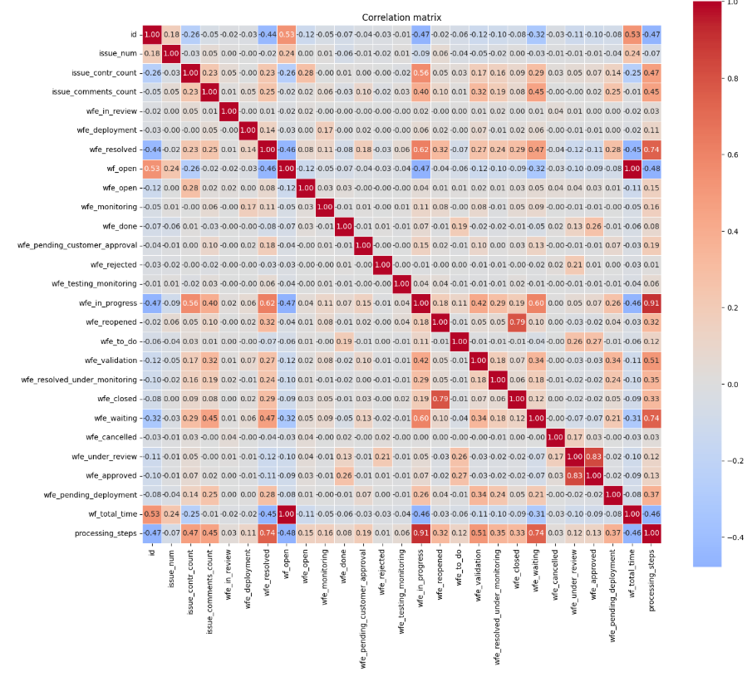
    - Top positive 20 correlation:
Variable1 Variable2 Correlation
wf_open wf_total_time 0.997955
processing_steps wfe_in_progress 0.907882
wfe_approved wfe_under_review 0.827900
wfe_closed wfe_reopened 0.792161
processing_steps wfe_waiting 0.744919
processing_steps wfe_resolved 0.741145
wfe_in_progress wfe_resolved 0.617569
wfe_in_progress wfe_waiting 0.602573
issue_contr_count wfe_in_progress 0.563392
id wf_open 0.534261
id wf_total_time 0.529180
processing_steps wfe_validation 0.512112
issue_contr_count processing_steps 0.474062
wfe_resolved wfe_waiting 0.468278
issue_comments_count processing_steps 0.454001
issue_comments_count wfe_waiting 0.450640
wfe_in_progress wfe_validation 0.420711
issue_comments_count wfe_in_progress 0.397830
processing_steps wfe_pending_deployment 0.367722
processing_steps wfe_resolved_under_monitoring 0.346289

    - Top negative 20 correlation

Variable1 Variable2 Correlation
processing_steps wf_open -0.477496
wf_open wfe_in_progress -0.473812
id wfe_in_progress -0.470631
id processing_steps -0.469826
processing_steps wf_total_time -0.463349
wf_total_time wfe_in_progress -0.462425
wf_open wfe_resolved -0.458286
wf_total_time wfe_resolved -0.454130
id wfe_resolved -0.436100
id wfe_waiting -0.317130
wf_open wfe_waiting -0.317014
wf_total_time wfe_waiting -0.305995
issue_contr_count wf_open -0.261781
id issue_contr_count -0.255270
issue_contr_count wf_total_time -0.253912
id wfe_open -0.120056
wfe_resolved wfe_under_review -0.119251
id wfe_validation -0.116321
wf_open wfe_open -0.115771
wf_open wfe_validation -0.115592

    - First interpretation:
      - wf_total_time is the target
      - wf_open have a high correlation of course, maybe droppable
      - wfe_approved - wfe_under_review 0.827900
      - wfe_closed - wfe_reopened 0.792161
      - processing_steps - wfe_waiting 0.744919

      - to finish
  - Preparation to make a correlation between the numeric variables and categorical variables
    - To size the data on the compute power, you can choose which categorical columns should be used.

categorical_cols = [
'issue_type', # 15 categorical → easy
'issue_priority', # 7 categorical → easy
'issue_resolution', # 4 categorical → easy
'issue_status', # 15 categorical → ok
'country_code', # 19 categorical → ok
#'issue_proj', # Attention: ~358 unique → produced ~357 dummies → very wide!
#'issue_reporter', # ~1114 unique → extrem much dummies → better to omit or group together
#'issue_assignee' # ~381 unique + much NA → same
]

    - Usage of get_dummies and creating a new heatmap and also a new csv with the results in ‘corr_matrix_issues_dummies.csv’ with Top +/- 20
    - Plot:
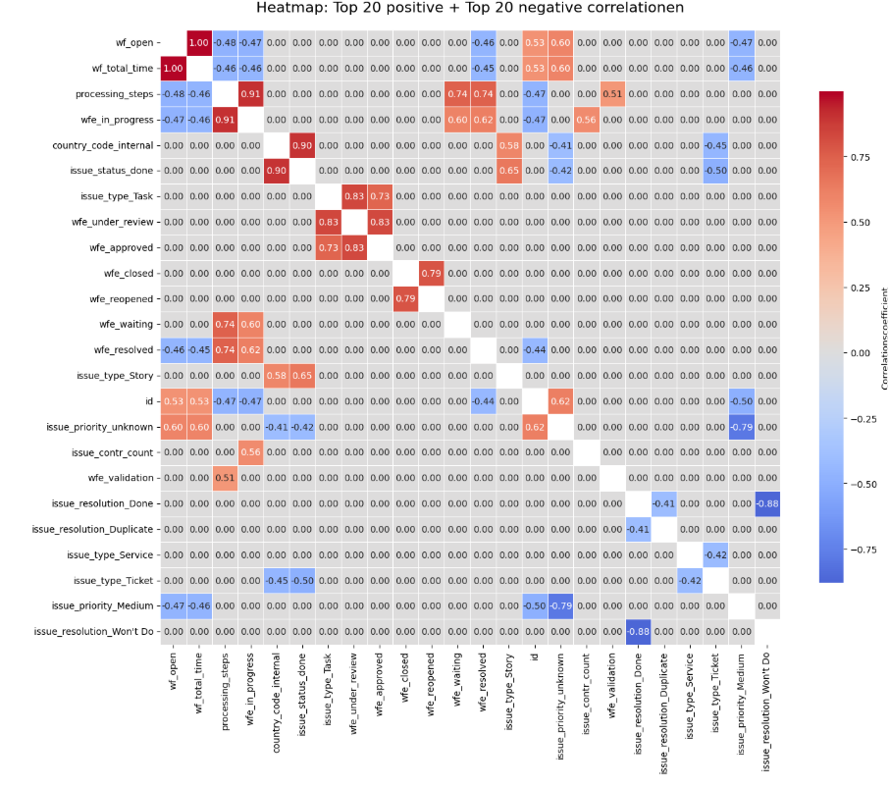

    - As list Top 40

Variable1 Variable2 Correlation
wf_open wf_total_time 0.997955
processing_steps wfe_in_progress 0.907882
country_code_internal issue_status_done 0.900094
issue_type_Task wfe_under_review 0.834062
wfe_approved wfe_under_review 0.827900
wfe_closed wfe_reopened 0.792161
processing_steps wfe_waiting 0.744919
processing_steps wfe_resolved 0.741145
issue_type_Task wfe_approved 0.725393
issue_status_done issue_type_Story 0.650368
id issue_priority_unknown 0.620205
wfe_in_progress wfe_resolved 0.617569
wfe_in_progress wfe_waiting 0.602573
issue_priority_unknown wf_open 0.600092
issue_priority_unknown wf_total_time 0.597161
country_code_internal issue_type_Story 0.579965
issue_contr_count wfe_in_progress 0.563392
id wf_open 0.534261
id wf_total_time 0.529180
processing_steps wfe_validation 0.512112
issue_resolution_Done issue_resolution_Duplicate -0.406676
country_code_internal issue_priority_unknown -0.411083
issue_priority_unknown issue_status_done -0.421361
issue_type_Service issue_type_Ticket -0.424718
id wfe_resolved -0.436100
wf_total_time wfe_resolved -0.454130
country_code_internal issue_type_Ticket -0.454885
wf_open wfe_resolved -0.458286
wf_total_time wfe_in_progress -0.462425
processing_steps wf_total_time -0.463349
issue_priority_Medium wf_total_time -0.464503
issue_priority_Medium wf_open -0.468247
id processing_steps -0.469826
id wfe_in_progress -0.470631
wf_open wfe_in_progress -0.473812
processing_steps wf_open -0.477496
id issue_priority_Medium -0.495877
issue_status_done issue_type_Ticket -0.495914
issue_priority_Medium issue_priority_unknown -0.788246
issue_resolution_Done issue_resolution_Won't Do -0.880969

    - First interpretation:
      - wf_open - wf_total_time 0.997955
Status open have a big influence on the target
      - processing_steps - wfe_in_progress 0.907882
Many steps have will indicate that a ticket is complicate
      - country_code_internal - issue_status_done 0.900094
Seems that internal problems will be solved more than external tickets.
      - issue_type_Task - wfe_under_review 0.834062
If issue type = Task….?
      - wfe_approved - wfe_under_review 0.827900
      - wfe_closed - wfe_reopened 0.792161
      - processing_steps - wfe_waiting 0.744919
      - issue_priority_unknown -wf_open 0.600092
      - issue_priority_unknown - wf_total_time 0.597161
      - country_code_internal - issue_type_Story 0.579965
      - issue_priority_Medium - issue_priority_unknown
-0.788246
      - issue_resolution_Done - issue_resolution_Won't Do -0.880969

