**Gesture RecognitIon Assignment:-**

**Group Facilitator –** Mihir Pawar

**Group member –** Anurag Mishra

**Sample image:-**

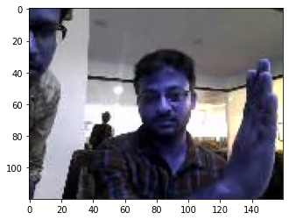

**Models:-**

|  |  |  |  |
| --- | --- | --- | --- |
| **Experiment Number** | **Model** | **Result** | **Decision + Explanation** |
| **1** | **Conv3D** | **Model not trainable – Getting Resource exhausted exception** | **Explanation:** Initially we considered batch size equal to total number of images in the train data set.  **Decision:** Reduce the batch size to half the total number of images in the train data set. |
| **2** | **Conv3D** | **Model not trainable as a lot of parameters** | **Explanation:** Initially we considered batch size equal to total number of images in the train data set.  **Decision:** Reduce the batch size to half the total number of images in the train data set. |
| **3** | **Conv3D** | **Training Accuracy: 0.181**  **Validation Accuracy: 1.60** | **Change the batch size, image size and try different model.** |
| **4** | **Conv2D+LSTM** | **Training Accuracy: 0.272**  **Validation Accuracy: 0.50** | **Change the batch size, image and increased epochs** |
| **5** | **Conv2D+LSTM** | **Training Accuracy: 0.1364**  **Validation Accuracy: 0.50** |  |