Databases – Task 1 – Basic SQL - Steve

Scenario: PlayMoreGames.co.uk
A small tabletop games review web site wants to implement a databases of tabletop board games. A visitor to the website can search for games they might like to try based on parameters such as maximum and minimum number of players, suggested minimum age, duration of a typical game and approximate retail cost of the game.
The site also wants to store what year the game was released with the version number. They would also like to store if the game is a competitive style boardgame or a collaborative style game (A game cannot be both at the same time). The store also issues a review star rating of between 1 and 5.
I have designed a database design that identifies the fields and data types that could be implemented in SQL.
Field | Data Type
GameCode | int
GameName | varchar(30)
Edition | int
ReleaseYear | Int
RegularPrice | Decimal(5,2)
ReviewScore | Int
GameType | Varchar(20)
MinPlayers | Int
MaxPlayers | Int
RunningTime | Int
MinAge | int

This is the information provided for the database:

Wingspan Regular price £64.99 5 Stars
Wingspan (2nd Edition 2019) is a competitive game for 1 to 5 players. Games take around an hour to play. Recommended minimum age is 10.
Carcassonne (3rd edition 2015) £24.99 4 Stars
Competitive game for 2–5 Players, running time is a average of 40 Minutes. Age rating is 7+.
Horrified (1st edition 2019) £40.00 3 Stars
Collaborative game for 1–5 Players. Average running time is 60 Min. Age: 10+
This is the database what was created:
CREATE TABLE Games (
GameCode int,
GameName varchar(30),
Edition int,
ReleaseYear int,
RegularPrice decimal(5,2),
ReviewScore int,
GameType varchar(20),
MinPlayers int,
MaxPlayers int,
RunningTime int,
MinAge int
);
INSERT INTO Games
VALUES
(1, "Wingspan", 1, "2019", 64.99, 5, "Competitive", 1, 5, 60, 10),
(2, "Carcassonne", 3, 2015, 24.99, 4, "Competitive", 2, 5, 40, 7),
(3, "Horrified", 1, 2019, 40.99, 3, "Collaborative", 1, 5, 60, 10);

Run in SQLFiddle as shown:
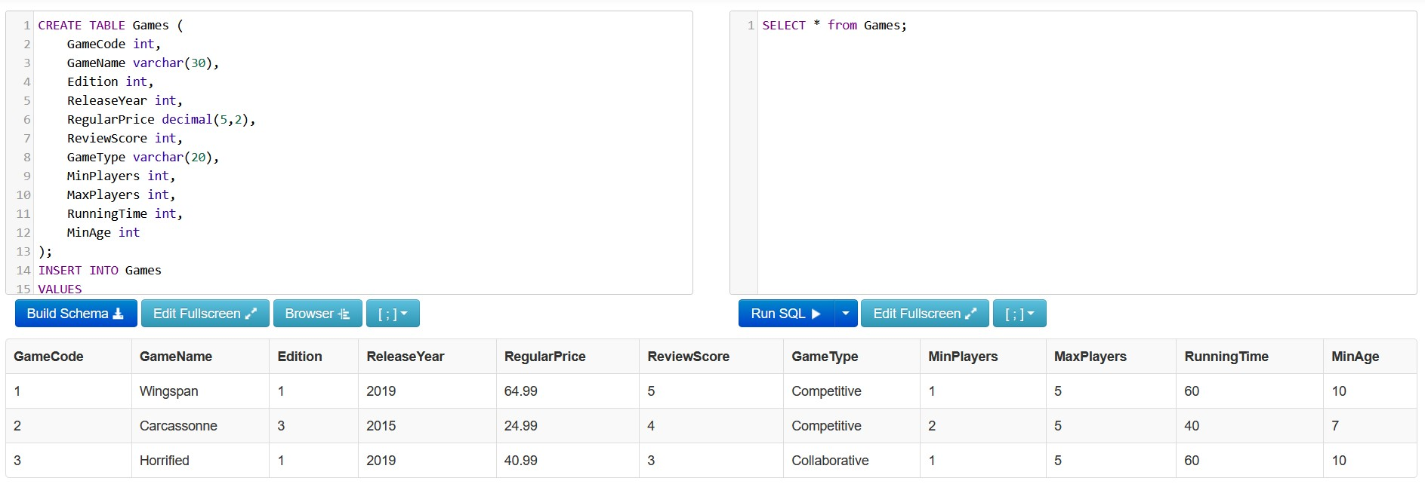
The price of Wingspan then changed to £54.99 the star rating of Horrified to a 4 and this was updated on the database. Two ways of updating are shown, one using the GameCode and one using the GameName, version and release year (maybe only need to put version number in here).
