Week 2 – Tuesday – SQL Workshop

Task:
A client wants you to create a database to store music tracks. They would like this to be an SQL database that will act as the back-end of an app for searching for music.
Here is an example of the sort of information they want to store.
Running up that Hill by Kate Bush, released 1985. Highest UK chart position was 6. Track from the album ‘Hounds of Love’, Written by Kate Bush, Produced by EMI, Running time: 4.58
Create a schema that would store this information in a suitable format.
Populate the database with a few tracks of your own choice.

My Database:

CREATE TABLE Music (
MusicID int,
Track varchar(255),
ArtistName varchar(255),
Released int,
HighestChartPosition int,
OriginalAlbumName varchar(255),
WriterName varChar(255),
Label varchar(255),
RunningTime decimal(4,2)
);
INSERT INTO Music
VALUES
(1, 'Running up that Hll', 'Kate Bush', 1985, 6, 'Hounds of Love', 'Kate Bush', 'EMI', 4.58),
(2, 'Babooshka', 'Kate Bush', '1980', 5, 'Never for Ever', 'Kate Bush', 'EMI', 3.26),
(3, 'Radio Ga Ga', 'Queen', 1984, 2, 'The Works', 'Roger Taylor', 'EMI', 5.48),
(4, 'Bohemian Rhapsody', 'Queen', 1975, 1, 'A Night at the Opera', 'Freddie Mercury', 'EMI', 5.55),
(5, 'Ironic', 'Alanis Morissette', 1996, 11, 'Jagged Little Pill', 'Alanis Morissette and Glen Ballard', 'Maverik', 3.48),
(6, 'Tik Tok', 'Kesha', 2009, 4, 'Animal', 'Kesha Sebeet, Dr Luke and Benny Blanco', 'RCA Records', 3.20);

Suggested queries:

- All tracks by Kate Bush
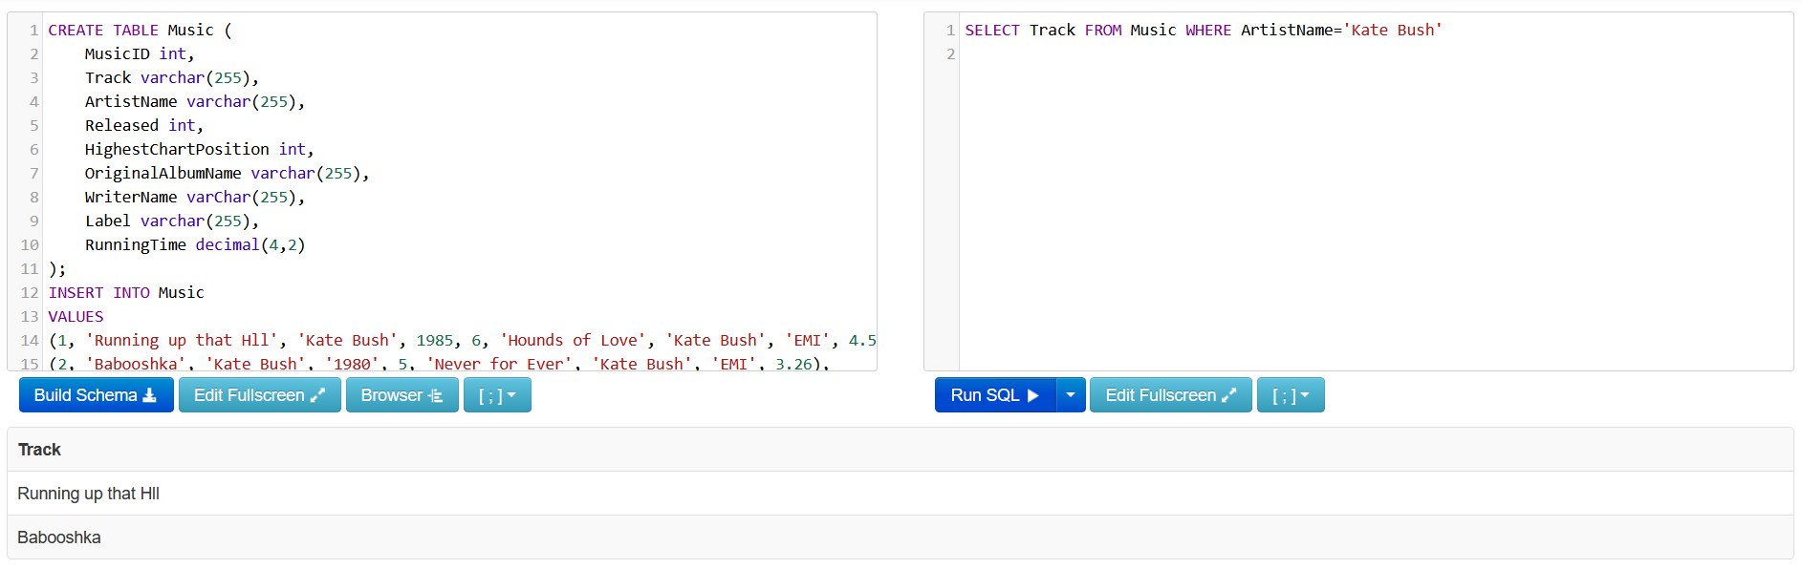

- All tracks that got into the top ten UK singles chart.
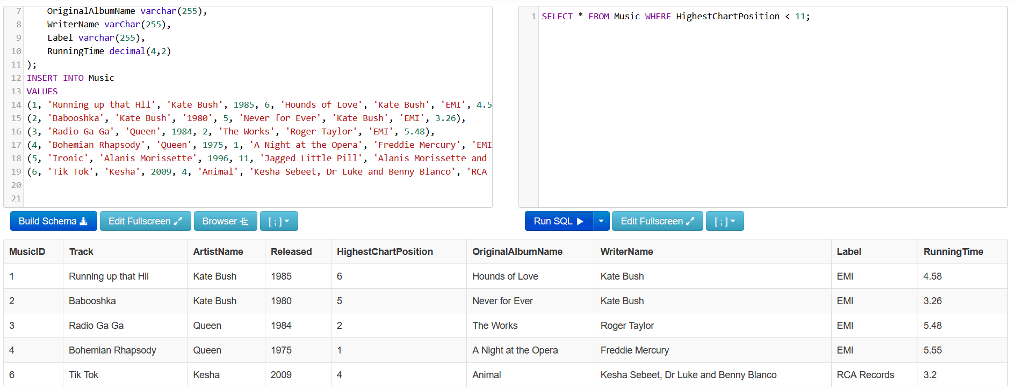
- All tracks released before a certain date.
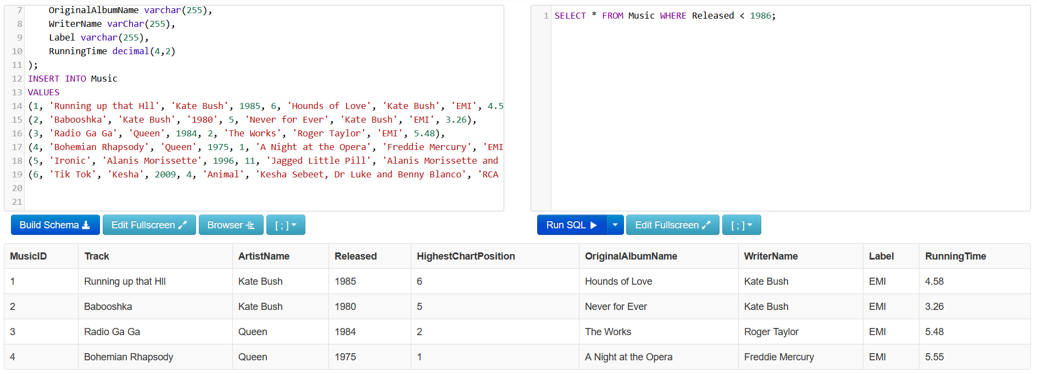
- Try and use some SUM/COUNT/AVG queries.

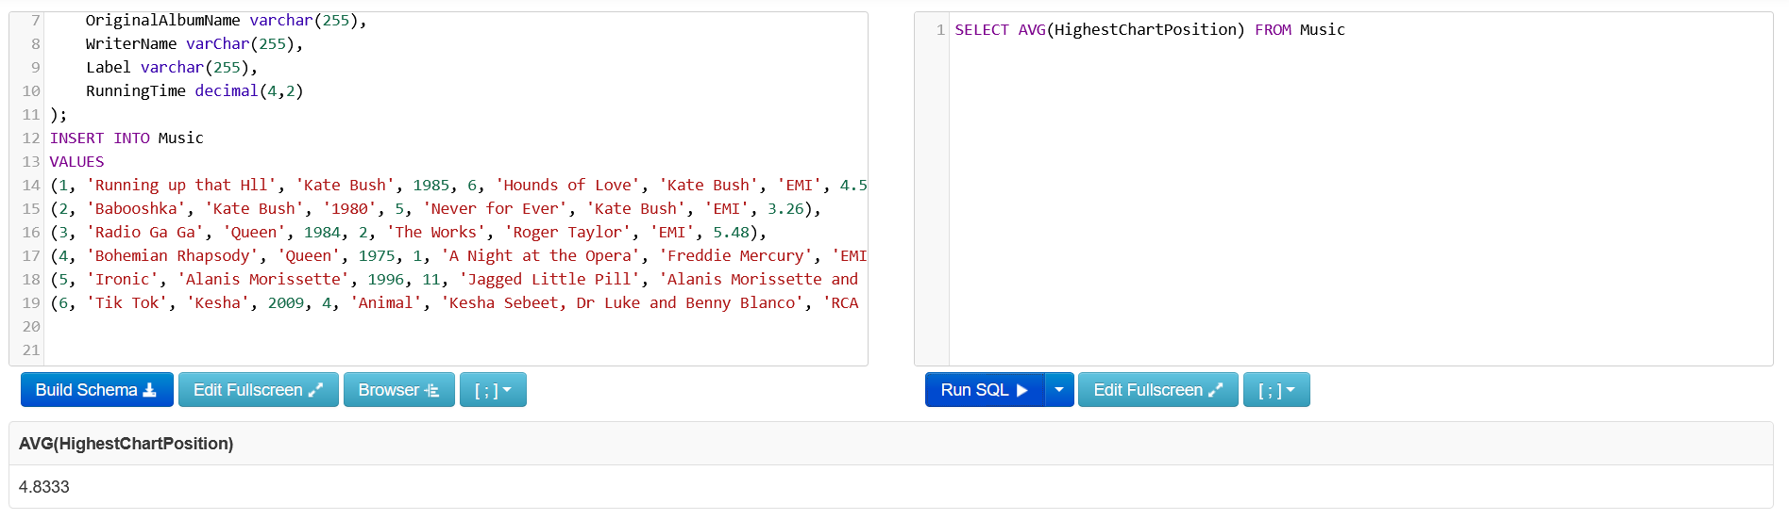
Number 1’s by Queen:
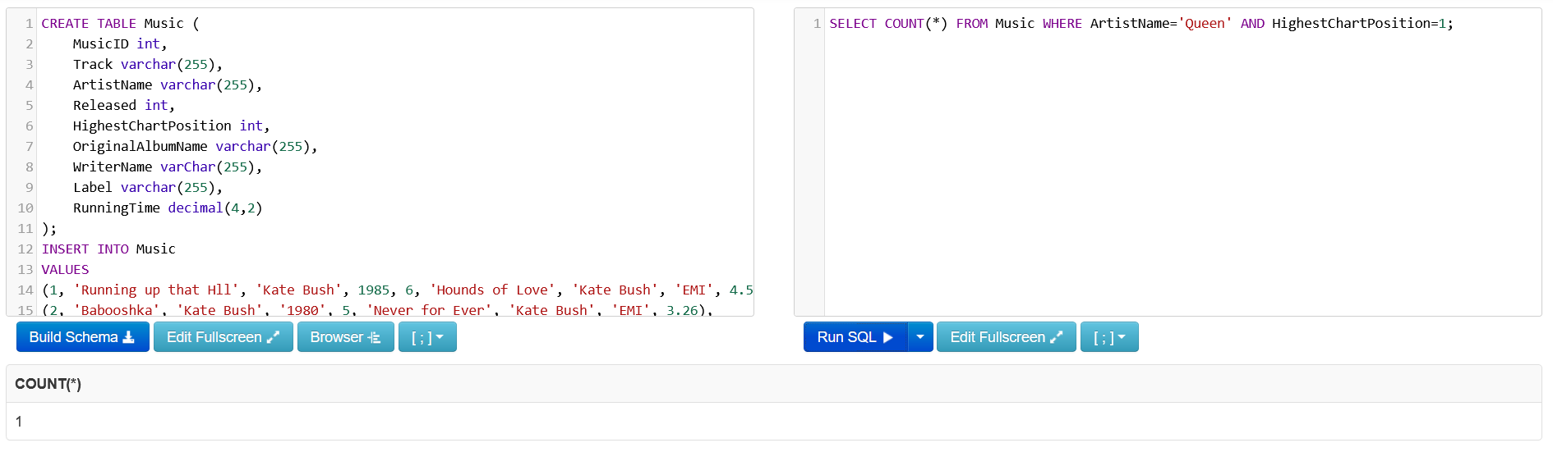
Total running time of tracks by Kate Bush:
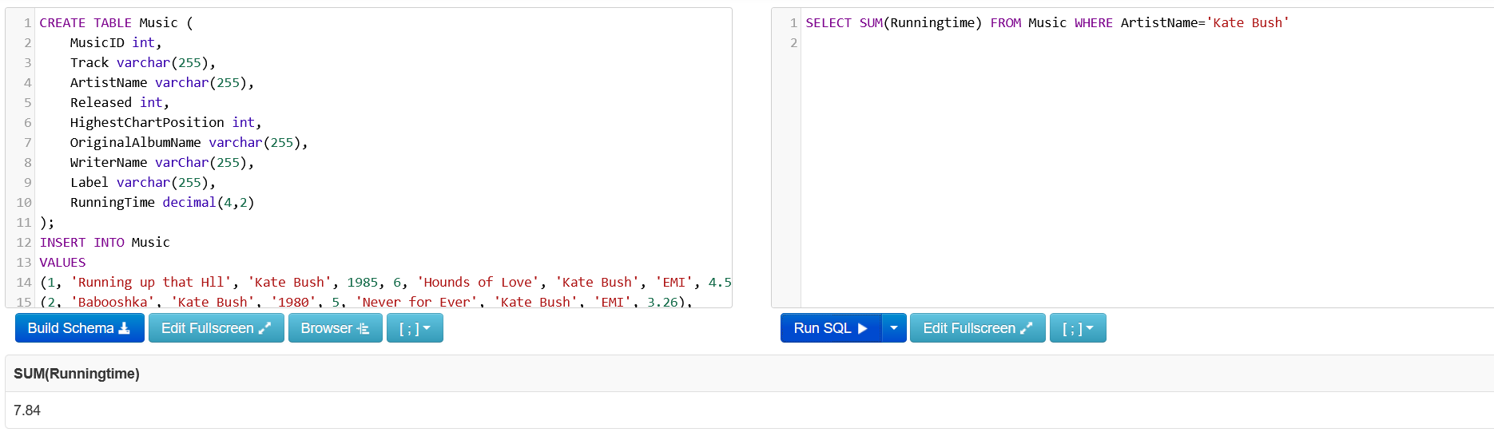
Average running time of tracks by Kate Bush:
