**DAY-1 Assignment**

**Student Attendance and Performance Analysis**

**Assignment Questions:**

1. Find the average attendance of all students who scored more than 80% in the final percentage.
2. List the bottom 5 students based on their final percentage, along with their subject-wise marks.
3. Identify the subject in which most students scored below 60 marks.
4. How many students scored above average in Maths but below average in science?
5. Compare the average marks of students who passed vs. those who failed.
6. Find the student who has the highest total across Maths + Science + English.
7. Show the distribution of students by their attendance categories: *<75%, 75–85%, >85%*.
8. Draw a bar chart of average scores in Maths, Science, and English for the class.
9. Create a scatter plot of Attendance vs Final Percentage show the trend.
10. Make a pie chart showing the percentage of Pass vs Fail students.

**Assignment Solution**

**Step 1: Open Julius AI**

1. Open **Google Chrome** (or any browser).
2. In the search bar, type: <https://julius.ai/>
3. Press **Enter**.
4. The Julius AI website will open.
5. Click **“Sign Up”**



**Step 2: Upload Your Dataset**

1. After logging into **Julius AI**, you will see the **workspace/chat screen**.

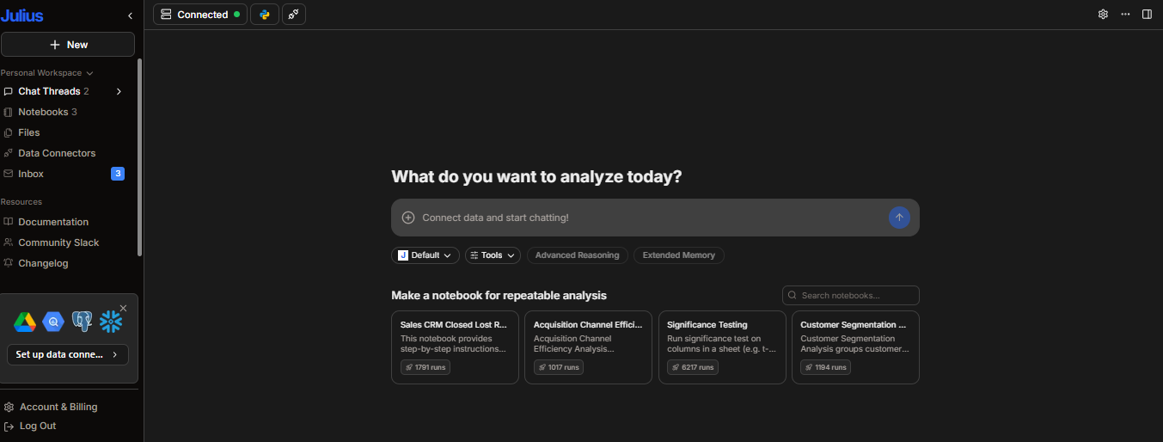

1. On the search bar (+), click on **“Upload”**.
2. Select your file **student_history.xlsx** from your computer.
3. Wait until Julius confirms the dataset is uploaded.
4. You should now see a message like *“student_history.xlsx uploaded successfully”*.
5. Julius will also show you the **columns** (Roll No, Student Name, Attendance, Maths, Science, English, Final Percentage, Pass/Fail).

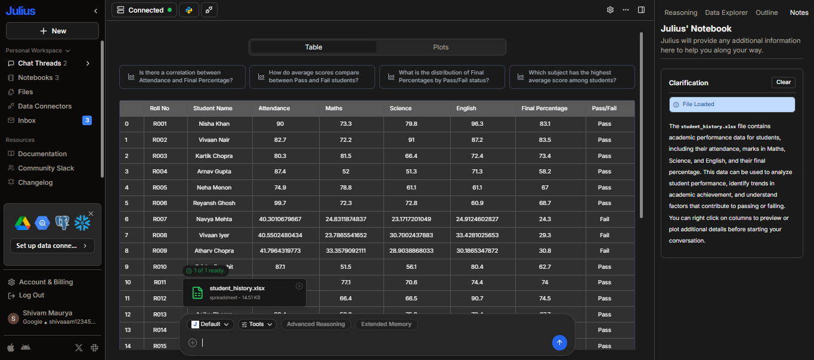

**Step 3: Let’s Start Prompting**

**Prompt 1:** Find the average attendance of all students who scored more than 80% in the final percentage.



**Output:**

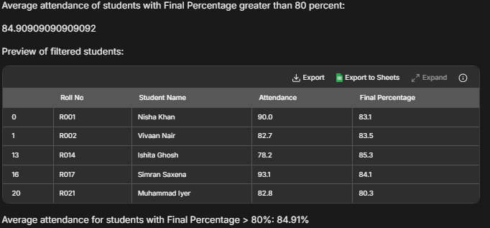

**Prompt 2:** List the bottom 5 students based on their final percentage, along with their subject-wise marks.



**Output:**

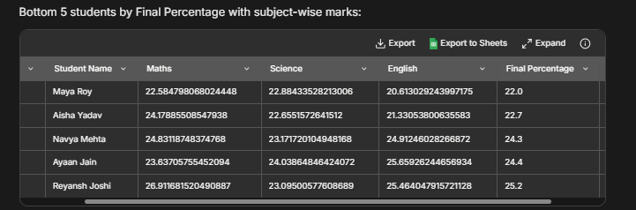

**Prompt 3:** Identify the subject in which most students scored below 60 marks.

  
**Output:**

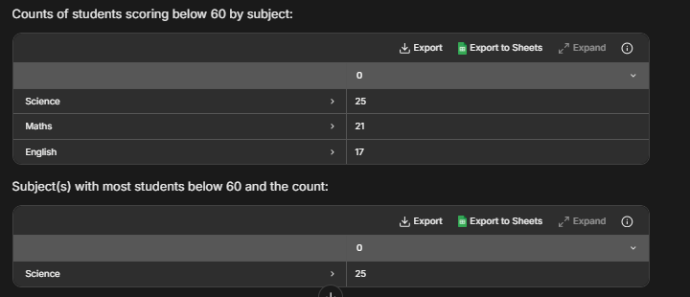

**Prompt 4:** How many students scored above average in Maths but below average in science?  


**Output:**

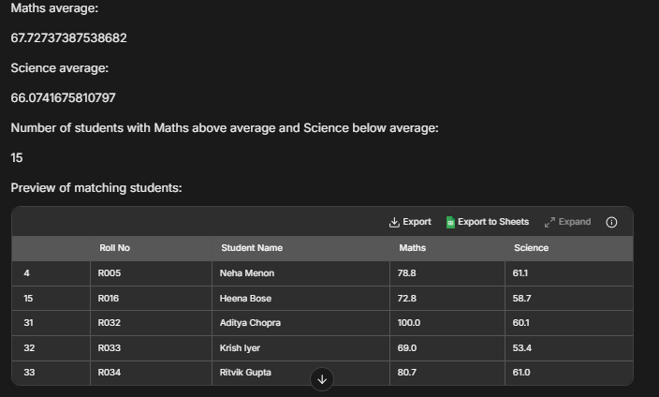

**Prompt 5:** Compare the average marks of students who passed vs. those who failed.

  
**Output:**

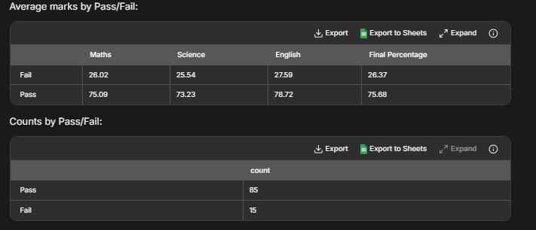

**Prompt 6:** Find the student who has the highest total across Maths + Science + English.

  
**Output:** 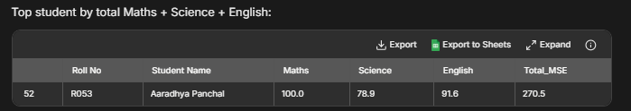

**Prompt 7:** Show the distribution of students by their attendance categories: <75%, 75–85%, >85%.

  
**Output:**

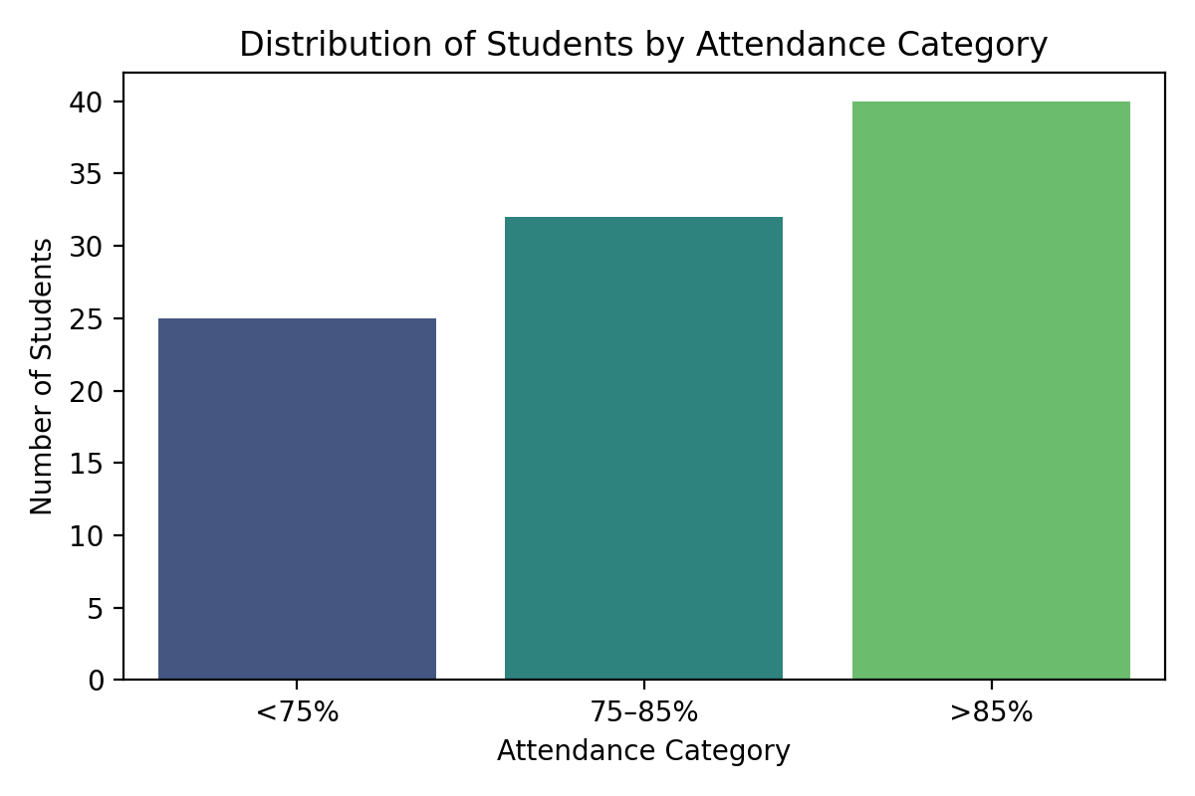

**Prompt 8:** Draw a bar chart of average scores in Maths, Science, and English for the class.

  
**Output:** 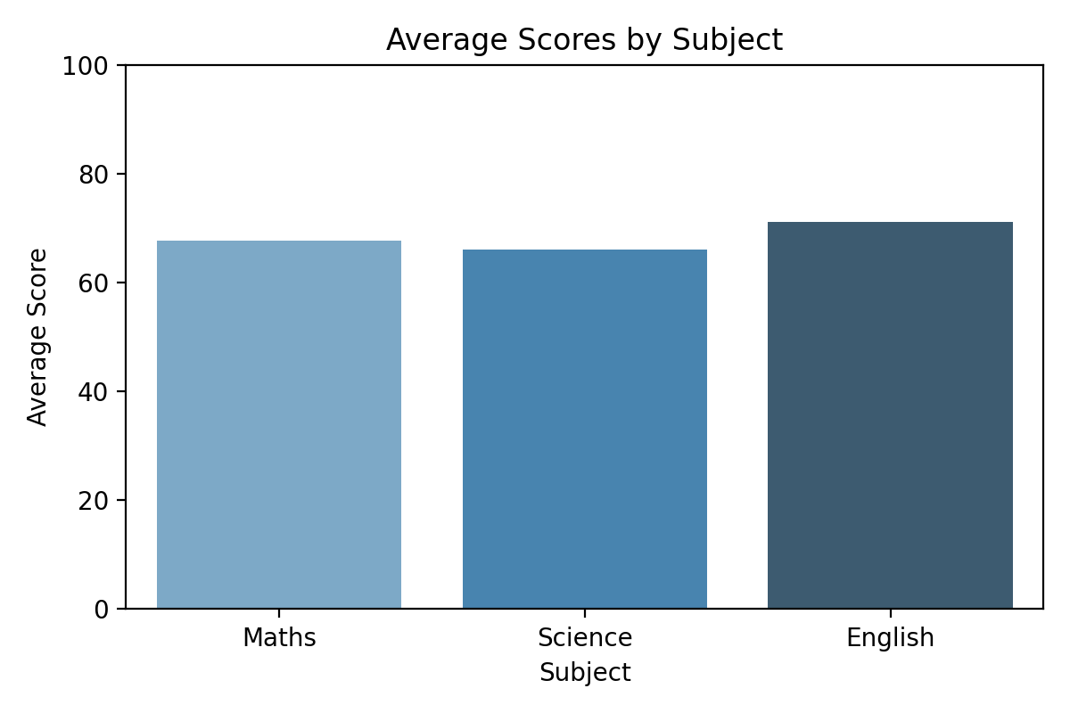

**Prompt 9:** Create a scatter plot of Attendance vs Final Percentage and show the trend.

  
**Output:**

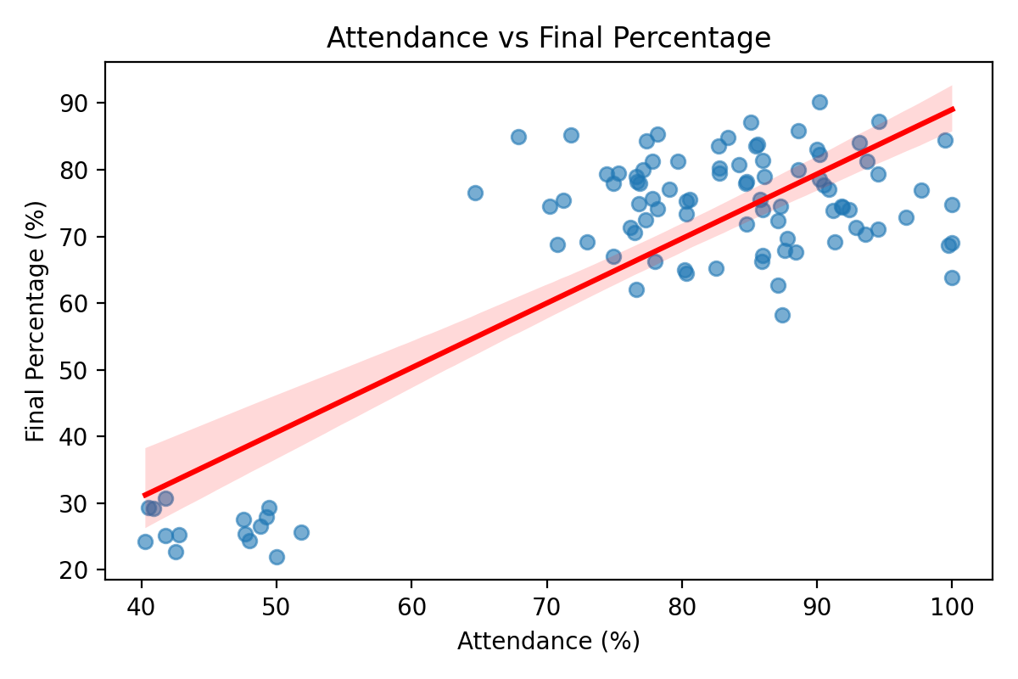

**Prompt 10:**  Make a pie chart showing the percentage of Pass vs Fail students.

  
**Output:**

