**Day-5 Assignment 3**

Create an automated teaching reminder workflow (sample email + schedule).

**Step 1: Understand the Task**

* Goal: Set up a system that automatically **reminds students/teachers** about upcoming classes.
* Required:
  + A **workflow** (automation process)
  + A **sample reminder email**
  + A **schedule**

**Step 2: Choose a Free Tool**

1. **Google Calendar** (best & free)

* Create events and enable automatic reminders (email/pop-up).

1. **Google Workspace + Gmail**

* Schedule reminder emails via Gmail.

**Step 3: Workflow Setup (Using Google Calendar + Gmail)**

* Open [https://calendar.google.com/.](https://calendar.google.com/)

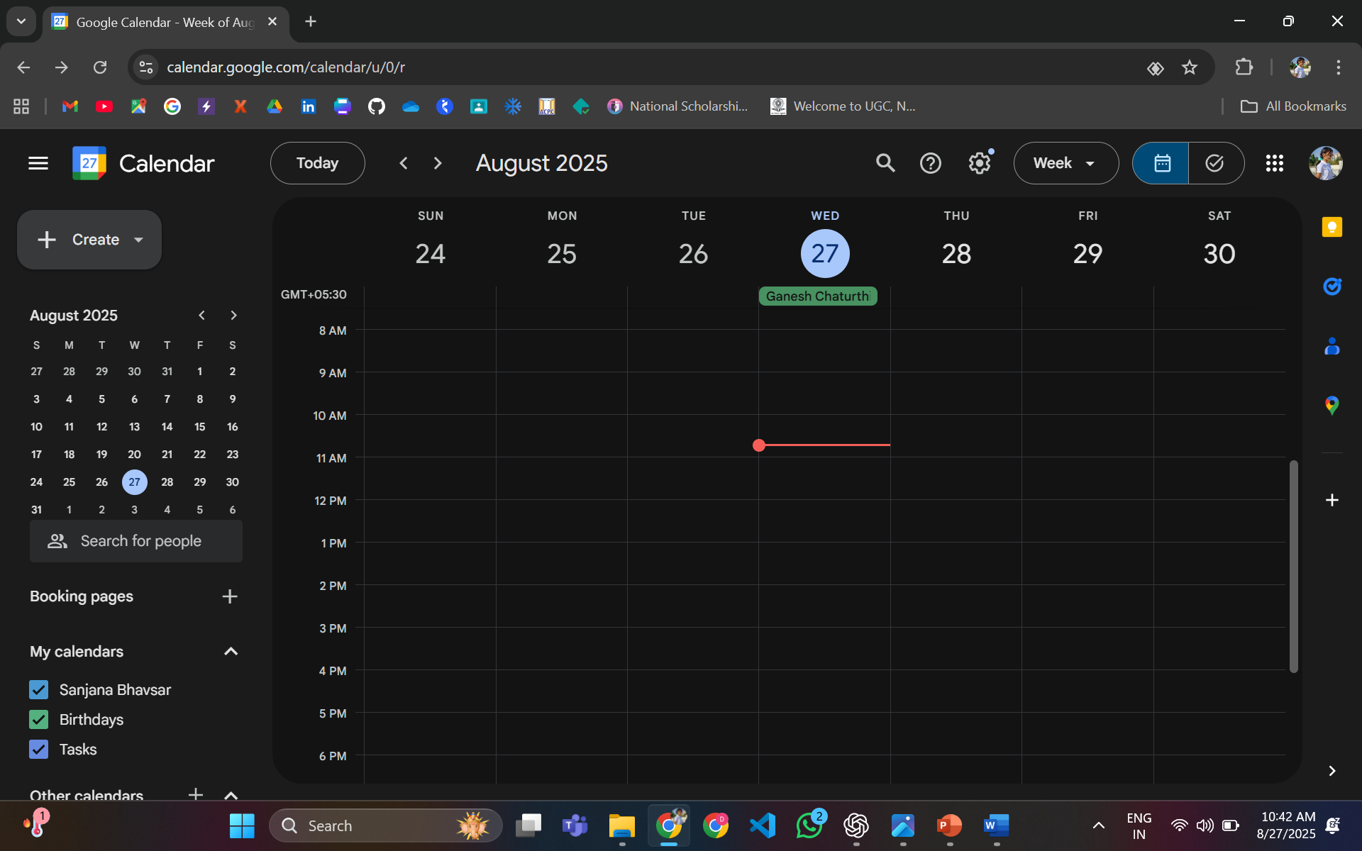

* Create a new event → Enter class title (e.g., *Math Lecture – Topic: Algebra*).

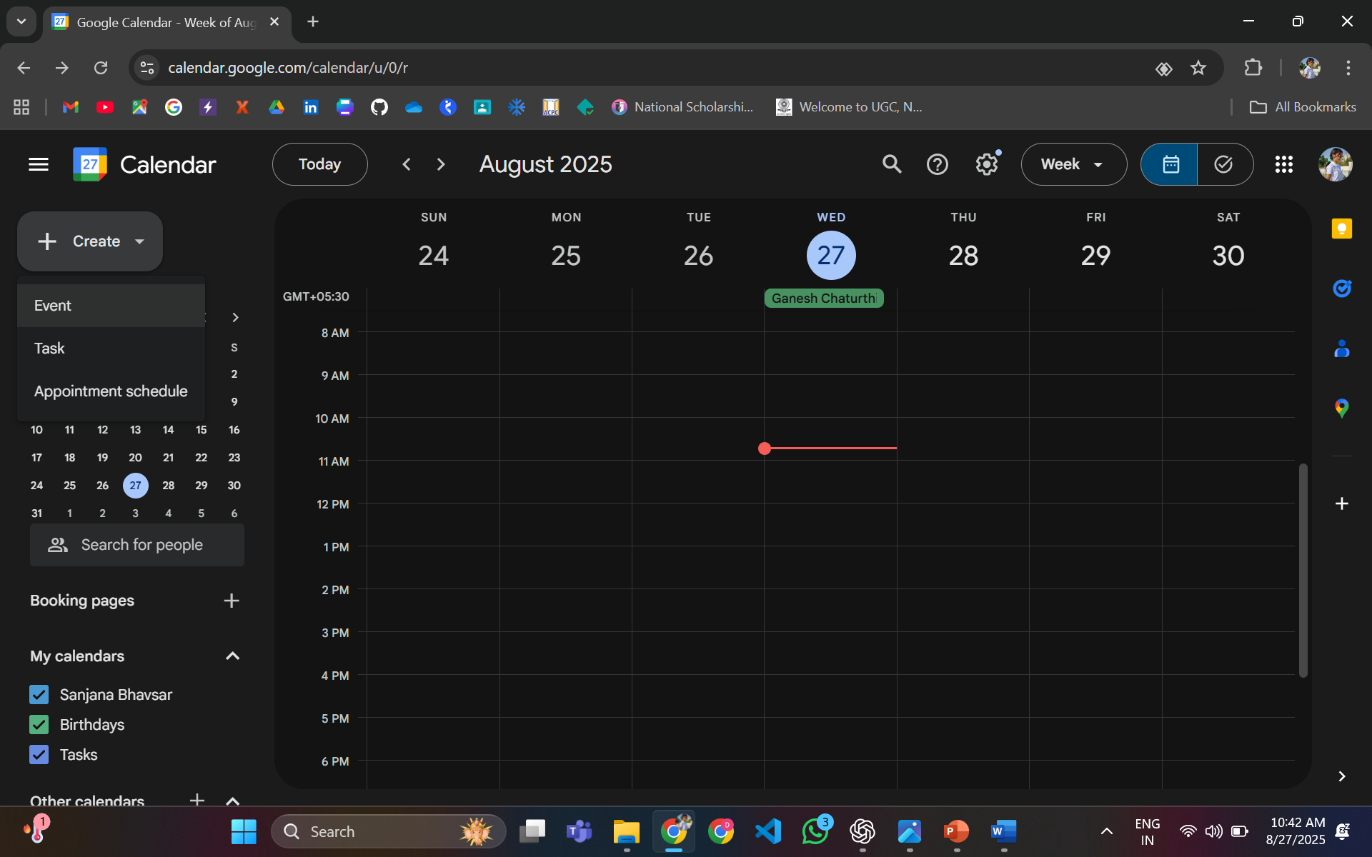

* Add date, time, and location (or online meeting link).

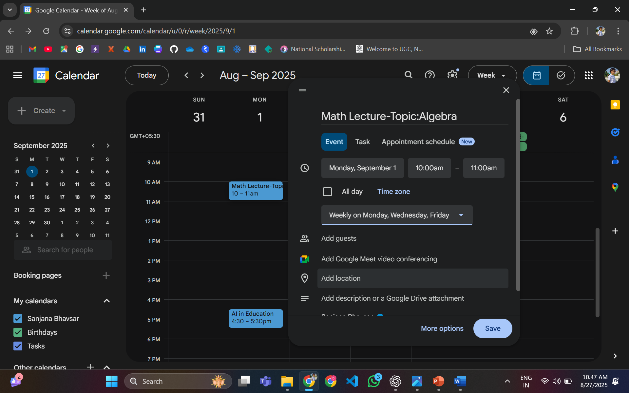

* Under “Notifications,” add reminders:
* **1 day before** (email)
* **1 hour before** (popup or email)

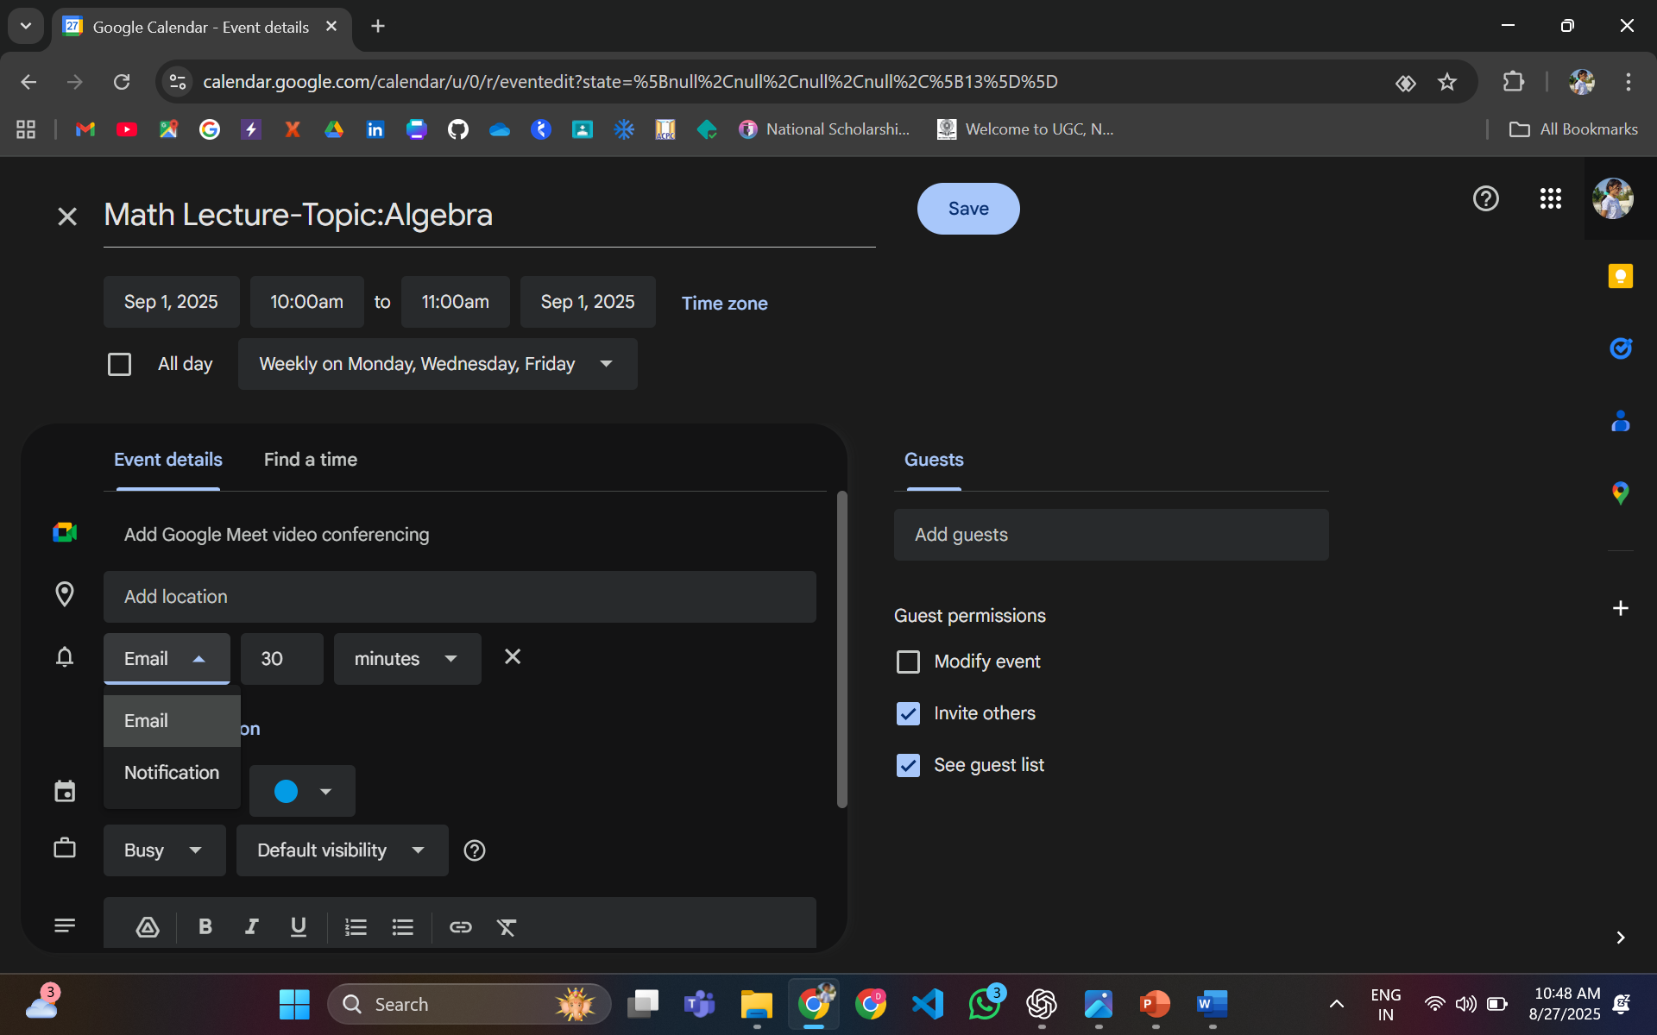

**Step 4: Create the Schedule**

Here’s a **sample teaching schedule** for one week:

|  |  |  |  |
| --- | --- | --- | --- |
| **Day** | **Time** | **Subject** | **Reminder (Email)** |
| Monday | 10:00 AM | Mathematics | Email reminder Sun 7 PM |
| Wednesday | 2:00 PM | Physics | Email reminder Tue 7 PM |
| Friday | 11:30 AM | Computer Sci. | Email reminder Thu 7 PM |

**Step 5: Draft Sample Reminder Email**

Here’s a simple reminder template:

**Subject:** Reminder: Upcoming Class – [Subject Name]

**Body:**  
Hello [Student/Teacher],

This is a gentle reminder that you have an upcoming class:

* **Subject:** [Subject Name]
* **Date & Time:** [Date + Time]
* **Mode:** [Classroom / Zoom / Google Meet link]

Please be on time and come prepared.

Best regards,  
[Your Name / Institution]

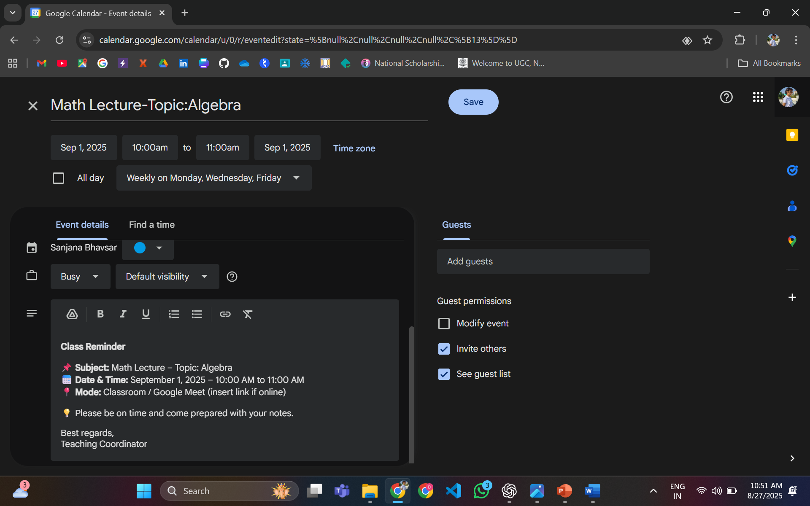

* Save the event.

**Step 6: Automate**

* Add this schedule to **Google Calendar**.
* Attach reminder emails in Gmail → schedule them.
* The workflow will then **send automatic reminders** without manual work.