Thomas Davis

Student Debt

In 2011, the median annual earning of full time, full-year wage and salary workers that were recent graduates with a bachelor degree earned $44,970 - though the unemployment rate remained at a high of 8.8%, according to The Institute for College Access and Success.

Are students graduating with a four-year degree in 2015 likely to make a lucrative income that will help them efficiently make monthly loan payments?

There are multiple ways students pay for their undergraduate education. Whether they’re borrowing loans, paying out of pocket or using other means – it’s expensive. First year bachelor students at the Fashion Institute of Technology in NYC pay $24,680 in tuition per year. By graduation, four years and eight semesters later and from the tuition alone – they will owe nearly $100,000. In 2013, nearly 56% of F.I.T’s undergraduate class graduated with debt.

These are hefty price tags to consider as a teenager fresh out of high school. Students and their families have a responsibility for finding a school that not only fulfills the student’s interests but also fits within the family’s fiscal constraints.

For students without financial support, there are options for affording their college education. Resources such as the Federal Pell Grant, which is awarded through FAFSA, can be distributed to need-based students and does not have to be paid back.

During the 2008 – 2011 recession, unemployed adults were enrolling in college credit courses at both associate (two year) and bachelor (four year) programs. People were not acquiring jobs, so to increase the chance of employment they were acquiring new skills and degrees. Fortunately for them, this strategy was successful, resulting in many individuals no longer perusing further education upon employment. Since interest in higher education dropped, the cost of college tuition continues to increase every couple of years. According to a U.S Department of Education survey, 33.8% of students who attended two-year programs in 2011 were projected to be in loan-default rather than the 13.8% of student who graduated from a four-year bachelor program.

Student Loan Justice is an organization dedicated to returning standard consumer protections to student loans and focuses primarily on research, media outreach, and grassroots lobbying initiatives.

Founder of the Student Loan Justice organization, Alan Collinge said, “Defaults are in fact a [preferred outcome](http://studentloanjustice.org/defaults-making-money.html" \t "_blank) for the lending system, up to and including the federal government.  This perverted, bad faith fiscal incentive has led to a myriad of systemic failings.”

Aside from loans, there are very few options for students looking to afford an undergraduate education such as grants, scholarships and work-study.

Though the economy has picked up and jobs are being created everyday, the employment rate in New York City is the lowest it’s been since 2008, according to the New York State Department of Labor. But depending on a student’s field of study – there may be post-graduation earning potential.

According to a PayScale College Salary Report for 2013-2014, **Petroleum Engineering, Actuarial Mathematics and Nuclear Engineering** have the highest earning potential of a salary between $60-$103,000 for a recent grad’s starting median pay. That being said, PayScale also reported degrees that most students pursue degrees in Business Administration, Psychology, Nursing and General Biology. The National Center for Education Statistics data from 2010-2011 also showed a similar popularity of those undergraduate majors.

For those who take future loan payments into account, seeking a degree in a particular field could help their future-selves. Along with finding options to afford college, varying In and Out-of-State tuition can be a deal breaker.

While it takes detailed strategic planning to look for other outlets that provide student aid, student loans are able to provide instant relief for students working toward a degree. Furthermore, students have to decide on programs with high quality education and increase the chance of future employment, or options that are more fiscally responsible, but perhaps don’t afford the same level of post-collegiate opportunities.

Bridget Emslie, a New Jersey resident, graduated Ramapo College of New Jersey in May 2014. Emslie studied Nursing for four years and became employed at Mount Sinai as a Nurse Practitioner in Pediatric Services two months after graduation. As an In-State resident, Emslie’s tuition costs were cut nearly half from $22K/year to $13K/year.

Emslie, who was also accepted to New York University, chose to attend Ramapo College of New Jersey not only for its excellent nursing program’s reputation but also because of the in-state tuition difference.

“I chose Ramapo rather than an Out-of-State school like NYU because I knew the cost would be significantly less. I knew once I graduated that my loans would be my problem since my mom wasn’t able to help me financially both before and after college,” said Emslie.

Emslie also said that she knew it was her responsibility to choose a school that would have a maximum benefit with a minimal amount of money being held against her. She also hopes to pay off her $20,000 debt with in the next ten years once her finances are in order.

“I didn't want to be paying off loans for the rest of my life for a degree I could get for a much more reasonable expense,” said Emslie.

ANALYSIS ON THAT EARNING POTENTIAL

Navigating the financial system as an undergraduate student can be daunting. Some students are able to afford some of the costs, while borrowing for the remained.

Anne Most, 22, a recent undergrad at Drexel University would have owed close to $150,000 for her bachelors degree but with the help of her parents and a few grants, Most left with a little under $50,000 in student loans.

“I can't say that I let money have much of an impact on my undergraduate education. I guess my motto was enjoy now, pay later. Paying back my loans will certainly be a grueling process, but going to Drexel gave me opportunities that I couldn't haven gotten anywhere else, so I don't regret it at all. But call me in ten years and I'll probably say otherwise,” said Most.

The Fashion Institute of Technology undergraduate student tuition amounts to just under $18K but the full undergrad cost doesn’t stop there. If you take into account Health Insurance, Health Services, Laboratory, Estimated Books and Supplies fees – out-of-state undergraduate student could accrue a yearly charge of $20,796 and that’s not including living expenses.

LEAD FOR KRISTI

Kristi Stoppiello is an out-of-state resident graduating from F.I.T with an associate’s degree that she started four years ago. Associate degrees tend to take no more than two years to acquire but Stoppiello was fortunate enough to take her time earning it. Graduating as a Fine Art major, Stoppiello feels that an associate over a bachelor degree was a good choice for her.

“Many artistic fields are based solely on portfolio rather than degree,” said Stoppiello.

Stoppiello recalls choosing F.I.T not only for the specialized arts program but also because it was the cheapest of other art schools she pondered applying to.

“I was fortunate enough to have parents who both worked very hard in order to pay my tuition. My college bills were completely paid in full and out of pocket each semester. It became far less expensive once I was no longer living in the city and taking no more than three classes a week. My parents were spending around $2,000 each semester,” said Stoppiello.

Schools like CUNY, which is a public college with multiple institutions around New York City forgive out-of-state tuition for students who:

* Were enrolled at CUNY for the Fall 2001 semester and qualified for in-state tition at that time.
* Attended a New York State high school for two or more years, graduated and applied to CUNY within five years of receiving a diploma.
* Received an accredited GED in New York State.

Wanting to find a school that would provide her with the best education at the lowest cost, Erica Davies turned down a more preferred private college.

“It was too expensive to attend and I didn't feel that the cost was worth the education. I figured that being closer to home would save the most money. My mom went to CUNY for her Masters and loved the program, so I decided to follow suit for undergrad,” said Davies.

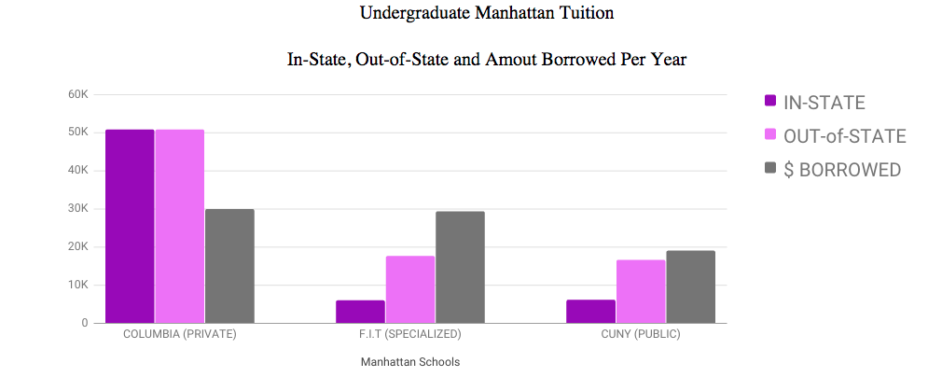

With research and responsible fiscal planning, students are able to find schools that not only suit their professional interests but also save them the burden of borrowing nearly double the amount in loans for a more prestigious, out-of-state college education.

President Obama’s Plan of Action

In January 2015, President Obama proposed that he will sign a Presidential Memorandum that will direct the Department of Education and other federal agencies to work across the federal government to do more to help borrowers afford their monthly loan payments. Within the Student Aid Bill of Rights, its student loan borrowers and the outstanding amount still to be paid categorize by each state.

According to the bill’s White House Press Release in March, “Americans are increasingly reliant on student loans to help pay for college.” More than 70 percent of those earning a bachelor’s degree graduate with debt, which averages $28,400 at public and non-profit colleges.

New York accounted for 2,821,000 people borrowing a total of 77,516,686,000 and counting.

Between the 2006 and 2011 academic years at Columbia College, full time undergraduate’s tuition increased by nearly eight thousand.

**MORE DATA TK:**

<http://www.columbia.edu/cu/opir/abstract/2010-11_tuition_rates_by_school.htm>

**SOURCE TK:**

Eleanor E Templeton

Director, Strategic Communications at Columbia University

eet2101@columbia.edu

[212-851-0634](tel:212-851-0634" \t "_blank)