Thomas Davis

Student Debt

There are a couple of ways students pay for their undergraduate education; they have resources to acquire the money on their own accord, they can borrow through student loans or they are on a need based plan that requires help from the state, either through grants, loans, scholarships or work-study.

Either route a student takes, they still have to pay something. In America, students begin to make major life decisions once they’re in their junior in high school. These students are usually around the age 17-19 when they’re asked to choose colleges, careers and make fiscally responsible decisions.

Choosing a college can be tough. Teenagers have to find a school that not only fits their interests but also suits their financial capabilities, in return affecting where they go to school and the opportunities/disadvantages that come along with.

Student Loan Justice is an organization dedicated to returning standard consumer protections to student loans and has focuses primarily on research, media outreach, and grassroots lobbying initiatives.

Founder of the Student Loan Justice organization, Alan Collinge said, “Many people who are paying student loans aren't able to pay enough to reduce their balances so they are seeing their debt increase every year rather than the opposite.”

Do those who can afford get more?

American education comes with a price tag, but not only are expenses a nightmare but what they school has to offer can have a major affect on a students life post college graduation. Though students are walking out with a bachelor’s degree and more loans than they know what to do with – there may be post-graduation earning potential.

According to a PayScale College Salary Report for 2013-2014, **Petroleum Engineering, Actuarial Mathematics and Nuclear Engineering** have the highest earning potential of a salary between $60-$103,000 for a recent grad’s starting median pay.

ANALYSIS ON THAT EARNING POTENTIAL

Navigating the financial system as an undergraduate student can be daunting and intimidating. Students are borrowing money to afford school because they can and feel it may be there only option to experience future opportunities.

Anne Most, 22, a recent Drexel University graduate owed close to $150, 000 for four years but with the help of her parents and a few grants, Most left with a little under $50,000 in student loans.

“I can't say that I let money have much of an impact on my undergraduate education. I guess my motto was *enjoy now, pay later.* Paying back my loans will certainly be a grueling process, but going to Drexel gave me opportunities that I couldn't haven gotten anywhere else, so I don't regret it at all. But call me in ten years and I'll probably say otherwise,” said Most.

1 STUDENT SOURCE TK: Sarah Galo - [sarah.galo@gmail.com](mailto:sarah.galo@gmail.com) - Phone Appt. Wed. Afternoon

Though F.I.T’s undergraduate student tuition amounts to just under $18K, the cost doesn’t stop there. If you take into account Health Insurance, Health Services, Laboratory, Estimated Books and Supplies fees – out-of-state undergraduate student could accrue a yearly charge of $20,796 and that’s not including living expenses.

1 STUDENT SOURCE TK: Kristi Stoppiello – [kristabell@gmail.com](mailto:sarah.galo@gmail.com) - Skype Appt. Friday Morning

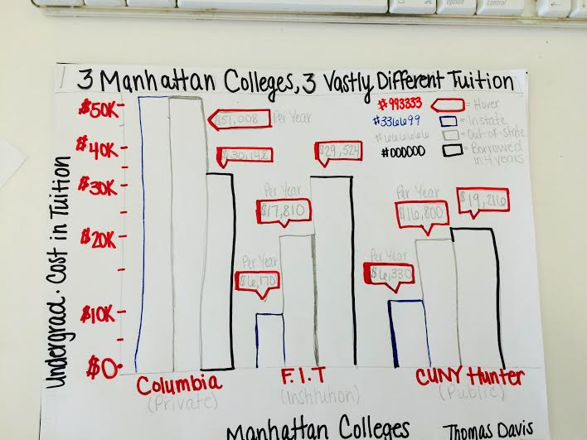

Bridget Emslie, a New Jersey resident, graduated Ramapo College of New Jersey in May 2014. Emslie studied Nursing for four years and quickly became employed at Mount Sinai as a Nurse Practitioner in Pediatric Services. As an In-State resident, Emslie’s tuition costs were cut nearly half from $22K/year to $13K/year.

Emslie who was also accepted to New York University chose to attend Ramapo College of New Jersey not only for its excellent nursing program’s reputation but also because of the in-state tuition difference.

“I chose Ramapo rather than an out-of-state school like NYU because I knew the cost would be significantly less. I knew once I graduated that my loans would be my problem since my mom wasn’t able to help me financially both before and after college,” said Emslie.

Emslie also said that she knew it was her responsibility to choose a school that would have a maximum benefit with a minimal amount of money being held against her. She also hopes to pay off her $20,000 debt with in the next ten years once her finances are in order.

“I didn't want to be paying off loans for the rest of my life for a degree I could get for a much more reasonable expense,” said Emslie.

With research and responsible fiscal planning, students are able to find schools that not only suit their professional interests but also save them the burden of borrowing nearly double the amount in loans for a more prestigious, out-of-state college education.

President Obama’s Plan of Action

In January 2015, President Obama proposed that he will sign a Presidential Memorandum that will direct the Department of Education and other federal agencies to work across the federal government to do more to help borrowers afford their monthly loan payments. Within the Student Aid Bill of Rights, its student loan borrowers and the outstanding amount still to be paid categorize by each state.

According to the bill’s White House Press Release in March, “Americans are increasingly reliant on student loans to help pay for college.” More than 70 percent of those earning a bachelor’s degree graduate with debt, which averages $28,400 at public and non-profit colleges.

New York accounted for 2,821,000 people borrowing a total of 77,516,686,000 and counting.

Between the 2006 and 2011 academic years at Columbia College, full time undergraduate’s tuition increased by nearly eight thousand.

**MORE DATA TK:**

<http://www.columbia.edu/cu/opir/abstract/2010-11_tuition_rates_by_school.htm>

**SOURCE TK:**

Eleanor E Templeton

Director, Strategic Communications at Columbia University

eet2101@columbia.edu

[212-851-0634](tel:212-851-0634" \t "_blank)