**A young but promising company, Pens and Pencils, is based in the USA and operates there as well. Since March 2017, its focus has been on B2B and B2C online sales of office supplies (office equipment, stationery, and furniture).**

**Formalized tasks:**

**1. Evaluate the sales dynamics and revenue distribution by products.**

**2. Create a customer profile by determining which customers generate the highest revenue.**

**3. Monitor the company's logistics (determine if all orders are delivered on time and identify the best state to open an offline store).**

To accomplish these tasks, I utilized the following tools, data, and methods:

1. Data Analysis: PostgreSQL was employed to manage and analyze the company's actual data. Querying the database and performing data manipulations provided insights into various aspects of the business.
2. Statistical Methods: Statistical techniques and methodologies were applied to analyze sales dynamics and revenue distribution. Descriptive statistics, regression analysis, and hypothesis testing were utilized to identify patterns, trends, and relationships within the data.
3. PowerBI: PowerBI, a powerful data visualization tool, was utilized to create interactive dashboards and reports. By connecting to the data sources, visual representations of key metrics and performance indicators were generated, facilitating a comprehensive understanding of the company's sales and revenue patterns.

By employing these tools, leveraging data, and applying statistical methods, meaningful insights were derived, and data-driven decisions were made for the company.

**27.5.1**

**Rounded monthly sales**

-- revenue by order

with sales_by_orders as

(

select

sc.order_id,

sum ((price - (price * discount)) * quantity) revenue

from sql.store_products sp

join sql.store_carts sc using (product_id)

group by order_id

)

-- rounded revenue by months

select

to_char(sd.order_date, 'yyyy-mm-01') date,

round (sum (revenue),0) revenue

from sales_by_orders sbo

join sql.store_delivery sd using (order_id)

group by date

order by date

**27.5.2**

Sales exhibit seasonality. January and February are the months with the lowest sales. But overall, sales are growing.

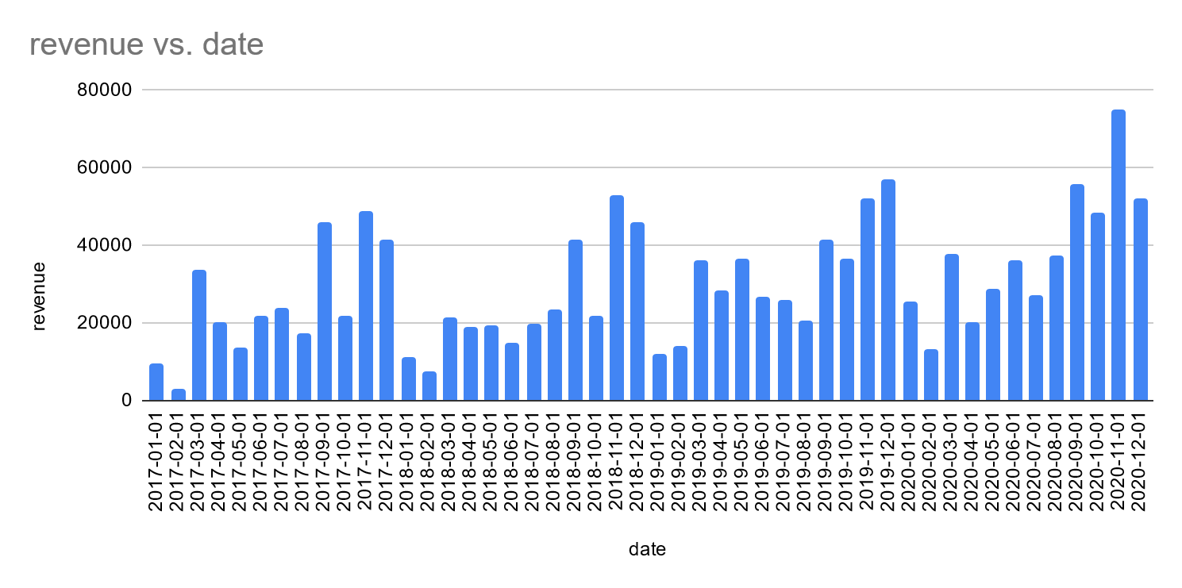

**27.5.5**

**Sales revenue split by category and subcategory**

-- revenue by category and subcategory

select

sp.category,

sp.subcategory,

round (sum (sc.quantity*(1-sc.discount)*sp.price)) revenue

from sql.store_carts sc

join sql.store_products sp using (product_id)

group by 1,2

order by 3 desc

**27.5.6**

-- **Top 25 products by sales revenue**

with top25_sales as

(

select

sp.product_nm,

sum ((price - (price * discount)) * quantity) revenue,

sum (sc.quantity) quantity

from sql.store_products sp

join sql.store_carts sc using (product_id)

group by 1

order by 2 desc

limit 25

),

-- Total revenue

total_revenue as

(

select

sum ((price - (price * discount)) * quantity) total

from sql.store_products sp

join sql.store_carts sc using (product_id)

)

-- top 25 products revenue, quantity and percentage share

select

product_nm,

round (revenue,2) revenue,

quantity,

(

select

round (revenue/total*100,2)

from total_revenue t

) percent_from_total

from top25_sales ts

**27.6.1**

-- **Sales revenue by customer**

with sales_by_customers as

(

select

sd.cust_id,

sum ((price - (price * discount)) * quantity) revenue

from sql.store_products sp

join sql.store_carts sc using (product_id)

join sql.store_delivery sd using (order_id)

group by cust_id

)

select

category,

count (distinct (cust_id)) cust_cnt,

round (sum (revenue)) revenue

from sql.store_customers sc

join sales_by_customers using (cust_id)

group by category

order by revenue desc

**27.6.2**

-- **Creating corporate customer cohorts by the 1st order**

with frst_order as

(

select

min (to_char(sd.order_date, 'yyyy-mm-01')) date,

cust_id

from sql.store_delivery sd

group by cust_id

)

-- Count of new corporate customers by month

select

fo.date,

count (distinct (cust_id)) new_custs

from sql.store_customers sc

join frst_order fo using (cust_id)

where category like 'Corporate'

group by date

order by date

Since the beginning of 2018, there have been noticeably fewer new customers, perhaps indicating that campaigns with the highest lead traffic were scaled back.

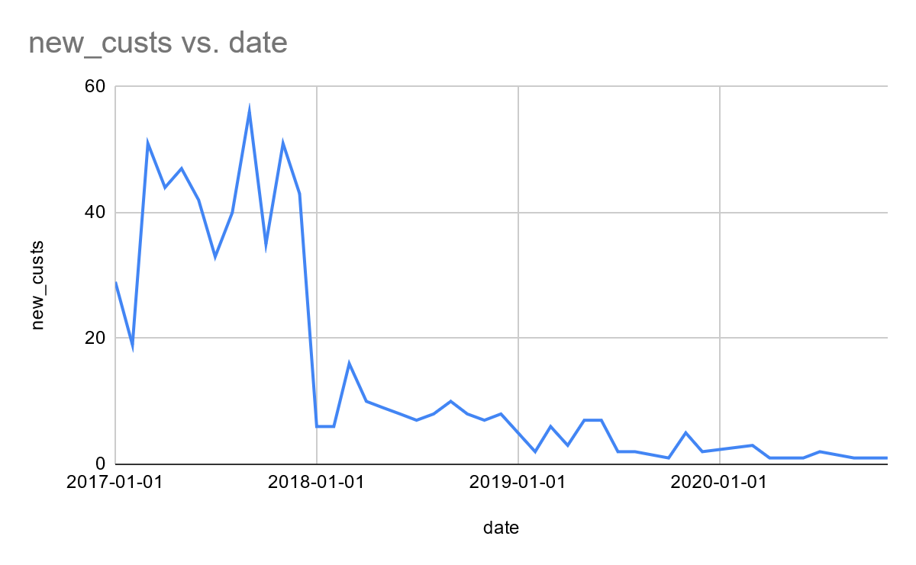

**27.6.4**

-- **1) Average number of items per order for corporate clients (2)**

with customer_orders as

(

select

sd.order_id,

count (distinct(scc.product_id)) items

from sql.store_delivery sd

join sql.store_customers sc on sd.cust_id = sc.cust_id

join sql.store_carts scc on scc.order_id = sd.order_id

where sc.category like 'Corporate'

group by 1

)

select

round (avg(items),1)

from customer_orders

-- **2) The average buy for corporate customers (285,9)**

with order_sum as

(

select

sc.order_id,

sum ((price - (price * discount)) * quantity) revenue

from sql.store_products sp

join sql.store_carts sc using (product_id)

group by sc.order_id

),

corp_cust as

(

select

sd.order_id

from sql.store_customers sc

join sql.store_delivery sd using (cust_id)

where category like 'Corporate'

group by sd.order_id

)

select

round ( avg (revenue),1)

from corp_cust cc

join order_sum os using (order_id)

**The average number of offices for corporate clients (6.2)**

-- **3) The total number of branches per corporate customer**

with corp_cust as

(

select

cust_id,

count(distinct (zip_code)) branch_num

from sql.store_customers sc

join sql.store_delivery sd using (cust_id)

where category like 'Corporate'

group by cust_id

)

-- average no of offices per corporate customer

select

round (avg(branch_num),1)

from corp_cust cc

**27.7.1**

-- **% of successful deliveries by class**

with delivery_intervals as

(

select

ship_mode,

count (order_id) as orders_cnt,

count (case when ship_mode = 'Same Day' and (ship_date - order_date) <= 0 then order_id

when ship_mode = 'First Class' and (ship_date - order_date) <= 3 then order_id

when ship_mode = 'Second Class' and (ship_date - order_date) <= 4 then order_id

when ship_mode = 'Standard Class' and (ship_date - order_date) <= 6 then order_id

else null end) as delievered_ontime

from sql.store_delivery

group by 1

)

select ship_mode,

orders_cnt,

(orders_cnt - delievered_ontime) late_orders_cnt,

round (delievered_ontime * 100.00 / orders_cnt, 2) as "% success"

from delivery_intervals

order by 4

**27.7.2**

**-- The quantity of failed 'Second Class' deliveries by quarter**

with delivery_intervals as

(

select

DATE_TRUNC('quarter', order_date)::date quarter,

ship_mode,

count (order_id) as orders_cnt,

count (case when ship_mode = 'Same Day' and (ship_date - order_date) <= 0 then order_id

when ship_mode = 'First Class' and (ship_date - order_date) <= 3 then order_id

when ship_mode = 'Second Class' and (ship_date - order_date) <= 4 then order_id

when ship_mode = 'Standard Class' and (ship_date - order_date) <= 6 then order_id

else null end) as delievered_ontime

from sql.store_delivery

where ship_mode = 'Second Class'

group by 1,2

)

select

quarter,

(orders_cnt - delievered_ontime) late_orders_cnt

from delivery_intervals

order by 1

**27.7.3**

Delivery deadlines have been missed throughout the observed period. This is most likely due to fluctuations in sales and logistical issues.

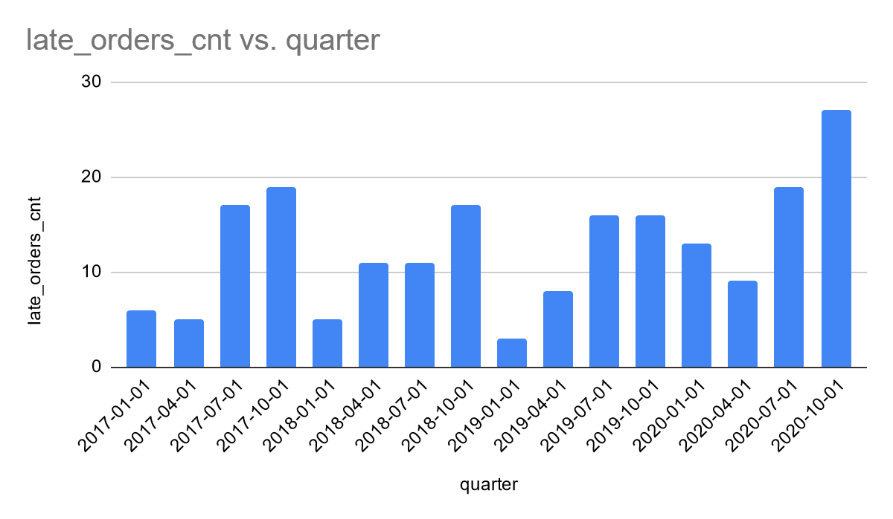

**27.7.6**

**-- Sales revenue by state**

select

state,

count (distinct (order_id))

from sql.store_delivery sd

group by state

order by count desc

Based on the sales map below, California appears to be the state with the highest sales volume. The next state in terms of sales on the West Coast is Washington. It would be recommended to consider establishing an offline sales point in Los Angeles, as it is the largest city with the highest purchasing power in California.

