Detection of Adulterants in Milk

Yadavalli V.K. Lakshmi Sravani¹, Prof. Suman Kapoor²
^{#1} Student, BITS Pilani, Hyderabad campus, Telangana, India.
^{#2} Professor, BITS Pilani, Hyderabad campus, Telangana, India.

ABSTRACT: Globally, milk adulteration is a widespread phenomenon. In addition to the economic loss incurred by consumers, this practice has numerous negative effects on public health. Despite significant advances in instrumentation and applied technologies, the problem persists. This is because conventional detection techniques are costly, time-consuming, and labor-intensive. This necessitated the development of portable, rapid, and on-site detection systems for identifying and quantifying various milk adulterants. This study analyses and compares the different on-site detection methods. There are a variety of qualitative procedures available for the various categories of adulterants. Typically, these are colorimetric techniques that alter the sample if a particular adulterant is present. However, they do not provide precise quantitative results and can only detect adulterants at higher concentrations. Several quantitative techniques, such as LC-MS/MS, MIR, and LC-APCI/MS-MS, can be used to precisely detect various milk adulterants. They are accurate but expensive and require a great deal of equipment and talent. In this paper, on-site adulterant detection systems, such as digital imaging, are analyzed to determine the optimal method for various concentrations of adulterants. On the basis of accuracy, machine learning algorithms are applied to the data to determine the optimal algorithm. The utmost accuracy provided by SVM is 96% for Binary classification and 87% for Multi-class classification.

Keywords: Adulteration of Milk, Machine Learning, Digital image colorimetry,

- Introduction:
Milk adulteration is a widespread practice around the globe. In addition to the economic loss incurred by consumers, this practice has numerous negative effects on public health. Despite significant advances in instrumentation and applied technologies, the problem persists. This is because conventional detection techniques are costly, time-consuming, and labor-intensive [1]. This necessitated the development of portable, rapid, and on-site detection systems for identifying and quantifying various milk adulterants. The detection of adulterants in milk is one of the most important research methodologies for ensuring human health safety. Spectroscopy-based adulteration detection is one of the most popular methods. Expensive, laboratory-based, and non-destructive, spectroscopic technologies are used to detect adulterants.
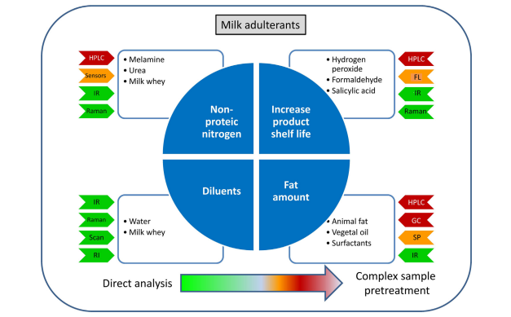
Fig 1: Various ways of Milk Adulteration

1.1 Detection of Adulteration of Milk
A milk adulterant detection system can detect adulteration by receiving signal analysis at a selected frequency. A transmitter is used to pass the signal through adulterated milk samples and the received signal is analysed using digital storage oscilloscope.

Sl. No. | Type of adulteration | Adulterants added | Detection techniques
1. | Protein content | Melamine, Urea, whey | LC-MS/MS, MIR, UV-vis
2. | Fat content | Vegetable oils and animal fat | LC-APCI/MS-MS, GC-FID,  MALDI-QTOF MS, RP-TLC
3. | Detergents | SDS, SDBS , LAS | HPLC-QTOF MS, Digital images.
4. | Preservatives | Salicylic acid, H₂O₂, Formalin, Dichromate. | HPLC-MS/MS, Flow injection spectrophotometry.
5. | Water and other substances. | Water, low cost milk, NaOH. | Digital images, chemometrics,  MALDI-TOF-MS

Several quantitative techniques like LC-MS/MS, MIR, LC-APCI/MS-MS can be used to detect various adulterants of milk very precisely [2]. They are accurate but require a lot of instrumentation, skill and are expensive.
FTIR (Fourier Transformed Infrared Spectroscopy) is one of the simple and fast method for obtaining its compositional information.
Table 1: Different Types of Milk Adulteration Techniques

1.2 Machine Learning: In Machine learning algorithms are categorised into supervised learning and supervised learning based on whether the data is labelled or not. Classification comes under supervised learning in which we need to find the class that the data or instance belongs.
1.3 Classification Techniques: The different methods of classification tasks are discussed in this section. These are classified into parametric and nonparametric techniques. Parametric model uses algebraic equations. The non-parametric [3] model is data-driven. No explicit formula is used to determine the model. Nonparametric techniques include neural networks, decision trees and random forest. Classification Techniques determine a classification function or classification model (called classifier) which maps the data in the database to a specific class. Classification techniques such as Decision Tree, Naive Bayes, Artificial Neural Network( ANN), K- Nearest Neighbour Algorithm ( KNN), Support Vector Machine ( SVM), and Logistic Regression.

- Literature Review:

Table 2: Various edible adulterants in milk
Name of Adulterant | Sample size | Testing procedure | Observation form the test
Sugar | 5 ml of milk in a test tube | Combine in a tube with conc HCL (1 ml) and resorcinol solution (0.1g) and keep 5 min in a water. | Changed its color in RED which indicates added sugar to Milk.
Glucose | 1 ml of milk add modified Barfoed’s reagent of 1 ml | heat for 3 minutes by keeping in hot water and quickly under cool water | Changed to dark blue colour
Starch | 3 ml of milk in test tube | Boil properly and keep it in the room to come to room temperature and add a single drop of iodine solution of 1% | Changed into blue color

- Proposed Methodology:
3.1 Milk adulteration data set: We used Brazil data set for Milk Quality Analysis Laboratory. The data set includes the following 13 features and two target variables [4]. They are Raw Milk and other Ingredients as mentioned in table 3 with classes peroxide, Bicarbonate, Formaldehyde, sucrose, bicarbonate.

Table 3: Ingredients of Raw Milk
Sl. No | Name of the feature
1 | Cells
2 | Q Value
3 | Fat
4 | Protein
5 | Lactose
6 | Solids
7 | FFA
8 | Citrate
9 | Frz point
10 | SNF
11 | MUN
12 | Casein
13 | Cells

3.2 Pre-processing Data: The data set may consist of some noisy data. The noisy data will degrade the accuracy of the detection model. So, we did pre-processing to improve the quality of the data set such as removing the null values, discarding the unwanted features [5] from the data set and normalising the data.
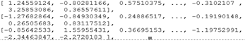
Fig 2: Sample Normalised data in the data set

3.3 Proposed architecture for Milk adulteration detection:
We used food analysis for analyzing various factors such as quality, adulteration and identity. Analytical measurements are based on rapid image acquisition by a scanner, webcam, or a smartphone, followed by conversion of the analytical information to RGB (red–green–blue), HSV (matrix, saturation, value) [6]. This instrumentation is accessible, portable, rapid, and cheap. Hence it can be used for on-site analysis for daily usage. They have been employed to detect protein content and also detergent presence in research studies. Linear responses were obtained between analytical signals and the adulterant concentration in both the cases.
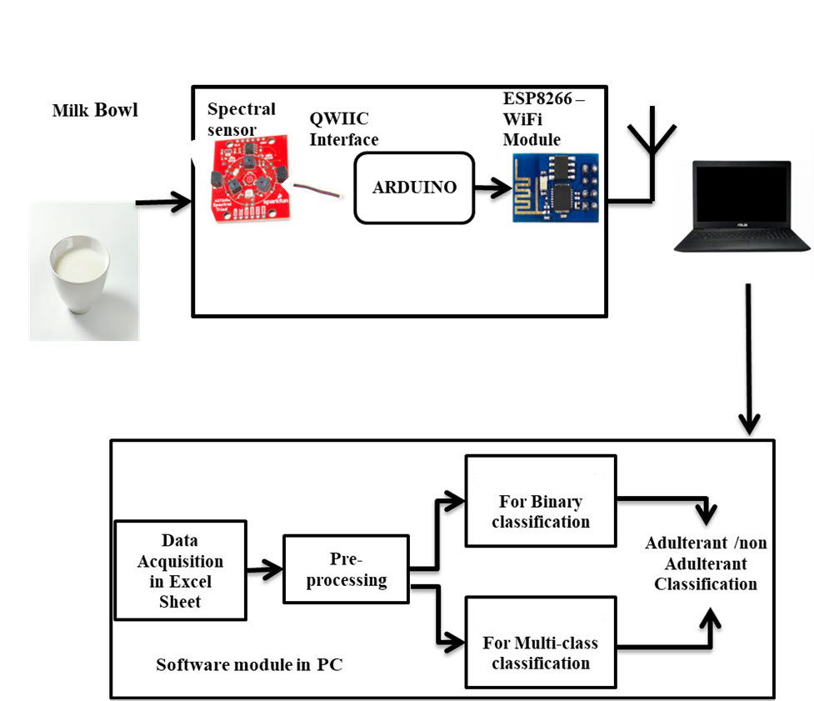
Fig 3: Architecture of Milk Adulteration process
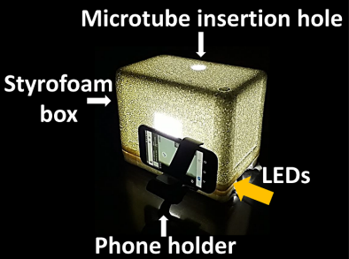

Fig 4: Digital image colorimetry

3.4 Classification of data using Machine learning algorithms:
- Naive Bayes: Naive Bayes is based on Bayes theorem with independence among predictors and it is a classification technique it means; this classifier assumes that the presence of features in a particular class is not related to the presence of any other features if these features are depend on each other than these properties contribute to the probability of the class independently and that is the men reason for calling this classification technique is “NAÏVE”. Navie Bayes is “Naïve” because it Assume that feature of a measurement are not depend of each other. Naïve Bayes is naïve because it almost never true. It is easy to bold and particularly useful for large data set. Along with simplicity, Naive Bayes is known as a sophisticated classification method.
- Random Forest: Random forest (RF) is a decision tree-based approach that employs rules to binary partition data. The major rules used to binary split data in classification issues are the Gini index, deviation, and the towing rule. Commonly, GINI index method is usually used in random forest.
- Support Vector Machine (SVM): Support vector machine (SVM) is an algorithm that attempts to find a linear separator (hyper-plane) between the data points of two classes in multidimensional space. SVMs are well suited to dealing with interactions among features and redundant features.

3.5. Qualitative methods

Adulterant | Method of testing | Observation
Sugar | Add 1ml conc HCL and 0.1g of resorcinol solution to a 5ml milk sample in a test tube and place it in a water bath for 5mins. [7] | In the presence of added sugar, the solution turns red in colour.
Starch | Boil 3ml sample in a test tube and, after cooling it to room temperature, add 1% iodine solution. [8] | In the presence of starch, the solution turns to a blue colour.
Common Salt | Add 1ml of 0.1N silver nitrate to 5ml milk sample, mix them thoroughly and add 0.5ml of 10%potassium chromate solution.  [9] | The appearance of yellow colour indicates salt presence whereas brick red colour indicates the absence.
Detergent | Add equal amounts of water to 5ml milk sample and shake well.  Add 0.1ml 0.5% Bromocresol Purple solution (BCP). [11] | The appearance of lather indicates the presence of detergent in the sample.  Appearance of a dark violet colour indicates the presence of detergent.
Buffalo milk | Dilute the milk to 1/10 and put a drop on the centre of a glass slide. Add a few drops of Hans test serum to the milk drop and mix together with a glass rod. [12] | Curd particles start developing within half a min in milk containing buffalo milk.
Formalin | Add 5ml con Sulphuric acid with a small amount of ferric chloride to 10ml milk sample without shaking. [13] | The appearance of violet or blue colour at the junction of two liquid layers indicates formalin presence in the milk.
Urea | Take 5 ml milk sample in a test tube. Add equal volume of 24% TCA to precipitate fat and proteins of milk. Take 1 ml filtrate and add 0.5 ml 2% sodium hypochlorite, 0.5 ml 2% sodium hydroxide and add 0.5 ml 5% phenol solution, then mix. [14] | A characteristic blue or bluish green colour develops in presence of added urea whereas pure milk remains colourless.
Benzoic acid and Salicylic acid | A 5ml milk sample is acidified with sulphuric acid in a test tube and 0.5% ferric chloride solution is added to it drop by drop. Mix it well. [15] | Development of buff colour indicates the presence of benzoic acid whereas violet colour development indicates salicylic acid.
Hydrogen peroxide | Add 1ml of potassium iodide solution to the milk sample and mix well. [16] | The appearance of blue colour indicates the presence of hydrogen peroxide in the sample.

4.Results:
After pre-processing the data, Random Forest, Naïve Bayes and SVM classification algorithms are applied. The following are the classification algorithms are trained and tested by considering Binary classification. Support Vector Machine, Random Forest and Gaussian Naive Bayes theorem and Support vector machine on Multiclass classification and accuracies are compared.
Table 4: Confusion matrix for the various classification algorithms
Algorithm | Confusion Matrix
SVM | 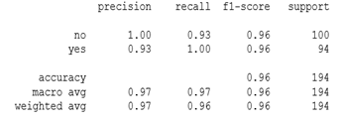
Random Forest | 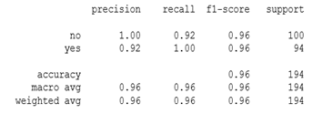
Naive Bayes | 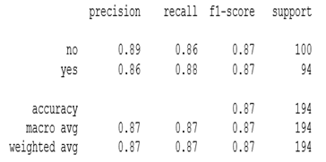

Table 5: Comparison from other algorithms for both Binary and Multi class classification

Classification | Algorithm | Accuracy
Binary | SVM | 0.9639175237731959
Binary | Random Forest | 0.958762886597382
Binary | Naive Bayes | 0.8711340206185567
Multi class | SVM | 0.88

Instance 1: Determination of detergents concentration in the Milk.
S = 1.56 C – 0.65 (R = 0.999, n = 5) was obtained under optimized conditions where S is difference between reference and analytical signals, and C is concentration of SDS in mg/L.

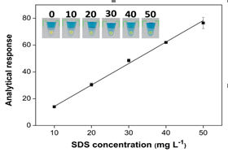
Fig 5: Analytical curve of Milk with various concentrations for detection of SDS

Instance 2: Protein concentration in the sample.
The proposed procedure presented a linear response between 0.36% and 3.6% m/v proteins as
R = (17.9 ± 0.4) C + (68 ± 1), r = 0.999.
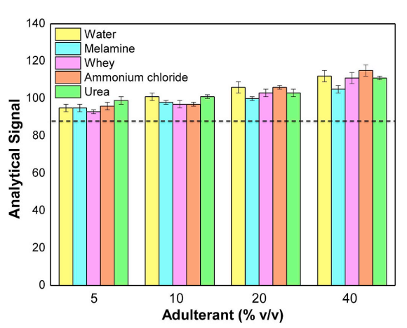
Fig 6: sample visualisation of adulterated Milk

- Conclusions:

The binary classification, which determines whether the data represents fresh milk or adulterated milk. Additionally, 5Fold cross validation is performed. Using classification algorithms, a new instance is classified as either fresh milk or adulterated milk, according to this proposal concerning the data on milk adulterations. SVM is more precise than the Random Forest and Gaussian Nave Bayes algorithms. SVM is optimal for multi-class classification with 96% accuracy for binary classification to detect whether milk was adulterated or not and 88% accuracy for multi-class classification in classifying the new instance or data as one of five classes representing the adulterants introduced to the milk. This method assists in determining whether the provided data is fresh milk or adulterated. If an adulterant is introduced, it helps determine which adulterant was added and their accuracy scores with and without five-fold cross validation.

References
- Domingo E, Tirelli AA, Nunes CA, Guerreiro MC, Pinto SM. Melamine detection in milk using vibrational spectroscopy and chemometrics analysis: A review. Food Res Int. 2014;60:131–9
- Ellis DI, Brewster VL, Dunn WB, Allwood JW, Golovanov AP, Goodacre R. Fingerprinting food: current technologies for the detection of food adulteration and contamination. Chem Soc Rev. 2012;41(17):5706–27
- FAO. In: Alimentarius C, editor. International experts limit melamine levels in food, vol. 2016. Geneva: Food and Agriculture Organization; 2010
- Liu B, Lin M, Li H. Potential of SERS for rapid detection of melamine and cyanuric acid extracted from milk. Sensing Instrum Food Qual Saf. 2010;4(1):13–9
- López-Calleja I, González I, Fajardo V, Rodríguez MA, Hernández PE, García T, Matín R. Rapid detection of cows’ milk in sheeps’ and goats’ milk by a species-specific polymerase chain reaction technique. J Dairy Sci. 2004;87:2839–45
- Garcia JS, Sanvido GB, Saraiva SA, Zacca JJ, Cosso RG, Eberlin MN. Bovine milk powder adulteration with vegetable oils or fats revealed by MALDI-QTOF MS. Food Chem. 2012;131(2012):722–6. 131 722–726.
- Guerreiro JS, Barros M, Fernandes P, Pires P, Bardsley R. Principal component analysis of proteolytic profiles as markers of authenticity of PDO cheeses. Food Chem. 2013;136(3–4):1526–32.
- Mishra GK, Mishra RK, Bhand S. Flow injection analysis biosensor for urea analysis in adulterated milk using enzyme thermistor. Biosensors and Bioelectronics. 2010;26:1560–4
- Ntakatsane MP, Liu XM, Zhou P. Short communication: Rapid detection of milk fat adulteration with vegetable oil by fluorescence spectroscopy. J Dairy Sci. 2013;96(4):2130–6.
- Kamthania M, Saxena J, Saxena K, Sharma DK. Methods of Detection &Remedial Measures. Int J Engg Tech Res. 2014;1:15–20.
- https://aurigaresearch.com/2021/04/milk-adulteration-how-to-check-adulteration/
[12] Common milk adulteration and their detection techniques: Tanzina Azad and Shoeb Ahmed, Azad and Ahmed International Journal of Food Contamination (2016) 3:22, DOI 10.1186/s40550-016-0045-3.
[13] Rupak Nagraik, Avinash Sharma, Deepak Kumar, Prince Chawla, Avvaru Praveen Kumar, Milk adulterant detection: Conventional and biosensor based approaches: A review, Sensing and Bio-Sensing Research, Volume 33,2021,100-433.
[14] Carina F. Nascimento, Poliana M. Santos, Edenir Rodrigues Pereira-Filho, Fábio R.P. Rocha, Recent advances on determination of milk adulterants, Food Chemistry, Volume 221,2017,Pages 1232-1244.
[15] Tanzina Azad, Shoeb Ahmed, Common milk adulterations and their detection techniques, International Journal of Food contamination,2016.
[16] Tanzina Azad, Shoeb Ahmed, Common milk adulterations and their detection techniques, International Journal of Food contamination,2016.

