Summarizing Report on Energy Prices

# aFRR Market Negative Data

Mean Prices:  
The mean price for 2025 started at 6.70, and by 2029, it dropped steadily to 3.70.  
Prices exhibit a consistent downward trend, indicating a gradual reduction in forecasted prices over the years.

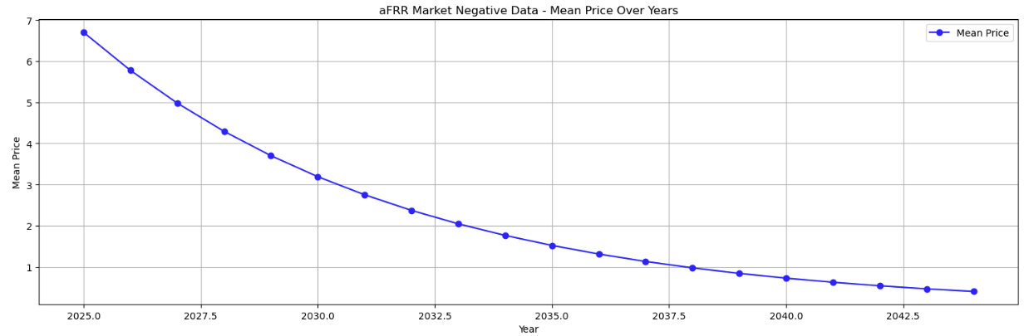  
  
Volatility (Standard Deviation):  
In 2025, the volatility (price fluctuation) is relatively high, with a standard deviation of 1.50.  
The volatility decreases slightly each year, reaching 1.33 in 2029, suggesting a stabilizing market with less price uncertainty over time.

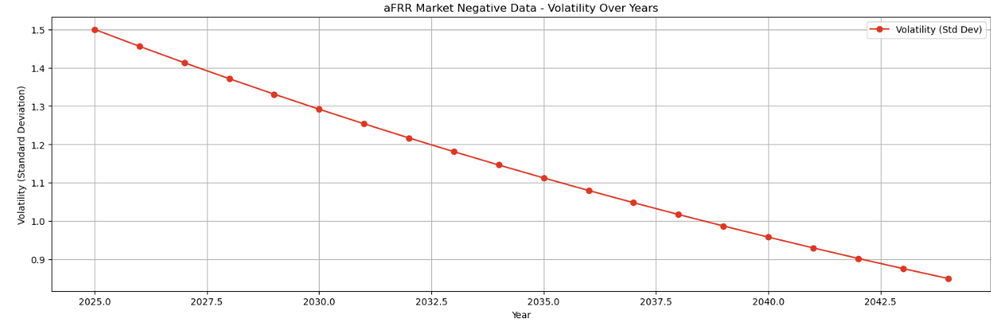  
  
Conclusion: The aFRR negative market data shows a trend of decreasing prices with declining volatility, indicating that prices are becoming more stable year over year.

# 2. aFRR Market Positive Data

Mean Prices:  
The mean price starts at 3.50 in 2025 and increases steadily to 4.54 in 2029.  
Unlike the negative market, the positive market experiences growth in prices, though the increase is gradual.

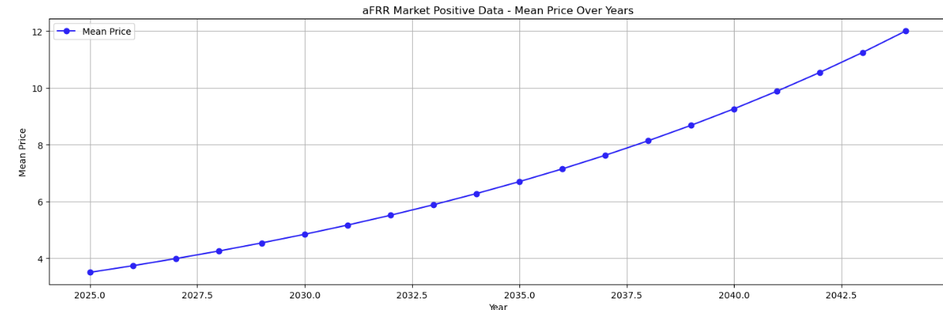  
  
Volatility (Standard Deviation):  
In 2025, the volatility is 0.85, and this decreases to 0.80 by 2029.  
The overall low volatility suggests that the positive market is quite stable, with minimal fluctuations in prices over the years.

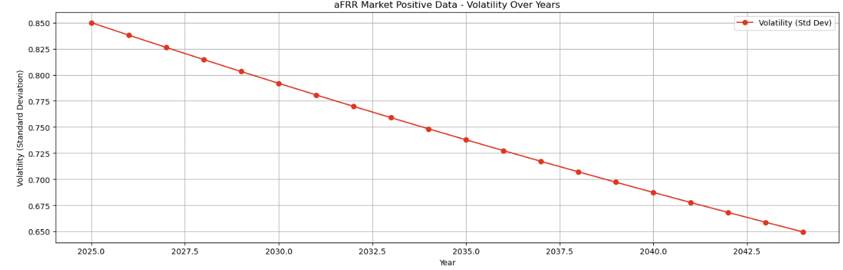  
  
Conclusion: The aFRR positive market data shows an upward trend in prices with low and stable volatility, suggesting a gradual price increase with limited risk or uncertainty in the market.

# 3. Dayahead Market Data

Mean Prices:  
Prices in the dayahead market are significantly higher than in the aFRR markets. The mean price in 2025 is 86.30, and it fluctuates over the years, peaking at 115.86 in 2027 before decreasing to 96.67 by 2029.  
This dataset shows a clear spike in prices mid-term, followed by a decline, indicating higher price volatility.

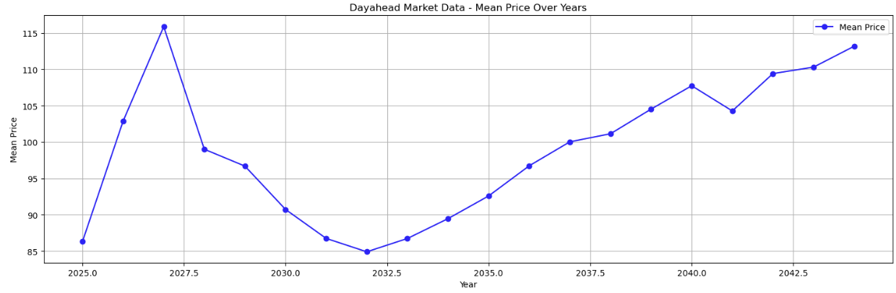  
  
Volatility (Standard Deviation):  
The standard deviation in 2025 is 15.00, indicating high volatility early on.  
Volatility rises further, reaching 43.30 in 2028, before reducing slightly to 39.37 in 2029.  
The large fluctuations in prices reflect a highly volatile market, likely influenced by unpredictable external factors.

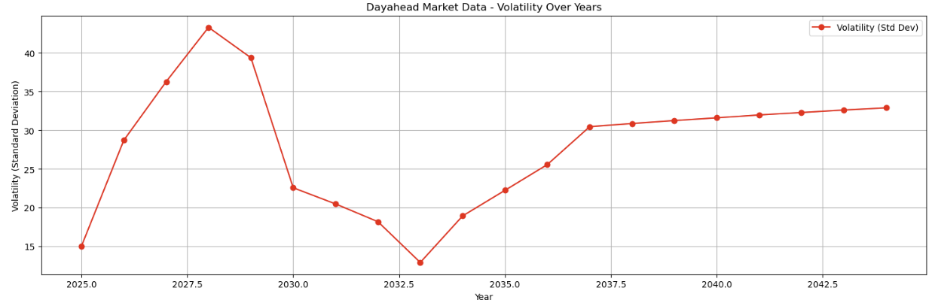  
  
Conclusion: The dayahead market experiences the highest levels of price volatility compared to the aFRR markets. Prices rise sharply before stabilizing but with considerable fluctuations, signaling higher market risk and instability.

# Overall Volatility Comparison

aFRR Market Negative: Declining prices with moderate volatility, showing a stabilizing market.  
aFRR Market Positive: Gradually increasing prices with very low volatility, indicating a stable market environment.  
Dayahead Market: High prices with significant volatility, suggesting a more uncertain and risk-prone market.

# Key Insights

Volatility is lowest in the aFRR positive market, which shows a consistent price increase.  
Dayahead Market prices are the most volatile, with substantial year-over-year fluctuations.  
Price Trends differ: aFRR negative market prices decline, aFRR positive prices rise slowly, while the dayahead market experiences sharp increases followed by some decline.

# Actionable Recommendations

1. Risk Management: The dayahead market requires robust risk management strategies due to its high volatility.  
2. Investment Opportunities: The aFRR positive market appears to be a safer investment option due to its stable and predictable price growth.  
3. Market Monitoring: Close monitoring of the dayahead market is essential to anticipate and mitigate price fluctuations, especially during the peak periods around 2027.