**RELATION- ASSIGNMENT**

**1.Have created 3 tables**

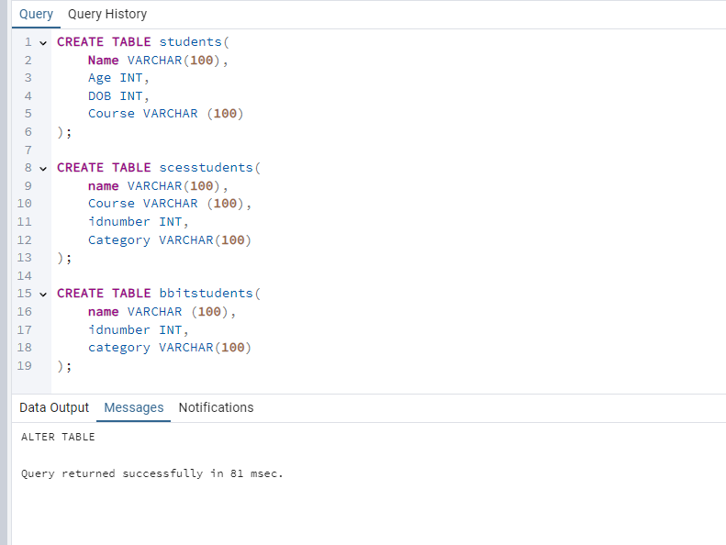

**2. Have inserted data into the tables**

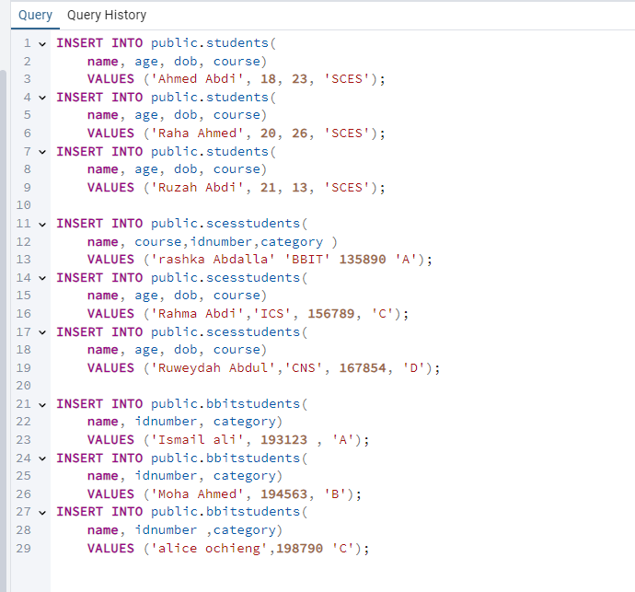

**3.Have a SELECT statement to view the data**

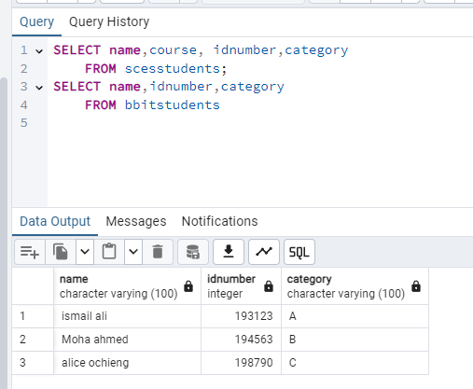

**4.Have updated the data in at least one of the tables**

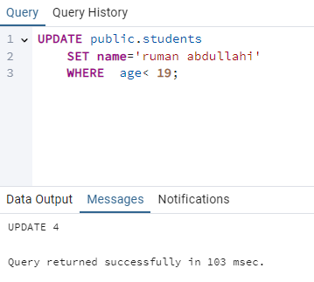

**5.Have added, altered and dropped at least 1 column in any of the tables**

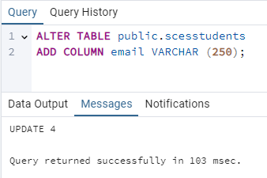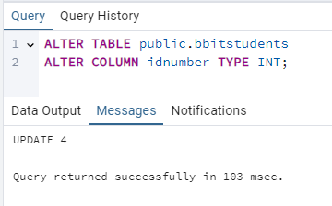

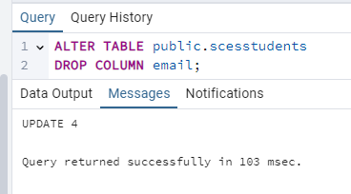

**6.Have deleted a table**

