**Supplementary Information**

**Supplementary Figure 1:** Time stability of [11C]Cimbi-36 *V*T values obtained by GA and the 2TCM in the cerebellum (A) and cortical regions (B) and cortical *BP*ND values obtained by the GA, 2TCM and SRTM (C). Outcome measures are expressed as relative to values obtained with a 123 minutes positron emission tomography (PET) measurement. Data points and error bars represent mean and S.D., respectively. For the *BP*ND evaluation one measurement was excluded for the 2TCM analysis, as it provided unreliable estimates of *BP*ND with shorter measurement duration than 96 minutes.

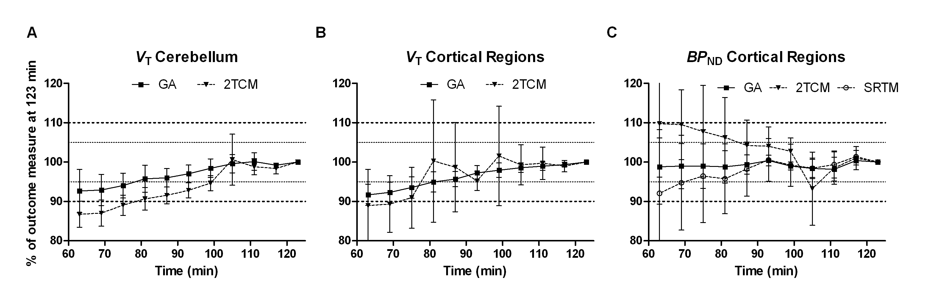

**Supplementary Figure 2:**In vitro autoradiographic images showing the level of [3H]Cimbi-36 binding in saggital cynomolgus monkey sections. Saturation binding experiments using the 5-HT2A agonist [3H]Cimbi-36 at concentrations 3 nM (A-B), 1 nM (C-D), 0.3 nM (E-F), 0.1 nM (G-H) and 0.03 nM (I-J). Non-specific binding (B, D, F, H and J) was determined by presence of 10 µM ketanserin.

[3H]Cimbi-36 bound in a saturable manner with apparent *K*D values of 1.3 nM, 2.4 nM and 1.1 nM in the hippocampus, caudate nucleus and cerebellum, respectively. However, it should be noted that the saturation graphs did not reach the plateau (graphs not shown), and that the study is limited by the small sample size (*n* =1), and is therefore not eligible for inference.

