Project
  - Deadline: Monday 09/08/2026 @ 23:59
[Total Mark is 20]

Introduction to Database
xxxxx
Instructions:
- You must submit two separate copies (one Word file and one PDF file) using the Assignment Template on Blackboard via the allocated folder. These files must not be in compressed format.
- It is your responsibility to check and make sure that you have uploaded both the correct files.
- Zero mark will be given if you try to bypass the SafeAssign (e.g. misspell words, remove spaces between words, hide characters, use different character sets, convert text into image or languages other than English or any kind of manipulation).
- Email submission will not be accepted.
- You are advised to make your work clear and well-presented. This includes filling your information on the cover page.
- You must use this template, failing which will result in zero mark.
- You MUST show all your work, and text must not be converted into an image, unless specified otherwise by the question.
- Late submission will result in ZERO mark.
- The work should be your own, copying from students or other resources will result in ZERO mark.
- Use Times New Roman font for all your answers.
Student Details: CRN: 50245
Name: Sultan Aljohani  Name: Amjad Najmi  Name: Abdulaziz Alharbi |  | ID: 240035689  ID: 240020509  ID: 250021379

Project Instructions
- You can work on this project as a group (minimum 3 and maximum 4 students). Each group member must submit the project individually with all group member names mentioned on the cover page.
- This project worth 20 marks and will be distributed as in the following:
  - Database Design. (6 marks)
  - Database Implementation. (6 marks)
  - SQL Operations. (6 marks)
  - Project Reflection. (2 marks)
- Each leader in the group must submit one report about their chosen Project via the Blackboard (Email submission will not be accepted and will be awarded ZERO marks) containing the following:
- Task 1 : database design
- Task 2: database implementation
- All requested queries/results
- Screenshots from MySQL (or any other software you use) of all the tables after population and query results.
- Reflection (300–500 words) describing the team's experience, challenges, design decisions, and AI usage (if applicable).
- Submit one SQL file containing the complete database implementation, including database creation, tables, data insertion, required queries, VIEW, and TRIGGER.
- Submit a GitHub (or GitLab) repository containing the complete project with regular commits and meaningful commit messages.
- Submit a progress report describing the completed work, key decisions, challenges, future plan, and contribution of each group member.
- Include links to the live report document, GitHub/GitLab repository, and Google Colab notebook (if applicable) in the Project Artifacts section of the final report.
- You are advised to make your work clear and well presented; marks may be reduced for poor presentation. This includes filling in your information on the cover page.
- You MUST show all your work, and text must not be converted into an image unless specified otherwise by the question.
- Late submission will result in ZERO marks being awarded.
- The work should be your own. Copying from students or other resources, including AI software, will result in ZERO marks.

Project Description
Design and Implementation of a Smart Clinic Database System
Learning Outcome(s):

CLO1, CLO2, CLO3, CLO4, CLO5

A private clinic currently manages its patient information manually, making it difficult to organize appointments, treatments, and payments. The clinic has decided to develop a database system to improve data organization and retrieval.
Your team is required to design, implement, and test a complete relational database using the concepts learned throughout this course. The project should demonstrate your understanding of database design, ER/EER modeling, relational mapping, SQL implementation, and advanced SQL queries. The project must be completed using MySQL.

Task 1 – Database Design (6 Marks)
- Design a complete database for the clinic that includes at least six entities such as Patients, Doctors, Appointments, Treatments, Medicines, Payments, or any other appropriate entities.
- A complete ER/EER diagram.
- Primary and foreign keys.
- Appropriate relationships with cardinality.
- At least one specialization/generalization (EER feature).
- Any assumptions made during the design process.

Task 2 – Database Implementation (6 Marks)
Complete the following tasks using MySQL. Include screenshots of both your SQL code and the corresponding output (results) for each task:
- Create the database and all required tables.
- Use appropriate data types and constraints (PRIMARY KEY, FOREIGN KEY, NOT NULL, UNIQUE, etc.).
- Insert at least 5 records into each main table.

Task 3 – SQL Operations (6 Marks)
Complete the following tasks using MySQL. For each task, include screenshots of both your SQL code and the corresponding output (results), along with a brief description (one to two sentences) explaining the purpose of the query and the information it is intended to retrieve.
- Write SELECT statements.
- Write JOIN queries.
- Write nested queries.
- Use aggregate functions with GROUP BY.
- Write UPDATE and DELETE statements.
- Create one VIEW.
- Create one TRIGGER.

Task 4 – Reflection (2 Marks)
Write a 300–500-word reflection on your experience while completing this project by
answering the following questions. Your responses should be clear, concise, and
supported with specific examples from your own work.
- Describe one specific challenge or obstacle you encountered during this project and explain in detail how you identified and resolved it.
- Explain why you chose your specific approach/method/model over at least one alternative you considered, and what tradeoffs informed that decision.
- If you used any AI tools during this project (e.g., ChatGPT, Claude, Copilot), disclose which tool(s), for what specific purpose (e.g., debugging, grammar checking, brainstorming), and how you verified or modified the output.
- What would you do differently if you were to redo this project with more time or resources?

Deliverables
- Project Report (PDF) – System description, ER/EER diagram, relational schema, SQL code, screenshots, and reflection.
- SQL Script (.sql) – Complete SQL implementation of the project.
- GitHub Repository – Repository link with the complete project and commit history.
- Mid-Project Progress Report – Summary of progress, challenges, decisions, and team contributions.
- Project Artifacts
  - Live report document (with edit history): [link]
  - GitHub/GitLab repository (with commit history): [link]
  - Google Colab notebook (if applicable): [link]

Table of Contents
Project Instructions 1
Project Description 2
Task 1 – Database Design (6 Marks) 3
Task 2 – Database Implementation (6 Marks) 4
Task 3 – SQL Operations (6 Marks) 5
Task 4 – Reflection (2 Marks) 6
Deliverables 7
Table of Contents 8
Project Overview 10
Background 10
Project Objective and Scope 10
Team Task Distribution 10
1. Task 1 - Database Design 11
1.1 Entity Catalogue 11
1.2 EER Specialization/Generalization 12
1.3 Relationships and Cardinalities 12
1.4 Relational Schema 13
1.5 Complete ER/EER Diagram 14
1.6 Design Assumptions 15
2 Task 2 - Database Implementation 16
2.1 Implementation Environment 16
2.2 Data Types and Integrity Constraints 16
2.3 Sample Data Population 17
2.4 Execution Sequence 17
2.5 MySQL Workbench Evidence 18
3 Task 3 - SQL Operations 24
3.1 Verified Result Summary 24
3.2 SELECT Statements 24
3.3 JOIN Query - Appointment Details 26
3.7 UPDATE Statement and Rollback Verification 31
3.8 DELETE Statement and Rollback Verification 32
3.9 VIEW Result 33
3.10 TRIGGER Creation and Stock-Control Test 34
4. Task 4 – Project Reflection 36
5. Project Artifacts 38
6. Appendix A - Mid-Project Progress Report 39
❖ Progress Summary 39
❖ Midpoint Progress Status 40
❖ Work Completed the Midpoint 40
❖ Key Design Decisions 41
❖ Challenges and Responses 41
❖ Team Contributions at the Midpoint 42
❖ Group's Plan for Next-Stage. 43
7. Appendix B - Complete SQL Implementation 44
8. Appendix C - Screenshot Evidence Index 60

Project Overview

Background
A private outpatient clinic that relies on manual records can experience fragmented patient information, duplicated data, appointment conflicts, and difficulty connecting clinical services with payment activity. The Smart Clinic Database System addresses these issues through one structured relational database that organizes the clinic's people, specialties, appointments, consultations, prescriptions, medication inventory, and payments.

Project Objective and Scope
The project designs, implements, and verifies a complete MySQL 8.0 database using enhanced entity-relationship modeling, relational mapping, integrity constraints, linked fictional Saudi-context records, required SQL operations, a reusable financial view, and an inventory-control trigger. Its scope covers database creation, sample-data population, code-and-result evidence, controlled transaction tests, documentation, and organized repository artifacts.

Team Task Distribution
Student | ID | Primary Assignment | Primary Evidence
Sultan Aljohani | 240035689 | Group Leader and Repository Manager; Task 1 | Project coordination, repository organization, EER design, relational mapping, and integration review.
Amjad Najmi | 240020509 | Task 2: Database Implementation | Database creation, ten table definitions, constraints, fictional data, and populated-table verification.
Abdulaziz Alharbi | 250021379 | Task 3: SQL Operations | SELECT, JOIN, nested, GROUP BY, UPDATE, DELETE, VIEW, TRIGGER, testing, and evidence.
All members | — | Task 4 and final review | Reflection, cross-review, testing, final documentation, and submission checking.

Task 1 - Database Design
The conceptual design contains ten relations and directly maps the clinic's main operational rules into a normalized relational structure.

Entity Catalogue
Entity | Primary Key | Purpose
CLINIC_PERSON | person_id | Supertype for identity, contact, demographic, and city information shared by patients and doctors.
PATIENT | patient_id | Stores medical record, blood group, insurance, emergency contact, and registration data.
SPECIALTY | specialty_id | Controls specialty names, clinic zones, and standard appointment-slot durations.
DOCTOR | doctor_id | Stores specialty assignment, professional license, office, fee, hire date, and availability.
APPOINTMENT | appointment_id | Schedules one patient with one doctor and records status, source, reason, and planned duration.
CONSULTATION | consultation_id | Records the completed clinical assessment, diagnosis, service fee, and follow-up date.
MEDICATION | medication_id | Stores medication identity, dosage form, price, stock, reorder threshold, and prescription requirement.
PRESCRIPTION | prescription_id | Stores a prescription header issued during a consultation.
PRESCRIPTION_ITEM | prescription_id + medication_id | Associative relation storing dose, frequency, course, route, instructions, and dispensed units.
PAYMENT | payment_id | Records appointment payments, method, status, payer type, time, amount, and receipt number.

EER Specialization/Generalization
CLINIC_PERSON is the supertype for shared identity and contact attributes. PATIENT and DOCTOR are modeled as total and disjoint subtypes at the application level: every clinic person in the project belongs to one subtype, and the same person is not simultaneously stored as both. Each subtype reuses person_id as its primary key and foreign key, reducing duplication while retaining role-specific attributes.

Relationships and Cardinalities
Relationship | Cardinality | Business Rule
CLINIC_PERSON - PATIENT | 1 : 0..1 | A clinic person may appear once as a patient subtype.
CLINIC_PERSON - DOCTOR | 1 : 0..1 | A clinic person may appear once as a doctor subtype.
SPECIALTY - DOCTOR | 1 : 0..N | A specialty may classify many doctors; every doctor has one specialty.
PATIENT - APPOINTMENT | 1 : 0..N | A patient may have many appointments; each appointment has one patient.
DOCTOR - APPOINTMENT | 1 : 0..N | A doctor may have many appointments; each appointment has one doctor.
APPOINTMENT - CONSULTATION | 1 : 0..1 | An appointment may produce at most one consultation.
APPOINTMENT - PAYMENT | 1 : 0..N | An appointment may have several payment transactions.
CONSULTATION - PRESCRIPTION | 1 : 0..N | A consultation may issue multiple prescriptions.
PRESCRIPTION - PRESCRIPTION_ITEM | 1 : 0..N | A prescription may contain multiple medication items.
MEDICATION - PRESCRIPTION_ITEM | 1 : 0..N | A medication may appear in multiple prescription items.

Relational Schema
Relation | Relational Schema Notation
CLINIC_PERSON | CLINIC_PERSON(person_id PK, national_identifier UK, first_name, last_name, birth_date, sex, mobile_number UK, email_address UK, city)
PATIENT | PATIENT(patient_id PK/FK → CLINIC_PERSON.person_id, medical_record_no UK, blood_group, insurance_company, emergency_contact_name, emergency_mobile, registered_on)
SPECIALTY | SPECIALTY(specialty_id PK, specialty_name UK, clinic_zone, standard_slot_minutes)
DOCTOR | DOCTOR(doctor_id PK/FK → CLINIC_PERSON.person_id, specialty_id FK → SPECIALTY.specialty_id, professional_license UK, office_code UK, hired_on, consultation_fee, availability_status)
APPOINTMENT | APPOINTMENT(appointment_id PK, patient_id FK → PATIENT.patient_id, doctor_id FK → DOCTOR.doctor_id, starts_at, planned_minutes, appointment_status, booking_source, visit_reason, booked_at; UK doctor/time and patient/time)
CONSULTATION | CONSULTATION(consultation_id PK, appointment_id FK/UK → APPOINTMENT.appointment_id, consulted_at, diagnosis, assessment_notes, service_fee, follow_up_date)
MEDICATION | MEDICATION(medication_id PK, generic_name, brand_name, strength, dosage_form, unit_price, stock_on_hand, reorder_level, requires_prescription; UK brand/strength/form)
PRESCRIPTION | PRESCRIPTION(prescription_id PK, consultation_id FK → CONSULTATION.consultation_id, issued_at, general_instructions)
PRESCRIPTION_ITEM | PRESCRIPTION_ITEM(prescription_id PK/FK → PRESCRIPTION.prescription_id, medication_id PK/FK → MEDICATION.medication_id, dose_description, frequency_per_day, course_days, units_dispensed, administration_route, item_instructions)
PAYMENT | PAYMENT(payment_id PK, appointment_id FK → APPOINTMENT.appointment_id, amount, recorded_at, payment_method, payment_status, payer_type, receipt_number UK)

Complete ER/EER Diagram
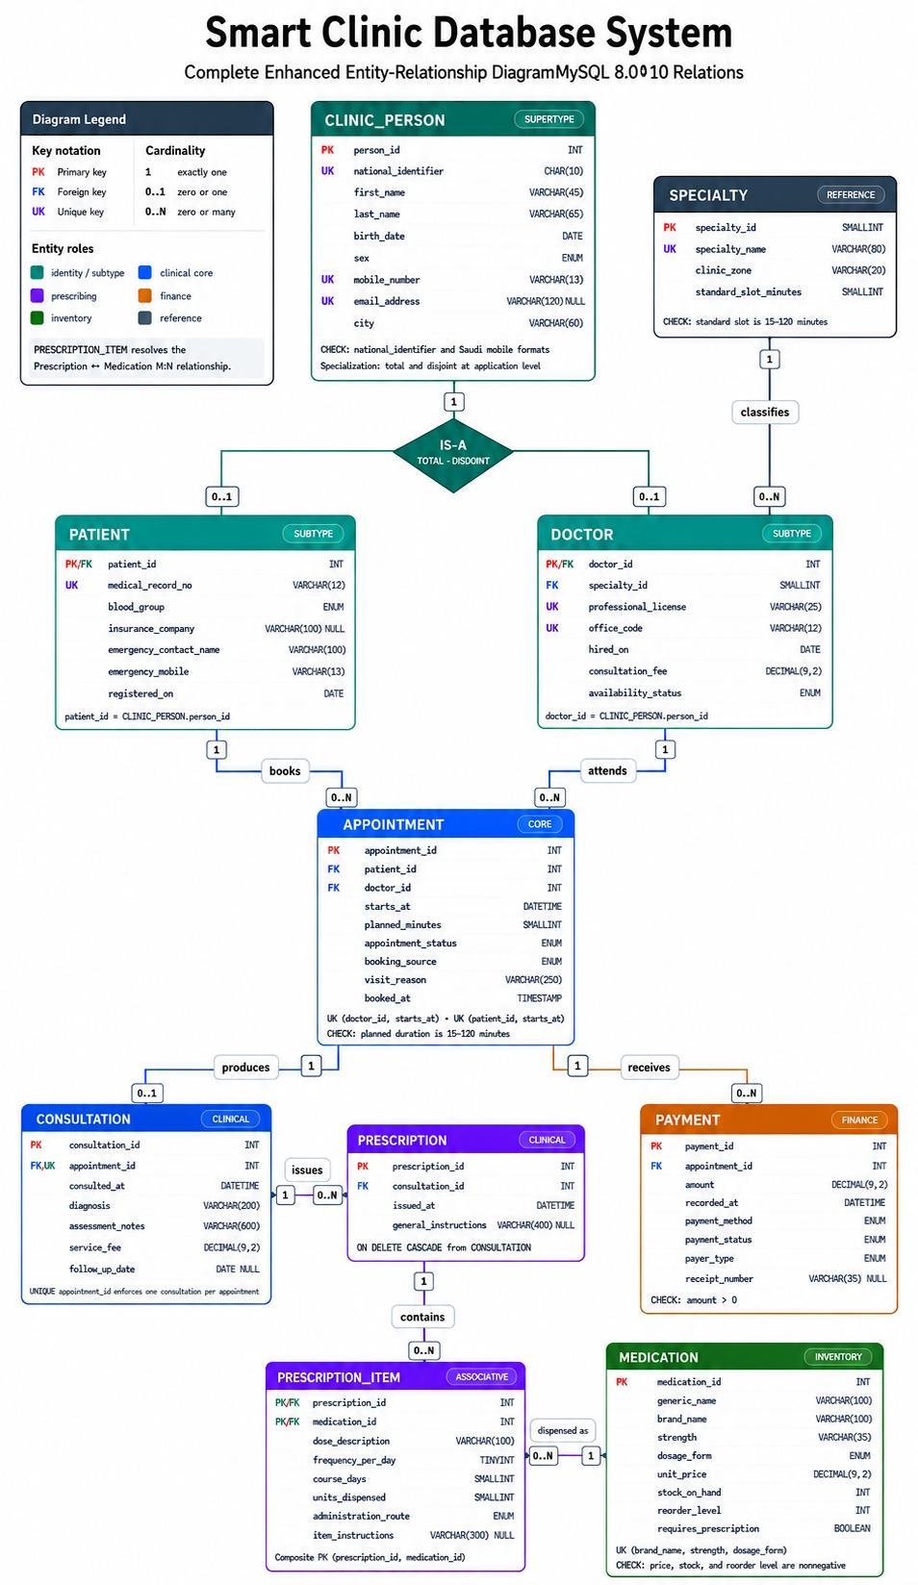
Figure 1. Complete Smart Clinic ER/EER diagram (diagrams/er_diagram.png).

Design Assumptions
- All personal, clinical, prescription, inventory, and payment records are fictional and used only for academic testing.
- The total and disjoint CLINIC_PERSON specialization is maintained by the application and verified sample data; each clinic person is assigned exactly one role.
- Every appointment references exactly one registered patient and one active or recorded doctor.
- An appointment can exist before a clinical outcome is recorded, but it can have no more than one consultation.
- A consultation can generate several prescription headers, and each prescription can contain several medication items.
- The composite primary key in PRESCRIPTION_ITEM prevents the same medication from being repeated in one prescription.
- Multiple payments are permitted for one appointment to support patient, insurance, and split-payment scenarios.
- Clinical and financial history uses restrictive parent deletion, while dependent prescription rows cascade when their clinical parent is removed.
- Doctor-time and patient-time unique constraints prevent duplicate bookings at the same start time.

Task 2 - Database Implementation
The conceptual design was translated into one repeatable MySQL script that creates the database, applies integrity constraints, inserts linked data, and provides verification statements for every table.

Implementation Environment
Item | Implementation
Database management system | MySQL 8.0 or newer
Development interface | MySQL Workbench
Database name | smart_clinic_system
Storage engine | InnoDB
Character set and collation | utf8mb4 / utf8mb4_0900_ai_ci
Implementation file | database/smart_clinic_database.sql

Data Types and Integrity Constraints
Constraint or Feature | Purpose in the Database
PRIMARY KEY | Uniquely identifies every entity and transaction; PRESCRIPTION_ITEM uses a composite primary key.
FOREIGN KEY | Preserves valid references between people, specialties, appointments, consultations, prescriptions, medications, and payments.
NOT NULL | Requires essential identity, clinical, scheduling, stock, and financial values.
UNIQUE | Prevents duplicate identifiers, contact values, licenses, offices, medical records, receipts, products, and appointment slots.
CHECK | Validates national/mobile formats, positive fees and amounts, valid stock, durations, frequencies, and dispensed units.
ENUM and BOOLEAN | Restricts controlled values such as status, source, method, payer, route, dosage form, sex, and availability.
CASCADE / RESTRICT | Balances dependent cleanup with protection of clinical and financial history.

Sample Data Population
Table | Rows | Population Summary
CLINIC_PERSON | 10 | Five patients and five doctors share the person supertype.
PATIENT | 5 | Five fictional Saudi-context patient profiles.
SPECIALTY | 5 | Family medicine, cardiology, dermatology, pediatrics, and dentistry.
DOCTOR | 5 | One doctor assigned to each specialty.
APPOINTMENT | 7 | Five completed, one booked, and one cancelled appointment.
CONSULTATION | 5 | One consultation for each completed appointment.
MEDICATION | 7 | Prescription and non-prescription products with stock controls.
PRESCRIPTION | 5 | One prescription for each recorded consultation in the sample.
PRESCRIPTION_ITEM | 7 | Dosage and course details linking prescriptions to medications.
PAYMENT | 7 | Paid and pending transactions from patients and insurers.

Execution Sequence
- Drop and recreate smart_clinic_system using utf8mb4.
- Create parent relations first: CLINIC_PERSON and SPECIALTY.
- Create PATIENT and DOCTOR, followed by APPOINTMENT and CONSULTATION.
- Create MEDICATION, PRESCRIPTION, PRESCRIPTION_ITEM, and PAYMENT in dependency order.
- Insert fictional sample data from parent relations to dependent relations inside a transaction.
- Commit the baseline dataset and run SHOW TABLES and ordered SELECT statements for verification.
- Create and test the reporting view and inventory trigger after the core data is available.
  - MySQL Workbench Evidence
The following MySQL Workbench screenshots verify the schema objects and every populated table. The original captures are retained without removing the lower taskbar area so the execution date and time remain visible.
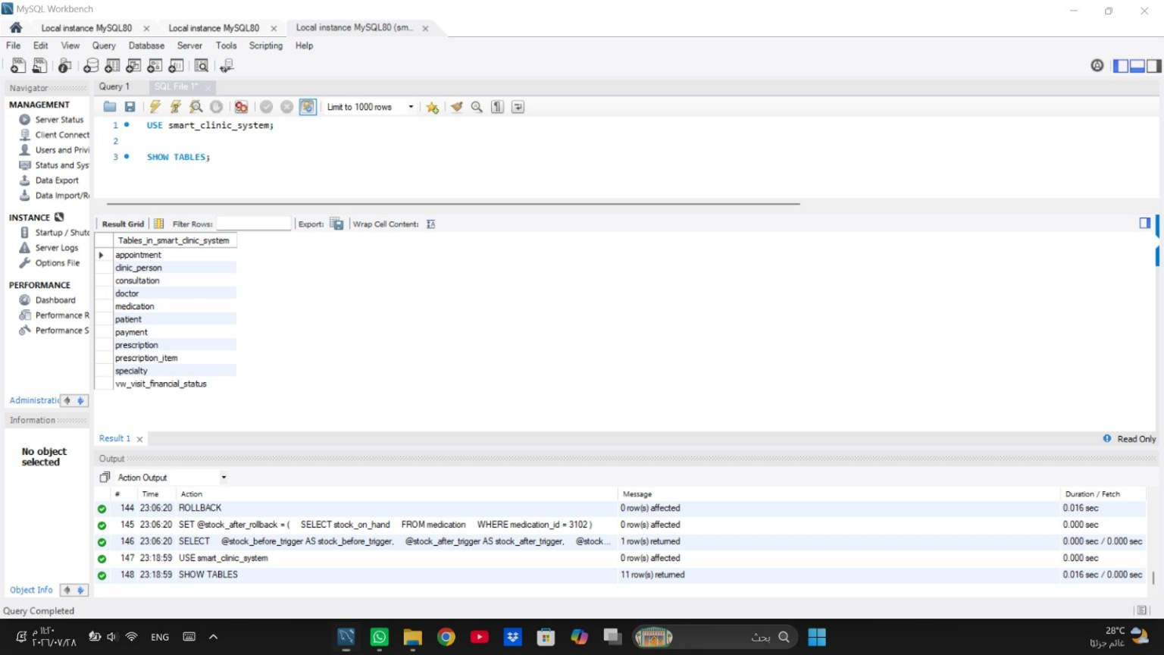
Figure 2.1. Database inventory showing 10 tables and vw_visit_financial_status.
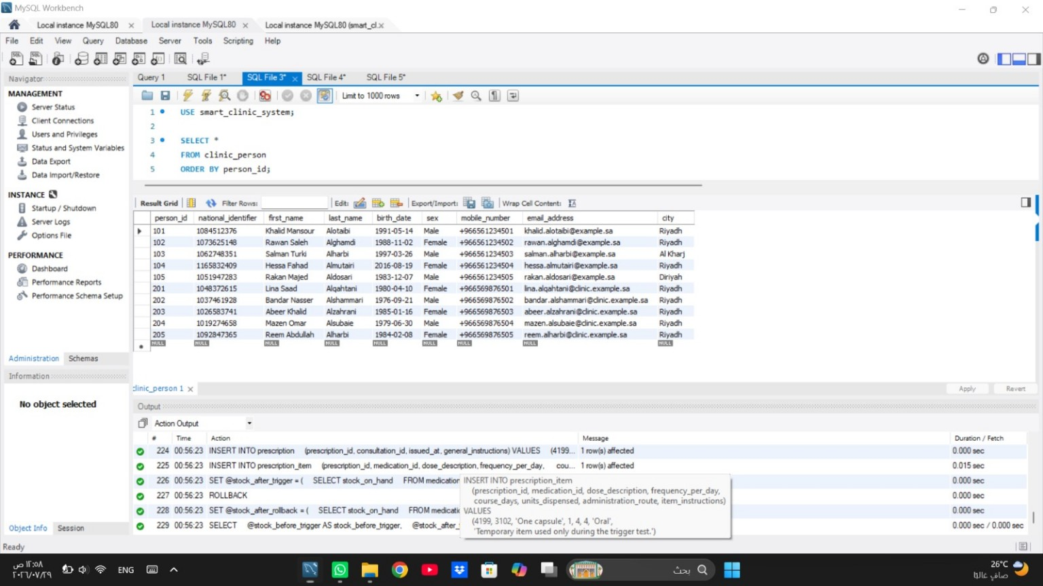
Figure 2.2. CLINIC_PERSON table containing 10 records.
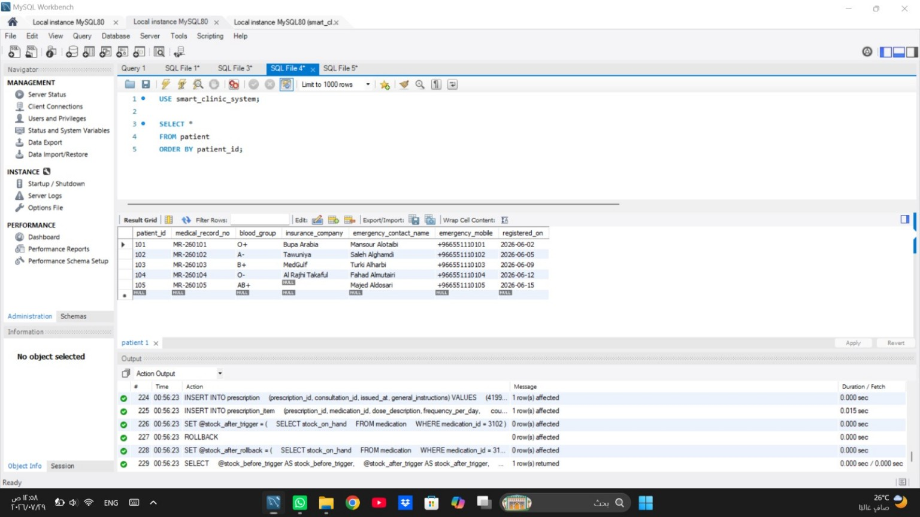
Figure 2.3. PATIENT table containing 5 records.
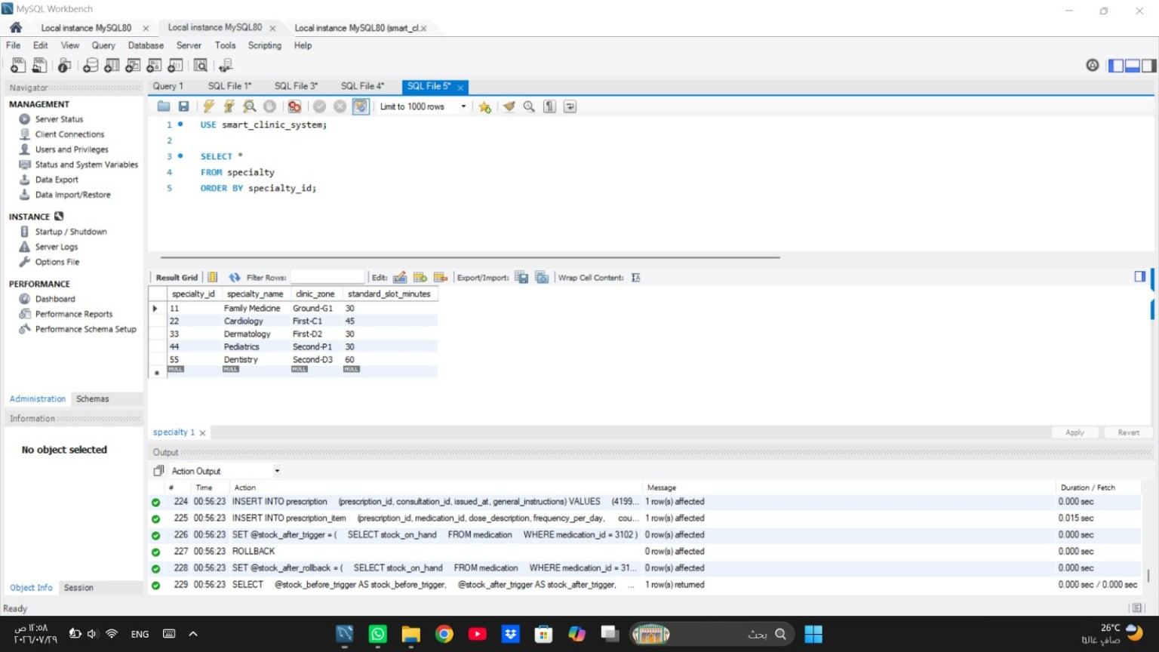
Figure 2.4. SPECIALTY table containing 5 records.
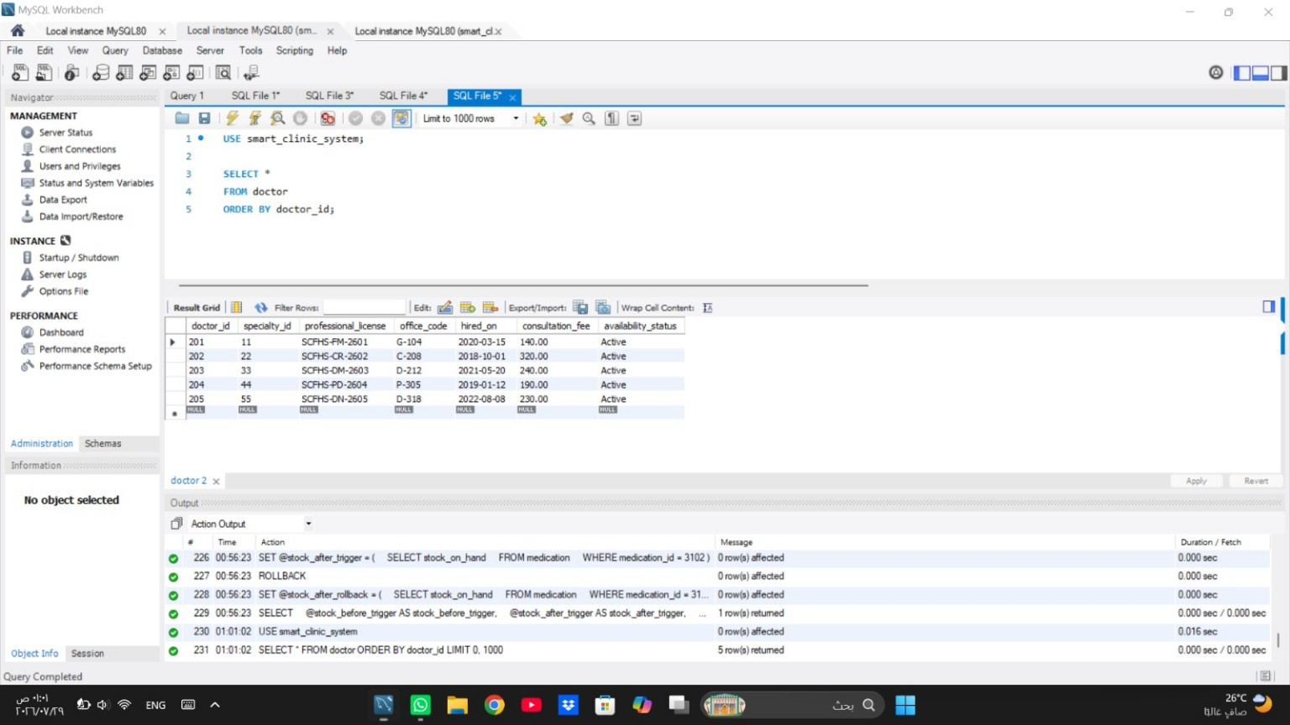
Figure 2.5. DOCTOR table containing 5 records.
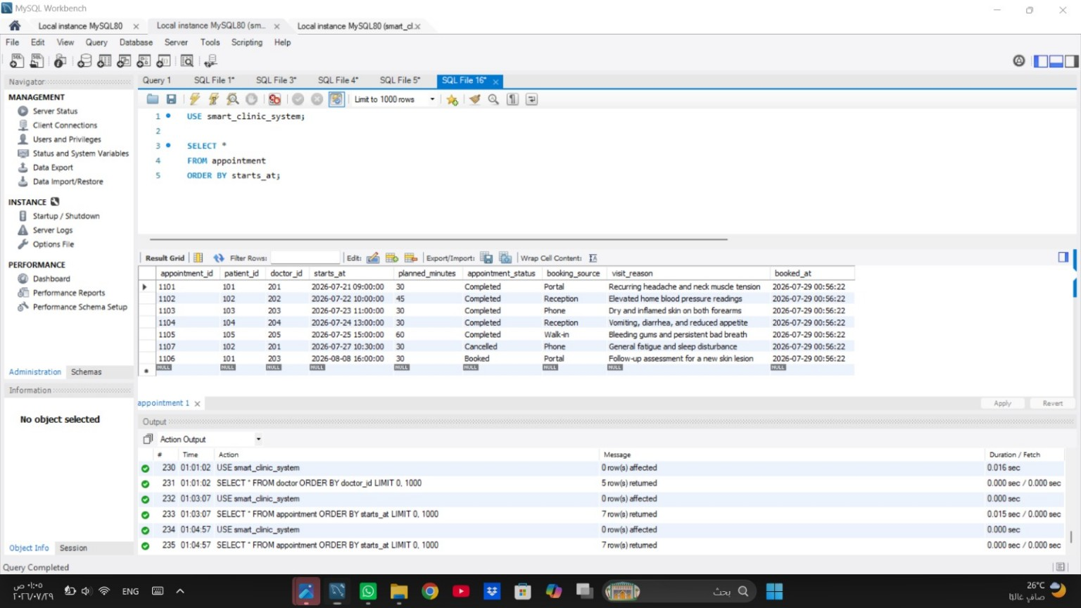
Figure 2.6. APPOINTMENT table containing 7 records.
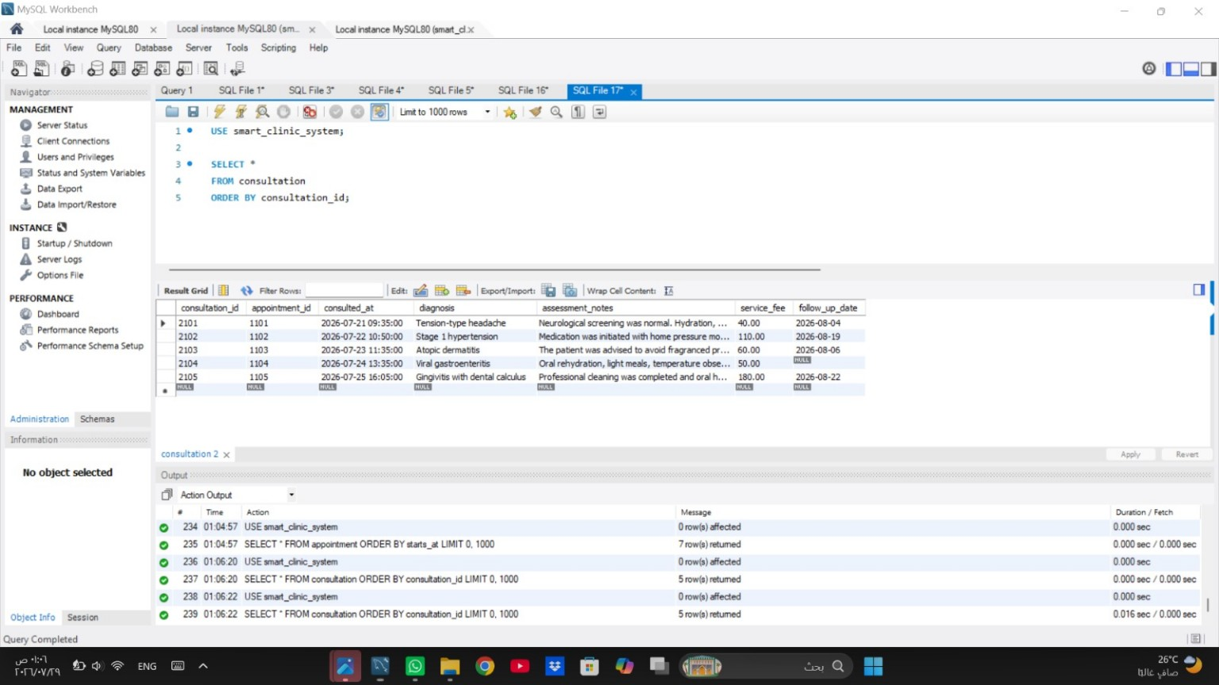
Figure 2.7. CONSULTATION table containing 5 records.
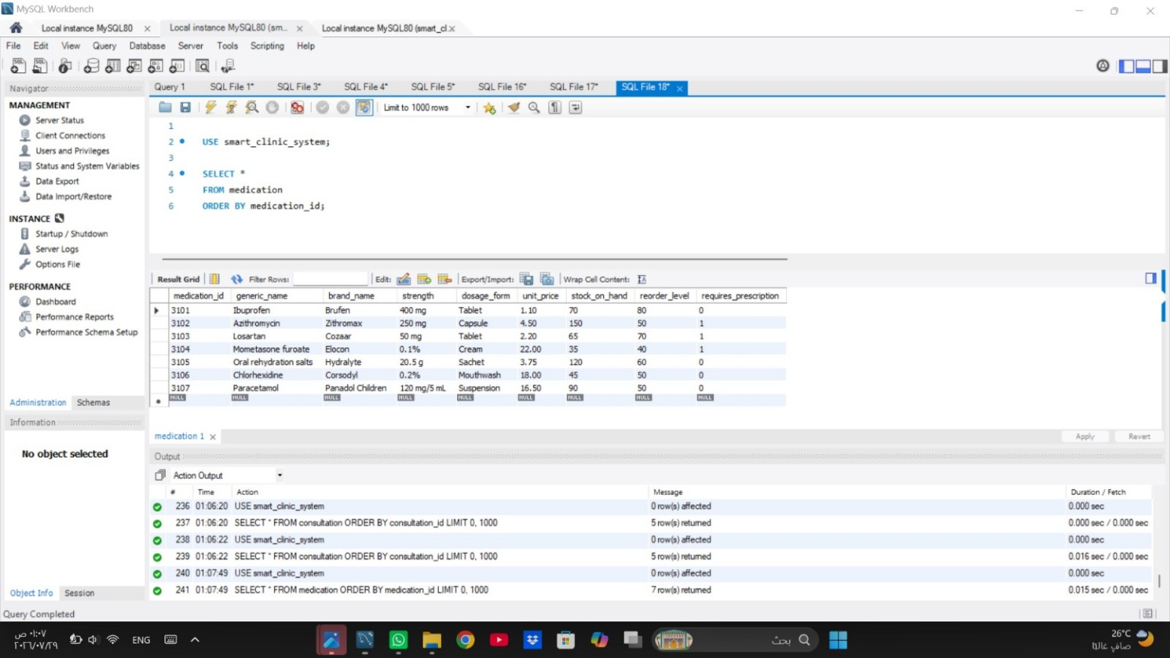
Figure 2.8. MEDICATION table containing 7 records.
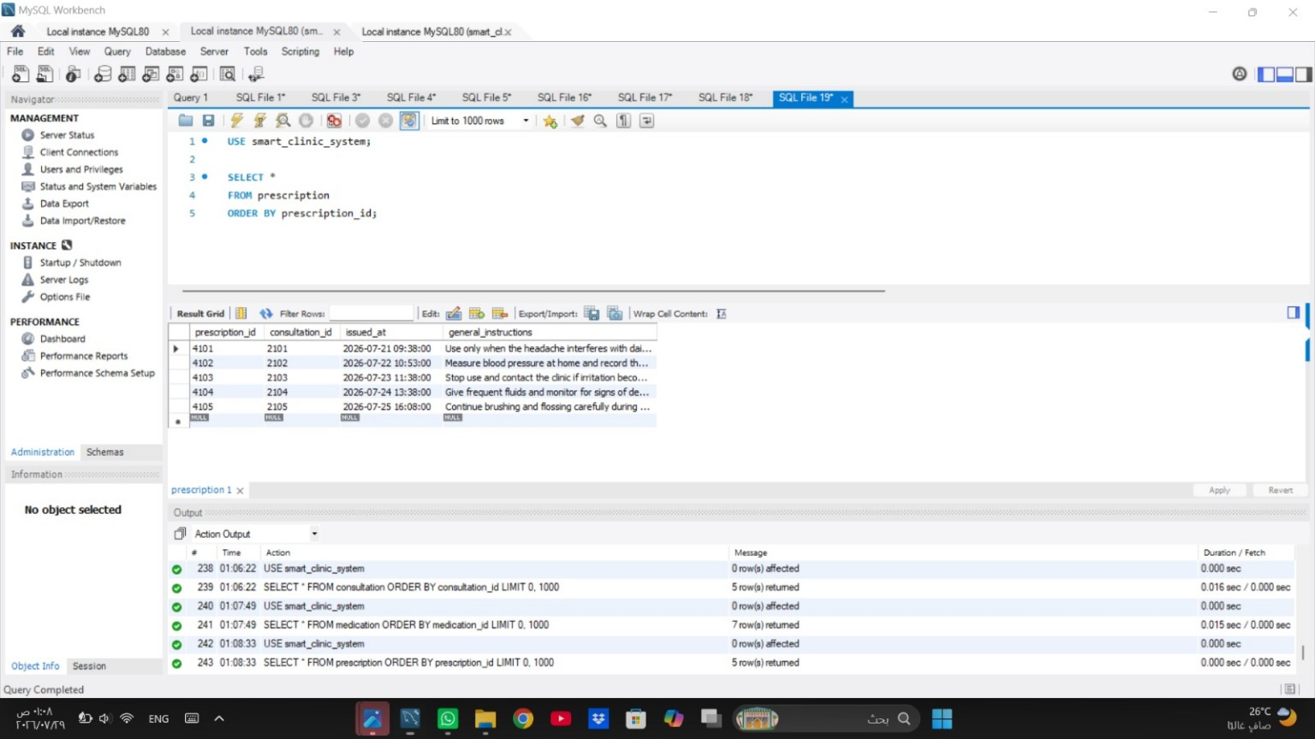
Figure 2.9. PRESCRIPTION table containing 5 records.
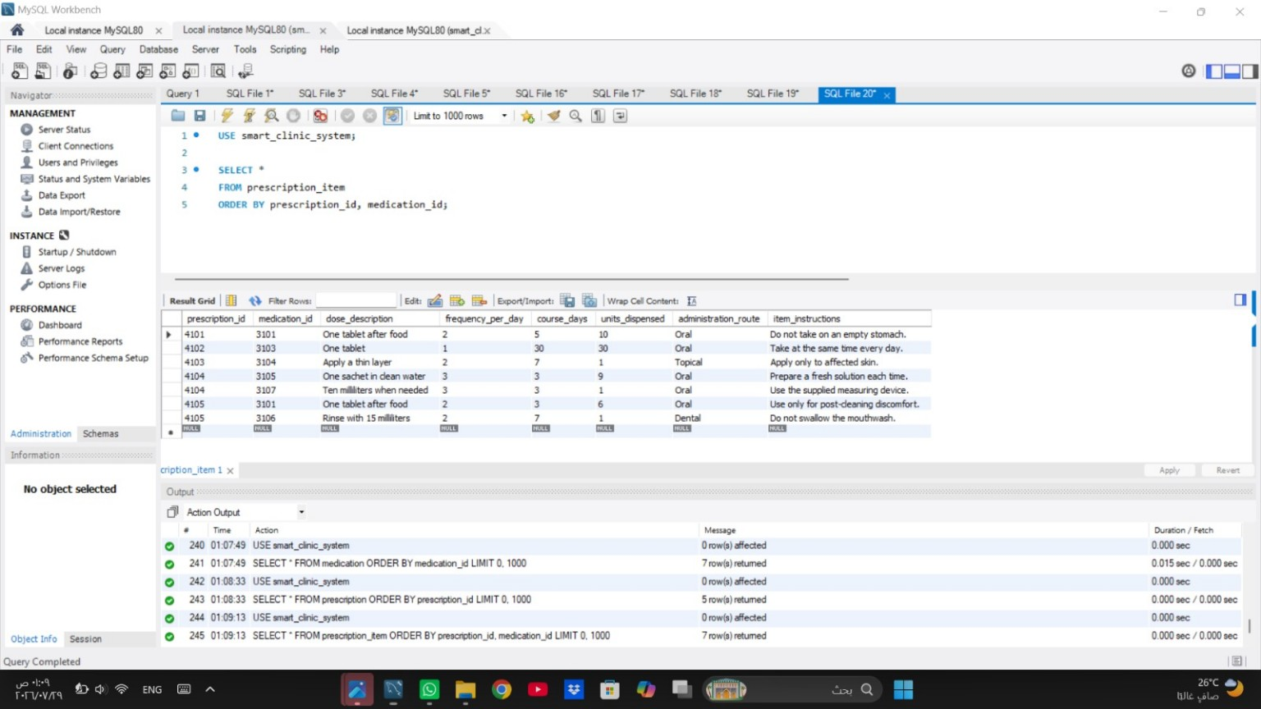
Figure 2.10. PRESCRIPTION_ITEM table containing 7 records.
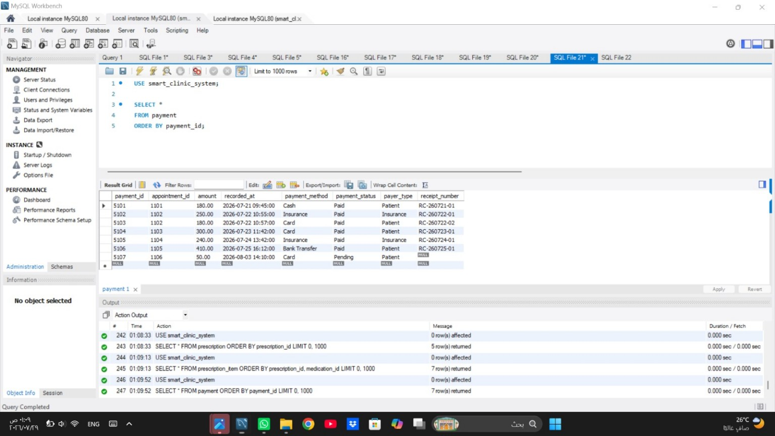
Figure 2.11. PAYMENT table containing 7 records.

Task 3 - SQL Operations
Each assessed operation was executed in MySQL Workbench and paired with readable code-and-result evidence. UPDATE, DELETE, and TRIGGER tests use transactions and ROLLBACK so the verified baseline data remains unchanged.

Verified Result Summary
Operation | Verified MySQL Result
SELECT - completed visits | 5 completed appointments.
SELECT - stock monitoring | 4 medications at or below their reorder levels.
JOIN - appointment details | 7 appointment rows with patient, doctor, specialty, and status.
JOIN - patient prescriptions | 7 rows linking patients, diagnoses, medication, dosage, and route.
Nested query | Patients 102 and 105 are above the average total paid per paying patient.
GROUP BY | 5 doctor summary rows.
UPDATE | No insurance → Arabian Shield Cooperative → No insurance.
DELETE | Rows before/deleted/after deletion/after rollback = 1 / 1 / 0 / 1.
VIEW | 7 visit-level financial rows.
TRIGGER | Medication stock = 150 → 146 → 150 after rollback.

SELECT Statements
The first SELECT produces the completed-visit register in chronological order. The second identifies products that have reached or fallen below the defined reorder threshold.
USE smart_clinic_system;

SELECT
appointment_id,
starts_at,
planned_minutes,
booking_source,
visit_reason
FROM appointment
WHERE appointment_status = 'Completed'
ORDER BY starts_at;

USE smart_clinic_system;

SELECT
medication_id,
brand_name,
strength,
stock_on_hand,
reorder_level,
(reorder_level - stock_on_hand) AS units_below_target
FROM medication
WHERE stock_on_hand <= reorder_level
ORDER BY stock_on_hand, brand_name;
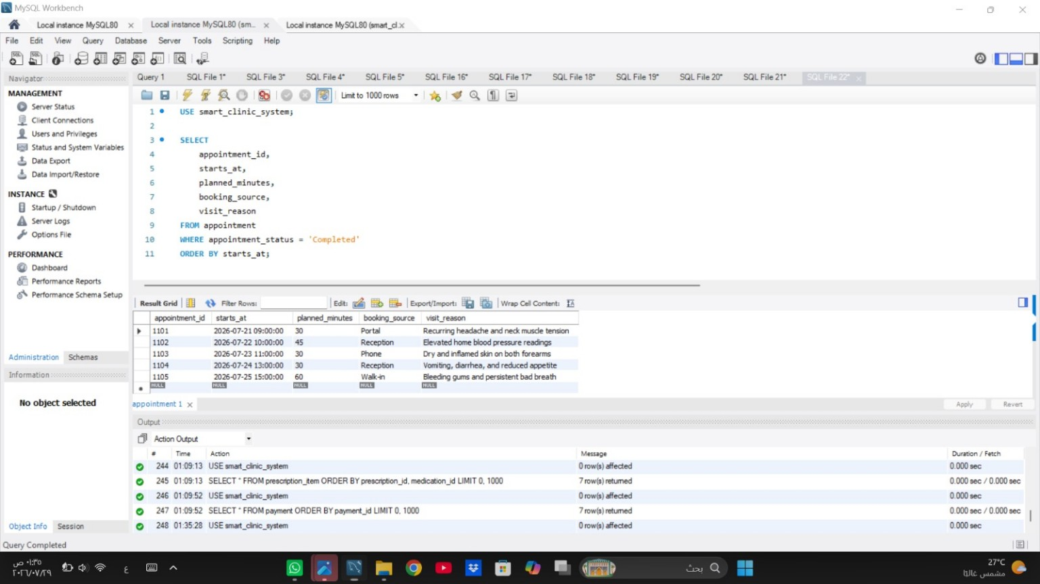
Figure 3.1. Completed appointments SELECT result: 5 rows.
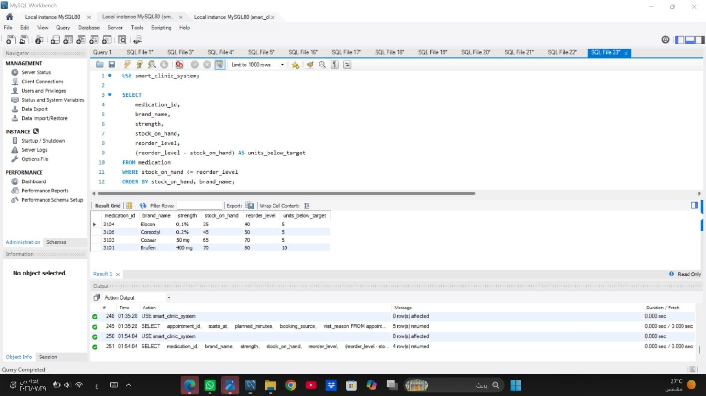Figure 3.2. Low-stock medications SELECT result: 4 rows.
The results support both clinical visit tracking and inventory replenishment decisions.

JOIN Query - Appointment Details
This query combines six relations to present each appointment with readable patient and doctor names, the doctor's specialty, time, and status.
USE smart_clinic_system;

SELECT
a.appointment_id,
a.starts_at,
CONCAT(pp.first_name, ' ', pp.last_name) AS patient_name,
CONCAT(dp.first_name, ' ', dp.last_name) AS doctor_name,
s.specialty_name,
a.appointment_status
FROM appointment AS a
JOIN patient AS p
ON p.patient_id = a.patient_id
JOIN clinic_person AS pp
ON pp.person_id = p.patient_id
JOIN doctor AS d
ON d.doctor_id = a.doctor_id
JOIN clinic_person AS dp
ON dp.person_id = d.doctor_id
JOIN specialty AS s
ON s.specialty_id = d.specialty_id
ORDER BY a.starts_at;
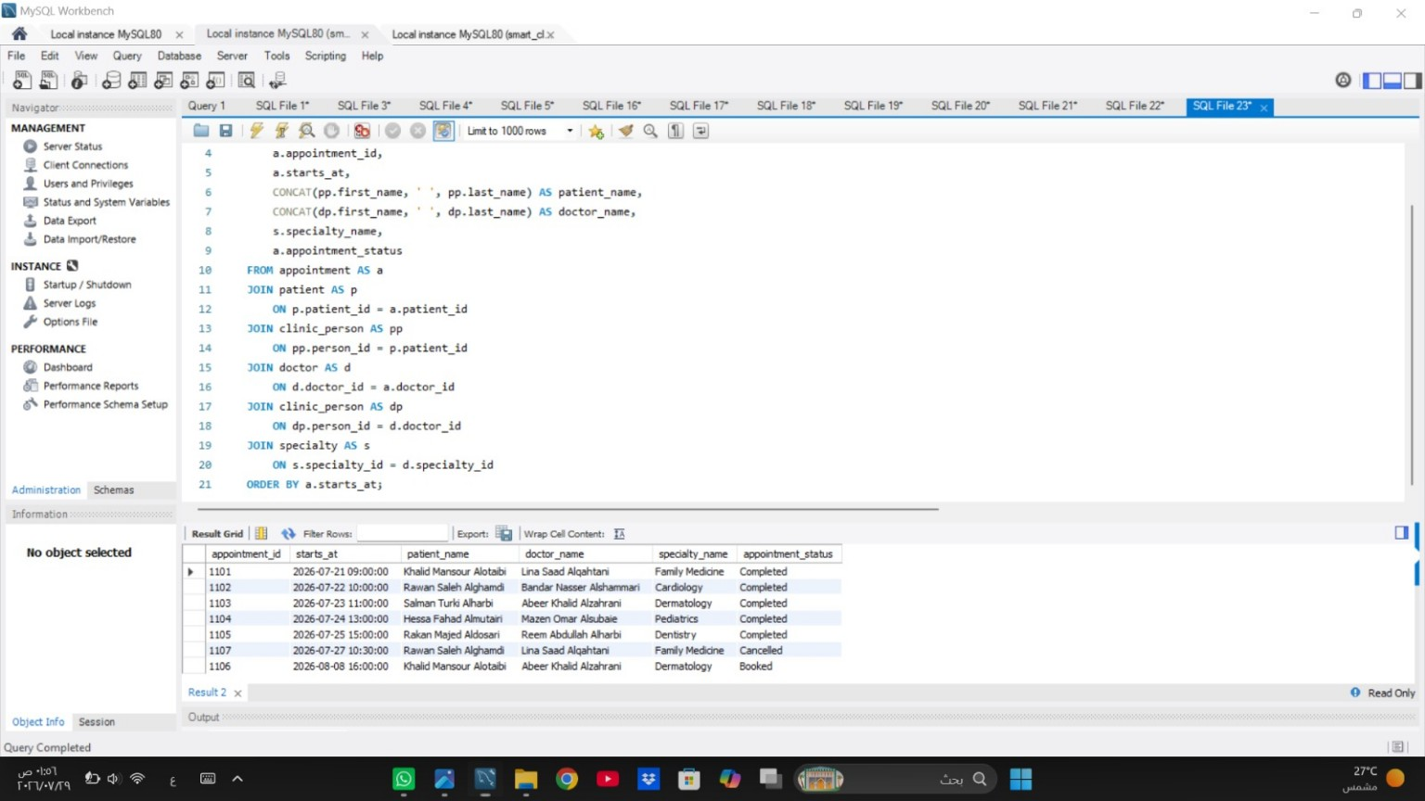
Figure 3.3. Appointment details JOIN result: 7 rows.
All seven appointments are returned without duplicating appointment identifiers.

  - JOIN Query - Patient Prescriptions
This query follows the clinical path from patient to appointment, consultation, prescription, prescription item, and medication so each issued treatment can be interpreted in context.
USE smart_clinic_system;

SELECT
pat.medical_record_no,
CONCAT(cp.first_name, ' ', cp.last_name) AS patient_name,
c.diagnosis,
m.brand_name AS medication,
m.strength,
pi.dose_description,
pi.frequency_per_day,
pi.course_days,
pi.administration_route
FROM patient AS pat
JOIN clinic_person AS cp
ON cp.person_id = pat.patient_id
JOIN appointment AS a
ON a.patient_id = pat.patient_id
JOIN consultation AS c
ON c.appointment_id = a.appointment_id
JOIN prescription AS pr
ON pr.consultation_id = c.consultation_id
JOIN prescription_item AS pi
ON pi.prescription_id = pr.prescription_id
JOIN medication AS m
ON m.medication_id = pi.medication_id
ORDER BY patient_name, medication;
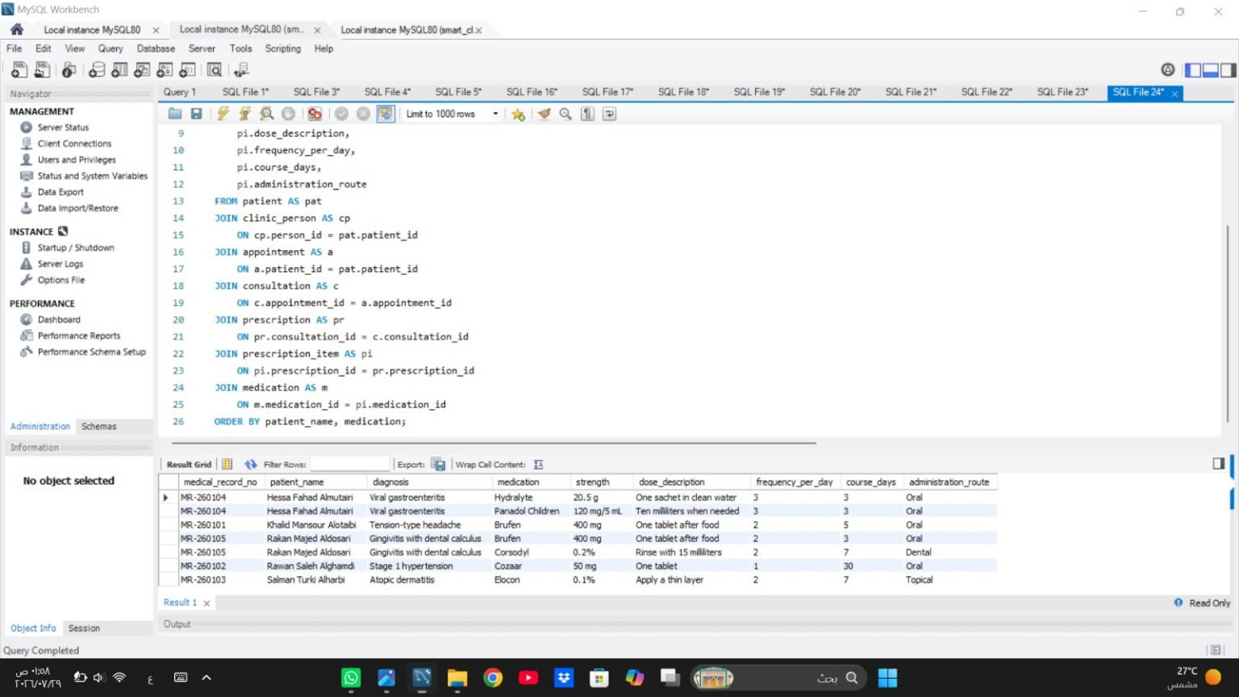
Figure 3.4. Patient prescriptions JOIN result: 7 rows.
The result contains seven prescribed medication items with their diagnosis, strength, dose, frequency, duration, and route.

  - Nested Query
The nested query first calculates each paying patient's completed payment total, then compares the outer patient total with the average of those grouped totals rather than with the average individual payment.
USE smart_clinic_system;
SELECT
pat.patient_id,
pat.medical_record_no,
CONCAT(cp.first_name, ' ', cp.last_name) AS patient_name,
SUM(pay.amount) AS patient_paid_total
FROM patient AS pat
JOIN clinic_person AS cp
ON cp.person_id = pat.patient_id
JOIN appointment AS a
ON a.patient_id = pat.patient_id
JOIN payment AS pay
ON pay.appointment_id = a.appointment_id
WHERE pay.payment_status = 'Paid'
GROUP BY pat.patient_id, pat.medical_record_no,
cp.first_name, cp.last_name
HAVING SUM(pay.amount) > (
SELECT AVG(patient_total)
FROM (
SELECT
a2.patient_id,
SUM(pay2.amount) AS patient_total
FROM appointment AS a2
JOIN payment AS pay2
ON pay2.appointment_id = a2.appointment_id
WHERE pay2.payment_status = 'Paid'
GROUP BY a2.patient_id
) AS paid_by_patient
)
ORDER BY patient_paid_total DESC;
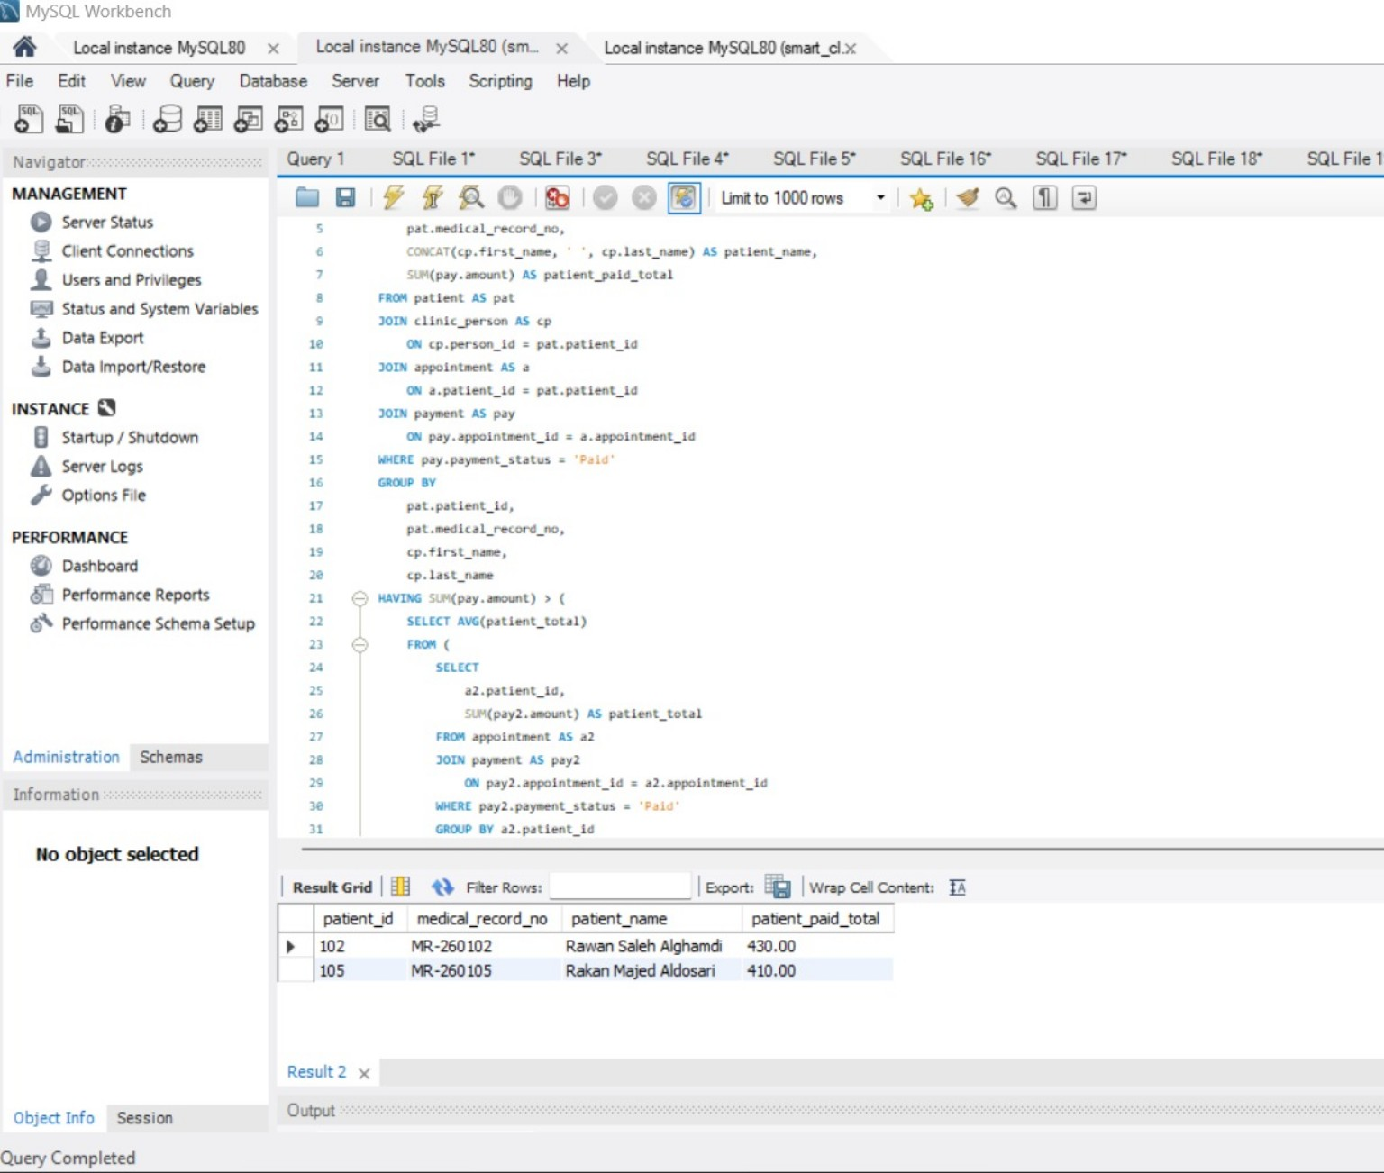
Figure 3.5. Nested query result: patient IDs 102 and 105.
  - Aggregate Functions with GROUP BY
The aggregate query summarizes each doctor's bookings, completed visits, average completed-visit duration, visit charges, and collected amount. Payments are aggregated by appointment before the main join to prevent duplicated totals.
USE smart_clinic_system;

SELECT
d.doctor_id,
CONCAT(cp.first_name, ' ', cp.last_name) AS doctor_name,
s.specialty_name,
COUNT(a.appointment_id) AS total_bookings,
SUM(CASE WHEN a.appointment_status = 'Completed'
THEN 1 ELSE 0 END) AS completed_visits,
ROUND(AVG(CASE WHEN a.appointment_status = 'Completed'
THEN a.planned_minutes END), 2)
AS average_completed_minutes,
COALESCE(SUM(CASE WHEN a.appointment_status = 'Completed'
THEN d.consultation_fee + COALESCE(c.service_fee, 0)
ELSE 0 END), 0.00)
AS completed_visit_charges,
COALESCE(SUM(pt.net_paid), 0.00) AS net_collected
FROM doctor AS d
JOIN clinic_person AS cp
ON cp.person_id = d.doctor_id
JOIN specialty AS s
ON s.specialty_id = d.specialty_id
LEFT JOIN appointment AS a
ON a.doctor_id = d.doctor_id
LEFT JOIN consultation AS c
ON c.appointment_id = a.appointment_id
LEFT JOIN (
SELECT
appointment_id,
SUM(CASE
WHEN payment_status = 'Paid' THEN amount
WHEN payment_status = 'Refunded' THEN -amount
ELSE 0
END) AS net_paid
FROM payment
GROUP BY appointment_id
) AS pt
ON pt.appointment_id = a.appointment_id
GROUP BY d.doctor_id, cp.first_name, cp.last_name, s.specialty_name
ORDER BY completed_visits DESC, doctor_name;

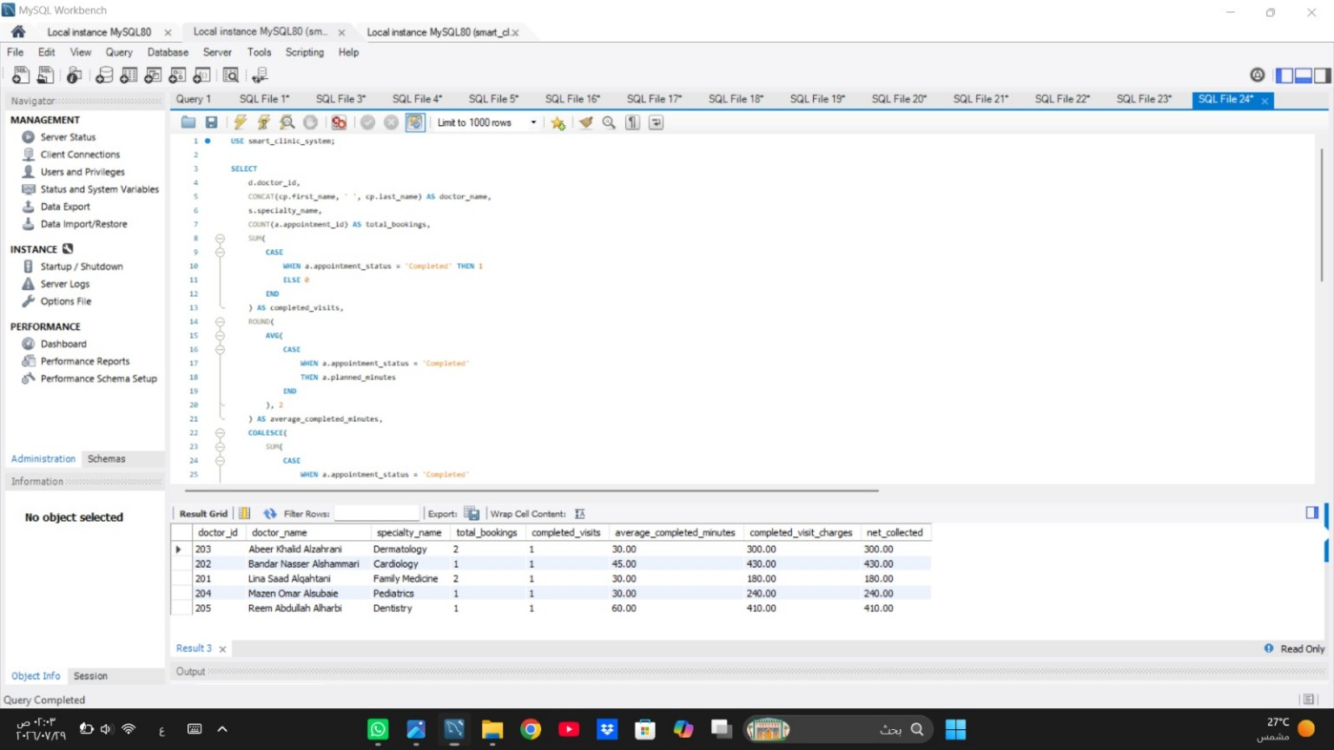
Figure 3.6A. Doctor GROUP BY evidence - Part A.
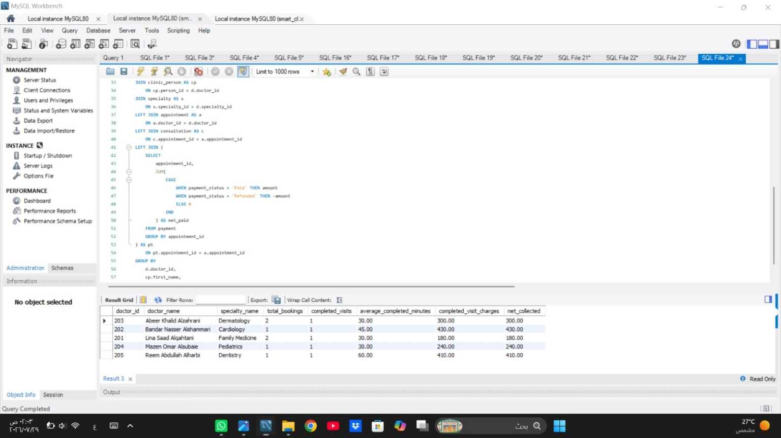
Figure 3.6B. Doctor GROUP BY evidence - Part B and 5-row result.
The final output contains one verified summary row for each of the
five doctors.

3.7 UPDATE Statement and Rollback Verification
The UPDATE test temporarily adds an insurance company to patient 105. Variables capture the value before and after the change, while ROLLBACK restores the original record.
USE smart_clinic_system;

SET @insurance_before = (
SELECT COALESCE(insurance_company, 'No insurance')
FROM patient
WHERE patient_id = 105
);

START TRANSACTION;

UPDATE patient
SET insurance_company = 'Arabian Shield Cooperative'
WHERE patient_id = 105;

SET @insurance_after = (
SELECT insurance_company
FROM patient
WHERE patient_id = 105
);

ROLLBACK;

SELECT
105 AS patient_id,
@insurance_before AS insurance_before_update,
@insurance_after AS insurance_after_update,
COALESCE((SELECT insurance_company
FROM patient
WHERE patient_id = 105),
'No insurance') AS insurance_after_rollback;
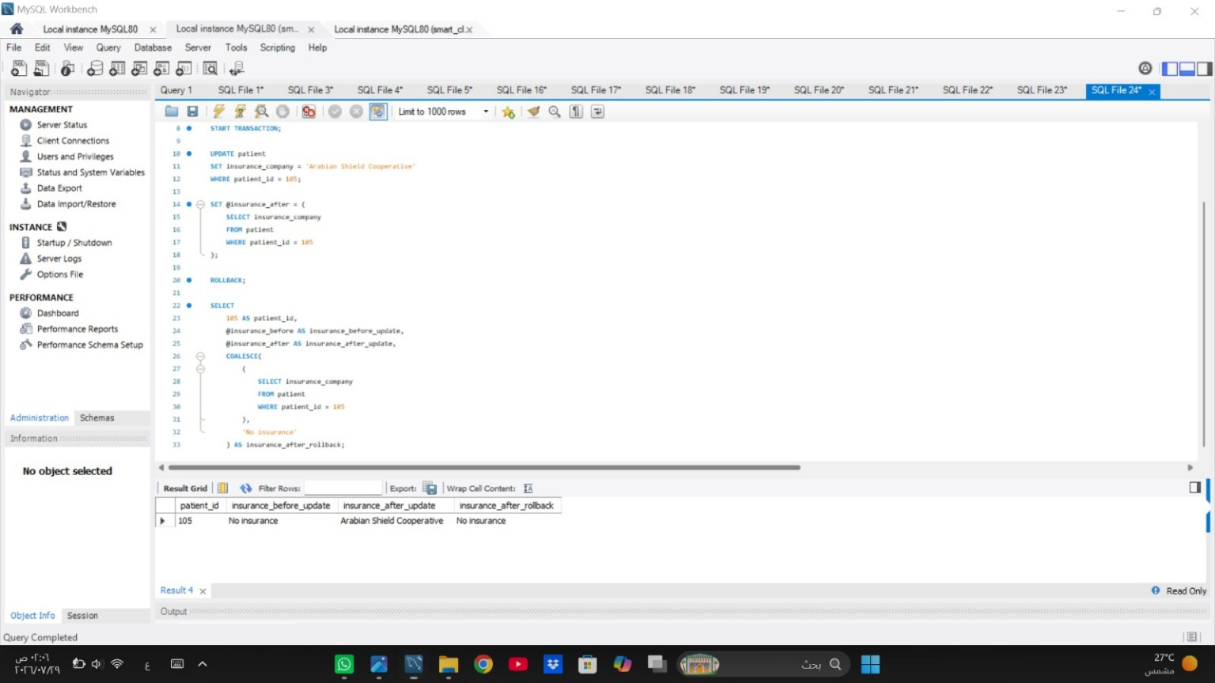
Figure 3.7. UPDATE verification: No insurance → Arabian Shield Cooperative → No insurance.
The one-row verification confirms both the temporary change and successful restoration.

3.8 DELETE Statement and Rollback Verification
The DELETE test removes pending payment 5107 inside a transaction, records the affected-row count, and restores the row with ROLLBACK.
USE smart_clinic_system;
SET @rows_before_delete = (
SELECT COUNT(*)
FROM payment
WHERE payment_id = 5107
);

START TRANSACTION;

DELETE FROM payment
WHERE payment_id = 5107
AND payment_status = 'Pending';

SET @deleted_rows = ROW_COUNT();

SET @rows_after_delete = (
SELECT COUNT(*)
FROM payment
WHERE payment_id = 5107
);

ROLLBACK;

SET @rows_after_rollback = (
SELECT COUNT(*)
FROM payment
WHERE payment_id = 5107
);

SELECT
@rows_before_delete AS rows_before_delete,
@deleted_rows AS deleted_rows,
@rows_after_delete AS rows_after_delete,
@rows_after_rollback AS rows_after_rollback;
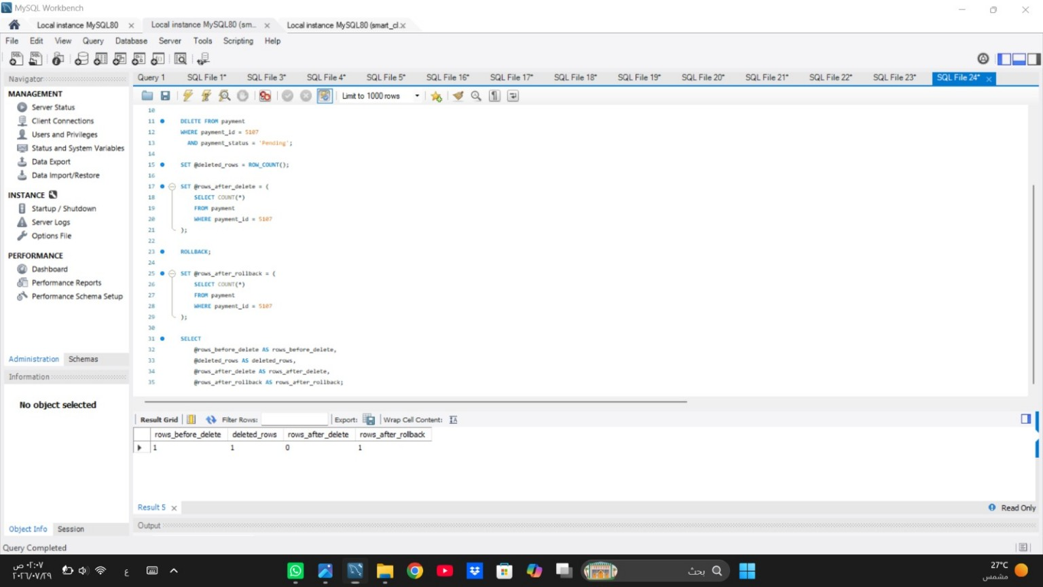
Figure 3.8. DELETE verification result: 1 | 1 | 0 | 1.
The sequence proves that one row existed, one row was deleted, zero remained before rollback, and one row existed again afterward.

3.9 VIEW Result
The reusable vw_visit_financial_status view combines scheduling, patient, doctor, specialty, consultation, and payment information and calculates expected charges, net payments, and outstanding balances.

USE smart_clinic_system;

SELECT *
FROM vw_visit_financial_status
ORDER BY starts_at;

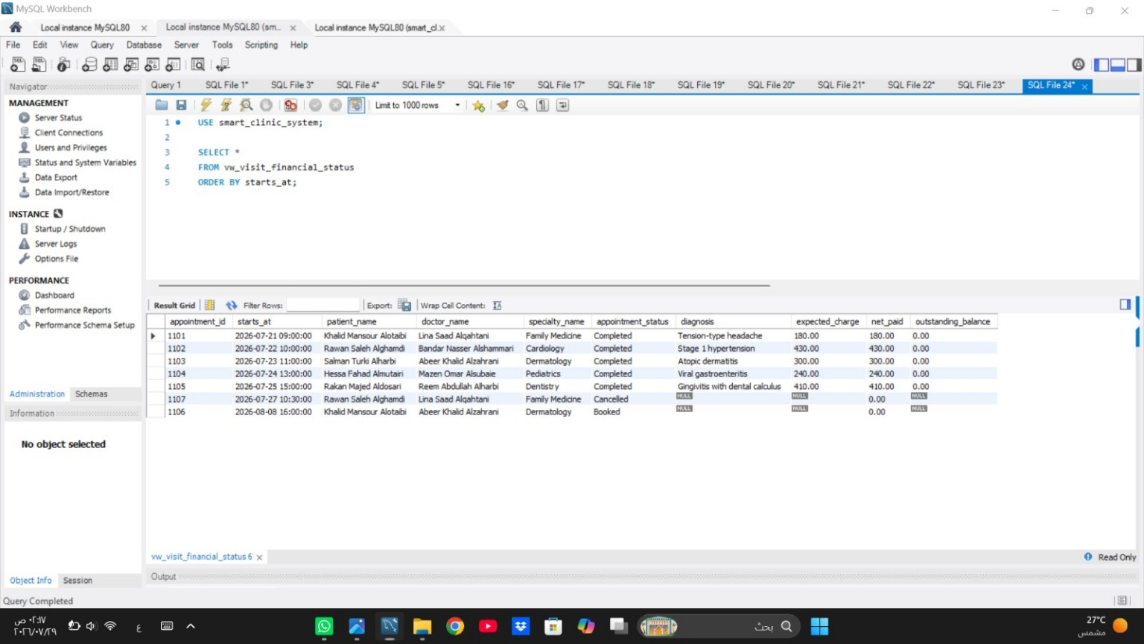
Figure 3.9. vw_visit_financial_status result: 7 appointment rows.
The view returns one financial summary row for every appointment, including appointments without a consultation.

3.10 TRIGGER Creation and Stock-Control Test
The BEFORE INSERT trigger checks medication availability, rejects excessive quantities, and deducts the units dispensed. A temporary prescription item tests the stock change inside a reversible transaction.

USE smart_clinic_system;

SET @stock_before_trigger = (
SELECT stock_on_hand
FROM medication
WHERE medication_id = 3102
);

START TRANSACTION;

INSERT INTO prescription
(prescription_id, consultation_id, issued_at, general_instructions)
VALUES
(4199, 2104, '2026-07-24 13:45:00',
'Temporary prescription used to test the trigger.');

INSERT INTO prescription_item
(prescription_id, medication_id, dose_description,
frequency_per_day, course_days, units_dispensed,
administration_route, item_instructions)
VALUES
(4199, 3102, 'One capsule', 1, 4, 4,
'Oral', 'Temporary trigger test.');

SET @stock_after_trigger = (
SELECT stock_on_hand
FROM medication
WHERE medication_id = 3102
);

ROLLBACK;

SET @stock_after_rollback = (
SELECT stock_on_hand
FROM medication
WHERE medication_id = 3102
);

SELECT
@stock_before_trigger AS stock_before_trigger,
@stock_after_trigger AS stock_after_trigger,
@stock_after_rollback AS stock_after_rollback;
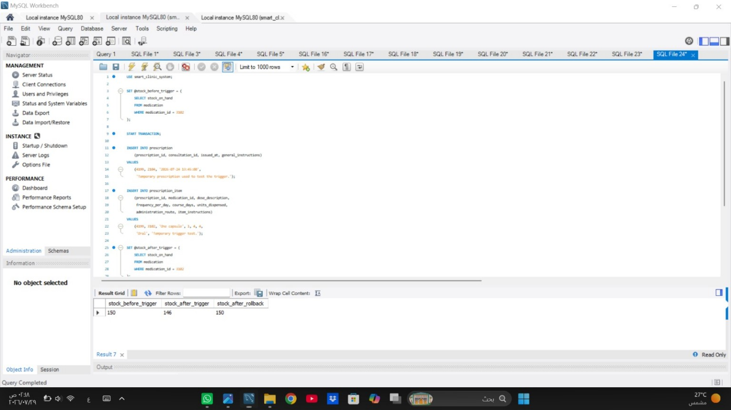
Figure 3.10A. TRIGGER test code - Part A.
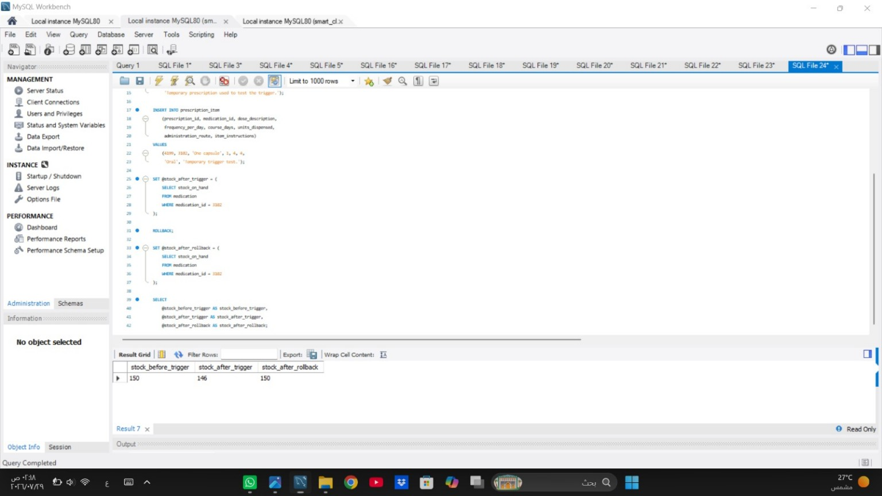
Figure 3.10B. TRIGGER result: stock 150 → 146 → 150 after rollback.
The stock sequence confirms the trigger deduction and the final rollback restoration.

4. Task 4 – Project Reflection
Developing the Smart Clinic Database System gave us a practical opportunity to connect database-design concepts with a realistic clinic workflow. Our most important shared challenge was keeping the EER diagram, relational schema, MySQL implementation, test operations, and screenshot evidence consistent. We identified this issue during review when small differences appeared between the diagram and the script, including attribute lengths, one renamed field, a missing unique-key marker, and unclear cardinality labels. We resolved it by creating a table-by-table checklist, comparing every attribute and relationship with the executable SQL file, correcting the diagram, rerunning the relevant queries, and reviewing each screenshot against its intended requirement.
Sultan Aljohani: As Group Leader and Repository Manager, Sultan coordinated milestones, organized the repository structure, integrated the project files, and completed Task 1. He selected CLINIC_PERSON as a shared supertype specialized into PATIENT and DOCTOR. The alternative was to repeat identity and contact attributes in both subtype tables. Although the selected model requires additional joins when displaying complete records, it reduces redundancy, supports consistent updates, and demonstrates the required total and disjoint specialization. He also reviewed keys, assumptions, relationship directions, and diagram-to-schema consistency.
Amjad Najmi: Amjad implemented the ten MySQL tables, data types, keys, constraints, and linked fictional records for Task 2. His main implementation challenge was satisfying foreign-key dependencies while keeping the sample data realistic. He addressed it by creating and populating parent relations before dependent clinical and financial relations, then checking the populated rows in MySQL Workbench. UNIQUE and CHECK constraints were used to detect duplicated identifiers, invalid appointment durations, incorrect Saudi mobile formats, and negative financial or stock values early.
Abdulaziz Alharbi: Abdulaziz completed Task 3 by preparing and testing the SELECT, JOIN, nested, GROUP BY, UPDATE, DELETE, VIEW, and TRIGGER operations. Because data-changing tests could damage the baseline dataset, he chose transaction-based testing with START TRANSACTION and ROLLBACK instead of permanently changing and manually restoring rows. This approach added several verification steps, but it produced repeatable evidence. The final results confirmed the DELETE sequence 1 to 0 to 1 and the trigger stock sequence 150 to 146 to 150.
ChatGPT was used in a limited supporting role for brainstorming document structure, reviewing grammar, and suggesting SQL syntax during troubleshooting. We did not accept its output automatically. Every table definition, query, diagram correction, and result was compared with the project requirements, executed in MySQL Workbench, and modified when the evidence did not match.
If we repeated the project with more time, we would prepare an automated test checklist before implementation, capture evidence during the first verified execution, test the script on more than one MySQL environment, and add stored procedures or audit logging for common clinic operations.

5. Project Artifacts
The following entries provide the final report location, repository, implementation files, diagram sources, and MySQL evidence used for the completed project.
Artifact | Final Entry
Live Report Folder | https://drive.google.com/drive/folders/1arzRO-tMa9YdED1HLBBBPtQnomPO1jSw
GitHub Repository | https://github.com/Database-project-lgtm/Smart-Clinical-Database-System
Complete SQL Script | database/smart_clinic_database.sql
Final EER Diagram | diagrams/er_diagram.png
Editable Diagram Source | diagrams/er_diagram_source.drawio
MySQL Workbench Evidence | evidence/screenshots/ (23 JPG files)
Evidence Index | evidence/Screenshot_Evidence_Index.md

6. Appendix A - Mid-Project Progress Report

SMART CLINIC DATABASE SYSTEM
Mid-Project Progress Report
Stage 1: Database Design and Initial Implementation
Reporting Point: End of Stage 1 - before Task 3
Table 1. Team Members and Primary Contributions
Student Name | ID | Primary Contribution
Sultan Aljohani | 240035689 | Group Leader and Repository Manager,  Task 1: Database Design
Amjad Najmi | 240020509 | Task 2: Database Implementation
Abdulaziz Alharbi | 250021379 | Task 3: SQL Operations

Progress Summary
At this reporting point, the project has reached the end of Stage 1. The team has defined the system scope, allocated responsibilities, completed the database design, and prepared the core MySQL implementation for validation. The design maps ten related tables and includes the required EER specialization, integrity constraints, and fictional Saudi-context data. Full MySQL Workbench verification, Task 2 screenshot evidence, Task 3 SQL operations, and the Project Reflection remain scheduled for the next stage.

Midpoint Progress Status
Table 2. Stage 1 Workstream Status
Workstream | Status | Evidence / Expected Output
Project planning and responsibility allocation | Completed | Contribution record, approved repository structure, and delivery plan.
Task 1  Database Design | Completed and reviewed | Ten-relation EER model, relational schema, keys, cardinalities, assumptions, and business rules.
Task 2  Core Implementation | Prepared for validation | MySQL database setup, ten CREATE TABLE statements, constraints, and fictional sample data.
Task 2  Workbench Evidence | Planned for  next stage | Successful execution, populated-table results, and readable screenshots.
Task 3  SQL Operations | Planned for  next stage | SELECT, JOIN, nested query, GROUP BY, UPDATE, DELETE, VIEW, and TRIGGER.
Task 4  Project Reflection | Planned for  next stage | Write Reflection after all technical work and evidence are complete.

Work Completed the Midpoint
- Defined ten connected relations: CLINIC_PERSON, PATIENT, SPECIALTY, DOCTOR, APPOINTMENT, CONSULTATION, MEDICATION, PRESCRIPTION, PRESCRIPTION_ITEM, and PAYMENT.
- Modeled CLINIC_PERSON as the supertype and PATIENT and DOCTOR as total, disjoint subtypes.
- Specified primary keys, foreign keys, unique keys, CHECK constraints, and controlled ENUM values.
- Mapped relationships and optional cardinalities between appointments, consultations, prescriptions, medication items, and payments.
- Prepared a repeatable MySQL 8.0 script using utf8mb4 and a dependency-aware table creation and insertion order.
- Conducted an initial consistency review between the EER design, relational schema, and core SQL implementation.

Key Design Decisions
Table 3. Design Decisions and Rationale
Decision | Reason
Shared CLINIC_PERSON supertype | Avoids repeating identity and contact attributes in separate patient and doctor tables.
Total, disjoint specialization | Gives each clinic person one clear subtype while demonstrating the required EER feature.
Separate SPECIALTY relation | Normalizes specialty details and lets multiple doctors share one controlled specialty record.
Separate APPOINTMENT and CONSULTATION | Distinguishes planned visits from clinical outcomes and allows an appointment to exist before consultation.
Associative PRESCRIPTION_ITEM relation | Resolves the prescription-medication many-to-many relationship while storing dosage, route, duration, and quantity.
Multiple PAYMENT records per appointment | Supports installments, insurance processing, refunds, and different payment statuses.
One evolving SQL file | Keeps the design, implementation, later operations, VIEW, and TRIGGER in one controlled project source.

Challenges and Responses
Table 4. Stage 1 Challenges and Responses
Stage 1 Challenge | Response
Aligning the EER model with the relational schema | Cross-checked every entity, key, relationship, and cardinality against the SQL design before implementation testing.
Maintaining referential insertion order | Ordered parent tables before dependent clinical and financial tables so every foreign key can be satisfied.
Preventing schedule conflicts | Added unique doctor-time and patient-time constraints to APPOINTMENT.
Representing optional clinical events | Separated APPOINTMENT, CONSULTATION, and PRESCRIPTION so records are created only when each real event occurs.
Maintaining realistic and valid sample data | Used linked Saudi-context records, unique identifiers, +966 validation rules, and CHECK constraints.

Team Contributions at the Midpoint
Table 5. Recorded Stage 1 Contributions
Member | Midpoint Contribution | Status | Output
Sultan Aljohani | Team coordination, repository planning, requirements, entities, keys, relationships, cardinalities, EER specialization, and schema alignment. | Completed and reviewed | Task 1 design package and repository organization.
Amjad Najmi | Database creation, ten table definitions, data types, constraints, insertion order, and fictional sample records. | Prepared for validation | Core smart_clinic_database.sql implementation.
Abdulaziz Alharbi | Reviewed Task 3 requirements and prepared the operation, testing, and screenshot checklist for the next stage. | Planned for next stage | Task 3 work and evidence plan.
All members | Cross-review of Stage 1, design-implementation consistency checking, milestone planning, and preparation of this progress report. | In progress | Review notes and Mid-Project Progress Report.

Group's Plan for Next-Stage.
- Review and approve the complete Stage 1 EER model, relational schema, assumptions, constraints, and sample data as a team.
- Run the complete Stage 1 script in MySQL Workbench and correct any environment-specific execution issues.
- Capture and organize the required Task 2 screenshots showing the populated tables and successful execution.
- Implement and test Task 3 SELECT, JOIN, nested, GROUP BY, UPDATE, DELETE, VIEW, and TRIGGER operations in the same SQL file.
- Capture Task 3 code-and-result evidence and connect each image to the Screenshot Evidence Index.
- Write the Project Reflection after the technical work, results, and team contributions have been verified.
- Complete the README and final report, then verify all file names, links, Word/PDF outputs, and submission requirements.

7. Appendix B - Complete SQL Implementation
database/smart_clinic_database.sql
/*
===============================================================================
Smart Clinic Database System
IT244 - Database Design and Implementation Project

Project Team
1. Sultan Aljohani - 240035689 - Group Leader, Repository Manager,
and Task 1: Database Design
2. Amjad Najmi - 240020509 - Task 2: Database Implementation
3. Abdulaziz Alharbi - 250021379 - Task 3: SQL Operations

This MySQL 8.0 script contains the relational implementation required for
Tasks 1-3. The project reflection is prepared jointly in the final report.
All names, identifiers, contact details, and medical records are fictional.
===============================================================================
*/

-- =============================================================================
-- PART A - DATABASE SETUP AND RELATIONAL DESIGN
-- =============================================================================

DROP DATABASE IF EXISTS smart_clinic_system;

CREATE DATABASE smart_clinic_system
CHARACTER SET utf8mb4
COLLATE utf8mb4_0900_ai_ci;

USE smart_clinic_system;
SET NAMES utf8mb4;

/*
EER design summary
------------------
CLINIC_PERSON is the supertype for shared identity and contact attributes.
PATIENT and DOCTOR are total, disjoint subtypes at the application level.

Main relationships
------------------
SPECIALTY 1 ---- M DOCTOR
PATIENT 1 ---- M APPOINTMENT
DOCTOR 1 ---- M APPOINTMENT
APPOINTMENT 1 ---- 0..1 CONSULTATION
CONSULTATION 1 ---- M PRESCRIPTION
PRESCRIPTION 1 ---- M PRESCRIPTION_ITEM
MEDICATION 1 ---- M PRESCRIPTION_ITEM
APPOINTMENT 1 ---- M PAYMENT

PRESCRIPTION_ITEM resolves the many-to-many relationship between
PRESCRIPTION and MEDICATION while storing the dosage and course details.
*/

CREATE TABLE clinic_person (
person_id INT NOT NULL,
national_identifier CHAR(10) NOT NULL,
first_name VARCHAR(45) NOT NULL,
last_name VARCHAR(65) NOT NULL,
birth_date DATE NOT NULL,
sex ENUM('Female', 'Male') NOT NULL,
mobile_number VARCHAR(13) NOT NULL,
email_address VARCHAR(120) NULL,
city VARCHAR(60) NOT NULL,
CONSTRAINT pk_clinic_person PRIMARY KEY (person_id),
CONSTRAINT uq_clinic_person_national UNIQUE (national_identifier),
CONSTRAINT uq_clinic_person_mobile UNIQUE (mobile_number),
CONSTRAINT uq_clinic_person_email UNIQUE (email_address),
CONSTRAINT ck_clinic_person_national
CHECK (national_identifier REGEXP '^[12][0-9]{9}$'),
CONSTRAINT ck_clinic_person_mobile
CHECK (mobile_number REGEXP '^\\+9665[0-9]{8}$')
) ENGINE = InnoDB;

CREATE TABLE patient (
patient_id INT NOT NULL,
medical_record_no VARCHAR(12) NOT NULL,
blood_group ENUM('A+', 'A-', 'B+', 'B-', 'AB+', 'AB-', 'O+', 'O-') NOT NULL,
insurance_company VARCHAR(100) NULL,
emergency_contact_name VARCHAR(100) NOT NULL,
emergency_mobile VARCHAR(13) NOT NULL,
registered_on DATE NOT NULL,
CONSTRAINT pk_patient PRIMARY KEY (patient_id),
CONSTRAINT uq_patient_medical_record UNIQUE (medical_record_no),
CONSTRAINT fk_patient_person
FOREIGN KEY (patient_id) REFERENCES clinic_person (person_id)
ON UPDATE CASCADE
ON DELETE RESTRICT,
CONSTRAINT ck_patient_emergency_mobile
CHECK (emergency_mobile REGEXP '^\\+9665[0-9]{8}$')
) ENGINE = InnoDB;

CREATE TABLE specialty (
specialty_id SMALLINT NOT NULL,
specialty_name VARCHAR(80) NOT NULL,
clinic_zone VARCHAR(20) NOT NULL,
standard_slot_minutes SMALLINT NOT NULL DEFAULT 30,
CONSTRAINT pk_specialty PRIMARY KEY (specialty_id),
CONSTRAINT uq_specialty_name UNIQUE (specialty_name),
CONSTRAINT ck_specialty_slot
CHECK (standard_slot_minutes BETWEEN 15 AND 120)
) ENGINE = InnoDB;

CREATE TABLE doctor (
doctor_id INT NOT NULL,
specialty_id SMALLINT NOT NULL,
professional_license VARCHAR(25) NOT NULL,
office_code VARCHAR(12) NOT NULL,
hired_on DATE NOT NULL,
consultation_fee DECIMAL(9, 2) NOT NULL,
availability_status ENUM('Active', 'Leave', 'Inactive') NOT NULL DEFAULT 'Active',
CONSTRAINT pk_doctor PRIMARY KEY (doctor_id),
CONSTRAINT uq_doctor_license UNIQUE (professional_license),
CONSTRAINT uq_doctor_office UNIQUE (office_code),
CONSTRAINT fk_doctor_person
FOREIGN KEY (doctor_id) REFERENCES clinic_person (person_id)
ON UPDATE CASCADE
ON DELETE RESTRICT,
CONSTRAINT fk_doctor_specialty
FOREIGN KEY (specialty_id) REFERENCES specialty (specialty_id)
ON UPDATE CASCADE
ON DELETE RESTRICT,
CONSTRAINT ck_doctor_fee CHECK (consultation_fee >= 0)
) ENGINE = InnoDB;

CREATE TABLE appointment (
appointment_id INT NOT NULL,
patient_id INT NOT NULL,
doctor_id INT NOT NULL,
starts_at DATETIME NOT NULL,
planned_minutes SMALLINT NOT NULL,
appointment_status ENUM('Booked', 'Completed', 'Cancelled', 'No Show') NOT NULL DEFAULT 'Booked',
booking_source ENUM('Reception', 'Phone', 'Portal', 'Walk-in') NOT NULL,
visit_reason VARCHAR(250) NOT NULL,
booked_at TIMESTAMP NOT NULL DEFAULT CURRENT_TIMESTAMP,
CONSTRAINT pk_appointment PRIMARY KEY (appointment_id),
CONSTRAINT uq_appointment_doctor_time UNIQUE (doctor_id, starts_at),
CONSTRAINT uq_appointment_patient_time UNIQUE (patient_id, starts_at),
CONSTRAINT fk_appointment_patient
FOREIGN KEY (patient_id) REFERENCES patient (patient_id)
ON UPDATE CASCADE
ON DELETE RESTRICT,
CONSTRAINT fk_appointment_doctor
FOREIGN KEY (doctor_id) REFERENCES doctor (doctor_id)
ON UPDATE CASCADE
ON DELETE RESTRICT,
CONSTRAINT ck_appointment_minutes
CHECK (planned_minutes BETWEEN 15 AND 120)
) ENGINE = InnoDB;

CREATE TABLE consultation (
consultation_id INT NOT NULL,
appointment_id INT NOT NULL,
consulted_at DATETIME NOT NULL,
diagnosis VARCHAR(220) NOT NULL,
assessment_notes VARCHAR(600) NOT NULL,
service_fee DECIMAL(9, 2) NOT NULL DEFAULT 0.00,
follow_up_date DATE NULL,
CONSTRAINT pk_consultation PRIMARY KEY (consultation_id),
CONSTRAINT uq_consultation_appointment UNIQUE (appointment_id),
CONSTRAINT fk_consultation_appointment
FOREIGN KEY (appointment_id) REFERENCES appointment (appointment_id)
ON UPDATE CASCADE
ON DELETE RESTRICT,
CONSTRAINT ck_consultation_service_fee CHECK (service_fee >= 0)
) ENGINE = InnoDB;

CREATE TABLE medication (
medication_id INT NOT NULL,
generic_name VARCHAR(100) NOT NULL,
brand_name VARCHAR(100) NOT NULL,
strength VARCHAR(35) NOT NULL,
dosage_form ENUM('Tablet', 'Capsule', 'Cream', 'Sachet', 'Suspension', 'Mouthwash', 'Other') NOT NULL,
unit_price DECIMAL(9, 2) NOT NULL,
stock_on_hand INT NOT NULL,
reorder_level INT NOT NULL,
requires_prescription BOOLEAN NOT NULL DEFAULT TRUE,
CONSTRAINT pk_medication PRIMARY KEY (medication_id),
CONSTRAINT uq_medication_product
UNIQUE (brand_name, strength, dosage_form),
CONSTRAINT ck_medication_price CHECK (unit_price >= 0),
CONSTRAINT ck_medication_stock CHECK (stock_on_hand >= 0),
CONSTRAINT ck_medication_reorder CHECK (reorder_level >= 0)
) ENGINE = InnoDB;

CREATE TABLE prescription (
prescription_id INT NOT NULL,
consultation_id INT NOT NULL,
issued_at DATETIME NOT NULL,
general_instructions VARCHAR(400) NULL,
CONSTRAINT pk_prescription PRIMARY KEY (prescription_id),
CONSTRAINT fk_prescription_consultation
FOREIGN KEY (consultation_id) REFERENCES consultation (consultation_id)
ON UPDATE CASCADE
ON DELETE CASCADE
) ENGINE = InnoDB;

CREATE TABLE prescription_item (
prescription_id INT NOT NULL,
medication_id INT NOT NULL,
dose_description VARCHAR(100) NOT NULL,
frequency_per_day TINYINT NOT NULL,
course_days SMALLINT NOT NULL,
units_dispensed SMALLINT NOT NULL,
administration_route ENUM('Oral', 'Topical', 'Dental', 'Other') NOT NULL,
item_instructions VARCHAR(300) NULL,
CONSTRAINT pk_prescription_item
PRIMARY KEY (prescription_id, medication_id),
CONSTRAINT fk_prescription_item_header
FOREIGN KEY (prescription_id) REFERENCES prescription (prescription_id)
ON UPDATE CASCADE
ON DELETE CASCADE,
CONSTRAINT fk_prescription_item_medication
FOREIGN KEY (medication_id) REFERENCES medication (medication_id)
ON UPDATE CASCADE
ON DELETE RESTRICT,
CONSTRAINT ck_prescription_item_frequency CHECK (frequency_per_day BETWEEN 1 AND 12),
CONSTRAINT ck_prescription_item_course CHECK (course_days > 0),
CONSTRAINT ck_prescription_item_units CHECK (units_dispensed > 0)
) ENGINE = InnoDB;

CREATE TABLE payment (
payment_id INT NOT NULL,
appointment_id INT NOT NULL,
amount DECIMAL(9, 2) NOT NULL,
recorded_at DATETIME NOT NULL,
payment_method ENUM('Cash', 'Card', 'Bank Transfer', 'Insurance') NOT NULL,
payment_status ENUM('Pending', 'Paid', 'Refunded', 'Failed') NOT NULL DEFAULT 'Pending',
payer_type ENUM('Patient', 'Insurance') NOT NULL,
receipt_number VARCHAR(35) NULL,
CONSTRAINT pk_payment PRIMARY KEY (payment_id),
CONSTRAINT uq_payment_receipt UNIQUE (receipt_number),
CONSTRAINT fk_payment_appointment
FOREIGN KEY (appointment_id) REFERENCES appointment (appointment_id)
ON UPDATE CASCADE
ON DELETE RESTRICT,
CONSTRAINT ck_payment_amount CHECK (amount > 0)
) ENGINE = InnoDB;

-- =============================================================================
-- PART B - FICTIONAL SAMPLE DATA
-- Every principal table contains at least five records.
-- =============================================================================

START TRANSACTION;

INSERT INTO clinic_person
(person_id, national_identifier, first_name, last_name, birth_date, sex,
mobile_number, email_address, city)
VALUES
(101, '1084512376', 'Khalid Mansour', 'Alotaibi', '1991-05-14', 'Male', '+966561234501', 'khalid.alotaibi@example.sa', 'Riyadh'),
(102, '1073625148', 'Rawan Saleh', 'Alghamdi', '1988-11-02', 'Female', '+966561234502', 'rawan.alghamdi@example.sa', 'Riyadh'),
(103, '1062748351', 'Salman Turki', 'Alharbi', '1997-03-26', 'Male', '+966561234503', 'salman.alharbi@example.sa', 'Al Kharj'),
(104, '1165832409', 'Hessa Fahad', 'Almutairi', '2016-08-19', 'Female', '+966561234504', 'hessa.almutairi@example.sa', 'Riyadh'),
(105, '1051947283', 'Rakan Majed', 'Aldosari', '1983-12-07', 'Male', '+966561234505', 'rakan.aldosari@example.sa', 'Diriyah'),
(201, '1048372615', 'Lina Saad', 'Alqahtani', '1980-04-10', 'Female', '+966569876501', 'lina.alqahtani@clinic.example.sa', 'Riyadh'),
(202, '1037461928', 'Bandar Nasser', 'Alshammari', '1976-09-21', 'Male', '+966569876502', 'bandar.alshammari@clinic.example.sa', 'Riyadh'),
(203, '1026583741', 'Abeer Khalid', 'Alzahrani', '1985-01-16', 'Female', '+966569876503', 'abeer.alzahrani@clinic.example.sa', 'Riyadh'),
(204, '1019274658', 'Mazen Omar', 'Alsubaie', '1979-06-30', 'Male', '+966569876504', 'mazen.alsubaie@clinic.example.sa', 'Riyadh'),
(205, '1092847365', 'Reem Abdullah', 'Alharbi', '1984-02-08', 'Female', '+966569876505', 'reem.alharbi@clinic.example.sa', 'Riyadh');

INSERT INTO patient
(patient_id, medical_record_no, blood_group, insurance_company,
emergency_contact_name, emergency_mobile, registered_on)
VALUES
(101, 'MR-260101', 'O+', 'Bupa Arabia', 'Mansour Alotaibi', '+966551110101', '2026-06-02'),
(102, 'MR-260102', 'A-', 'Tawuniya', 'Saleh Alghamdi', '+966551110102', '2026-06-05'),
(103, 'MR-260103', 'B+', 'MedGulf', 'Turki Alharbi', '+966551110103', '2026-06-09'),
(104, 'MR-260104', 'O-', 'Al Rajhi Takaful', 'Fahad Almutairi', '+966551110104', '2026-06-12'),
(105, 'MR-260105', 'AB+', NULL, 'Majed Aldosari', '+966551110105', '2026-06-15');

INSERT INTO specialty
(specialty_id, specialty_name, clinic_zone, standard_slot_minutes)
VALUES
(11, 'Family Medicine', 'Ground-G1', 30),
(22, 'Cardiology', 'First-C1', 45),
(33, 'Dermatology', 'First-D2', 30),
(44, 'Pediatrics', 'Second-P1', 30),
(55, 'Dentistry', 'Second-D3', 60);

INSERT INTO doctor
(doctor_id, specialty_id, professional_license, office_code, hired_on,
consultation_fee, availability_status)
VALUES
(201, 11, 'SCFHS-FM-2601', 'G-104', '2020-03-15', 140.00, 'Active'),
(202, 22, 'SCFHS-CR-2602', 'C-208', '2018-10-01', 320.00, 'Active'),
(203, 33, 'SCFHS-DM-2603', 'D-212', '2021-05-20', 240.00, 'Active'),
(204, 44, 'SCFHS-PD-2604', 'P-305', '2019-01-12', 190.00, 'Active'),
(205, 55, 'SCFHS-DN-2605', 'D-318', '2022-08-08', 230.00, 'Active');

INSERT INTO appointment
(appointment_id, patient_id, doctor_id, starts_at, planned_minutes,
appointment_status, booking_source, visit_reason)
VALUES
(1101, 101, 201, '2026-07-21 09:00:00', 30, 'Completed', 'Portal', 'Recurring headache and neck muscle tension'),
(1102, 102, 202, '2026-07-22 10:00:00', 45, 'Completed', 'Reception', 'Elevated home blood pressure readings'),
(1103, 103, 203, '2026-07-23 11:00:00', 30, 'Completed', 'Phone', 'Dry and inflamed skin on both forearms'),
(1104, 104, 204, '2026-07-24 13:00:00', 30, 'Completed', 'Reception', 'Vomiting, diarrhea, and reduced appetite'),
(1105, 105, 205, '2026-07-25 15:00:00', 60, 'Completed', 'Walk-in', 'Bleeding gums and persistent bad breath'),
(1106, 101, 203, '2026-08-08 16:00:00', 30, 'Booked', 'Portal', 'Follow-up assessment for a new skin lesion'),
(1107, 102, 201, '2026-07-27 10:30:00', 30, 'Cancelled', 'Phone', 'General fatigue and sleep disturbance');

INSERT INTO consultation
(consultation_id, appointment_id, consulted_at, diagnosis,
assessment_notes, service_fee, follow_up_date)
VALUES
(2101, 1101, '2026-07-21 09:35:00', 'Tension-type headache',
'Neurological screening was normal. Hydration, posture correction, and short-term analgesia were advised.', 40.00, '2026-08-04'),
(2102, 1102, '2026-07-22 10:50:00', 'Stage 1 hypertension',
'Medication was initiated with home pressure monitoring and reduced dietary sodium.', 110.00, '2026-08-19'),
(2103, 1103, '2026-07-23 11:35:00', 'Atopic dermatitis',
'The patient was advised to avoid fragranced products and use a short topical treatment course.', 60.00, '2026-08-06'),
(2104, 1104, '2026-07-24 13:35:00', 'Viral gastroenteritis',
'Oral rehydration, light meals, temperature observation, and warning-sign education were provided.', 50.00, NULL),
(2105, 1105, '2026-07-25 16:05:00', 'Gingivitis with dental calculus',
'Professional cleaning was completed and oral hygiene instructions were demonstrated.', 180.00, '2026-08-22');

INSERT INTO medication
(medication_id, generic_name, brand_name, strength, dosage_form, unit_price,
stock_on_hand, reorder_level, requires_prescription)
VALUES
(3101, 'Ibuprofen', 'Brufen', '400 mg', 'Tablet', 1.10, 70, 80, FALSE),
(3102, 'Azithromycin', 'Zithromax', '250 mg', 'Capsule', 4.50, 150, 50, TRUE),
(3103, 'Losartan', 'Cozaar', '50 mg', 'Tablet', 2.20, 65, 70, TRUE),
(3104, 'Mometasone furoate', 'Elocon', '0.1%', 'Cream', 22.00, 35, 40, TRUE),
(3105, 'Oral rehydration salts', 'Hydralyte', '20.5 g', 'Sachet', 3.75, 120, 60, FALSE),
(3106, 'Chlorhexidine', 'Corsodyl', '0.2%', 'Mouthwash', 18.00, 45, 50, FALSE),
(3107, 'Paracetamol', 'Panadol Children', '120 mg/5 mL', 'Suspension', 16.50, 90, 50, FALSE);

INSERT INTO prescription
(prescription_id, consultation_id, issued_at, general_instructions)
VALUES
(4101, 2101, '2026-07-21 09:38:00', 'Use only when the headache interferes with daily activity.'),
(4102, 2102, '2026-07-22 10:53:00', 'Measure blood pressure at home and record the readings.'),
(4103, 2103, '2026-07-23 11:38:00', 'Stop use and contact the clinic if irritation becomes worse.'),
(4104, 2104, '2026-07-24 13:38:00', 'Give frequent fluids and monitor for signs of dehydration.'),
(4105, 2105, '2026-07-25 16:08:00', 'Continue brushing and flossing carefully during treatment.');

INSERT INTO prescription_item
(prescription_id, medication_id, dose_description, frequency_per_day,
course_days, units_dispensed, administration_route, item_instructions)
VALUES
(4101, 3101, 'One tablet after food', 2, 5, 10, 'Oral', 'Do not take on an empty stomach.'),
(4102, 3103, 'One tablet', 1, 30, 30, 'Oral', 'Take at the same time every day.'),
(4103, 3104, 'Apply a thin layer', 2, 7, 1, 'Topical', 'Apply only to affected skin.'),
(4104, 3105, 'One sachet in clean water', 3, 3, 9, 'Oral', 'Prepare a fresh solution each time.'),
(4104, 3107, 'Ten milliliters when needed', 3, 3, 1, 'Oral', 'Use the supplied measuring device.'),
(4105, 3106, 'Rinse with 15 milliliters', 2, 7, 1, 'Dental', 'Do not swallow the mouthwash.'),
(4105, 3101, 'One tablet after food', 2, 3, 6, 'Oral', 'Use only for post-cleaning discomfort.');

INSERT INTO payment
(payment_id, appointment_id, amount, recorded_at, payment_method,
payment_status, payer_type, receipt_number)
VALUES
(5101, 1101, 180.00, '2026-07-21 09:45:00', 'Cash', 'Paid', 'Patient', 'RC-260721-01'),
(5102, 1102, 250.00, '2026-07-22 10:55:00', 'Insurance', 'Paid', 'Insurance', 'RC-260722-01'),
(5103, 1102, 180.00, '2026-07-22 10:57:00', 'Card', 'Paid', 'Patient', 'RC-260722-02'),
(5104, 1103, 300.00, '2026-07-23 11:42:00', 'Card', 'Paid', 'Patient', 'RC-260723-01'),
(5105, 1104, 240.00, '2026-07-24 13:42:00', 'Insurance', 'Paid', 'Insurance', 'RC-260724-01'),
(5106, 1105, 410.00, '2026-07-25 16:12:00', 'Bank Transfer', 'Paid', 'Patient', 'RC-260725-01'),
(5107, 1106, 50.00, '2026-08-03 14:10:00', 'Card', 'Pending', 'Patient', NULL);

COMMIT;

-- =============================================================================
-- PART C - TASK 2 VERIFICATION AND SCREENSHOT QUERIES
-- Run each statement separately so the code and its result appear together.
-- =============================================================================

SHOW TABLES FROM smart_clinic_system;

SELECT 'clinic_person' AS table_name, COUNT(*) AS row_count FROM clinic_person
UNION ALL SELECT 'patient', COUNT(*) FROM patient
UNION ALL SELECT 'specialty', COUNT(*) FROM specialty
UNION ALL SELECT 'doctor', COUNT(*) FROM doctor
UNION ALL SELECT 'appointment', COUNT(*) FROM appointment
UNION ALL SELECT 'consultation', COUNT(*) FROM consultation
UNION ALL SELECT 'medication', COUNT(*) FROM medication
UNION ALL SELECT 'prescription', COUNT(*) FROM prescription
UNION ALL SELECT 'prescription_item', COUNT(*) FROM prescription_item
UNION ALL SELECT 'payment', COUNT(*) FROM payment;

SELECT * FROM clinic_person ORDER BY person_id;
SELECT * FROM patient ORDER BY patient_id;
SELECT * FROM specialty ORDER BY specialty_id;
SELECT * FROM doctor ORDER BY doctor_id;
SELECT * FROM appointment ORDER BY starts_at;
SELECT * FROM consultation ORDER BY consultation_id;
SELECT * FROM medication ORDER BY medication_id;
SELECT * FROM prescription ORDER BY prescription_id;
SELECT * FROM prescription_item ORDER BY prescription_id, medication_id;
SELECT * FROM payment ORDER BY payment_id;

-- =============================================================================
-- PART D - TASK 3 SQL OPERATIONS
-- Each assessed operation has a purpose statement and a verifiable result.
-- =============================================================================

-- -----------------------------------------------------------------------------
-- TASK 3.1A - SELECT STATEMENT
-- Purpose: Display completed appointments in chronological order for the
-- clinic's completed-visit register.
-- -----------------------------------------------------------------------------
SELECT
appointment_id,
starts_at,
planned_minutes,
booking_source,
visit_reason
FROM appointment
WHERE appointment_status = 'Completed'
ORDER BY starts_at;

-- -----------------------------------------------------------------------------
-- TASK 3.1B - SELECT STATEMENT
-- Purpose: Identify products that have reached or fallen below their reorder
-- thresholds so the clinic can prioritize replenishment.
-- -----------------------------------------------------------------------------
SELECT
medication_id,
brand_name,
strength,
stock_on_hand,
reorder_level,
(reorder_level - stock_on_hand) AS units_below_target
FROM medication
WHERE stock_on_hand <= reorder_level
ORDER BY stock_on_hand, brand_name;

-- -----------------------------------------------------------------------------
-- TASK 3.2A - JOIN QUERY
-- Purpose: Produce a readable appointment schedule containing the patient,
-- doctor, specialty, booking status, and appointment time.
-- -----------------------------------------------------------------------------
SELECT
a.appointment_id,
a.starts_at,
CONCAT(pp.first_name, ' ', pp.last_name) AS patient_name,
CONCAT(dp.first_name, ' ', dp.last_name) AS doctor_name,
s.specialty_name,
a.appointment_status
FROM appointment AS a
JOIN patient AS p
ON p.patient_id = a.patient_id
JOIN clinic_person AS pp
ON pp.person_id = p.patient_id
JOIN doctor AS d
ON d.doctor_id = a.doctor_id
JOIN clinic_person AS dp
ON dp.person_id = d.doctor_id
JOIN specialty AS s
ON s.specialty_id = d.specialty_id
ORDER BY a.starts_at;

-- -----------------------------------------------------------------------------
-- TASK 3.2B - JOIN QUERY
-- Purpose: Connect patients and diagnoses with the medicines issued to them,
-- including dosage, course length, and administration route.
-- -----------------------------------------------------------------------------
SELECT
pat.medical_record_no,
CONCAT(cp.first_name, ' ', cp.last_name) AS patient_name,
c.diagnosis,
m.brand_name AS medication,
m.strength,
pi.dose_description,
pi.frequency_per_day,
pi.course_days,
pi.administration_route
FROM patient AS pat
JOIN clinic_person AS cp
ON cp.person_id = pat.patient_id
JOIN appointment AS a
ON a.patient_id = pat.patient_id
JOIN consultation AS c
ON c.appointment_id = a.appointment_id
JOIN prescription AS pr
ON pr.consultation_id = c.consultation_id
JOIN prescription_item AS pi
ON pi.prescription_id = pr.prescription_id
JOIN medication AS m
ON m.medication_id = pi.medication_id
ORDER BY patient_name, medication;

-- -----------------------------------------------------------------------------
-- TASK 3.3 - NESTED QUERY
-- Purpose: Find patients whose total completed payments are higher than the
-- average total paid per paying patient, rather than the average single payment.
-- -----------------------------------------------------------------------------
SELECT
pat.patient_id,
pat.medical_record_no,
CONCAT(cp.first_name, ' ', cp.last_name) AS patient_name,
SUM(pay.amount) AS patient_paid_total
FROM patient AS pat
JOIN clinic_person AS cp
ON cp.person_id = pat.patient_id
JOIN appointment AS a
ON a.patient_id = pat.patient_id
JOIN payment AS pay
ON pay.appointment_id = a.appointment_id
WHERE pay.payment_status = 'Paid'
GROUP BY pat.patient_id, pat.medical_record_no, cp.first_name, cp.last_name
HAVING SUM(pay.amount) > (
SELECT AVG(patient_total)
FROM (
SELECT
a2.patient_id,
SUM(pay2.amount) AS patient_total
FROM appointment AS a2
JOIN payment AS pay2
ON pay2.appointment_id = a2.appointment_id
WHERE pay2.payment_status = 'Paid'
GROUP BY a2.patient_id
) AS paid_by_patient
)
ORDER BY patient_paid_total DESC;

-- -----------------------------------------------------------------------------
-- TASK 3.4 - AGGREGATE FUNCTIONS WITH GROUP BY
-- Purpose: Summarize each doctor's bookings, completed visits, average visit
-- length, completed-visit charges, and collected payments. Payment totals are
-- aggregated by appointment before the main join to avoid duplicated charges.
-- -----------------------------------------------------------------------------
SELECT
d.doctor_id,
CONCAT(cp.first_name, ' ', cp.last_name) AS doctor_name,
s.specialty_name,
COUNT(a.appointment_id) AS total_bookings,
SUM(CASE WHEN a.appointment_status = 'Completed' THEN 1 ELSE 0 END)
AS completed_visits,
ROUND(AVG(CASE WHEN a.appointment_status = 'Completed'
THEN a.planned_minutes END), 2)
AS average_completed_minutes,
COALESCE(SUM(CASE WHEN a.appointment_status = 'Completed'
THEN d.consultation_fee + COALESCE(c.service_fee, 0)
ELSE 0 END), 0.00)
AS completed_visit_charges,
COALESCE(SUM(pt.net_paid), 0.00) AS net_collected
FROM doctor AS d
JOIN clinic_person AS cp
ON cp.person_id = d.doctor_id
JOIN specialty AS s
ON s.specialty_id = d.specialty_id
LEFT JOIN appointment AS a
ON a.doctor_id = d.doctor_id
LEFT JOIN consultation AS c
ON c.appointment_id = a.appointment_id
LEFT JOIN (
SELECT
appointment_id,
SUM(CASE
WHEN payment_status = 'Paid' THEN amount
WHEN payment_status = 'Refunded' THEN -amount
ELSE 0
END) AS net_paid
FROM payment
GROUP BY appointment_id
) AS pt
ON pt.appointment_id = a.appointment_id
GROUP BY d.doctor_id, cp.first_name, cp.last_name, s.specialty_name
ORDER BY completed_visits DESC, doctor_name;

-- -----------------------------------------------------------------------------
-- TASK 3.5 - UPDATE STATEMENT
-- Purpose: Demonstrate adding an insurance provider to an uninsured patient's
-- profile. ROLLBACK restores the original academic data after verification.
-- -----------------------------------------------------------------------------
SET @insurance_before = (
SELECT COALESCE(insurance_company, 'No insurance')
FROM patient
WHERE patient_id = 105
);

START TRANSACTION;

UPDATE patient
SET insurance_company = 'Arabian Shield Cooperative'
WHERE patient_id = 105;

SELECT
patient_id,
medical_record_no,
@insurance_before AS insurance_before_update,
insurance_company AS insurance_after_update
FROM patient
WHERE patient_id = 105;

ROLLBACK;

SELECT
patient_id,
COALESCE(insurance_company, 'No insurance') AS insurance_after_rollback
FROM patient
WHERE patient_id = 105;

-- -----------------------------------------------------------------------------
-- TASK 3.6 - DELETE STATEMENT
-- Purpose: Demonstrate deletion of a pending payment authorization and verify
-- that ROLLBACK restores the row for subsequent project operations.
-- -----------------------------------------------------------------------------
SET @pending_before_delete = (
SELECT COUNT(*)
FROM payment
WHERE payment_id = 5107
AND payment_status = 'Pending'
);

START TRANSACTION;

DELETE FROM payment
WHERE payment_id = 5107
AND payment_status = 'Pending';

SET @deleted_payment_rows = ROW_COUNT();

SET @pending_after_delete = (
SELECT COUNT(*)
FROM payment
WHERE payment_id = 5107
);

ROLLBACK;

SET @pending_after_rollback = (
SELECT COUNT(*)
FROM payment
WHERE payment_id = 5107
);

SELECT
@pending_before_delete AS rows_before_delete,
@deleted_payment_rows AS deleted_rows,
@pending_after_delete AS rows_after_delete,
@pending_after_rollback AS rows_after_rollback;

-- -----------------------------------------------------------------------------
-- TASK 3.7 - VIEW
-- Purpose: Create a reusable visit-level financial report showing expected
-- charges, net payments, and outstanding balances for every appointment.
-- -----------------------------------------------------------------------------
DROP VIEW IF EXISTS vw_visit_financial_status;

CREATE VIEW vw_visit_financial_status AS
SELECT
a.appointment_id,
a.starts_at,
CONCAT(pp.first_name, ' ', pp.last_name) AS patient_name,
CONCAT(dp.first_name, ' ', dp.last_name) AS doctor_name,
s.specialty_name,
a.appointment_status,
c.diagnosis,
CASE
WHEN c.consultation_id IS NULL THEN NULL
ELSE d.consultation_fee + c.service_fee
END AS expected_charge,
COALESCE(SUM(CASE
WHEN pay.payment_status = 'Paid' THEN pay.amount
WHEN pay.payment_status = 'Refunded' THEN -pay.amount
ELSE 0
END), 0.00) AS net_paid,
CASE
WHEN c.consultation_id IS NULL THEN NULL
ELSE (d.consultation_fee + c.service_fee)
- COALESCE(SUM(CASE
WHEN pay.payment_status = 'Paid' THEN pay.amount
WHEN pay.payment_status = 'Refunded' THEN -pay.amount
ELSE 0
END), 0.00)
END AS outstanding_balance
FROM appointment AS a
JOIN patient AS pat
ON pat.patient_id = a.patient_id
JOIN clinic_person AS pp
ON pp.person_id = pat.patient_id
JOIN doctor AS d
ON d.doctor_id = a.doctor_id
JOIN clinic_person AS dp
ON dp.person_id = d.doctor_id
JOIN specialty AS s
ON s.specialty_id = d.specialty_id
LEFT JOIN consultation AS c
ON c.appointment_id = a.appointment_id
LEFT JOIN payment AS pay
ON pay.appointment_id = a.appointment_id
GROUP BY
a.appointment_id,
a.starts_at,
pp.first_name,
pp.last_name,
dp.first_name,
dp.last_name,
s.specialty_name,
a.appointment_status,
c.consultation_id,
c.diagnosis,
d.consultation_fee,
c.service_fee;

SHOW FULL TABLES
WHERE Table_type = 'VIEW';

SELECT *
FROM vw_visit_financial_status
ORDER BY starts_at;

-- -----------------------------------------------------------------------------
-- TASK 3.8 - TRIGGER
-- Purpose: Prevent a prescription from dispensing more units than available
-- and deduct the dispensed quantity from medication inventory automatically.
-- -----------------------------------------------------------------------------
DROP TRIGGER IF EXISTS trg_prescription_item_reduce_stock;

DELIMITER $$

CREATE TRIGGER trg_prescription_item_reduce_stock
BEFORE INSERT ON prescription_item
FOR EACH ROW
BEGIN
DECLARE v_stock_available INT DEFAULT NULL;
DECLARE CONTINUE HANDLER FOR NOT FOUND SET v_stock_available = NULL;

SELECT stock_on_hand
INTO v_stock_available
FROM medication
WHERE medication_id = NEW.medication_id;

IF v_stock_available IS NULL THEN
SIGNAL SQLSTATE '45000'
SET MESSAGE_TEXT = 'Medication record was not found.';
ELSEIF NEW.units_dispensed > v_stock_available THEN
SIGNAL SQLSTATE '45000'
SET MESSAGE_TEXT = 'Requested quantity exceeds available clinic stock.';
ELSE
UPDATE medication
SET stock_on_hand = stock_on_hand - NEW.units_dispensed
WHERE medication_id = NEW.medication_id;
END IF;
END$$

DELIMITER ;

SHOW TRIGGERS FROM smart_clinic_system LIKE 'prescription_item';

-- Trigger test: a temporary prescription dispenses four units of medication
-- 3102. The stock changes from 150 to 146, then ROLLBACK restores it to 150.
SET @stock_before_trigger = (
SELECT stock_on_hand
FROM medication
WHERE medication_id = 3102
);

START TRANSACTION;

INSERT INTO prescription
(prescription_id, consultation_id, issued_at, general_instructions)
VALUES
(4199, 2104, '2026-07-24 13:45:00',
'Temporary prescription used to verify the inventory trigger.');

INSERT INTO prescription_item
(prescription_id, medication_id, dose_description, frequency_per_day,
course_days, units_dispensed, administration_route, item_instructions)
VALUES
(4199, 3102, 'One capsule', 1, 4, 4, 'Oral',
'Temporary item used only during the trigger test.');

SET @stock_after_trigger = (
SELECT stock_on_hand
FROM medication
WHERE medication_id = 3102
);

ROLLBACK;

SET @stock_after_rollback = (
SELECT stock_on_hand
FROM medication
WHERE medication_id = 3102
);

SELECT
@stock_before_trigger AS stock_before_trigger,
@stock_after_trigger AS stock_after_trigger,
@stock_after_rollback AS stock_after_rollback;

/*
Optional negative trigger test
------------------------------
Run the following statement separately if evidence of the rejection rule is
required. MySQL should return the custom "Requested quantity exceeds available
clinic stock" error. It is commented out so the complete script runs without an
intentional failure.

INSERT INTO prescription_item
(prescription_id, medication_id, dose_description, frequency_per_day,
course_days, units_dispensed, administration_route, item_instructions)
VALUES
(4101, 3102, 'Invalid test quantity', 1, 1, 9999, 'Oral',
'This row must be rejected by the trigger.');
*/
-- =============================================================================
-- END OF SMART CLINIC DATABASE IMPLEMENTATION
-- =============================================================================

8. Appendix C - Screenshot Evidence Index
This index maps every embedded MySQL Workbench screenshot to the Task 2 or Task 3 requirement it supports.
No. | Evidence Purpose | Source File
2.1 | Database object inventory: ten base tables and one view | 01_database_objects.jpg
2.2 | CLINIC_PERSON populated table (10 rows) | 02_clinic_person_table.jpg
2.3 | PATIENT populated table (5 rows) | 03_patient_table.jpg
2.4 | SPECIALTY populated table (5 rows) | 04_specialty_table.jpg
2.5 | DOCTOR populated table (5 rows) | 05_doctor_table.jpg
2.6 | APPOINTMENT populated table (7 rows) | 06_appointment_table.jpg
2.7 | CONSULTATION populated table (5 rows) | 07_consultation_table.jpg
2.8 | MEDICATION populated table (7 rows) | 08_medication_table.jpg
2.9 | PRESCRIPTION populated table (5 rows) | 09_prescription_table.jpg
2.10 | PRESCRIPTION_ITEM populated table (7 rows) | 10_prescription_item_table.jpg
2.11 | PAYMENT populated table (7 rows) | 11_payment_table.jpg
3.1 | Completed appointments SELECT result (5 rows) | 12_select_completed.jpg
3.2 | Low-stock medications SELECT result (4 rows) | 13_select_low_stock.jpg
3.3 | Appointment details JOIN result (7 rows) | 14_join_appointments.jpg
3.4 | Patient prescriptions JOIN result (7 rows) | 15_join_prescriptions.jpg
3.5 | Nested query: patients above average paid total (IDs 102 and 105) | 16_nested_payments.jpg
3.6A | Doctor aggregate and GROUP BY evidence - Part A | 17_group_by_part_a.jpg
3.6B | Doctor aggregate and GROUP BY evidence - Part B | 18_group_by_part_b.jpg
3.7 | UPDATE and ROLLBACK verification | 19_update_rollback.jpg
3.8 | DELETE and ROLLBACK verification | 20_delete_rollback.jpg
3.9 | Financial VIEW result (7 rows) | 21_financial_view.jpg
3.10A | TRIGGER stock-control test - Part A | 22_trigger_part_a.jpg
3.10B | TRIGGER stock-control test - Part B and final result | 23_trigger_part_b.jpg

