AST identification

Code fragments identification evaluation
For evaluating the performance of our identification approach, we compare the actual analysis report automatically generated by our implementation with the ground truth manually annotated previously. For each project, we compute the precision, the recall, and the F1 metrics.
comments-api | Precision | 84,00%
 | Recall | 87,50%
 | F1 | 85,71%
 | Duration | 00:01:39
 | LoC | 9226
 | Length | 1551
 | # folders | 10
 | # files | 27
 | # code fragments | 70
 | Notes | Score min = 3
cinema-microservice | Precision | 100,00%
 | Recall | 79,41%
 | F1 | 88,52%
 | Duration | 00:01:06
 | LoC | 6391
 | Length | 3459
 | # folders | 55
 | # files | 84
 | # code fragments | 138
 | Notes | Score min = 3
overleaf | Precision | 91,39%
 | Recall | 98,90%
 | F1 | 95,00%
 | Duration | 00:07:04
 | LoC | 102336
 | Length | 18347
 | # folders | 56
 | # files | 239
 | # code fragments | 852
 | Notes | Score min = 3
cloudboost | Precision | 90,55%
 | Recall | 95,29%
 | F1 | 92,86%
 | Duration | 00:02:03
 | LoC | 68599
 | Length | 14702
 | # folders | 27
 | # files | 93
 | # code fragments | 754
 | Notes | Score min = 3
robot-shop | Precision | 82,54%
 | Recall | 100,00%
 | F1 | 90,43%
 | Duration | 00:02:02
 | LoC | 6207
 | Length | 3143
 | # folders | 16
 | # files | 60
 | # code fragments | 142
 | Notes | Score min = 4

We also considered a more detailed analysis based on the minimum score threshold set for each technology.
The following chart represents the trends in the evolution of the mean (µ) precision and the mean (µ) recall as a function of score thresholds.
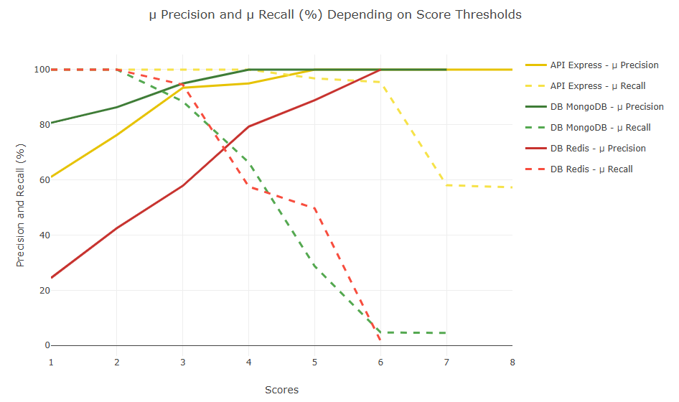
The following chart represents raw data behind the previous chart.
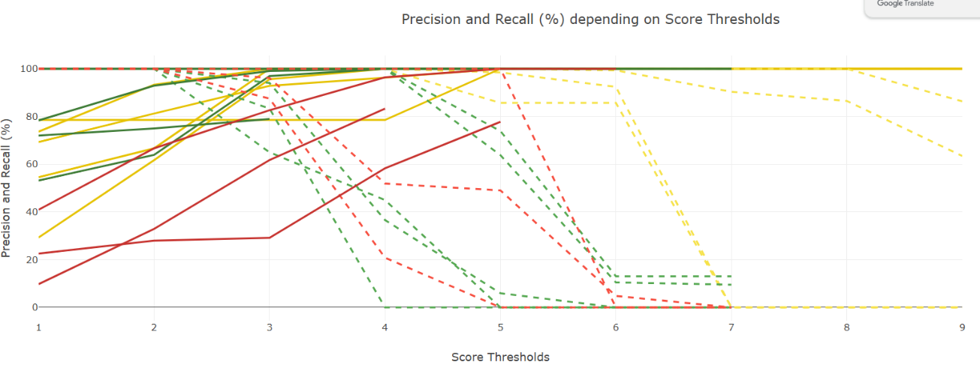
From the previous graphs, we can deduce the optimal score threshold for each project, which is located at each intersection of the precision and recall lines, i.e., between 2 and 5.

The charts above are created based on the following table.
API Express |  | Scores | 1 | 2 | 3 | 4 | 5 | 6 | 7 | 8 | 9
 | comments-api | Precision | 54,55% | 66,67% | 100,00% | 100,00% | 100,00% | 100,00% | 100,00% | 100,00% | 100,00%
 |  | Recall | 100,00% | 100,00% | 100,00% | 100,00% | 100,00% | 100,00% | 100,00% | 100,00% | 100,00%
 |  | F1 | 70,59% | 80,00% | 100,00% | 100,00% | 100,00% | 100,00% | 100,00% | 100,00% | 100,00%
 | cinema-microservice | Precision | 73,68% | 93,33% | 100,00% | 100,00% | 100,00% | 100,00% | N/A | N/A | N/A
 |  | Recall | 100,00% | 100,00% | 100,00% | 100,00% | 85,71% | 85,71% | 0,00% | 0,00% | 0,00%
 |  | F1 | 84,85% | 96,55% | 100,00% | 100,00% | 92,31% | 92,31% | N/A | N/A | N/A
 | overleaf | Precision | 69,33% | 81,25% | 92,86% | 96,30% | 100,00% | 100,00% | 100,00% | 100,00% | 100,00%
 |  | Recall | 100,00% | 100,00% | 100,00% | 100,00% | 100,00% | 99,36% | 90,38% | 86,54% | 63,46%
 |  | F1 | 81,89% | 89,66% | 96,30% | 98,11% | 100,00% | 99,68% | 94,95% | 92,78% | 77,65%
 | cloudboost | Precision | 29,33% | 61,68% | 95,65% | 100,00% | 100,00% | 100,00% | N/A | N/A | N/A
 |  | Recall | 100,00% | 100,00% | 100,00% | 100,00% | 98,48% | 92,42% | 0,00% | 0,00% | 0,00%
 |  | F1 | 45,36% | 76,30% | 97,78% | 100,00% | 99,24% | 96,06% | N/A | N/A | N/A
 | robot-shop | Precision | 78,57% | 78,57% | 78,57% | 78,57% | 100,00% | 100,00% | 100,00% | 100,00% | 100,00%
 |  | Recall | 100,00% | 100,00% | 100,00% | 100,00% | 100,00% | 100,00% | 100,00% | 100,00% | 86,36%
 |  | F1 | 88,00% | 88,00% | 88,00% | 88,00% | 100,00% | 100,00% | 100,00% | 100,00% | 92,68%
 |  | Precision average | 61,09% | 76,30% | 93,42% | 94,97% | 100,00% | 100,00% | 100,00% | 100,00% | 100,00%
 |  | Recall average | 100,00% | 100,00% | 100,00% | 100,00% | 96,84% | 95,50% | 58,08% | 57,31% | 49,96%
 |  | F1 | 74,14% | 86,10% | 96,42% | 97,22% | 98,31% | 97,61% | 98,32% | 97,59% | 90,11%

DB Mongo |  | Scores | 1 | 2 | 3 | 4 | 5 | 6 | 7
 | comments-api | Precision | 72,00% | 75,00% | 78,95% | 100,00% | N/A | N/A | N/A
 |  | Recall | 100,00% | 100,00% | 83,33% | 50,00% | 0,00% | 0,00% | 0,00%
 |  | F1 | 83,72% | 85,71% | 81,08% | 66,67% | N/A | N/A | N/A
 | cinema-microservice | Precision | 100,00% | 100,00% | 100,00% | 100,00% | N/A | N/A | N/A
 |  | Recall | 100,00% | 100,00% | 65,00% | 45,00% | 0,00% | 0,00% | 0,00%
 |  | F1 | 100,00% | 100,00% | 78,79% | 62,07% | N/A | N/A | N/A
 | overleaf | Precision | 78,36% | 92,92% | 99,06% | 100,00% | 100,00% | 100,00% | 100,00%
 |  | Recall | 100,00% | 100,00% | 100,00% | 100,00% | 63,81% | 10,48% | 9,52%
 |  | F1 | 87,87% | 96,33% | 99,53% | 100,00% | 77,91% | 18,97% | 17,39%
 | cloudboost | Precision | 53,16% | 63,92% | 96,94% | 100,00% | 100,00% | N/A | N/A
 |  | Recall | 100,00% | 100,00% | 94,06% | 36,63% | 5,94% | 0,00% | 0,00%
 |  | F1 | 69,42% | 77,99% | 95,48% | 53,62% | 11,21% | N/A | N/A
 | robot-shop | Precision | 100,00% | 100,00% | 100,00% | 100,00% | 100,00% | 100,00% | 100,00%
 |  | Recall | 100,00% | 100,00% | 100,00% | 100,00% | 73,91% | 13,04% | 13,04%
 |  | F1 | 100,00% | 100,00% | 100,00% | 100,00% | 85,00% | 23,08% | 23,08%
 |  | Precision average | 80,70% | 86,37% | 94,99% | 100,00% | 100,00% | 100,00% | 100,00%
 |  | Recall average | 100,00% | 100,00% | 88,48% | 66,33% | 28,73% | 4,70% | 4,51%
 |  | F1 | 88,20% | 92,01% | 90,98% | 76,47% | 58,04% | 21,03% | 20,24%

DB Redis |  | Scores | 1 | 2 | 3 | 4 | 5 | 6 | 7
 | overleaf | Precision | 40,94% | 66,67% | 82,64% | 96,43% | 100,00% | 100,00% | N/A
 |  | Recall | 100,00% | 100,00% | 96,15% | 51,92% | 49,04% | 4,81% | 0,00%
 |  | F1 | 58,10% | 80,00% | 88,89% | 67,50% | 65,81% | 9,17% | N/A
 | cloudboost | Precision | 9,76% | 32,88% | 61,76% | 83,33% | N/A | N/A | N/A
 |  | Recall | 100,00% | 100,00% | 87,50% | 20,83% | 0,00% | 0,00% | 0,00%
 |  | F1 | 17,78% | 49,48% | 72,41% | 33,33% | N/A | N/A | N/A
 | robot-shop | Precision | 22,58% | 28,00% | 29,17% | 58,33% | 77,78% | N/A | N/A
 |  | Recall | 100,00% | 100,00% | 100,00% | 100,00% | 100,00% | 0,00% | 0,00%
 |  | F1 | 36,84% | 43,75% | 45,16% | 73,68% | 87,50% | N/A | N/A
 |  | Precision average | 24,43% | 42,51% | 57,86% | 79,36% | 88,89% | 100,00% | N/A
 |  | Recall average | 100,00% | 100,00% | 94,55% | 57,58% | 49,68% | 1,60% | 0,00%
 |  | F1 | 37,57% | 57,74% | 68,82% | 58,17% | 76,66% | 9,17% | N/A

Heuristics usage evaluation
For evaluating the breakdown of heuristics used in our approach, we analyzed the frequency of heuristics in the analysis report automatically generated by our implementation. For all the projects, we extracted, summed, and computed the frequency of each heuristic in each category.
The following chart represents the frequency of each heuristic in each category across the projects.
