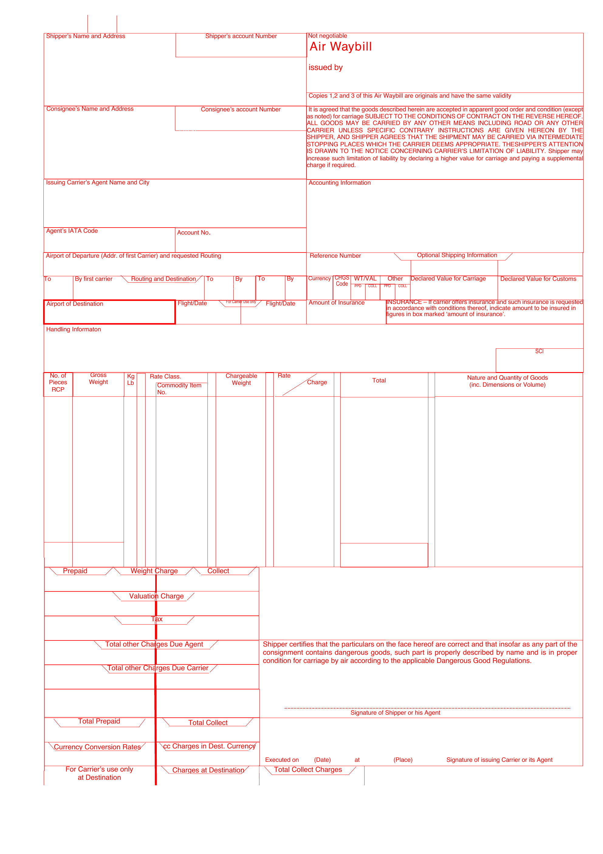
[[MAWB_COPY_START]]
{d.routing[isMainCarriage=true].masterTransportReference:substr(0,3)}
{d.routing[isMainCarriage=true].origin.unlocode:substr(2,5)}
{d.routing[isMainCarriage=true].masterTransportReference:substr(4,12)}
{d.routing[isMainCarriage=true].masterTransportReference:ellipsis(18)}
MNG AIRLINES
YESILKOY CAD.NO 9 FLORYA
ISTANBUL
{d.shipper.name:ellipsis(48)}
{d.shipper.address.line1:ellipsis(52)}
{d.shipper.address.line2:ellipsis(52)}
{d.shipper.address.city:ellipsis(28)} {d.shipper.address.countyOrState:ellipsis(20)}
{d.shipper.address.postalCode:ellipsis(16)} {d.shipper.address.countryCode:ellipsis(3)}
{d.consignee.name:ellipsis(48)}
{d.consignee.address.line1:ellipsis(52)}
{d.consignee.address.line2:ellipsis(52)}
{d.consignee.address.city:ellipsis(28)} {d.consignee.address.countyOrState:ellipsis(20)}
{d.consignee.address.postalCode:ellipsis(16)} {d.consignee.address.countryCode:ellipsis(3)}
{d.job.legalEntityName:ellipsis(46)}
{d.job.origin.name:ellipsis(46)}
SHP REF: {d.job.period:ellipsis(12)}-{d.job.number:ellipsis(18)}
AGT REF: {d.routing[isMainCarriage=true].houseTransportReference:ellipsis(34)}
BOOKING: {d.routing[isMainCarriage=true].carrierBookingReference:ellipsis(30)}
{d.routing[isMainCarriage=true].origin.name:ellipsis(52)}
{d.routing[isMainCarriage=true].destination.unlocode:substr(2,5)}
MNG AIRLINES
{d.routing[isMainCarriage=true].flightNumber:ellipsis(10)}
{d.routing[isMainCarriage=true].destination.name:ellipsis(28)}
{d.routing[isMainCarriage=true].flightNumber:ellipsis(14)}
{d.routing[isMainCarriage=true].plannedDepartureAt:formatD(DD/MM/YYYY):ellipsis(10)}
SPX JOB {d.job.period:ellipsis(12)}-{d.job.number:ellipsis(18)}
{d.cargo[].marksAndNumbers:aggStr(' · '):ellipsis(92)}
X
{d.cargo[].packageQuantity:aggSum}
{d.cargo[].grossWeight:aggSum:formatN(2)}
{d.cargo[0].weightUnit:substr(0,1)}
{d.cargo[].hsCode:aggStr(' · '):ellipsis(12)}
{d.cargo[].grossWeight:aggSum:formatN(2)}
{d.cargo[].commodity:aggStr(' · '):ellipsis(30)}
{d.cargo[].description:aggStr(' · '):ellipsis(30)}
{d.cargo[].marksAndNumbers:aggStr(' · '):ellipsis(30)}
{d.cargo[].packageQuantity:aggSum}
{d.cargo[].grossWeight:aggSum:formatN(2)}
{d.cargo[].grossWeight:aggSum:formatN(2)}
{d.cargo[].volume:aggSum:formatN(3)} {d.cargo[0].volumeUnit:ellipsis(3)}
{d.cargo[].description:aggStr(' · '):ellipsis(76)}
{d.job.legalEntityName:ellipsis(42)}
AS AGENTS FOR THE CARRIER MNG AIRLINES
{d.routing[isMainCarriage=true].plannedDepartureAt:formatD(DD/MM/YYYY):ellipsis(10)} {d.routing[isMainCarriage=true].origin.name:ellipsis(32)}
{d.job.legalEntityName:ellipsis(26)}
ORIGINAL 1 (FOR ISSUING CARRIER)
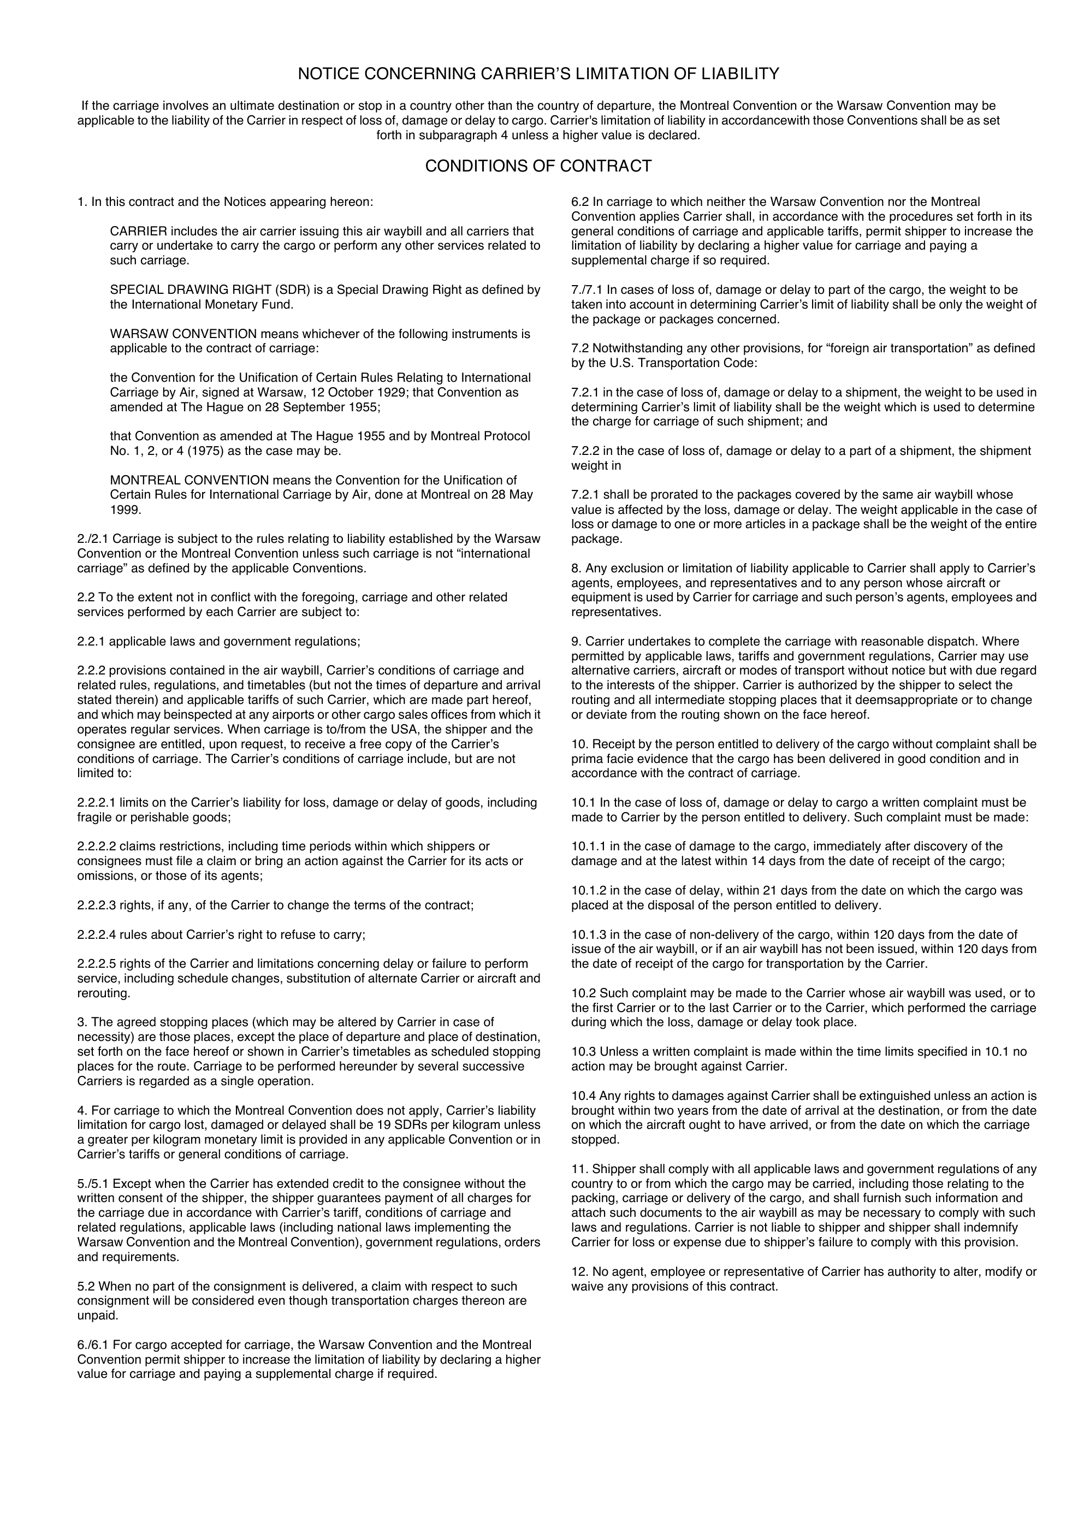
[[MAWB_TERMS_START]]

[[MAWB_COPY_START]]
{d.routing[isMainCarriage=true].masterTransportReference:substr(0,3)}
{d.routing[isMainCarriage=true].origin.unlocode:substr(2,5)}
{d.routing[isMainCarriage=true].masterTransportReference:substr(4,12)}
{d.routing[isMainCarriage=true].masterTransportReference:ellipsis(18)}
MNG AIRLINES
YESILKOY CAD.NO 9 FLORYA
ISTANBUL
{d.shipper.name:ellipsis(48)}
{d.shipper.address.line1:ellipsis(52)}
{d.shipper.address.line2:ellipsis(52)}
{d.shipper.address.city:ellipsis(28)} {d.shipper.address.countyOrState:ellipsis(20)}
{d.shipper.address.postalCode:ellipsis(16)} {d.shipper.address.countryCode:ellipsis(3)}
{d.consignee.name:ellipsis(48)}
{d.consignee.address.line1:ellipsis(52)}
{d.consignee.address.line2:ellipsis(52)}
{d.consignee.address.city:ellipsis(28)} {d.consignee.address.countyOrState:ellipsis(20)}
{d.consignee.address.postalCode:ellipsis(16)} {d.consignee.address.countryCode:ellipsis(3)}
{d.job.legalEntityName:ellipsis(46)}
{d.job.origin.name:ellipsis(46)}
SHP REF: {d.job.period:ellipsis(12)}-{d.job.number:ellipsis(18)}
AGT REF: {d.routing[isMainCarriage=true].houseTransportReference:ellipsis(34)}
BOOKING: {d.routing[isMainCarriage=true].carrierBookingReference:ellipsis(30)}
{d.routing[isMainCarriage=true].origin.name:ellipsis(52)}
{d.routing[isMainCarriage=true].destination.unlocode:substr(2,5)}
MNG AIRLINES
{d.routing[isMainCarriage=true].flightNumber:ellipsis(10)}
{d.routing[isMainCarriage=true].destination.name:ellipsis(28)}
{d.routing[isMainCarriage=true].flightNumber:ellipsis(14)}
{d.routing[isMainCarriage=true].plannedDepartureAt:formatD(DD/MM/YYYY):ellipsis(10)}
SPX JOB {d.job.period:ellipsis(12)}-{d.job.number:ellipsis(18)}
{d.cargo[].marksAndNumbers:aggStr(' · '):ellipsis(92)}
X
{d.cargo[].packageQuantity:aggSum}
{d.cargo[].grossWeight:aggSum:formatN(2)}
{d.cargo[0].weightUnit:substr(0,1)}
{d.cargo[].hsCode:aggStr(' · '):ellipsis(12)}
{d.cargo[].grossWeight:aggSum:formatN(2)}
{d.cargo[].commodity:aggStr(' · '):ellipsis(30)}
{d.cargo[].description:aggStr(' · '):ellipsis(30)}
{d.cargo[].marksAndNumbers:aggStr(' · '):ellipsis(30)}
{d.cargo[].packageQuantity:aggSum}
{d.cargo[].grossWeight:aggSum:formatN(2)}
{d.cargo[].grossWeight:aggSum:formatN(2)}
{d.cargo[].volume:aggSum:formatN(3)} {d.cargo[0].volumeUnit:ellipsis(3)}
{d.cargo[].description:aggStr(' · '):ellipsis(76)}
{d.job.legalEntityName:ellipsis(42)}
AS AGENTS FOR THE CARRIER MNG AIRLINES
{d.routing[isMainCarriage=true].plannedDepartureAt:formatD(DD/MM/YYYY):ellipsis(10)} {d.routing[isMainCarriage=true].origin.name:ellipsis(32)}
{d.job.legalEntityName:ellipsis(26)}
ORIGINAL 2 (FOR CONSIGNEE)

[[MAWB_TERMS_START]]

[[MAWB_COPY_START]]
{d.routing[isMainCarriage=true].masterTransportReference:substr(0,3)}
{d.routing[isMainCarriage=true].origin.unlocode:substr(2,5)}
{d.routing[isMainCarriage=true].masterTransportReference:substr(4,12)}
{d.routing[isMainCarriage=true].masterTransportReference:ellipsis(18)}
MNG AIRLINES
YESILKOY CAD.NO 9 FLORYA
ISTANBUL
{d.shipper.name:ellipsis(48)}
{d.shipper.address.line1:ellipsis(52)}
{d.shipper.address.line2:ellipsis(52)}
{d.shipper.address.city:ellipsis(28)} {d.shipper.address.countyOrState:ellipsis(20)}
{d.shipper.address.postalCode:ellipsis(16)} {d.shipper.address.countryCode:ellipsis(3)}
{d.consignee.name:ellipsis(48)}
{d.consignee.address.line1:ellipsis(52)}
{d.consignee.address.line2:ellipsis(52)}
{d.consignee.address.city:ellipsis(28)} {d.consignee.address.countyOrState:ellipsis(20)}
{d.consignee.address.postalCode:ellipsis(16)} {d.consignee.address.countryCode:ellipsis(3)}
{d.job.legalEntityName:ellipsis(46)}
{d.job.origin.name:ellipsis(46)}
SHP REF: {d.job.period:ellipsis(12)}-{d.job.number:ellipsis(18)}
AGT REF: {d.routing[isMainCarriage=true].houseTransportReference:ellipsis(34)}
BOOKING: {d.routing[isMainCarriage=true].carrierBookingReference:ellipsis(30)}
{d.routing[isMainCarriage=true].origin.name:ellipsis(52)}
{d.routing[isMainCarriage=true].destination.unlocode:substr(2,5)}
MNG AIRLINES
{d.routing[isMainCarriage=true].flightNumber:ellipsis(10)}
{d.routing[isMainCarriage=true].destination.name:ellipsis(28)}
{d.routing[isMainCarriage=true].flightNumber:ellipsis(14)}
{d.routing[isMainCarriage=true].plannedDepartureAt:formatD(DD/MM/YYYY):ellipsis(10)}
SPX JOB {d.job.period:ellipsis(12)}-{d.job.number:ellipsis(18)}
{d.cargo[].marksAndNumbers:aggStr(' · '):ellipsis(92)}
X
{d.cargo[].packageQuantity:aggSum}
{d.cargo[].grossWeight:aggSum:formatN(2)}
{d.cargo[0].weightUnit:substr(0,1)}
{d.cargo[].hsCode:aggStr(' · '):ellipsis(12)}
{d.cargo[].grossWeight:aggSum:formatN(2)}
{d.cargo[].commodity:aggStr(' · '):ellipsis(30)}
{d.cargo[].description:aggStr(' · '):ellipsis(30)}
{d.cargo[].marksAndNumbers:aggStr(' · '):ellipsis(30)}
{d.cargo[].packageQuantity:aggSum}
{d.cargo[].grossWeight:aggSum:formatN(2)}
{d.cargo[].grossWeight:aggSum:formatN(2)}
{d.cargo[].volume:aggSum:formatN(3)} {d.cargo[0].volumeUnit:ellipsis(3)}
{d.cargo[].description:aggStr(' · '):ellipsis(76)}
{d.job.legalEntityName:ellipsis(42)}
AS AGENTS FOR THE CARRIER MNG AIRLINES
{d.routing[isMainCarriage=true].plannedDepartureAt:formatD(DD/MM/YYYY):ellipsis(10)} {d.routing[isMainCarriage=true].origin.name:ellipsis(32)}
{d.job.legalEntityName:ellipsis(26)}
ORIGINAL 3 (FOR SHIPPER)

[[MAWB_TERMS_START]]

[[MAWB_COPY_START]]
{d.routing[isMainCarriage=true].masterTransportReference:substr(0,3)}
{d.routing[isMainCarriage=true].origin.unlocode:substr(2,5)}
{d.routing[isMainCarriage=true].masterTransportReference:substr(4,12)}
{d.routing[isMainCarriage=true].masterTransportReference:ellipsis(18)}
MNG AIRLINES
YESILKOY CAD.NO 9 FLORYA
ISTANBUL
{d.shipper.name:ellipsis(48)}
{d.shipper.address.line1:ellipsis(52)}
{d.shipper.address.line2:ellipsis(52)}
{d.shipper.address.city:ellipsis(28)} {d.shipper.address.countyOrState:ellipsis(20)}
{d.shipper.address.postalCode:ellipsis(16)} {d.shipper.address.countryCode:ellipsis(3)}
{d.consignee.name:ellipsis(48)}
{d.consignee.address.line1:ellipsis(52)}
{d.consignee.address.line2:ellipsis(52)}
{d.consignee.address.city:ellipsis(28)} {d.consignee.address.countyOrState:ellipsis(20)}
{d.consignee.address.postalCode:ellipsis(16)} {d.consignee.address.countryCode:ellipsis(3)}
{d.job.legalEntityName:ellipsis(46)}
{d.job.origin.name:ellipsis(46)}
SHP REF: {d.job.period:ellipsis(12)}-{d.job.number:ellipsis(18)}
AGT REF: {d.routing[isMainCarriage=true].houseTransportReference:ellipsis(34)}
BOOKING: {d.routing[isMainCarriage=true].carrierBookingReference:ellipsis(30)}
{d.routing[isMainCarriage=true].origin.name:ellipsis(52)}
{d.routing[isMainCarriage=true].destination.unlocode:substr(2,5)}
MNG AIRLINES
{d.routing[isMainCarriage=true].flightNumber:ellipsis(10)}
{d.routing[isMainCarriage=true].destination.name:ellipsis(28)}
{d.routing[isMainCarriage=true].flightNumber:ellipsis(14)}
{d.routing[isMainCarriage=true].plannedDepartureAt:formatD(DD/MM/YYYY):ellipsis(10)}
SPX JOB {d.job.period:ellipsis(12)}-{d.job.number:ellipsis(18)}
{d.cargo[].marksAndNumbers:aggStr(' · '):ellipsis(92)}
X
{d.cargo[].packageQuantity:aggSum}
{d.cargo[].grossWeight:aggSum:formatN(2)}
{d.cargo[0].weightUnit:substr(0,1)}
{d.cargo[].hsCode:aggStr(' · '):ellipsis(12)}
{d.cargo[].grossWeight:aggSum:formatN(2)}
{d.cargo[].commodity:aggStr(' · '):ellipsis(30)}
{d.cargo[].description:aggStr(' · '):ellipsis(30)}
{d.cargo[].marksAndNumbers:aggStr(' · '):ellipsis(30)}
{d.cargo[].packageQuantity:aggSum}
{d.cargo[].grossWeight:aggSum:formatN(2)}
{d.cargo[].grossWeight:aggSum:formatN(2)}
{d.cargo[].volume:aggSum:formatN(3)} {d.cargo[0].volumeUnit:ellipsis(3)}
{d.cargo[].description:aggStr(' · '):ellipsis(76)}
{d.job.legalEntityName:ellipsis(42)}
AS AGENTS FOR THE CARRIER MNG AIRLINES
{d.routing[isMainCarriage=true].plannedDepartureAt:formatD(DD/MM/YYYY):ellipsis(10)} {d.routing[isMainCarriage=true].origin.name:ellipsis(32)}
{d.job.legalEntityName:ellipsis(26)}
COPY 4 (DELIVERY RECEIPT)

[[MAWB_TERMS_START]]

[[MAWB_COPY_START]]
{d.routing[isMainCarriage=true].masterTransportReference:substr(0,3)}
{d.routing[isMainCarriage=true].origin.unlocode:substr(2,5)}
{d.routing[isMainCarriage=true].masterTransportReference:substr(4,12)}
{d.routing[isMainCarriage=true].masterTransportReference:ellipsis(18)}
MNG AIRLINES
YESILKOY CAD.NO 9 FLORYA
ISTANBUL
{d.shipper.name:ellipsis(48)}
{d.shipper.address.line1:ellipsis(52)}
{d.shipper.address.line2:ellipsis(52)}
{d.shipper.address.city:ellipsis(28)} {d.shipper.address.countyOrState:ellipsis(20)}
{d.shipper.address.postalCode:ellipsis(16)} {d.shipper.address.countryCode:ellipsis(3)}
{d.consignee.name:ellipsis(48)}
{d.consignee.address.line1:ellipsis(52)}
{d.consignee.address.line2:ellipsis(52)}
{d.consignee.address.city:ellipsis(28)} {d.consignee.address.countyOrState:ellipsis(20)}
{d.consignee.address.postalCode:ellipsis(16)} {d.consignee.address.countryCode:ellipsis(3)}
{d.job.legalEntityName:ellipsis(46)}
{d.job.origin.name:ellipsis(46)}
SHP REF: {d.job.period:ellipsis(12)}-{d.job.number:ellipsis(18)}
AGT REF: {d.routing[isMainCarriage=true].houseTransportReference:ellipsis(34)}
BOOKING: {d.routing[isMainCarriage=true].carrierBookingReference:ellipsis(30)}
{d.routing[isMainCarriage=true].origin.name:ellipsis(52)}
{d.routing[isMainCarriage=true].destination.unlocode:substr(2,5)}
MNG AIRLINES
{d.routing[isMainCarriage=true].flightNumber:ellipsis(10)}
{d.routing[isMainCarriage=true].destination.name:ellipsis(28)}
{d.routing[isMainCarriage=true].flightNumber:ellipsis(14)}
{d.routing[isMainCarriage=true].plannedDepartureAt:formatD(DD/MM/YYYY):ellipsis(10)}
SPX JOB {d.job.period:ellipsis(12)}-{d.job.number:ellipsis(18)}
{d.cargo[].marksAndNumbers:aggStr(' · '):ellipsis(92)}
X
{d.cargo[].packageQuantity:aggSum}
{d.cargo[].grossWeight:aggSum:formatN(2)}
{d.cargo[0].weightUnit:substr(0,1)}
{d.cargo[].hsCode:aggStr(' · '):ellipsis(12)}
{d.cargo[].grossWeight:aggSum:formatN(2)}
{d.cargo[].commodity:aggStr(' · '):ellipsis(30)}
{d.cargo[].description:aggStr(' · '):ellipsis(30)}
{d.cargo[].marksAndNumbers:aggStr(' · '):ellipsis(30)}
{d.cargo[].packageQuantity:aggSum}
{d.cargo[].grossWeight:aggSum:formatN(2)}
{d.cargo[].grossWeight:aggSum:formatN(2)}
{d.cargo[].volume:aggSum:formatN(3)} {d.cargo[0].volumeUnit:ellipsis(3)}
{d.cargo[].description:aggStr(' · '):ellipsis(76)}
{d.job.legalEntityName:ellipsis(42)}
AS AGENTS FOR THE CARRIER MNG AIRLINES
{d.routing[isMainCarriage=true].plannedDepartureAt:formatD(DD/MM/YYYY):ellipsis(10)} {d.routing[isMainCarriage=true].origin.name:ellipsis(32)}
{d.job.legalEntityName:ellipsis(26)}
COPY 5 (FOR AIRPORT OF DESTINATION)

[[MAWB_TERMS_START]]

[[MAWB_COPY_START]]
{d.routing[isMainCarriage=true].masterTransportReference:substr(0,3)}
{d.routing[isMainCarriage=true].origin.unlocode:substr(2,5)}
{d.routing[isMainCarriage=true].masterTransportReference:substr(4,12)}
{d.routing[isMainCarriage=true].masterTransportReference:ellipsis(18)}
MNG AIRLINES
YESILKOY CAD.NO 9 FLORYA
ISTANBUL
{d.shipper.name:ellipsis(48)}
{d.shipper.address.line1:ellipsis(52)}
{d.shipper.address.line2:ellipsis(52)}
{d.shipper.address.city:ellipsis(28)} {d.shipper.address.countyOrState:ellipsis(20)}
{d.shipper.address.postalCode:ellipsis(16)} {d.shipper.address.countryCode:ellipsis(3)}
{d.consignee.name:ellipsis(48)}
{d.consignee.address.line1:ellipsis(52)}
{d.consignee.address.line2:ellipsis(52)}
{d.consignee.address.city:ellipsis(28)} {d.consignee.address.countyOrState:ellipsis(20)}
{d.consignee.address.postalCode:ellipsis(16)} {d.consignee.address.countryCode:ellipsis(3)}
{d.job.legalEntityName:ellipsis(46)}
{d.job.origin.name:ellipsis(46)}
SHP REF: {d.job.period:ellipsis(12)}-{d.job.number:ellipsis(18)}
AGT REF: {d.routing[isMainCarriage=true].houseTransportReference:ellipsis(34)}
BOOKING: {d.routing[isMainCarriage=true].carrierBookingReference:ellipsis(30)}
{d.routing[isMainCarriage=true].origin.name:ellipsis(52)}
{d.routing[isMainCarriage=true].destination.unlocode:substr(2,5)}
MNG AIRLINES
{d.routing[isMainCarriage=true].flightNumber:ellipsis(10)}
{d.routing[isMainCarriage=true].destination.name:ellipsis(28)}
{d.routing[isMainCarriage=true].flightNumber:ellipsis(14)}
{d.routing[isMainCarriage=true].plannedDepartureAt:formatD(DD/MM/YYYY):ellipsis(10)}
SPX JOB {d.job.period:ellipsis(12)}-{d.job.number:ellipsis(18)}
{d.cargo[].marksAndNumbers:aggStr(' · '):ellipsis(92)}
X
{d.cargo[].packageQuantity:aggSum}
{d.cargo[].grossWeight:aggSum:formatN(2)}
{d.cargo[0].weightUnit:substr(0,1)}
{d.cargo[].hsCode:aggStr(' · '):ellipsis(12)}
{d.cargo[].grossWeight:aggSum:formatN(2)}
{d.cargo[].commodity:aggStr(' · '):ellipsis(30)}
{d.cargo[].description:aggStr(' · '):ellipsis(30)}
{d.cargo[].marksAndNumbers:aggStr(' · '):ellipsis(30)}
{d.cargo[].packageQuantity:aggSum}
{d.cargo[].grossWeight:aggSum:formatN(2)}
{d.cargo[].grossWeight:aggSum:formatN(2)}
{d.cargo[].volume:aggSum:formatN(3)} {d.cargo[0].volumeUnit:ellipsis(3)}
{d.cargo[].description:aggStr(' · '):ellipsis(76)}
{d.job.legalEntityName:ellipsis(42)}
AS AGENTS FOR THE CARRIER MNG AIRLINES
{d.routing[isMainCarriage=true].plannedDepartureAt:formatD(DD/MM/YYYY):ellipsis(10)} {d.routing[isMainCarriage=true].origin.name:ellipsis(32)}
{d.job.legalEntityName:ellipsis(26)}
COPY 6 (FOR THIRD CARRIER)

[[MAWB_TERMS_START]]

