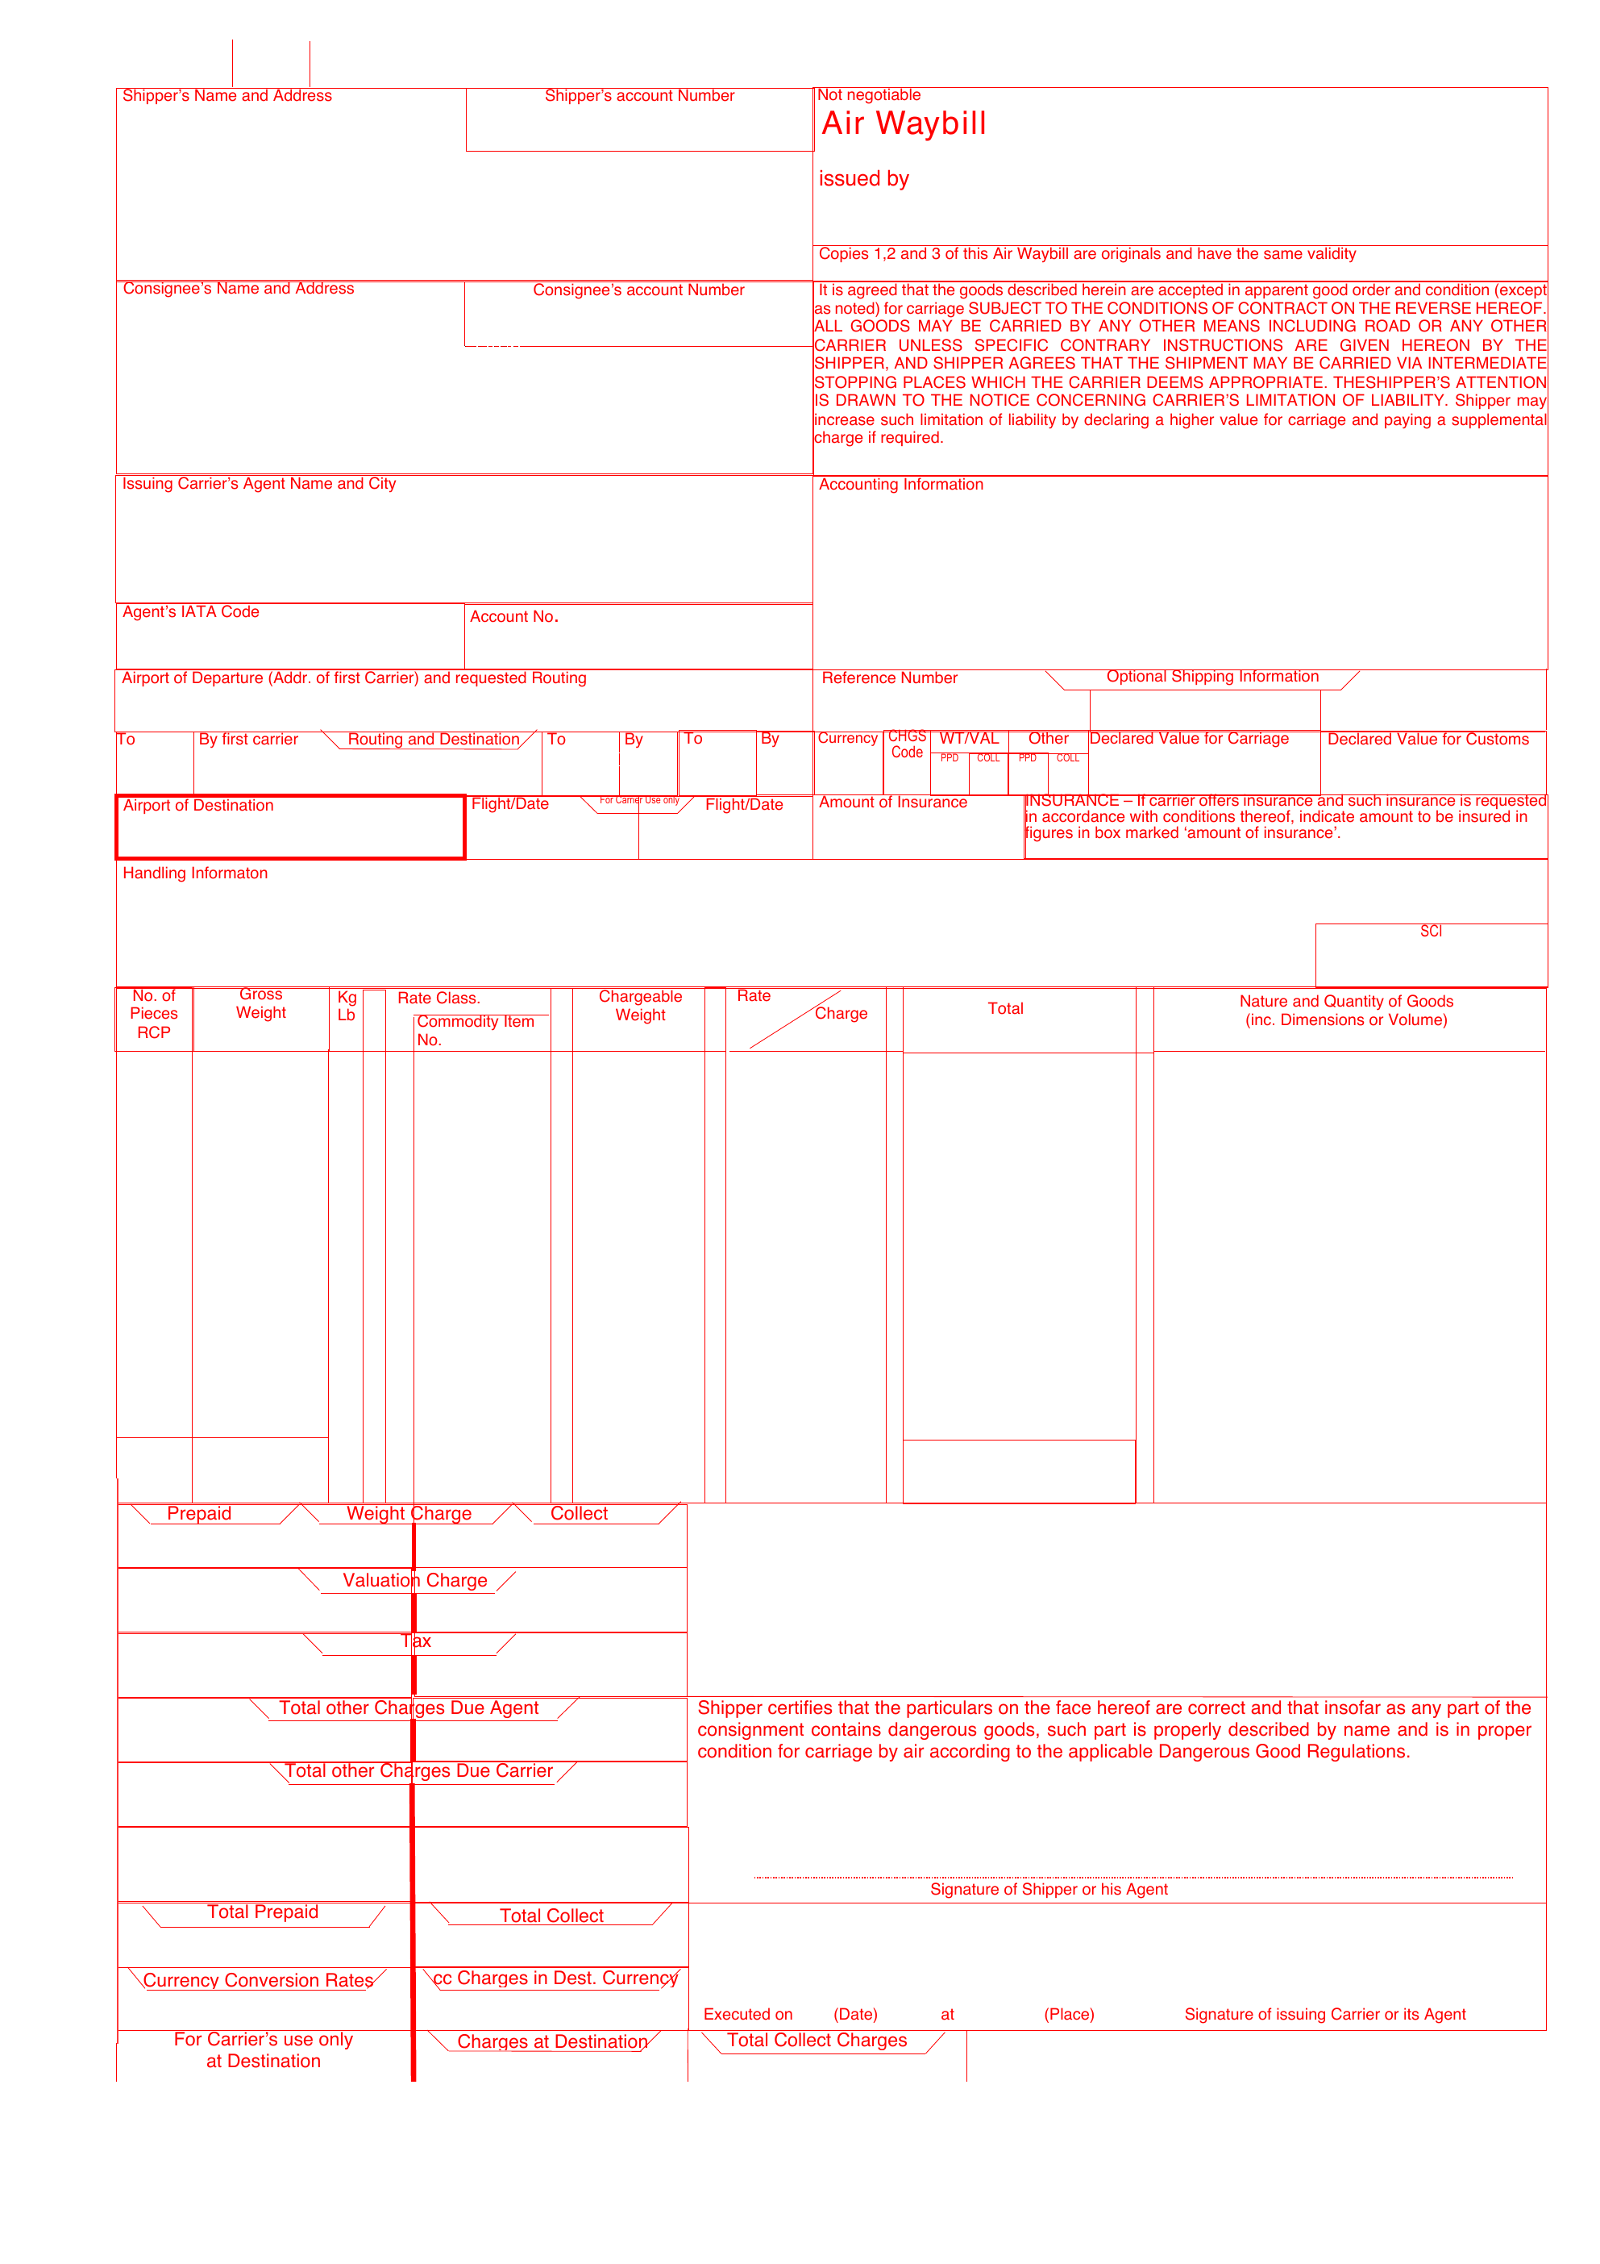
[[MAWB_COPY_START]]
{d.routing[isMainCarriage=true].masterTransportReference:substr(0,3)}
{d.routing[isMainCarriage=true].origin.iataCode}
{d.routing[isMainCarriage=true].masterTransportReference:substr(4,12)}
{d.routing[isMainCarriage=true].masterTransportReference:ellipsis(18)}
{d.routing[isMainCarriage=true].carrierName:ellipsis(28)}
{d.routing[isMainCarriage=true].carrierAddressLine1:ellipsis(34)}
{d.routing[isMainCarriage=true].carrierAddressCity:ellipsis(28)}
{d.shipper.name:ellipsis(48)}
{d.shipper.address.line1:ellipsis(52)}
{d.shipper.address.line2:ellipsis(52)}
{d.shipper.address.city:ellipsis(28)} {d.shipper.address.countyOrState:ellipsis(20)}
{d.shipper.address.postalCode:ellipsis(16)} {d.shipper.address.countryCode:ellipsis(3)}
{d.consignee.name:ellipsis(48)}
{d.consignee.address.line1:ellipsis(52)}
{d.consignee.address.line2:ellipsis(52)}
{d.consignee.address.city:ellipsis(28)} {d.consignee.address.countyOrState:ellipsis(20)}
{d.consignee.address.postalCode:ellipsis(16)} {d.consignee.address.countryCode:ellipsis(3)}
{d.job.legalEntityName:ellipsis(46)}

BOOKING REF: {d.transport.reference:ellipsis(28)}
AGT REF: {d.routing[isMainCarriage=true].houseTransportReference:ellipsis(34)}
BOOKING: {d.routing[isMainCarriage=true].carrierBookingReference:ellipsis(30)}
{d.routing[isMainCarriage=true].origin.name:ellipsis(52)}
{d.routing[isMainCarriage=true].destination.iataCode}
{d.routing[isMainCarriage=true].carrierName:ellipsis(28)}
{d.routing[isMainCarriage=true].flightNumber:ellipsis(10)}
{d.routing[isMainCarriage=true].destination.name:ellipsis(28)}
{d.routing[isMainCarriage=true].flightNumber:ellipsis(14)}
{d.routing[isMainCarriage=true].plannedDepartureAt:formatD(DD/MM/YYYY):ellipsis(10)}
DRAFT - SEE ATTACHED CARGO SCHEDULE

{d.transport.totals.packages}
{d.transport.totals.grossWeight}
{d.cargo[0].weightUnit:substr(0,1)}

{d.transport.totals.chargeableWeight}
SEE ATTACHED
CARGO SCHEDULE
FULL PARTICULARS
{d.transport.totals.packages}
{d.transport.totals.grossWeight}
{d.transport.totals.chargeableWeight}
{d.transport.totals.volume} M3

DRAFT - FORM 1 (FOR ISSUING CARRIER)
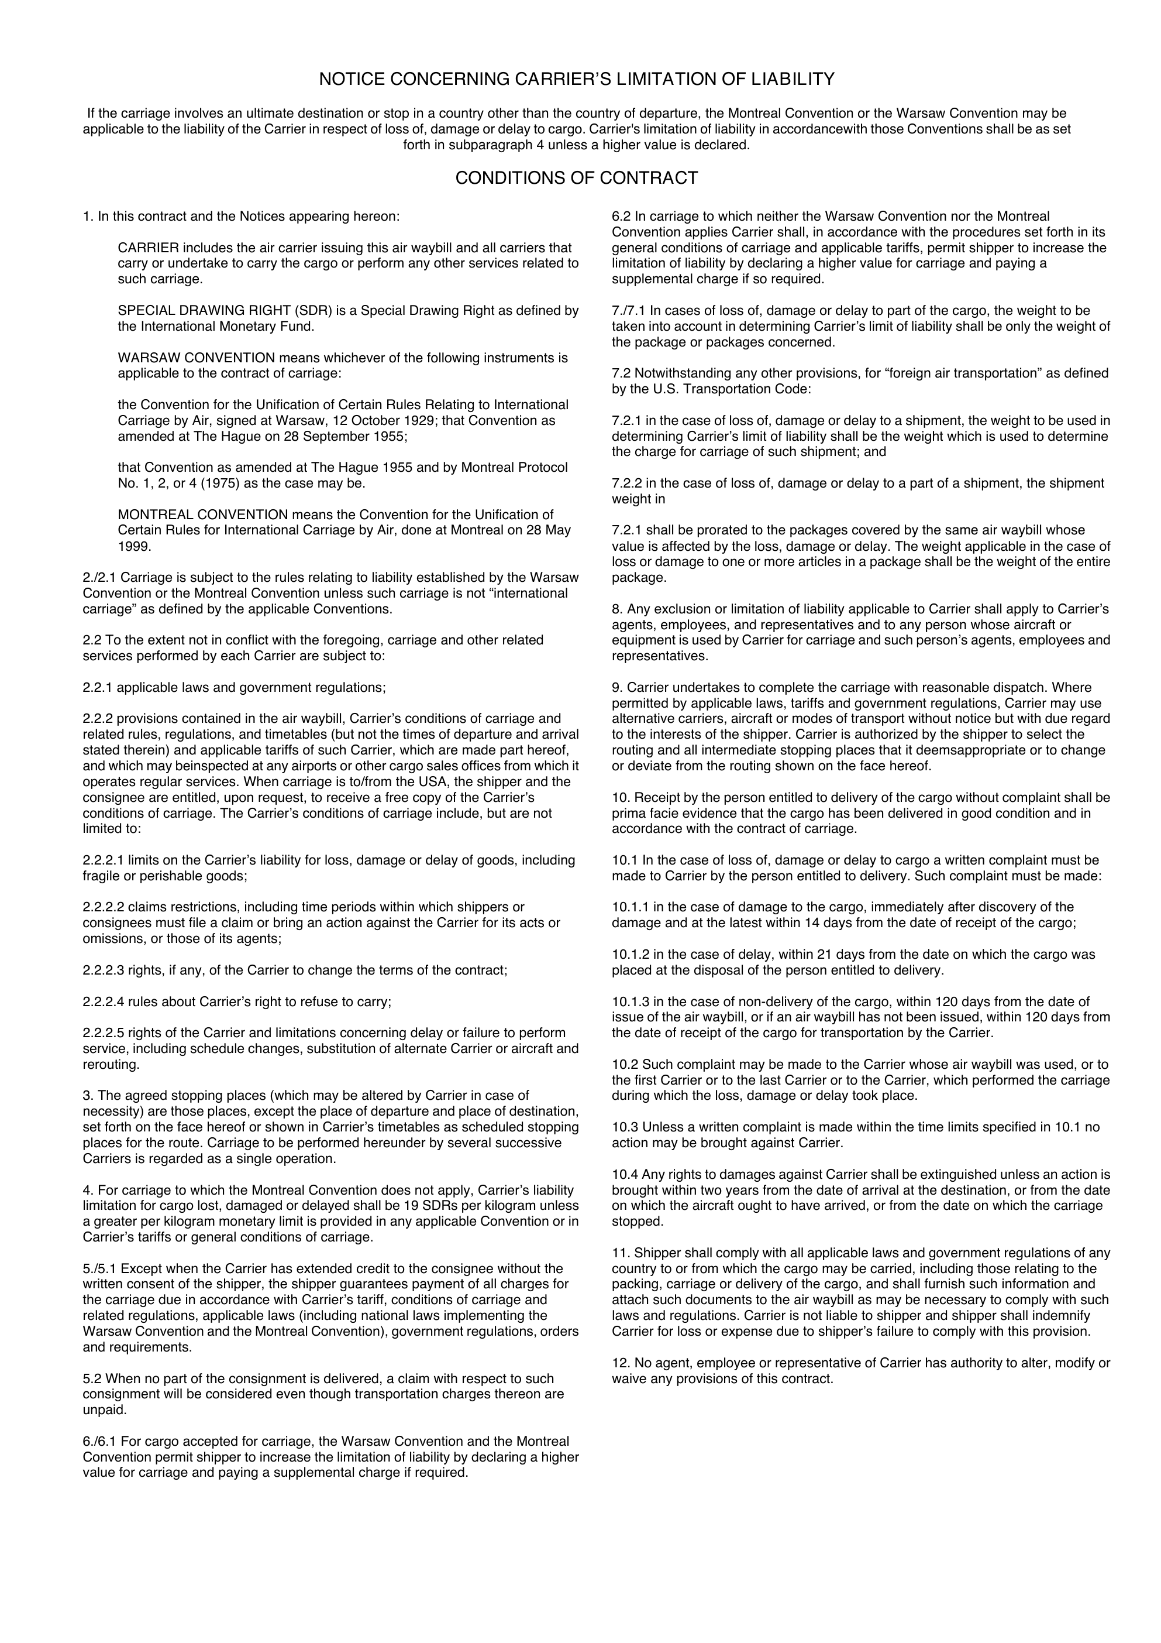
[[MAWB_TERMS_START]]
[[MAWB_COPY_START]]
{d.routing[isMainCarriage=true].masterTransportReference:substr(0,3)}
{d.routing[isMainCarriage=true].origin.iataCode}
{d.routing[isMainCarriage=true].masterTransportReference:substr(4,12)}
{d.routing[isMainCarriage=true].masterTransportReference:ellipsis(18)}
{d.routing[isMainCarriage=true].carrierName:ellipsis(28)}
{d.routing[isMainCarriage=true].carrierAddressLine1:ellipsis(34)}
{d.routing[isMainCarriage=true].carrierAddressCity:ellipsis(28)}
{d.shipper.name:ellipsis(48)}
{d.shipper.address.line1:ellipsis(52)}
{d.shipper.address.line2:ellipsis(52)}
{d.shipper.address.city:ellipsis(28)} {d.shipper.address.countyOrState:ellipsis(20)}
{d.shipper.address.postalCode:ellipsis(16)} {d.shipper.address.countryCode:ellipsis(3)}
{d.consignee.name:ellipsis(48)}
{d.consignee.address.line1:ellipsis(52)}
{d.consignee.address.line2:ellipsis(52)}
{d.consignee.address.city:ellipsis(28)} {d.consignee.address.countyOrState:ellipsis(20)}
{d.consignee.address.postalCode:ellipsis(16)} {d.consignee.address.countryCode:ellipsis(3)}
{d.job.legalEntityName:ellipsis(46)}

BOOKING REF: {d.transport.reference:ellipsis(28)}
AGT REF: {d.routing[isMainCarriage=true].houseTransportReference:ellipsis(34)}
BOOKING: {d.routing[isMainCarriage=true].carrierBookingReference:ellipsis(30)}
{d.routing[isMainCarriage=true].origin.name:ellipsis(52)}
{d.routing[isMainCarriage=true].destination.iataCode}
{d.routing[isMainCarriage=true].carrierName:ellipsis(28)}
{d.routing[isMainCarriage=true].flightNumber:ellipsis(10)}
{d.routing[isMainCarriage=true].destination.name:ellipsis(28)}
{d.routing[isMainCarriage=true].flightNumber:ellipsis(14)}
{d.routing[isMainCarriage=true].plannedDepartureAt:formatD(DD/MM/YYYY):ellipsis(10)}
DRAFT - SEE ATTACHED CARGO SCHEDULE

{d.transport.totals.packages}
{d.transport.totals.grossWeight}
{d.cargo[0].weightUnit:substr(0,1)}

{d.transport.totals.chargeableWeight}
SEE ATTACHED
CARGO SCHEDULE
FULL PARTICULARS
{d.transport.totals.packages}
{d.transport.totals.grossWeight}
{d.transport.totals.chargeableWeight}
{d.transport.totals.volume} M3

DRAFT - FORM 2 (FOR CONSIGNEE)
[[MAWB_TERMS_START]]
[[MAWB_COPY_START]]
{d.routing[isMainCarriage=true].masterTransportReference:substr(0,3)}
{d.routing[isMainCarriage=true].origin.iataCode}
{d.routing[isMainCarriage=true].masterTransportReference:substr(4,12)}
{d.routing[isMainCarriage=true].masterTransportReference:ellipsis(18)}
{d.routing[isMainCarriage=true].carrierName:ellipsis(28)}
{d.routing[isMainCarriage=true].carrierAddressLine1:ellipsis(34)}
{d.routing[isMainCarriage=true].carrierAddressCity:ellipsis(28)}
{d.shipper.name:ellipsis(48)}
{d.shipper.address.line1:ellipsis(52)}
{d.shipper.address.line2:ellipsis(52)}
{d.shipper.address.city:ellipsis(28)} {d.shipper.address.countyOrState:ellipsis(20)}
{d.shipper.address.postalCode:ellipsis(16)} {d.shipper.address.countryCode:ellipsis(3)}
{d.consignee.name:ellipsis(48)}
{d.consignee.address.line1:ellipsis(52)}
{d.consignee.address.line2:ellipsis(52)}
{d.consignee.address.city:ellipsis(28)} {d.consignee.address.countyOrState:ellipsis(20)}
{d.consignee.address.postalCode:ellipsis(16)} {d.consignee.address.countryCode:ellipsis(3)}
{d.job.legalEntityName:ellipsis(46)}

BOOKING REF: {d.transport.reference:ellipsis(28)}
AGT REF: {d.routing[isMainCarriage=true].houseTransportReference:ellipsis(34)}
BOOKING: {d.routing[isMainCarriage=true].carrierBookingReference:ellipsis(30)}
{d.routing[isMainCarriage=true].origin.name:ellipsis(52)}
{d.routing[isMainCarriage=true].destination.iataCode}
{d.routing[isMainCarriage=true].carrierName:ellipsis(28)}
{d.routing[isMainCarriage=true].flightNumber:ellipsis(10)}
{d.routing[isMainCarriage=true].destination.name:ellipsis(28)}
{d.routing[isMainCarriage=true].flightNumber:ellipsis(14)}
{d.routing[isMainCarriage=true].plannedDepartureAt:formatD(DD/MM/YYYY):ellipsis(10)}
DRAFT - SEE ATTACHED CARGO SCHEDULE

{d.transport.totals.packages}
{d.transport.totals.grossWeight}
{d.cargo[0].weightUnit:substr(0,1)}

{d.transport.totals.chargeableWeight}
SEE ATTACHED
CARGO SCHEDULE
FULL PARTICULARS
{d.transport.totals.packages}
{d.transport.totals.grossWeight}
{d.transport.totals.chargeableWeight}
{d.transport.totals.volume} M3

DRAFT - FORM 3 (FOR SHIPPER)
[[MAWB_TERMS_START]]
[[MAWB_COPY_START]]
{d.routing[isMainCarriage=true].masterTransportReference:substr(0,3)}
{d.routing[isMainCarriage=true].origin.iataCode}
{d.routing[isMainCarriage=true].masterTransportReference:substr(4,12)}
{d.routing[isMainCarriage=true].masterTransportReference:ellipsis(18)}
{d.routing[isMainCarriage=true].carrierName:ellipsis(28)}
{d.routing[isMainCarriage=true].carrierAddressLine1:ellipsis(34)}
{d.routing[isMainCarriage=true].carrierAddressCity:ellipsis(28)}
{d.shipper.name:ellipsis(48)}
{d.shipper.address.line1:ellipsis(52)}
{d.shipper.address.line2:ellipsis(52)}
{d.shipper.address.city:ellipsis(28)} {d.shipper.address.countyOrState:ellipsis(20)}
{d.shipper.address.postalCode:ellipsis(16)} {d.shipper.address.countryCode:ellipsis(3)}
{d.consignee.name:ellipsis(48)}
{d.consignee.address.line1:ellipsis(52)}
{d.consignee.address.line2:ellipsis(52)}
{d.consignee.address.city:ellipsis(28)} {d.consignee.address.countyOrState:ellipsis(20)}
{d.consignee.address.postalCode:ellipsis(16)} {d.consignee.address.countryCode:ellipsis(3)}
{d.job.legalEntityName:ellipsis(46)}

BOOKING REF: {d.transport.reference:ellipsis(28)}
AGT REF: {d.routing[isMainCarriage=true].houseTransportReference:ellipsis(34)}
BOOKING: {d.routing[isMainCarriage=true].carrierBookingReference:ellipsis(30)}
{d.routing[isMainCarriage=true].origin.name:ellipsis(52)}
{d.routing[isMainCarriage=true].destination.iataCode}
{d.routing[isMainCarriage=true].carrierName:ellipsis(28)}
{d.routing[isMainCarriage=true].flightNumber:ellipsis(10)}
{d.routing[isMainCarriage=true].destination.name:ellipsis(28)}
{d.routing[isMainCarriage=true].flightNumber:ellipsis(14)}
{d.routing[isMainCarriage=true].plannedDepartureAt:formatD(DD/MM/YYYY):ellipsis(10)}
DRAFT - SEE ATTACHED CARGO SCHEDULE

{d.transport.totals.packages}
{d.transport.totals.grossWeight}
{d.cargo[0].weightUnit:substr(0,1)}

{d.transport.totals.chargeableWeight}
SEE ATTACHED
CARGO SCHEDULE
FULL PARTICULARS
{d.transport.totals.packages}
{d.transport.totals.grossWeight}
{d.transport.totals.chargeableWeight}
{d.transport.totals.volume} M3

DRAFT - FORM 4 (DELIVERY RECEIPT)
[[MAWB_TERMS_START]]
[[MAWB_COPY_START]]
{d.routing[isMainCarriage=true].masterTransportReference:substr(0,3)}
{d.routing[isMainCarriage=true].origin.iataCode}
{d.routing[isMainCarriage=true].masterTransportReference:substr(4,12)}
{d.routing[isMainCarriage=true].masterTransportReference:ellipsis(18)}
{d.routing[isMainCarriage=true].carrierName:ellipsis(28)}
{d.routing[isMainCarriage=true].carrierAddressLine1:ellipsis(34)}
{d.routing[isMainCarriage=true].carrierAddressCity:ellipsis(28)}
{d.shipper.name:ellipsis(48)}
{d.shipper.address.line1:ellipsis(52)}
{d.shipper.address.line2:ellipsis(52)}
{d.shipper.address.city:ellipsis(28)} {d.shipper.address.countyOrState:ellipsis(20)}
{d.shipper.address.postalCode:ellipsis(16)} {d.shipper.address.countryCode:ellipsis(3)}
{d.consignee.name:ellipsis(48)}
{d.consignee.address.line1:ellipsis(52)}
{d.consignee.address.line2:ellipsis(52)}
{d.consignee.address.city:ellipsis(28)} {d.consignee.address.countyOrState:ellipsis(20)}
{d.consignee.address.postalCode:ellipsis(16)} {d.consignee.address.countryCode:ellipsis(3)}
{d.job.legalEntityName:ellipsis(46)}

BOOKING REF: {d.transport.reference:ellipsis(28)}
AGT REF: {d.routing[isMainCarriage=true].houseTransportReference:ellipsis(34)}
BOOKING: {d.routing[isMainCarriage=true].carrierBookingReference:ellipsis(30)}
{d.routing[isMainCarriage=true].origin.name:ellipsis(52)}
{d.routing[isMainCarriage=true].destination.iataCode}
{d.routing[isMainCarriage=true].carrierName:ellipsis(28)}
{d.routing[isMainCarriage=true].flightNumber:ellipsis(10)}
{d.routing[isMainCarriage=true].destination.name:ellipsis(28)}
{d.routing[isMainCarriage=true].flightNumber:ellipsis(14)}
{d.routing[isMainCarriage=true].plannedDepartureAt:formatD(DD/MM/YYYY):ellipsis(10)}
DRAFT - SEE ATTACHED CARGO SCHEDULE

{d.transport.totals.packages}
{d.transport.totals.grossWeight}
{d.cargo[0].weightUnit:substr(0,1)}

{d.transport.totals.chargeableWeight}
SEE ATTACHED
CARGO SCHEDULE
FULL PARTICULARS
{d.transport.totals.packages}
{d.transport.totals.grossWeight}
{d.transport.totals.chargeableWeight}
{d.transport.totals.volume} M3

DRAFT - FORM 5 (FOR AIRPORT OF DESTINATION)
[[MAWB_TERMS_START]]
[[MAWB_COPY_START]]
{d.routing[isMainCarriage=true].masterTransportReference:substr(0,3)}
{d.routing[isMainCarriage=true].origin.iataCode}
{d.routing[isMainCarriage=true].masterTransportReference:substr(4,12)}
{d.routing[isMainCarriage=true].masterTransportReference:ellipsis(18)}
{d.routing[isMainCarriage=true].carrierName:ellipsis(28)}
{d.routing[isMainCarriage=true].carrierAddressLine1:ellipsis(34)}
{d.routing[isMainCarriage=true].carrierAddressCity:ellipsis(28)}
{d.shipper.name:ellipsis(48)}
{d.shipper.address.line1:ellipsis(52)}
{d.shipper.address.line2:ellipsis(52)}
{d.shipper.address.city:ellipsis(28)} {d.shipper.address.countyOrState:ellipsis(20)}
{d.shipper.address.postalCode:ellipsis(16)} {d.shipper.address.countryCode:ellipsis(3)}
{d.consignee.name:ellipsis(48)}
{d.consignee.address.line1:ellipsis(52)}
{d.consignee.address.line2:ellipsis(52)}
{d.consignee.address.city:ellipsis(28)} {d.consignee.address.countyOrState:ellipsis(20)}
{d.consignee.address.postalCode:ellipsis(16)} {d.consignee.address.countryCode:ellipsis(3)}
{d.job.legalEntityName:ellipsis(46)}

BOOKING REF: {d.transport.reference:ellipsis(28)}
AGT REF: {d.routing[isMainCarriage=true].houseTransportReference:ellipsis(34)}
BOOKING: {d.routing[isMainCarriage=true].carrierBookingReference:ellipsis(30)}
{d.routing[isMainCarriage=true].origin.name:ellipsis(52)}
{d.routing[isMainCarriage=true].destination.iataCode}
{d.routing[isMainCarriage=true].carrierName:ellipsis(28)}
{d.routing[isMainCarriage=true].flightNumber:ellipsis(10)}
{d.routing[isMainCarriage=true].destination.name:ellipsis(28)}
{d.routing[isMainCarriage=true].flightNumber:ellipsis(14)}
{d.routing[isMainCarriage=true].plannedDepartureAt:formatD(DD/MM/YYYY):ellipsis(10)}
DRAFT - SEE ATTACHED CARGO SCHEDULE

{d.transport.totals.packages}
{d.transport.totals.grossWeight}
{d.cargo[0].weightUnit:substr(0,1)}

{d.transport.totals.chargeableWeight}
SEE ATTACHED
CARGO SCHEDULE
FULL PARTICULARS
{d.transport.totals.packages}
{d.transport.totals.grossWeight}
{d.transport.totals.chargeableWeight}
{d.transport.totals.volume} M3

DRAFT - FORM 6 (FOR THIRD CARRIER)
[[MAWB_TERMS_START]]

DRAFT — TRANSPORT PARTICULARS FOR REVIEW
Booking: {d.transport.reference}
This schedule forms part of the Draft. Blank values are not recorded. No security clearance, verified mass, signature or issuing authority is implied.
Parties — full saved names and addresses
Role | Name | Full address
{d.transport.parties[i].role:convCRLF} | {d.transport.parties[i].name:convCRLF} | {d.transport.parties[i].fullAddress:convCRLF}
{d.transport.parties[i+1].role:convCRLF} | {d.transport.parties[i+1].name:convCRLF} | {d.transport.parties[i+1].fullAddress:convCRLF}
Cargo — all lines
Line | Goods | Packages | Pack type | Gross kg | Chargeable kg | CBM
{d.transport.cargo[i].lineNumber:convCRLF} | {d.transport.cargo[i].description:convCRLF} | {d.transport.cargo[i].packageQuantity:convCRLF} | {d.transport.cargo[i].packageType:convCRLF} | {d.transport.cargo[i].grossWeight:convCRLF} | {d.transport.cargo[i].chargeableWeight:convCRLF} | {d.transport.cargo[i].volume:convCRLF}
{d.transport.cargo[i+1].lineNumber:convCRLF} | {d.transport.cargo[i+1].description:convCRLF} | {d.transport.cargo[i+1].packageQuantity:convCRLF} | {d.transport.cargo[i+1].packageType:convCRLF} | {d.transport.cargo[i+1].grossWeight:convCRLF} | {d.transport.cargo[i+1].chargeableWeight:convCRLF} | {d.transport.cargo[i+1].volume:convCRLF}
Cargo marks, commodity and handling
Line | Marks | Commodity | HS code | Handling
{d.transport.cargo[i].lineNumber:convCRLF} | {d.transport.cargo[i].marksAndNumbers:convCRLF} | {d.transport.cargo[i].commodity:convCRLF} | {d.transport.cargo[i].hsCode:convCRLF} | {d.transport.cargo[i].handling:convCRLF}
{d.transport.cargo[i+1].lineNumber:convCRLF} | {d.transport.cargo[i+1].marksAndNumbers:convCRLF} | {d.transport.cargo[i+1].commodity:convCRLF} | {d.transport.cargo[i+1].hsCode:convCRLF} | {d.transport.cargo[i+1].handling:convCRLF}
Equipment — all containers or ULDs
Number | Type | Seal | Recorded gross kg | Recorded VGM kg | CBM
{d.transport.equipment[i].number:convCRLF} | {d.transport.equipment[i].type:convCRLF} | {d.transport.equipment[i].seal:convCRLF} | {d.transport.equipment[i].grossWeight:convCRLF} | {d.transport.equipment[i].verifiedGrossMass:convCRLF} | {d.transport.equipment[i].volume:convCRLF}
{d.transport.equipment[i+1].number:convCRLF} | {d.transport.equipment[i+1].type:convCRLF} | {d.transport.equipment[i+1].seal:convCRLF} | {d.transport.equipment[i+1].grossWeight:convCRLF} | {d.transport.equipment[i+1].verifiedGrossMass:convCRLF} | {d.transport.equipment[i+1].volume:convCRLF}
Cargo splits — recorded quantities only
Cargo line | Equipment | Type | Packages | Allocated gross kg | Allocated CBM
{d.transport.allocations[i].cargoLine:convCRLF} | {d.transport.allocations[i].equipmentNumber:convCRLF} | {d.transport.allocations[i].equipmentType:convCRLF} | {d.transport.allocations[i].packages:convCRLF} | {d.transport.allocations[i].grossWeight:convCRLF} | {d.transport.allocations[i].volume:convCRLF}
{d.transport.allocations[i+1].cargoLine:convCRLF} | {d.transport.allocations[i+1].equipmentNumber:convCRLF} | {d.transport.allocations[i+1].equipmentType:convCRLF} | {d.transport.allocations[i+1].packages:convCRLF} | {d.transport.allocations[i+1].grossWeight:convCRLF} | {d.transport.allocations[i+1].volume:convCRLF}
Package quantities do not calculate container weight or VGM. Unnumbered equipment remains listed. Unrecorded splits are not estimated.
Information still to review
Not recorded / review required
{d.transport.gaps[i].label:convCRLF}
{d.transport.gaps[i+1].label:convCRLF}

