 | issued subject to UNCTAD/ICC Rules for  Multimodal Transport Documents (ICC Publication 481).  {d.fiata.carrierName}  BILL OF LADING  {d.fiata.billType}  {d.fiata.billTypeDescription}
  Consignor
  {d.fiata.consignor:convCRLF}
  Consigned to order of
  {d.fiata.consignee:convCRLF}
  Notify Address
  {d.fiata.notify:convCRLF}
  Place of Receipt
  {d.fiata.placeOfReceipt}
  Ocean Vessel  {d.fiata.oceanVessel} | Port of loading  {d.fiata.portOfLoading}
  Port of discharge  {d.fiata.portOfDischarge} | Place of Delivery  {d.fiata.placeOfDelivery}
   | FBL | {d.fiata.reference} | Country  Code  {d.fiata.countryCode}
  NEGOTIABLE FIATA  MULTIMODAL TRANSPORT  BILL OF LADING | 
  

Marks and Numbers | Number and Kind of Packages | Description of Goods | Gross Weight | Measurement
{d.fiata.goods[0].marks} | {d.fiata.goods[0].packages} | {d.fiata.goods[0].description:convCRLF} | {d.fiata.goods[0].grossWeight} | {d.fiata.goods[0].measurement}
{d.fiata.goods[1].marks} | {d.fiata.goods[1].packages} | {d.fiata.goods[1].description:convCRLF} | {d.fiata.goods[1].grossWeight} | {d.fiata.goods[1].measurement}

Container | Seals | Type | Packages | Mode
{d.fiata.equipment[0].number} | {d.fiata.equipment[0].seal} | {d.fiata.equipment[0].type} | {d.fiata.equipment[0].packages} | {d.fiata.equipment[0].mode}
{d.fiata.equipment[1].number} | {d.fiata.equipment[1].seal} | {d.fiata.equipment[1].type} | {d.fiata.equipment[1].packages} | {d.fiata.equipment[1].mode}

{d.fiata.remarks:convCRLF} | Consol Ref: {d.fiata.consolidationReference} | {d.fiata.serviceMode}
Total Packages: {d.fiata.totalPackages} |  | {d.fiata.loadAndCount}
{d.fiata.shippedOnBoardStatement}
Declaration of Interest of the consignor in  timely delivery (Clause 6.2.)  {d.fiata.deliveryInterest} | Declared value for ad valorem rate according to  the declaration of the consignor (Clauses 7 and 8)  {d.fiata.declaredValue}

The goods and instructions are accepted and dealt with subject to the Standard Conditions printed overleaf.
Taken in charge in apparent good order and condition, unless otherwise noted herein, at the place of receipt for transport and delivery as mentioned above.
One of these Multimodal Transport Bills of Lading must be surrendered duly endorsed in exchange for the goods. In Witness whereof the original Multimodal Transport Bills of Lading and all of this tenor and date have been signed in the number stated below, one of which being accomplished the other(s) to be void.
Freight amount  {d.fiata.freightAmount} | Freight Payable at  {d.fiata.freightPayableAt} | Place and date of issue  {d.fiata.placeAndDateOfIssue}
Cargo Insurance through the undersigned  {d.fiata.insurance} | No. of Originals  {d.fiata.originals} | Stamp and Signature  {d.fiata.signingCapacity}
For delivery of goods please apply to:  {d.fiata.deliveryAgent:convCRLF} |  | Stamp and Signature  {d.fiata.signingCapacity}
HBoL-FIATA

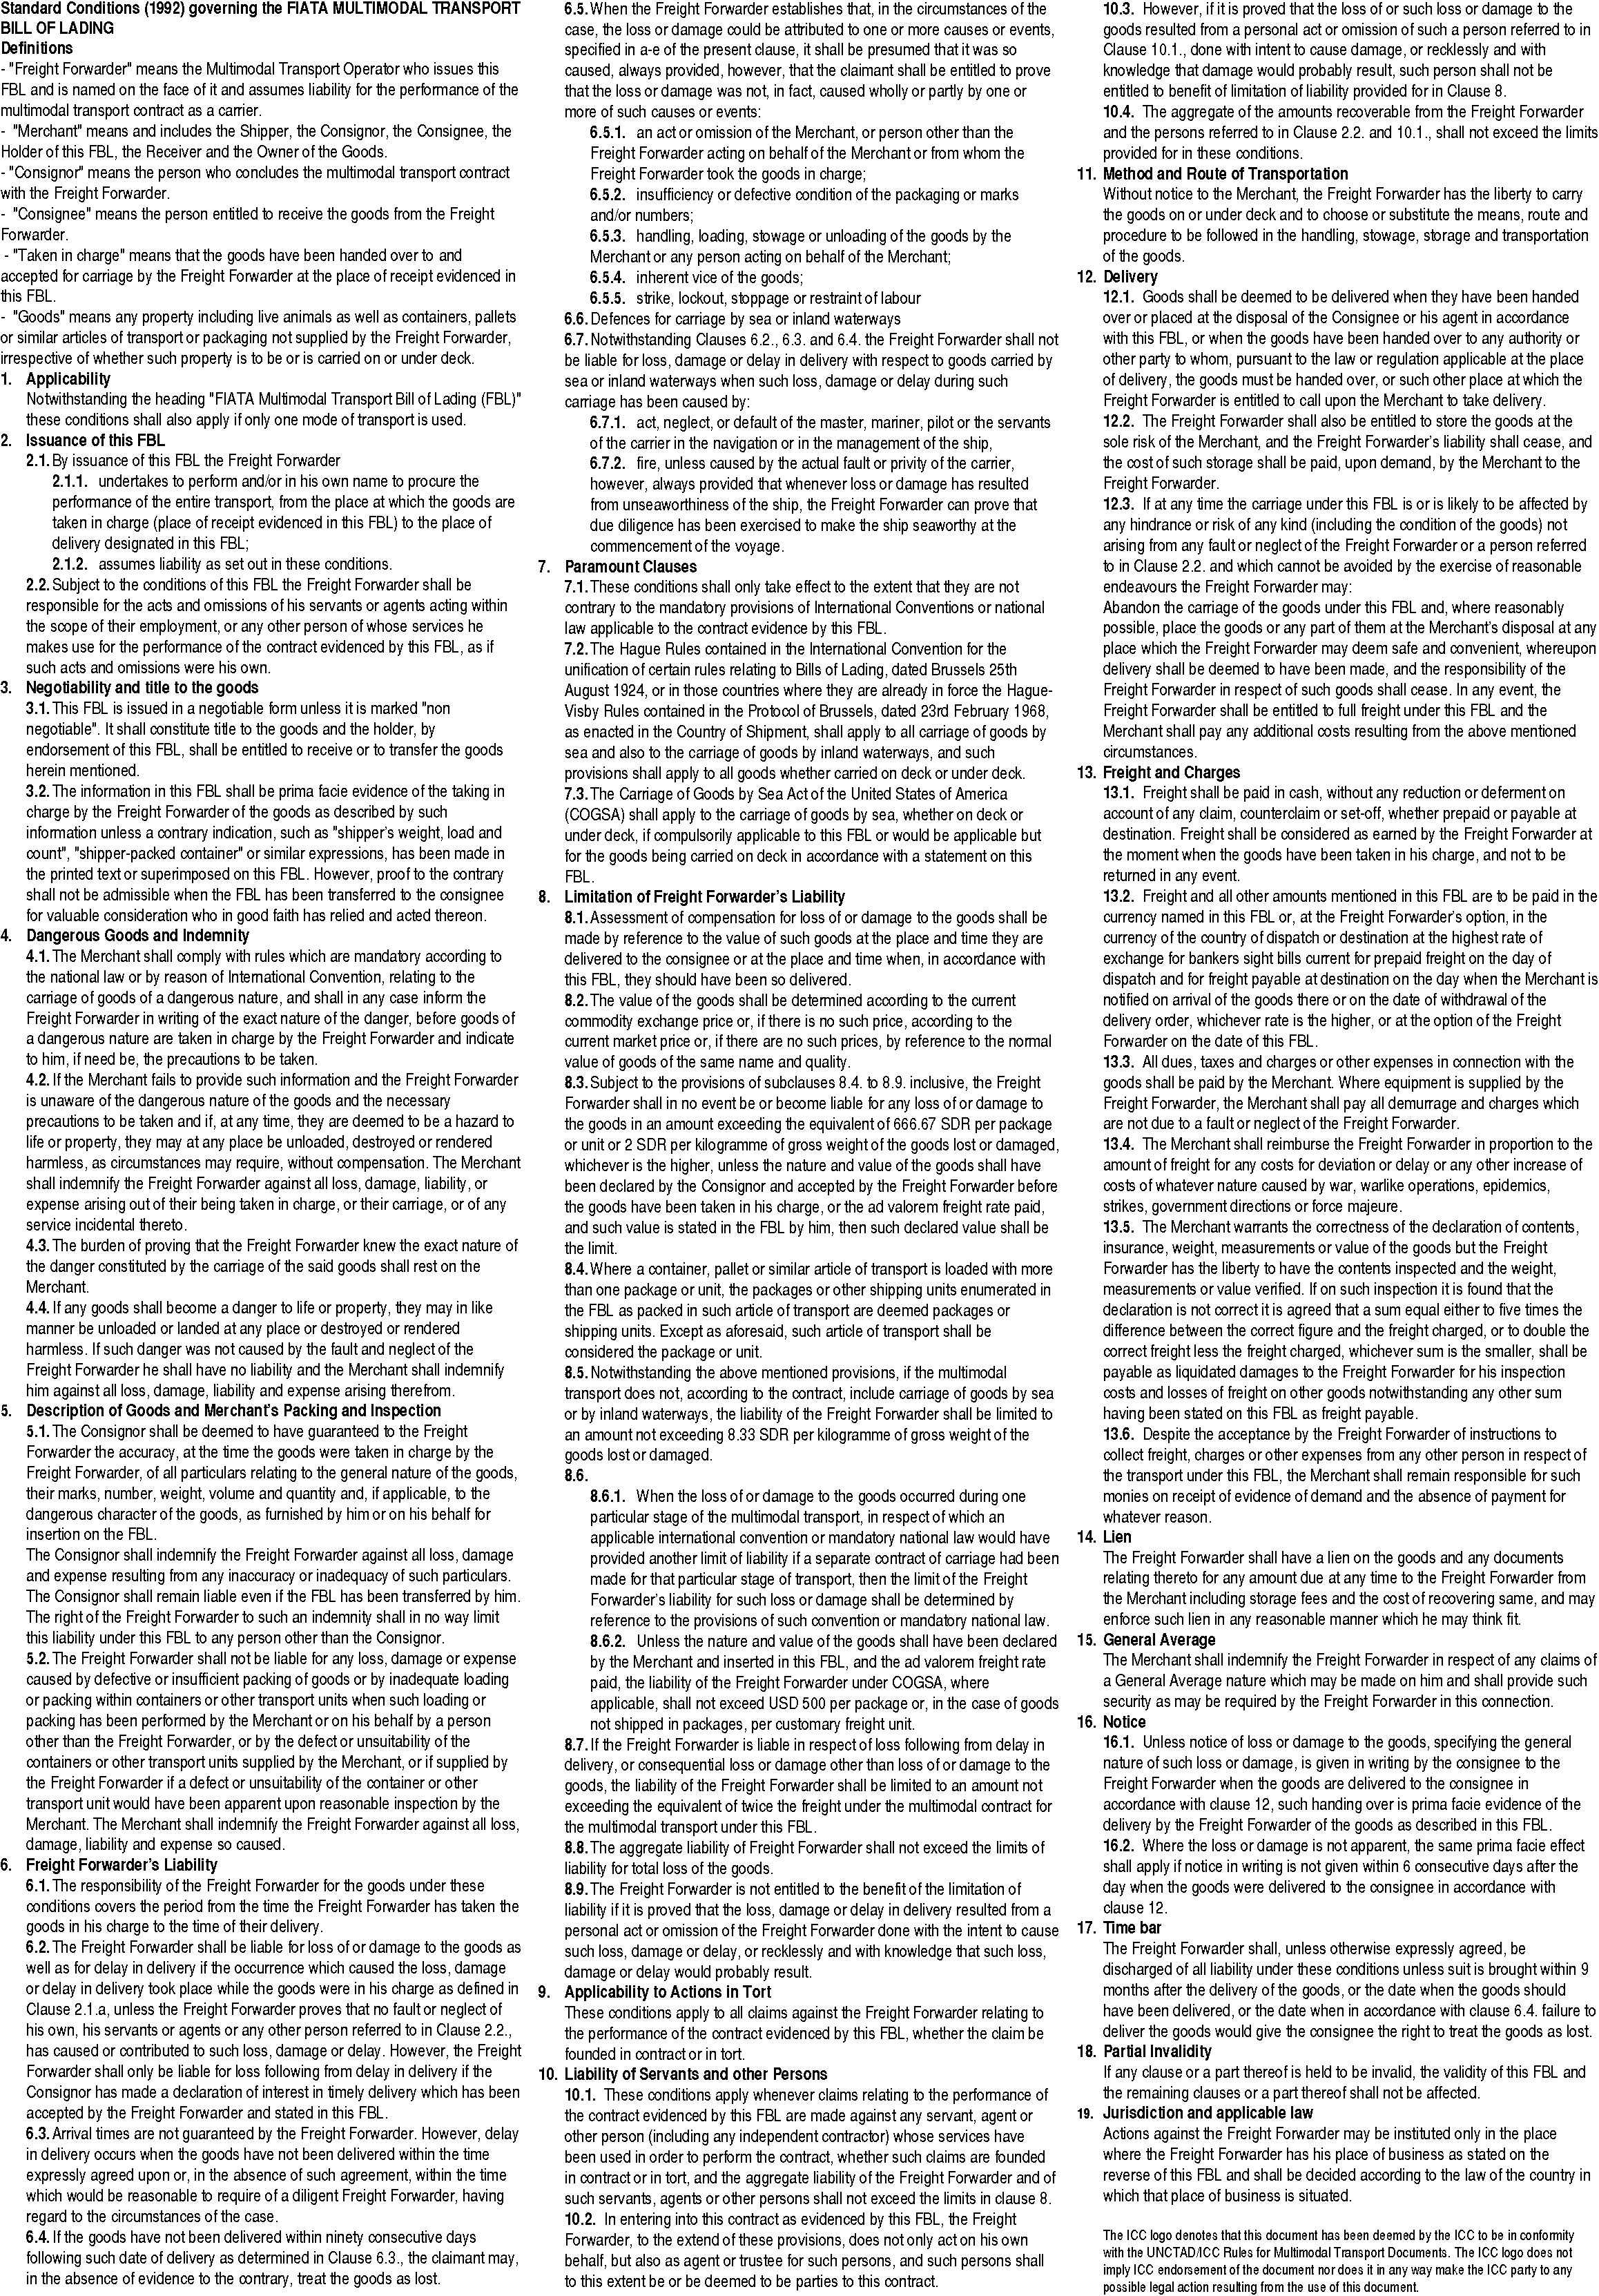

DRAFT — TRANSPORT PARTICULARS FOR REVIEW
Booking: {d.transport.reference}
This schedule forms part of the Draft. Blank values are not recorded. No security clearance, verified mass, signature or issuing authority is implied.
Parties — full saved names and addresses
Role | Name | Full address
{d.transport.parties[i].role:convCRLF} | {d.transport.parties[i].name:convCRLF} | {d.transport.parties[i].fullAddress:convCRLF}
{d.transport.parties[i+1].role:convCRLF} | {d.transport.parties[i+1].name:convCRLF} | {d.transport.parties[i+1].fullAddress:convCRLF}
Cargo — all lines
Line | Goods | Packages | Pack type | Gross kg | Chargeable kg | CBM
{d.transport.cargo[i].lineNumber:convCRLF} | {d.transport.cargo[i].description:convCRLF} | {d.transport.cargo[i].packageQuantity:convCRLF} | {d.transport.cargo[i].packageType:convCRLF} | {d.transport.cargo[i].grossWeight:convCRLF} | {d.transport.cargo[i].chargeableWeight:convCRLF} | {d.transport.cargo[i].volume:convCRLF}
{d.transport.cargo[i+1].lineNumber:convCRLF} | {d.transport.cargo[i+1].description:convCRLF} | {d.transport.cargo[i+1].packageQuantity:convCRLF} | {d.transport.cargo[i+1].packageType:convCRLF} | {d.transport.cargo[i+1].grossWeight:convCRLF} | {d.transport.cargo[i+1].chargeableWeight:convCRLF} | {d.transport.cargo[i+1].volume:convCRLF}
Cargo marks, commodity and handling
Line | Marks | Commodity | HS code | Handling
{d.transport.cargo[i].lineNumber:convCRLF} | {d.transport.cargo[i].marksAndNumbers:convCRLF} | {d.transport.cargo[i].commodity:convCRLF} | {d.transport.cargo[i].hsCode:convCRLF} | {d.transport.cargo[i].handling:convCRLF}
{d.transport.cargo[i+1].lineNumber:convCRLF} | {d.transport.cargo[i+1].marksAndNumbers:convCRLF} | {d.transport.cargo[i+1].commodity:convCRLF} | {d.transport.cargo[i+1].hsCode:convCRLF} | {d.transport.cargo[i+1].handling:convCRLF}
Equipment — all containers or ULDs
Number | Type | Seal | Recorded gross kg | Recorded VGM kg | CBM
{d.transport.equipment[i].number:convCRLF} | {d.transport.equipment[i].type:convCRLF} | {d.transport.equipment[i].seal:convCRLF} | {d.transport.equipment[i].grossWeight:convCRLF} | {d.transport.equipment[i].verifiedGrossMass:convCRLF} | {d.transport.equipment[i].volume:convCRLF}
{d.transport.equipment[i+1].number:convCRLF} | {d.transport.equipment[i+1].type:convCRLF} | {d.transport.equipment[i+1].seal:convCRLF} | {d.transport.equipment[i+1].grossWeight:convCRLF} | {d.transport.equipment[i+1].verifiedGrossMass:convCRLF} | {d.transport.equipment[i+1].volume:convCRLF}
Cargo splits — recorded quantities only
Cargo line | Equipment | Type | Packages | Allocated gross kg | Allocated CBM
{d.transport.allocations[i].cargoLine:convCRLF} | {d.transport.allocations[i].equipmentNumber:convCRLF} | {d.transport.allocations[i].equipmentType:convCRLF} | {d.transport.allocations[i].packages:convCRLF} | {d.transport.allocations[i].grossWeight:convCRLF} | {d.transport.allocations[i].volume:convCRLF}
{d.transport.allocations[i+1].cargoLine:convCRLF} | {d.transport.allocations[i+1].equipmentNumber:convCRLF} | {d.transport.allocations[i+1].equipmentType:convCRLF} | {d.transport.allocations[i+1].packages:convCRLF} | {d.transport.allocations[i+1].grossWeight:convCRLF} | {d.transport.allocations[i+1].volume:convCRLF}
Package quantities do not calculate container weight or VGM. Unnumbered equipment remains listed. Unrecorded splits are not estimated.
Information still to review
Not recorded / review required
{d.transport.gaps[i].label:convCRLF}
{d.transport.gaps[i+1].label:convCRLF}

