Capstone Project - 1
Predicting Property Prices in a Specific Location Using Machine Learning
Project Summary Report
Item | Details
Student name | Karan
Course / Program | Digicrome - Data Science & AI
Dataset | Digicrome_project_dataset.csv (1,460 properties, 81 columns)
Target variable | PropPrice (sale price in dollars)
Best model | Lasso regression (alpha = 0.001)
Hold-out test R2 / MAE / RMSE | 0.932 / $13,741 / $21,673
Date | 09 October 2026
Submitted files | Jupyter Notebook + this report (also: saved model, helper module, predict.py, requirements.txt, and submission.csv = predictions for the internal hold-out set, not an official test set)

1. Introduction to the Project

Background
The real-estate market is dynamic and a property's price is influenced by many factors at the same time: its size, quality, age, neighbourhood, the number of bathrooms, the garage, the basement and the conditions of the sale. Buyers, sellers, agents and banks all need a fair and quick estimate of a property's value.

Problem
The task is to build a supervised machine-learning regression model that predicts the selling price (PropPrice) of a property from its structural, quality, location, size and other characteristics.

Motivation and importance
- A wrong price estimate means a buyer overpays or a seller loses money.
- Manual valuation is slow and subjective; a model gives a consistent price within milliseconds.
- The model also shows which features drive prices, which helps owners decide where to invest (for example quality or area).

Role of machine learning
Property prices depend on dozens of variables whose effects interact (a large house is worth more when its quality is high). Machine-learning regression learns these patterns automatically from past sales. In this project the data is cleaned, explored, encoded, tested with scaling and PCA, and several regression algorithms are trained, tuned and compared with R2, MAE and RMSE.

About the data
Only one file was supplied (Digicrome_project_dataset.csv, which contains the target). Because the separate test.csv mentioned in the project PDF was not provided, the data was split into train (70 %), validation (15 %) and a hold-out test set (15 %) that was used only once at the end. Only the PropertyID column was removed; no other column was dropped. Columns starting with 'Basement' describe the garage (for example BasementCars = garage capacity), while the real basement columns start with 'Bsmnt'.

2. Objectives of the Project
- Collect and clean real-estate/property data.
- Understand and handle ordinal and nominal variables separately, using the metadata.
- Handle missing values with fillna() and imputers.
- Perform Exploratory Data Analysis (EDA) to find the key variables that influence property prices.
- Apply suitable encoding techniques (ordinal encoding for ordinal, one-hot encoding for nominal variables).
- Apply scaling where required.
- Investigate PCA and test whether it improves the model.
- Perform feature engineering.
- Build multiple machine-learning models (linear, tree-based and boosting models).
- Compare the performance of the models (R2, MAE, RMSE, cross-validation).
- Select the best-performing model and check overfitting.
- Evaluate the final model on unseen data.
- Generate property price predictions (submission file and a prediction function).
- Save the model for deployment.
- Present the findings and insights clearly.

3. Flow Chart of Operations
The complete workflow followed in this project is shown below (colour = phase of the project).
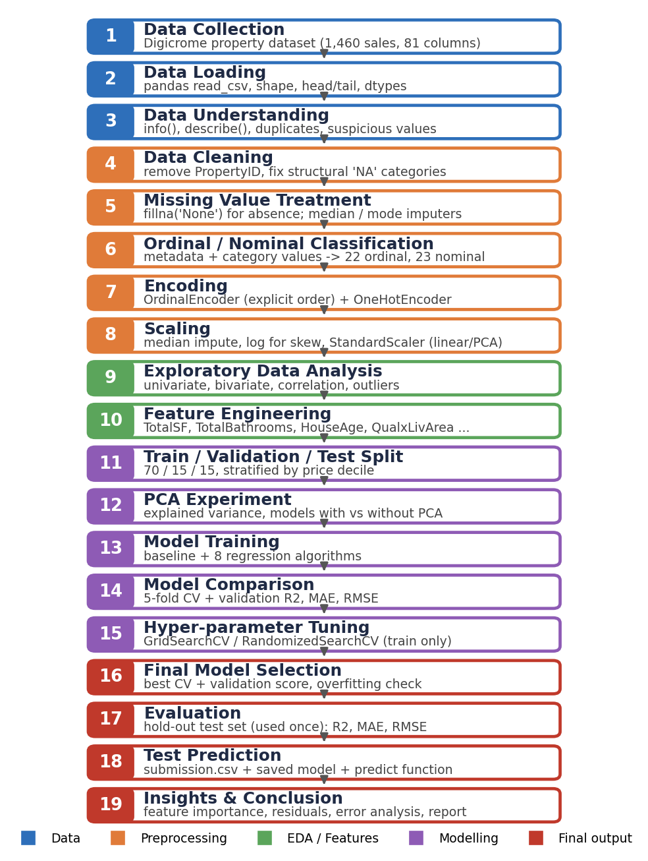
Figure 1: Flow chart of operations

4. Python Codes
The full code is in the Jupyter Notebook (Property_Price_Prediction.ipynb) and the helper file property_utils.py. Representative parts are shown here.

4.1 Loading the data
import pandas as pd, numpy as np
df = pd.read_csv("Digicrome_project_dataset.csv")
print("Dataset shape:", df.shape) # (1460, 81)
display(df.head()); display(df.tail(3))
print(df.dtypes.value_counts())
print("Duplicate rows:", df.duplicated().sum())

4.2 Cleaning and missing values (fillna)
def clean_data(df):
df = df.copy()
df = df.drop(columns=[c for c in ["PropertyID", "PropPrice"] if c in df.columns])
# basement columns: NaN + zero basement area -> 'None' (feature absent)
no_bsmt = df["BsmntSqFtage"].fillna(0) == 0
for c in ["BsmntFinish", "BsmntMaintenance", "BsmntVisibility", "BsmntFinRat1", "BsmntFinQual1"]:
df[c] = df[c].where(~(no_bsmt & df[c].isna()), "None")
df["BasementYrBlt"] = df["BasementYrBlt"].fillna(df["YearBuilt"])
for c in ["Alley", "BoundaryFeatures", "AddFeatures"]:
df[c] = df[c].fillna("None") # NaN really means 'no such feature'
df["PropertyClass"] = df["PropertyClass"].astype(str) # numeric code -> category
return df

4.3 Ordinal / nominal encoding, imputation and scaling
QUAL = ["None", "Po", "Fa", "TA", "Gd", "Ex"] # Poor < Fair < Typical < Good < Excellent
ORDINAL_ORDER = {"ExterQual": QUAL, "KitchenQual": QUAL, "PavedDrive": ["N", "P", "Y"], ...}

numeric = Pipeline([("impute", SimpleImputer(strategy="median", add_indicator=True)),
("skew", SkewFixer()), ("scale", StandardScaler())])
ordinal = Pipeline([("impute", SimpleImputer(strategy="most_frequent")),
("encode", OrdinalEncoder(categories=[ORDINAL_ORDER[c] for c in ORDINAL_COLS],
handle_unknown="use_encoded_value", unknown_value=-1))])
nominal = Pipeline([("impute", SimpleImputer(strategy="most_frequent")),
("onehot", OneHotEncoder(handle_unknown="ignore", sparse_output=False))])
encoder = ColumnTransformer([("num", numeric, make_column_selector(dtype_include=np.number)),
("ord", ordinal, ORDINAL_COLS), ("nom", nominal, NOMINAL_COLS)])

4.4 Exploratory data analysis
sns.histplot(df["PropPrice"], bins=40, kde=True) # target distribution
sns.boxplot(x="OverallQual", y="PropPrice", data=df) # quality vs price
corr = df.select_dtypes("number").corr()["PropPrice"].sort_values(key=abs, ascending=False)
sns.heatmap(df[top_cols].corr(), annot=True, cmap="RdBu_r", center=0)

4.5 Feature engineering
def add_features(df):
df["TotalSF"] = df["BsmntSqFtage"] + df["1stFlrSF"] + df["2ndFlrSF"]
df["TotalBathrooms"] = df["Bath1"] + 0.5*df["Bath2"] + df["BsmtFullBath"] + 0.5*df["BsmtHalfBath"]
df["HouseAge"] = (df["SaleYr"] - df["YearBuilt"]).clip(lower=0)
df["QualxLivArea"] = df["OverallQual"] * df["GrLivArea"]
return df

4.6 Model training, cross-validation and tuning
X_train, X_valid, y_train, y_valid = train_test_split(X_dev, y_dev, test_size=0.1765,
random_state=42, stratify=bins_dev)
model = make_model(Lasso(alpha=0.001), scaled=True) # Pipeline + log-price target
cv = KFold(n_splits=5, shuffle=True, random_state=42)
print(cross_val_score(model, X_train, y_train, cv=cv, scoring="r2").mean())

search = RandomizedSearchCV(make_model(GradientBoostingRegressor(random_state=42), scaled=False),
param_grid, n_iter=12, cv=cv, scoring="r2", random_state=42)
search.fit(X_train, y_train) # tuning uses the TRAIN part only

4.7 Evaluation and prediction
pred = final_model.predict(X_test)
print("R2 :", r2_score(y_test, pred))
print("MAE :", mean_absolute_error(y_test, pred))
print("RMSE:", root_mean_squared_error(y_test, pred))

joblib.dump(final_model, "property_price_model.pkl")
def predict_property_price(property_data, model=loaded):
out = model.predict(pd.DataFrame([property_data]))
return float(out[0])

5. Screenshot of the Outputs
The screenshots below were generated directly from the notebook outputs.
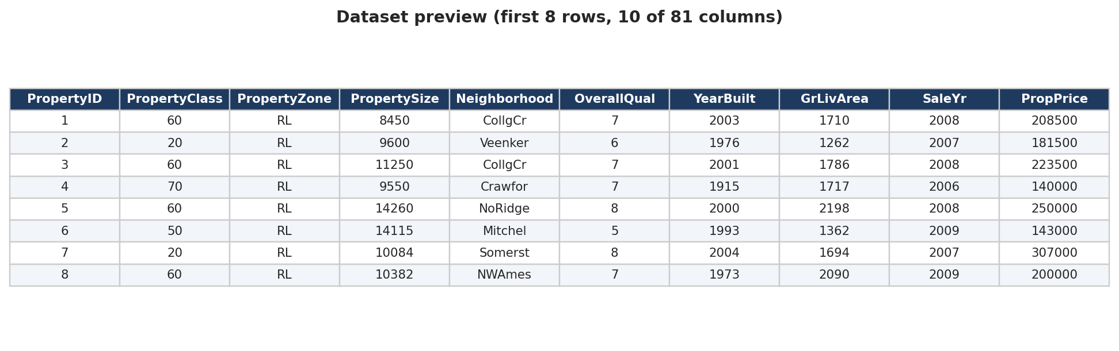
Output 1: Dataset preview
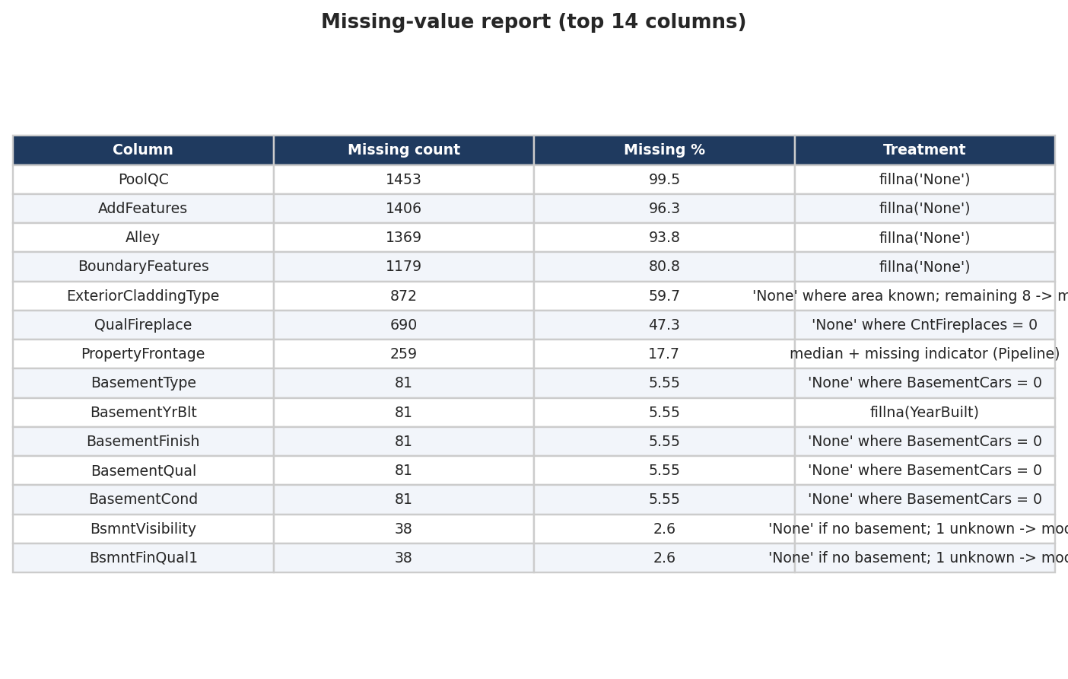
Output 2: Missing-value report with treatment
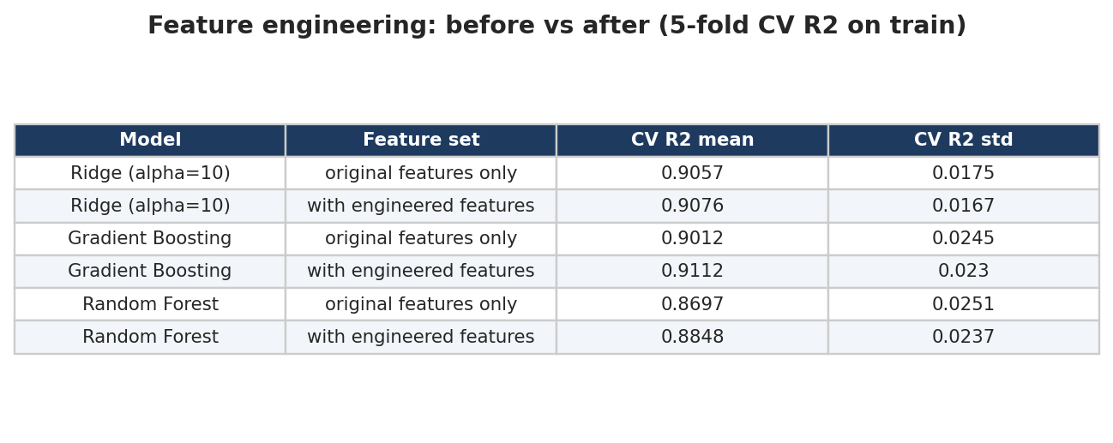
Output 3: Feature engineering before vs after
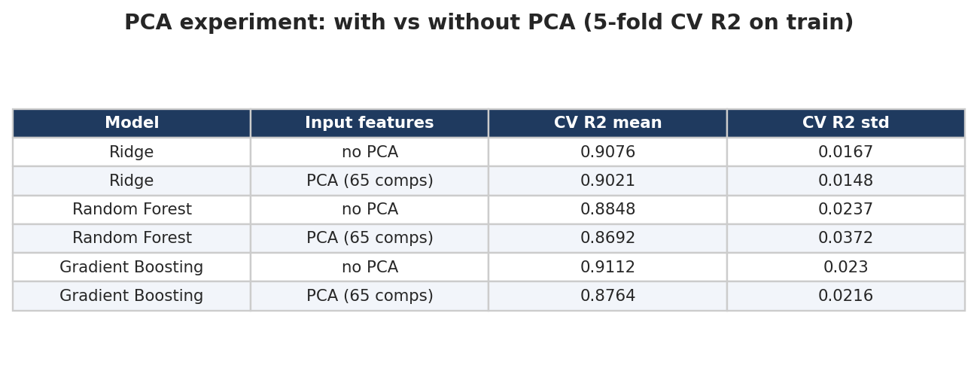
Output 4: PCA experiment
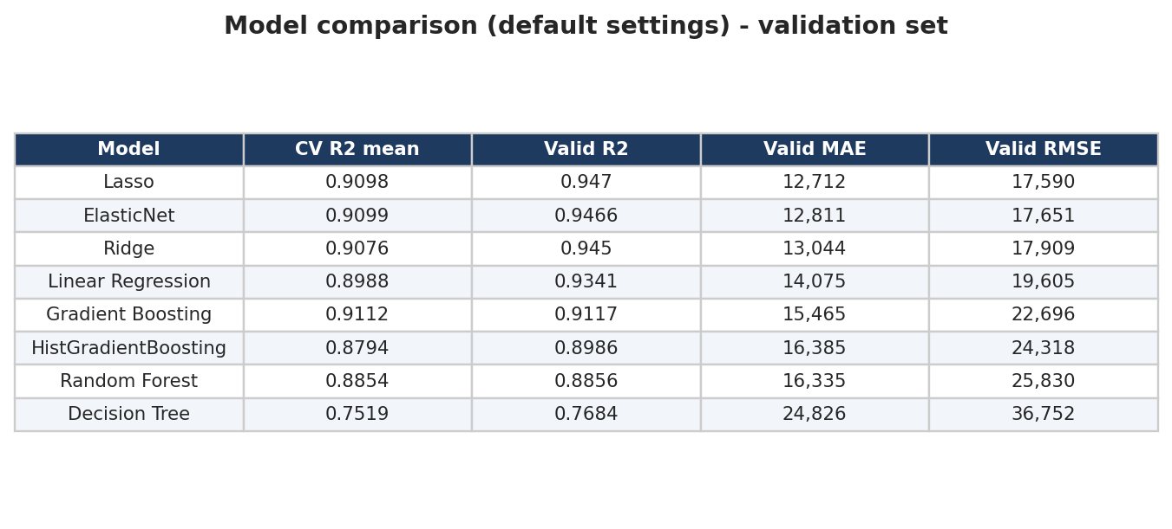
Output 5: Model comparison (default settings)
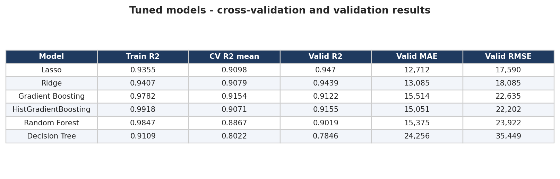
Output 6: Tuned models
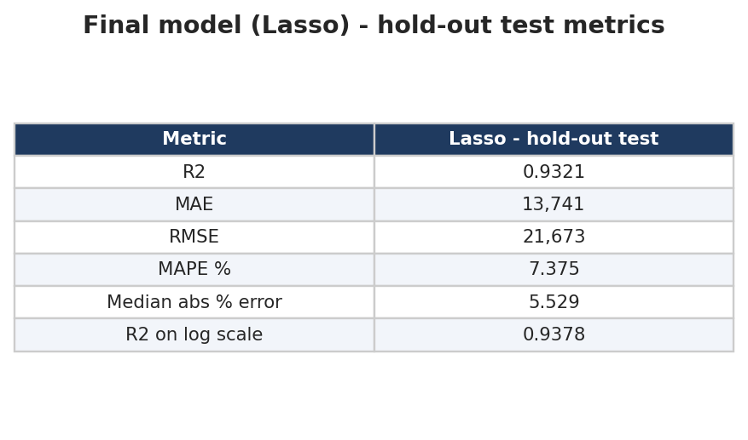
Output 7: Final metrics on the hold-out test set
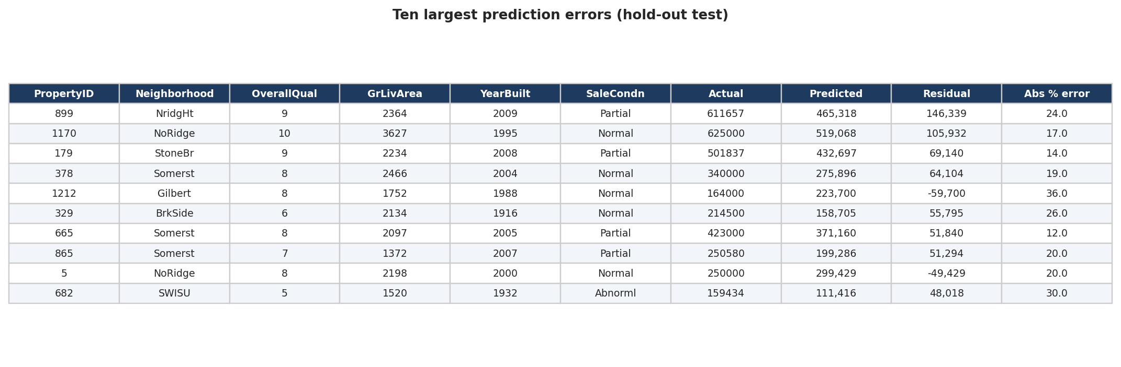
Output 8: Largest prediction errors
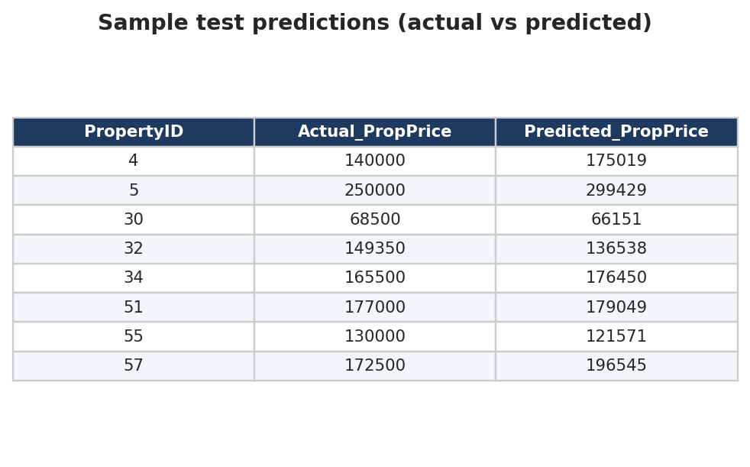
Output 9: Sample test predictions

6. Report on EDA

6.1 Target variable
PropPrice ranges from $34,900 to $755,000 with mean $180,921 and median $163,000. The skewness is 1.88 (right-skewed); after log(1 + price) it falls to 0.12.
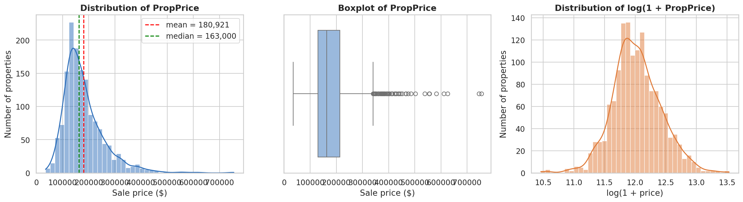
Figure 2: Distribution of PropPrice

6.2 Missing values and outliers
19 columns contain NaN, but most of them mean that the property does not have the feature (no alley, pool, fence, fireplace, garage or basement). These were filled with an explicit 'None' category using fillna(); only 5 columns keep real unknowns (PropertyFrontage 259 rows, masonry veneer type/area 8, two basement columns 1 each, Electrical 1), which are imputed with the median/mode inside the pipeline.
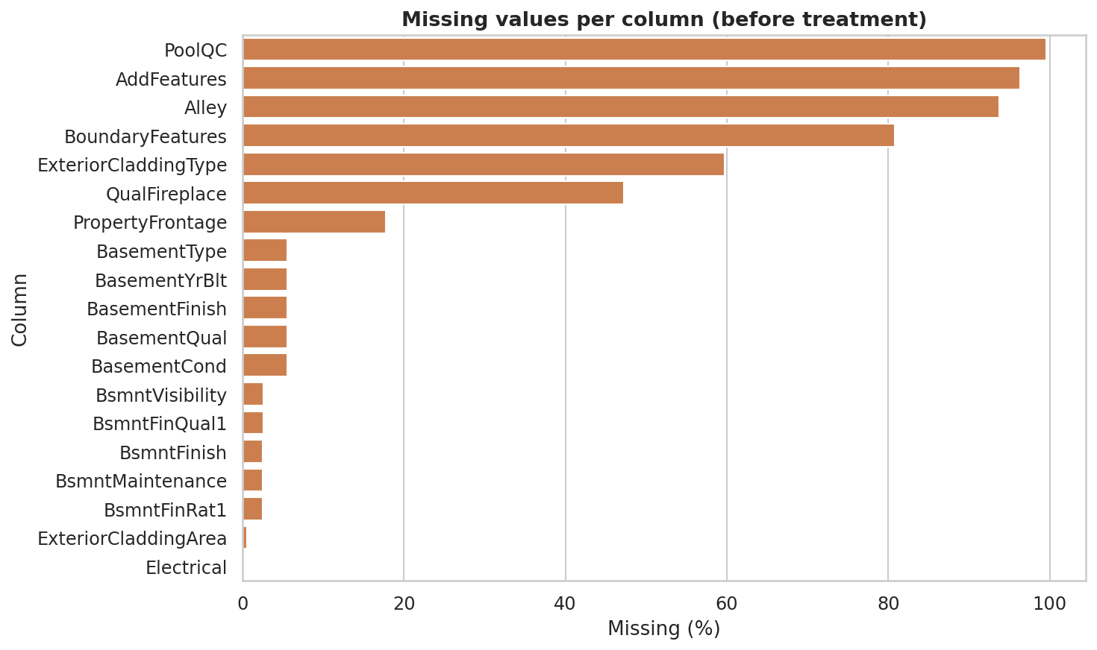
Figure 3: Missing values per column before treatment
Four houses exceed 4,000 sq ft. Two are 'Partial' sales at only $184,750 and $160,000 (non-representative); two are genuine luxury sales ($755,000 and $745,000). Only the two non-representative sales were removed - from the training data only - because they made linear models unstable (Ridge CV R2 0.727 with them, 0.908 without).
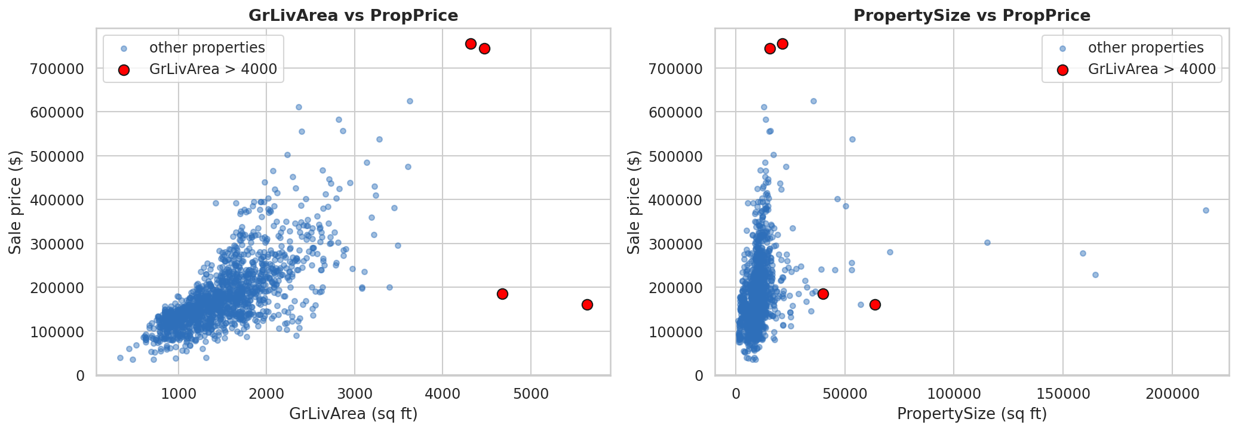
Figure 4: Outliers - GrLivArea and PropertySize vs price

6.3 Univariate analysis
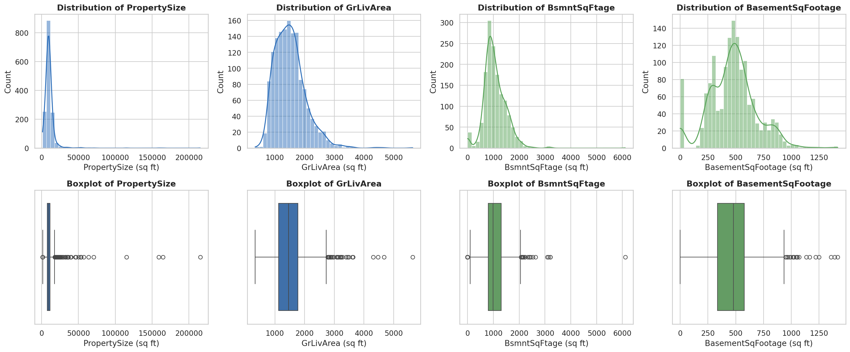
Figure 5: Distribution of area variables
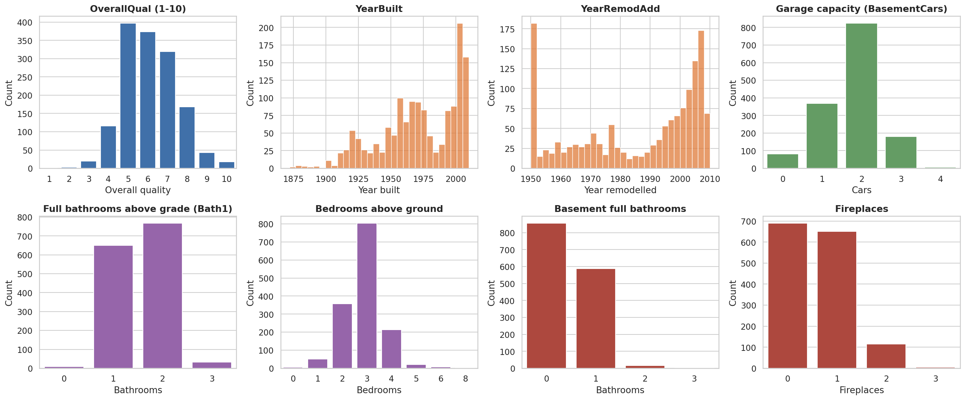
Figure 6: Quality, year, garage, bathroom and bedroom counts
Area variables are right-skewed with a few very large properties. OverallQual is centred around 5-7, houses were built between 1872 and 2010, and a typical property has about 3 bedrooms, 1-2 full bathrooms and a garage for 1-2 cars.

6.4 Bivariate analysis
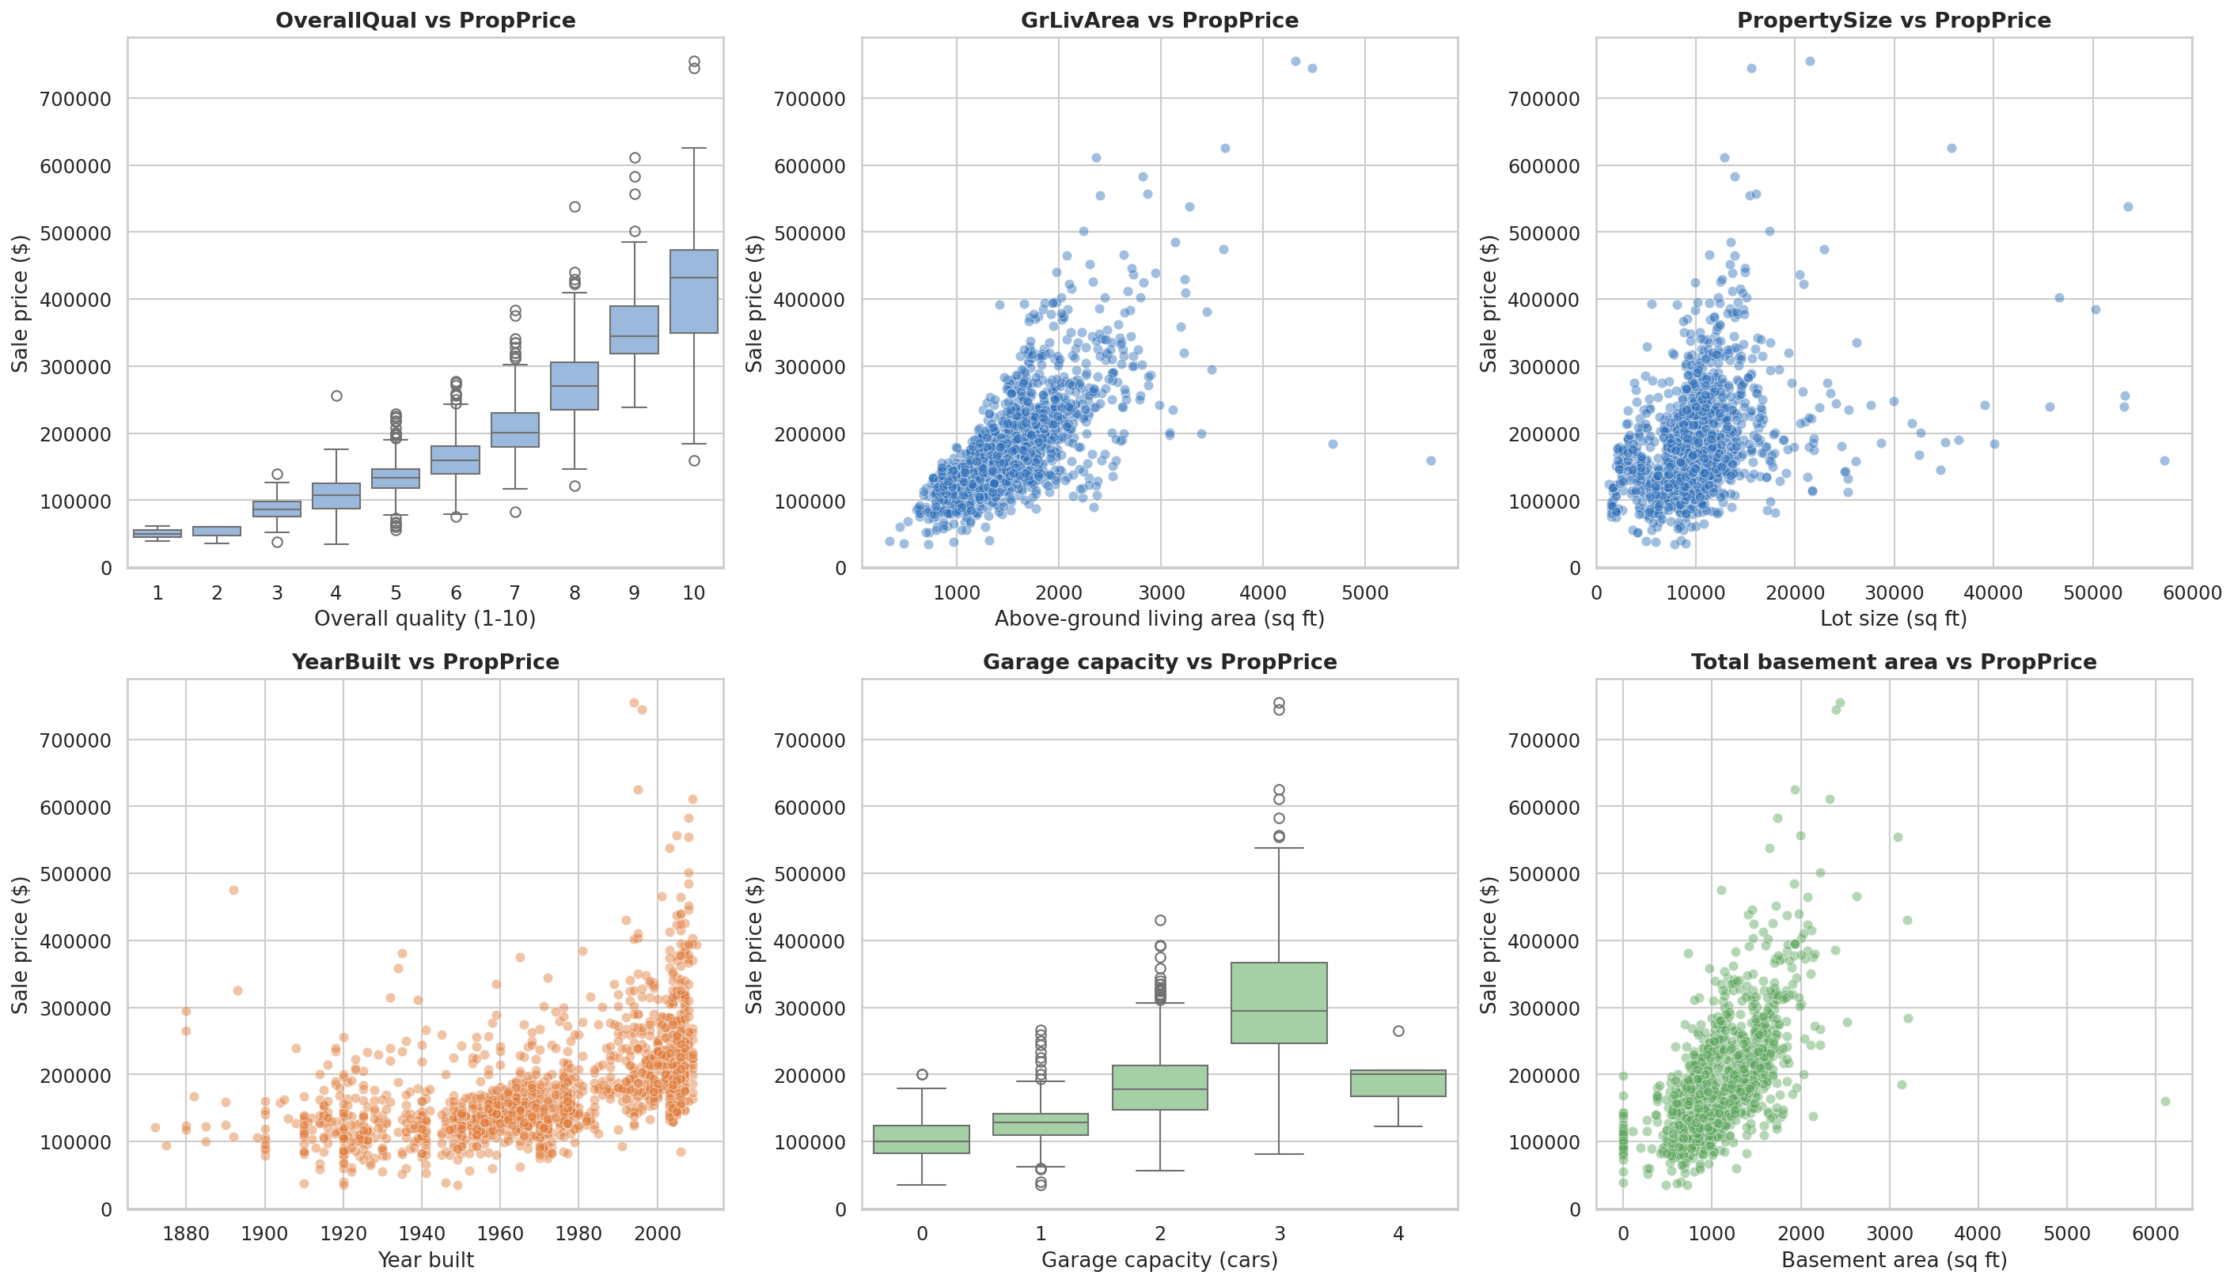
Figure 7: Key features vs PropPrice
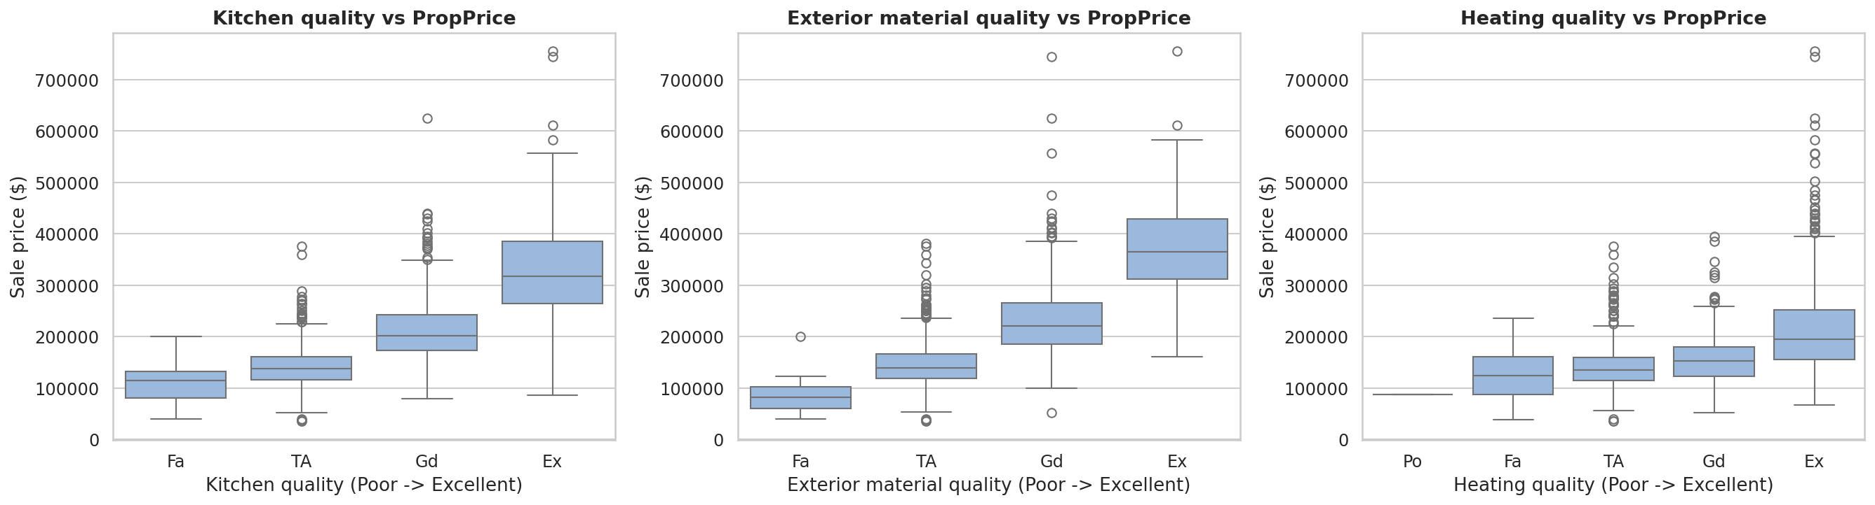
Figure 8: Kitchen, exterior and heating quality vs PropPrice
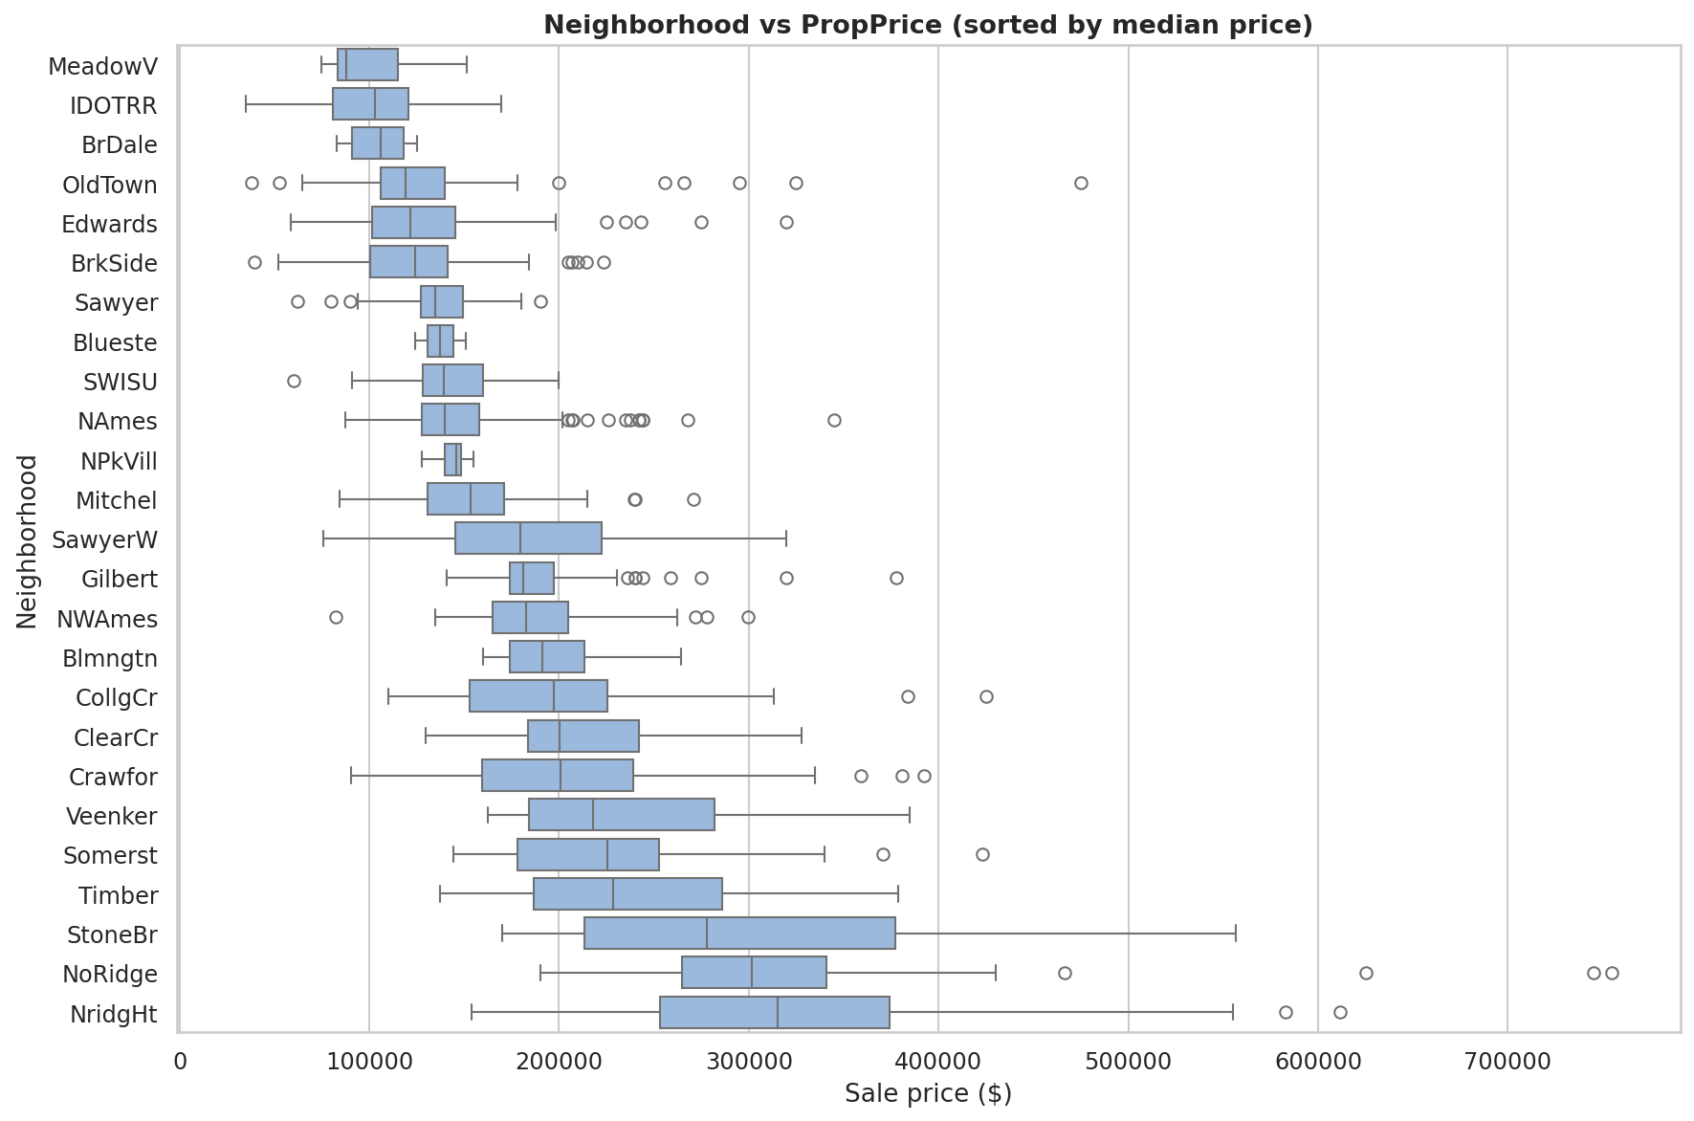
Figure 9: Neighborhood vs PropPrice
- Quality is the strongest pattern: median price rises from $50,150 (OverallQual 1) to $200,141 (7) and $432,390 (10).
- Price grows almost linearly with above-ground living area; lot size has only a weak relationship (correlation 0.26).
- Newer houses, bigger basements and larger garages (up to 3 cars) sell for more; better kitchen and exterior quality means a higher price.
- Location matters: the median price is $88,000 in MeadowV, but $315,000 in NridgHt - a difference of about 3.5 times.

6.5 Correlation analysis
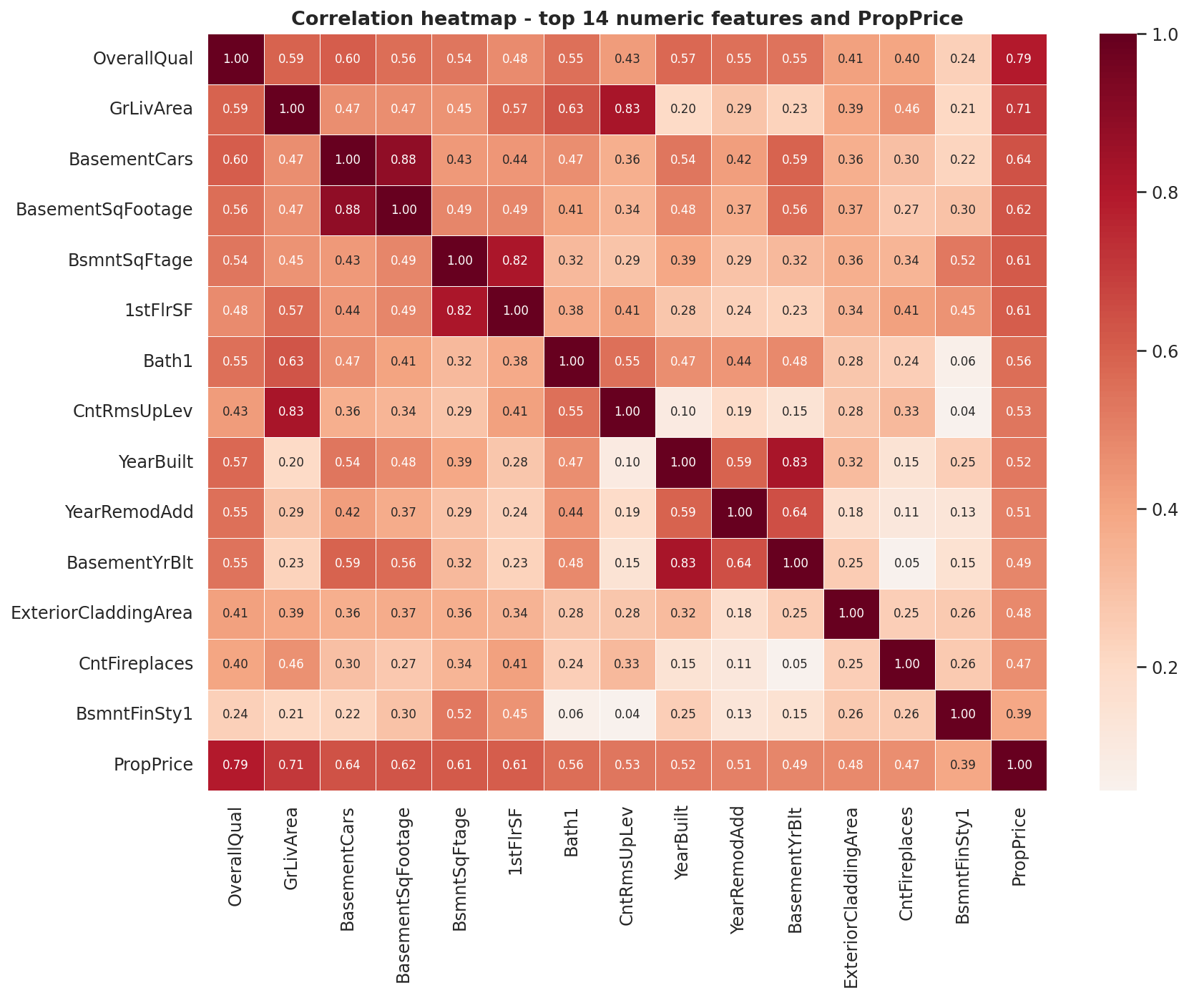
Figure 10: Correlation heatmap of the top features
Feature | Correlation with PropPrice
OverallQual | 0.791
GrLivArea | 0.709
BasementCars | 0.640
BasementSqFootage | 0.623
BsmntSqFtage | 0.614
1stFlrSF | 0.606
Bath1 | 0.561
CntRmsUpLev | 0.534

Correlation does not prove causation: a bigger garage does not by itself raise the price; it comes together with a bigger, newer and better house. Strongly inter-correlated pairs (garage cars and garage area 0.88, YearBuilt and garage year 0.83, GrLivArea and room count 0.83) explain why regularised linear models are stable on this data.

6.6 Important features and feature engineering
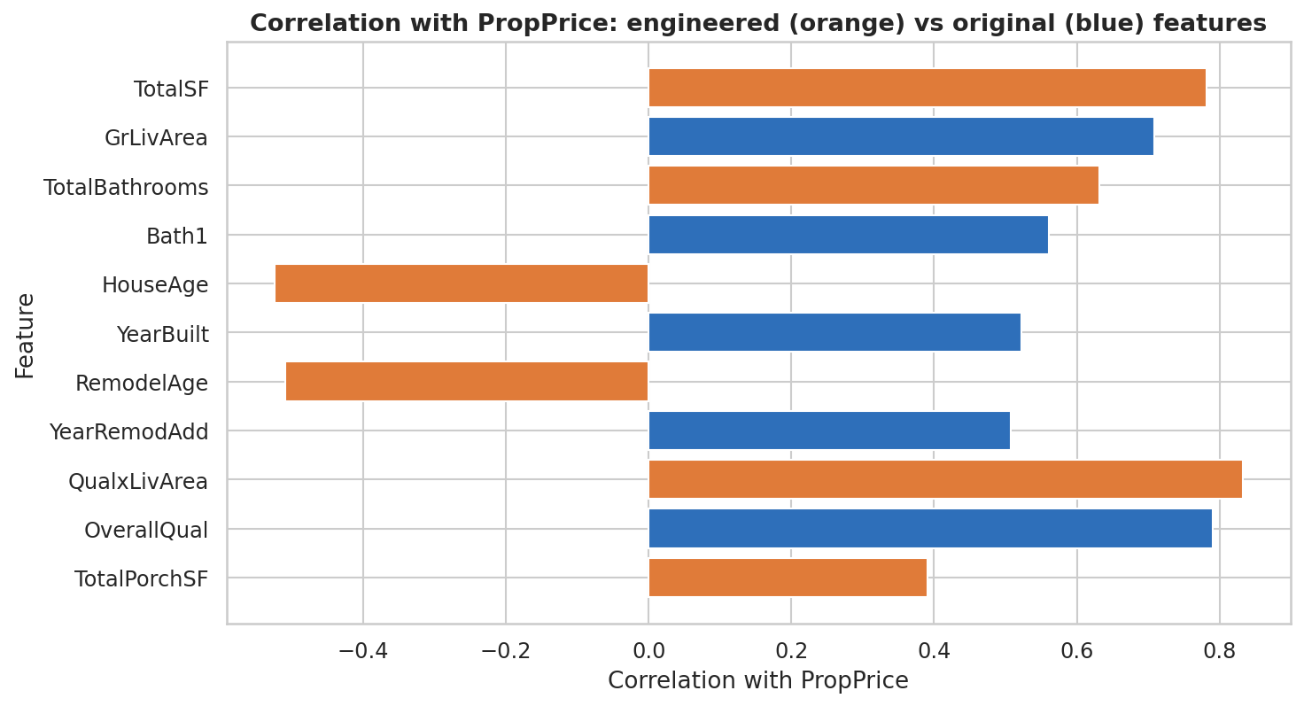
Figure 11: Engineered vs original features - correlation with PropPrice
Engineered features such as QualxLivArea (0.83), TotalSF (0.78) and TotalBathrooms (0.63) correlate more strongly with price than the original columns. In cross-validation they improved every model (Ridge 0.906 to 0.908, Gradient Boosting 0.901 to 0.911, Random Forest 0.870 to 0.885).

6.7 Key findings of the EDA
- Price is right-skewed; a log transformation fixes this and helped the linear models.
- OverallQual and GrLivArea are the two strongest predictors; basement area, garage size and YearBuilt follow.
- Neighborhood has a strong effect on price.
- Most missing values mean 'feature absent' and must not be replaced by zero or the median.
- Outliers must be judged one by one: genuine luxury sales were kept, two non-representative partial sales were removed from training.

7. Learning Outcomes
Topic | What was learned
Python | Writing clean, commented code, functions, a reusable helper module (property_utils.py) and saving/loading a model with joblib.
Pandas | Loading data, inspecting it (info, describe, isnull), filtering, group-by summaries and using fillna() and where() for cleaning.
NumPy | Numerical operations, log1p/expm1 transformations, percentile and statistics calculations.
Data cleaning | Telling real missing data apart from 'feature absent', checking duplicates and suspicious values, and judging outliers instead of deleting them blindly.
EDA | Histograms, boxplots, scatterplots, violin plots and correlation heatmaps, and writing insights based on the real data.
Feature engineering | Building TotalSF, TotalBathrooms, HouseAge and interaction features and testing whether they really help.
Encoding | Ordinal encoding with explicit order for ratings, one-hot encoding for nominal categories, and why arbitrary numbers for nominal data are wrong.
Scaling | Why linear models, penalties and PCA need scaled features and trees do not; fitting the scaler on training data only.
PCA | Explained variance, choosing components, and showing experimentally that PCA did not improve this model.
Regression | Linear, Ridge, Lasso, ElasticNet, Decision Tree, Random Forest and Gradient Boosting, including regularisation and overfitting.
Model evaluation | R2, MAE, RMSE, percentage error, cross-validation, train/validation/test splitting, residual and error analysis.
ML pipelines | Pipeline and ColumnTransformer, which keep preprocessing and model together and prevent data leakage.
Model comparison | Comparing models fairly with the same folds and metrics, tuning with GridSearchCV/RandomizedSearchCV and choosing the final model with a rule decided in advance.

8. Conclusion
Objective. To predict the sale price of a property from 80 features using machine learning.
Data preparation. Only PropertyID was removed. Absent features were filled with an explicit 'None' category using fillna(); real unknowns were imputed inside the pipeline; 22 ordinal columns were encoded with explicit order, 23 nominal columns were one-hot encoded (261 model features on the training split) and numeric features were scaled for linear models.
Experiments. Engineered features improved cross-validation R2 for all models; a log target helped; PCA did not improve any model (Ridge 0.908 to 0.902, Random Forest 0.885 to 0.869, Gradient Boosting 0.911 to 0.876), so it was not used in the final model.

Model comparison (tuned models)
Model | CV R2 | Valid R2 | Valid MAE | Valid RMSE
Lasso | 0.9098 | 0.9470 | $12,712 | $17,590
Ridge | 0.9079 | 0.9439 | $13,085 | $18,085
Gradient Boosting | 0.9154 | 0.9122 | $15,514 | $22,635
HistGradientBoosting | 0.9071 | 0.9155 | $15,051 | $22,202
Random Forest | 0.8867 | 0.9019 | $15,375 | $23,922
Decision Tree | 0.8022 | 0.7846 | $24,256 | $35,449

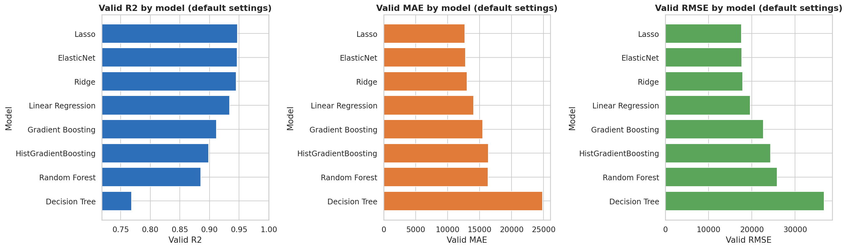
Figure 12: Model comparison (default settings)
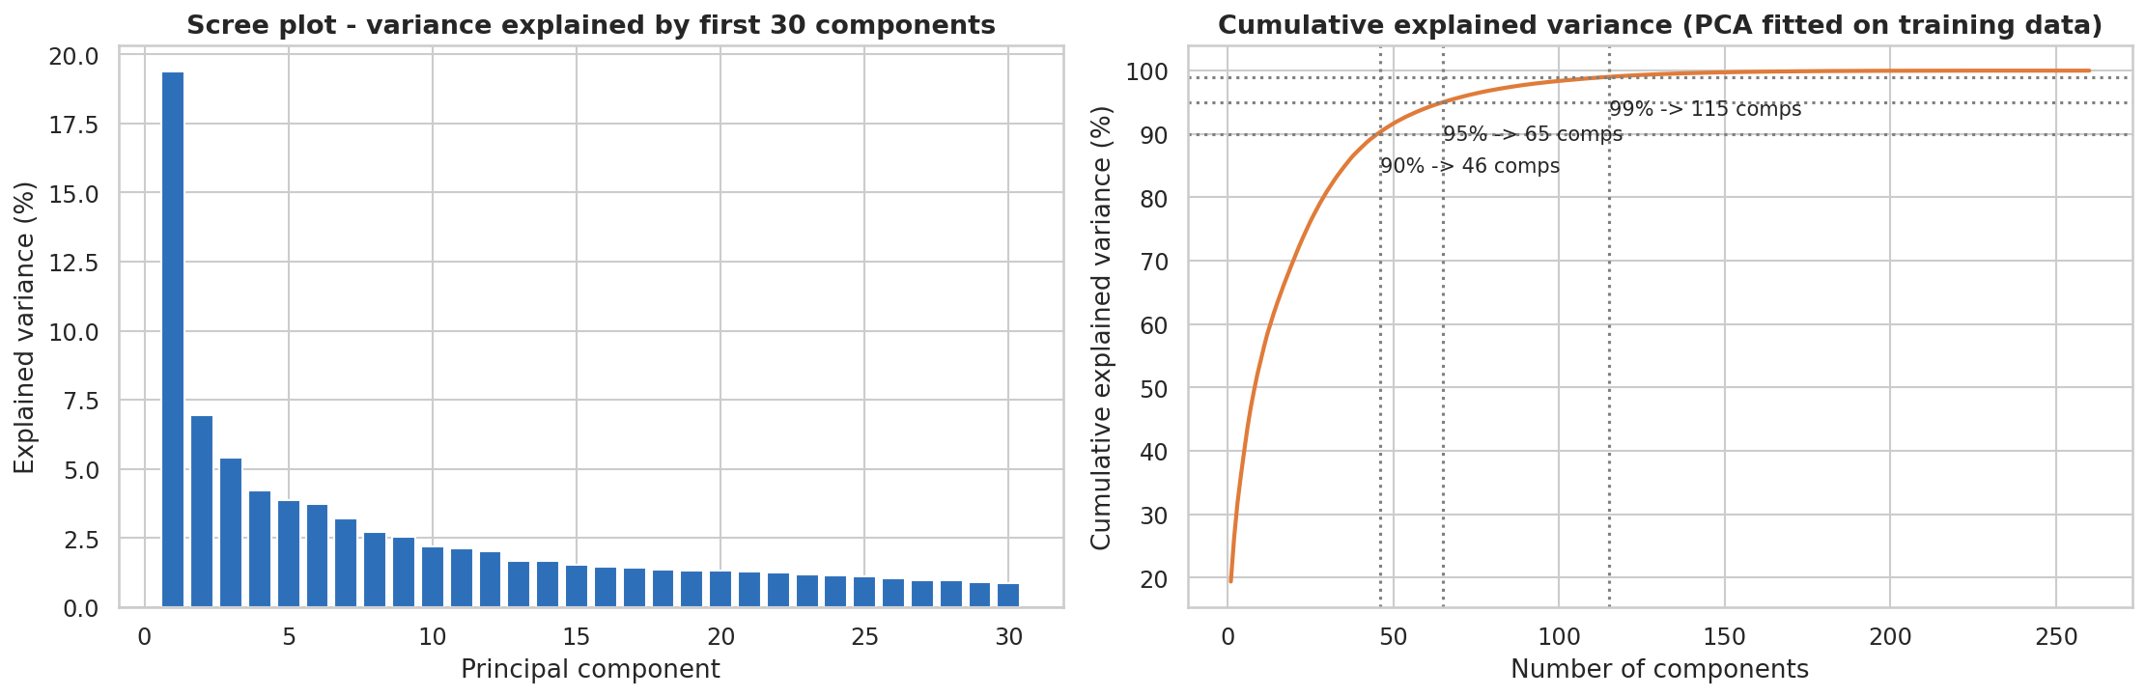
Figure 13: PCA explained variance
Best model: Lasso regression (alpha = 0.001) on log-price. It had the best combined CV/validation score, the lowest validation MAE and RMSE and no overfitting. Gradient Boosting had the best CV R2 but a larger train-validation gap (0.066). The top models are close in score.

Final result on the hold-out test set (219 properties)
Metric | Value
R2 | 0.9321
MAE | $13,741
RMSE | $21,673
Mean absolute % error | 7.4 %
Median absolute % error | 5.5 %
Predictions within 10 % of the real price | 73.1 %
Predictions within 20 % of the real price | 94.1 %

The R2 of 93.2 % is above the 85 % level that the project describes as much better.
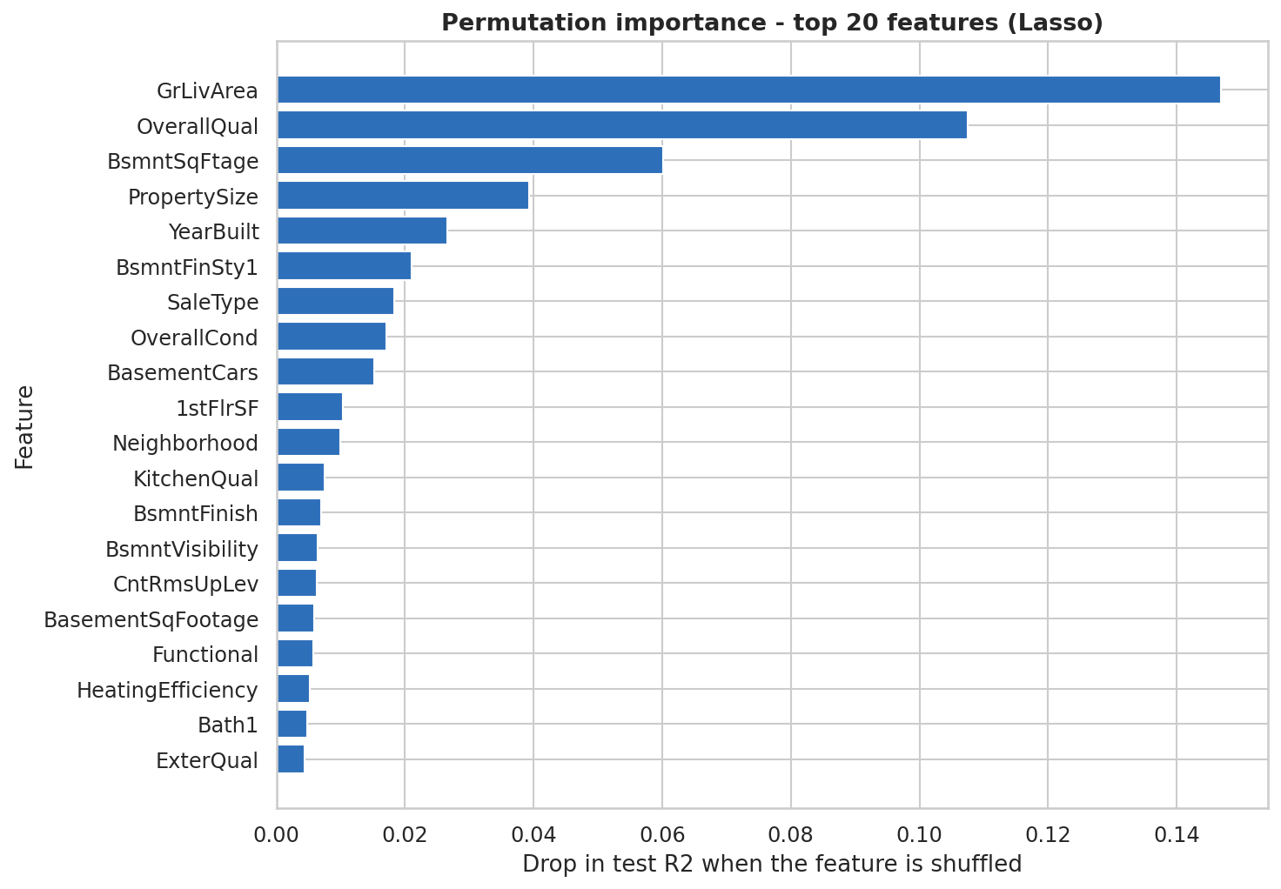
Figure 14: Permutation importance (top 20 features)
Important features: GrLivArea (0.147) and OverallQual (0.108) are far ahead, followed by total basement area (0.060), lot size (0.039) and YearBuilt (0.027); Neighborhood and KitchenQual also contribute.
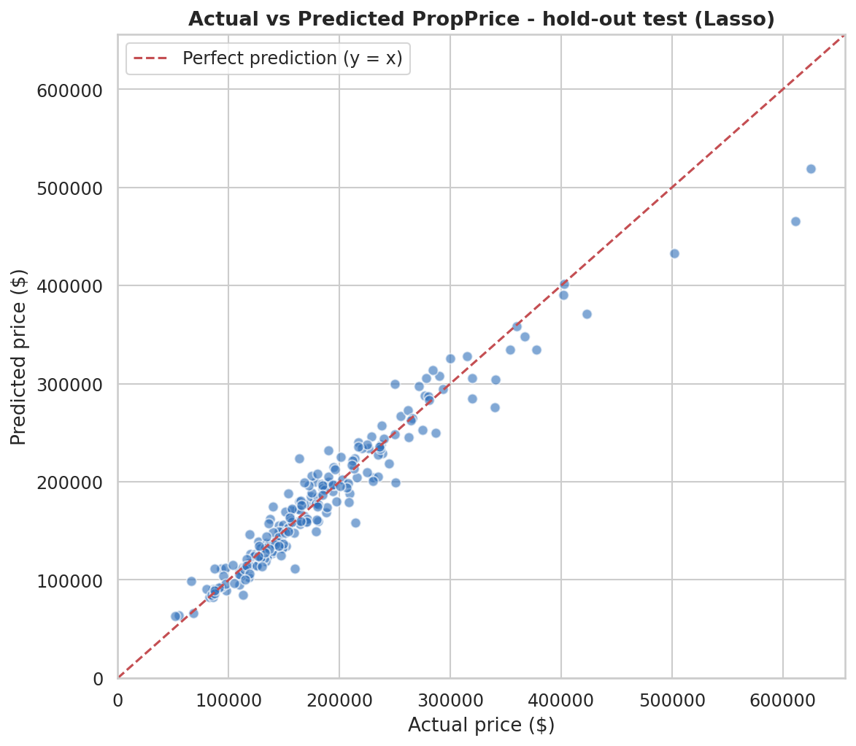
Figure 15: Actual vs predicted price (hold-out test)
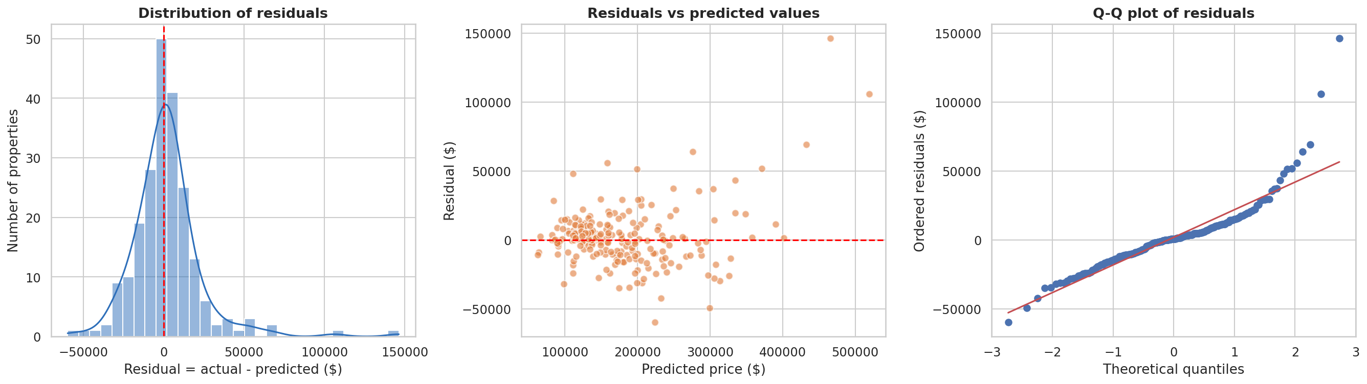
Figure 16: Residual analysis
Predictions follow the diagonal closely. The percentage error is similar in all price bands (about 7-8 %), but the dollar error grows with price and the model under-predicts expensive houses (average residual +$11,168 in the top quarter). The largest errors are expensive, high-quality houses and 'Partial' sales.

Limitations
- Only 1,460 sales from one city; no separate test file was provided, so a hold-out split was used.
- submission.csv contains predictions for the 219-property internal hold-out set, not for an official test.csv. sample_submission.csv and data_description.txt were also not supplied, so the file follows the PropertyID, PropPrice convention and the feature definitions come from the project PDF (they could not be checked against a separate description file).
- Expensive houses are under-predicted and abnormal sale conditions add noise.
- The top models are close, so small R2 differences should not be over-interpreted.
- XGBoost, LightGBM, CatBoost and SHAP were not available in the environment.

Possible future improvements
- Try XGBoost / LightGBM / CatBoost and SHAP explanations.
- Stacking or ensembling Lasso with boosting models.
- More interaction and neighbourhood-level features.
- A time-aware split and prediction intervals.
- Deploy the saved model as a small web app.

Verification of the saved model and files
- Saved model: property_price_model.pkl loads with scikit-learn 1.8.0 (the version it was saved with) and returns numeric, finite predictions in a sensible range (about $138,000 to $298,000) for 8 real property records taken from the dataset preview in the notebook. The same call works for a single property given as a dictionary, including a record with only 5 fields. This is a functional test, not an accuracy measurement, because those records were part of the data the deployed model was trained on.
- submission.csv: 219 rows, columns PropertyID and PropPrice, no duplicate IDs, no missing values, all prices positive (minimum $62,983, maximum $519,068). These are hold-out predictions, not official test predictions.
- Metrics: the hold-out values in this report (R2 0.9321, MAE $13,741, RMSE $21,673) are the values recorded in the notebook output and they agree with the notebook text. They were not recalculated independently because the dataset file was not available at the time of this check. A zero-safe metrics function (regression_metrics in property_utils.py) was added; it excludes rows with a true price of 0 from percentage metrics. PropPrice has no zero values (minimum $34,900), so no row is excluded.
- Reproducibility: requirements.txt, README.md and predict.py describe and automate how to run the project from a clean environment, and how to create a submission file once an official test.csv and sample_submission.csv are available.

9. Citations
- Pedregosa, F. et al. (2011). Scikit-learn: Machine Learning in Python. Journal of Machine Learning Research, 12, 2825-2830. https://scikit-learn.org
- scikit-learn user guide and API documentation (Pipeline, ColumnTransformer, OrdinalEncoder, OneHotEncoder, SimpleImputer, PCA, Lasso, RandomizedSearchCV, permutation_importance). https://scikit-learn.org/stable/user_guide.html
- pandas documentation. https://pandas.pydata.org/docs/
- NumPy documentation. https://numpy.org/doc/
- Matplotlib documentation (https://matplotlib.org/stable/) and Seaborn documentation (https://seaborn.pydata.org/).
- De Cock, D. (2011). Ames, Iowa: Alternative to the Boston Housing Data as an End of Semester Regression Project. Journal of Statistics Education, 19(3) - source of the original data description cited in the project PDF.
- Digicrome. Capstone Project 1: Predicting Property Prices in a Specific Location Using Machine Learning (project PDF and dataset).
- Geron, A. (2022). Hands-On Machine Learning with Scikit-Learn, Keras and TensorFlow, 3rd edition. O'Reilly Media.

