**Author:** Nathan Ngo

**Created at**: 25/07/2025

## **Trends Over Time**:

What trends do you observe in contract volumes and award amounts over time? What might explain seasonal or yearly spikes?

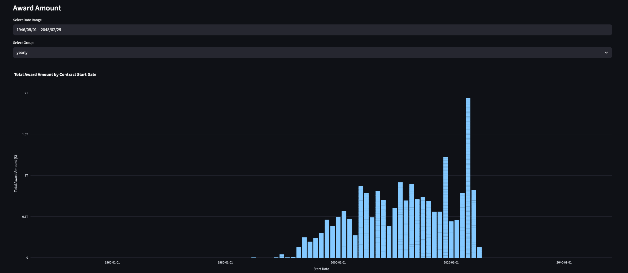

Based on the chart.

**Early Years (Pre-1990s)**:

* Very few contracts with low total award amounts.
* Possibly incomplete data or limited digital record-keeping before the 1990s.

**Steady Growth (1995–2010)**:

* A clear increase in total award amounts year-over-year.
* Indicates growth in procurement activity or broader economic expansion.

**Peaks Around 2015–2020**:

* Notable spikes in contract award amounts.
* These could reflect:  
  + Major infrastructure or modernization projects.
  + Response to large-scale city programs.
  + Stimulus funding or political changes (e.g., mayoral terms).

**Post-2020 Drop & Outliers**:

* Some extremely high spikes (especially around 2019–2020).  
  + May correspond to emergency COVID-19 contracts or long-term city initiatives.
* Sudden dips afterward could indicate:  
  + Budget cuts
  + Delays or audits
  + Data incompleteness for recent years

***Yearly explanation:***

**Election cycles**: Government spending often surges before elections.

**External shocks**: Events like the 2008 recession or COVID-19 heavily influence spikes/drops.

## **Departmental Spend Analysis:**

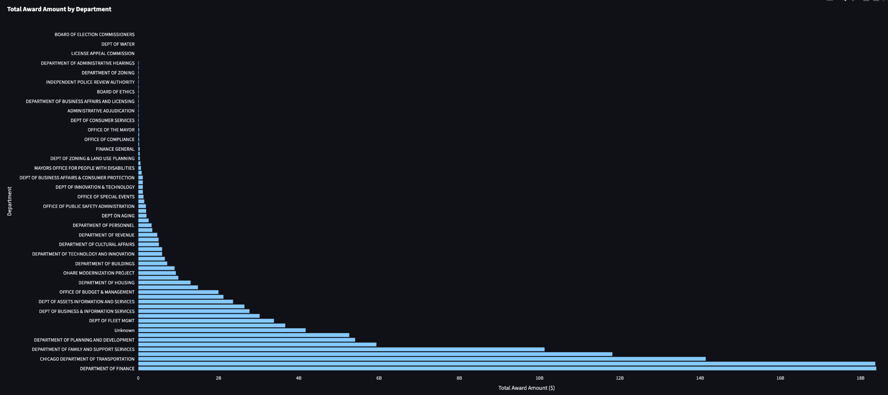

The departments awarding the highest total contract amounts include:

1. **Department of Finance**
2. **Chicago Department of Transportation**
3. **Department of Family and Support Services**
4. **Department of Planning and Development**
5. **Unknown** (misclassified data)

These departments collectively account for a **significantly larger share** of the city’s procurement budget.

*The relationship between contract duration vs award amount:*

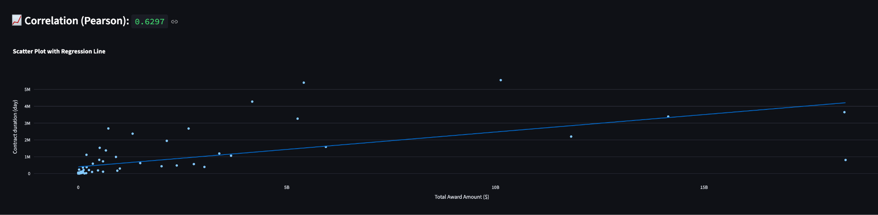

Because both of the features are numeric values → Compute correlation.

Coefficient correlation (pearson method) result: **0.6297**

**Conclusion**: both of the features have a positive relation (but it is medium level) so we can conclude there is a relationship (but not strong) between *contract duration*  and *award amount*.

## **Vendor concentration:**

Total award amount:

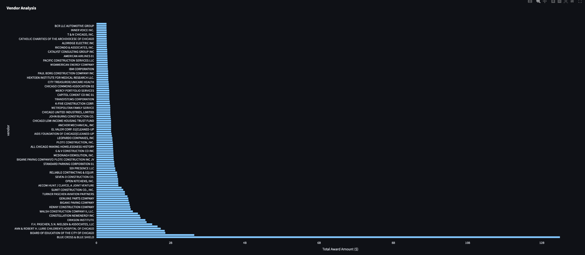

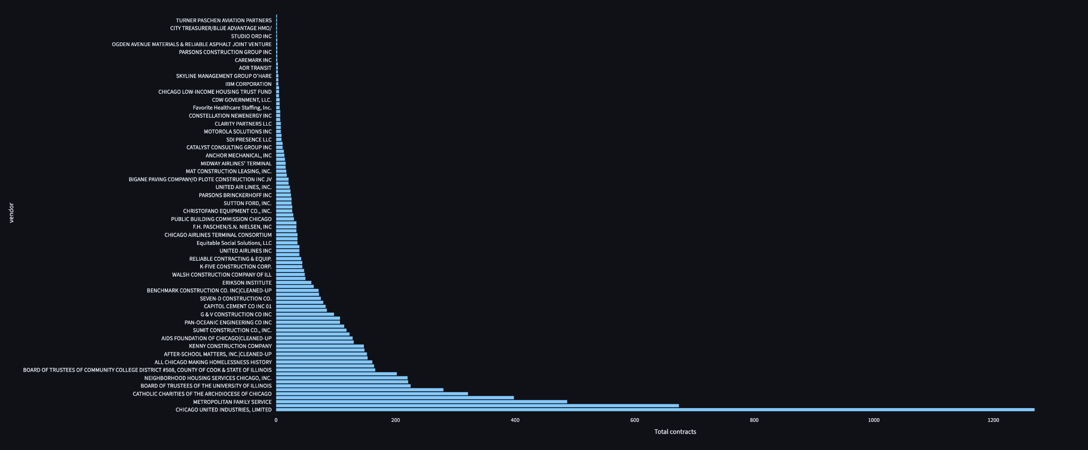

From the **first chart** (Total Award Amount):

* One vendor stands out with **over $12 billion** in total award amount — likely the **Board of Education of the City of Chicago** or a major infrastructure/construction vendor.
* A steep drop follows after the top few vendors, highlighting a **highly skewed distribution**.

From the **second chart** (Total Contracts):

* Some vendors like **CHICAGO UNITED INDUSTRIES, LIMITED**, **CATHOLIC CHARITIES**, or **METROPOLITAN FAMILY SERVICE** have **hundreds to over a thousand contracts**, but their **award amounts may be smaller**.

#### **Risks:**

1. **Overreliance on a few vendors**:  
   * If top vendors fail to deliver or face legal/financial issues, the city's operations could be disrupted.
2. **Reduced competition**:  
   * Favoritism or structural advantages might discourage new or smaller vendors from bidding.
3. **Procurement risk**:  
   * High concentration might signal the need to audit those contracts for fairness, compliance, or inflated costs.
4. **Accountability issues**:  
   * The higher the concentration, the harder it is to ensure transparency without strict oversight.

#### **Opportunities:**

1. **Strategic partnerships**:  
   * Long-standing vendors with a strong performance record can be key partners in scaling city initiatives.
2. **Efficiency gains**:  
   * Repeat contracts may reflect streamlined processes and strong vendor familiarity with city systems.
3. **Cost negotiation**:  
   * High-volume vendors may offer better terms or economies of scale, reducing unit costs.