**Technical Design Document: Scalable Inspection Data Pipeline on AWS**

# **1. Overview**

This document outlines the technical design of a scalable, lakehouse-based data pipeline architecture on AWS for processing over 1 million vehicle inspections per month. The architecture ingests, processes, and transforms streaming and batch data—focusing on metadata from image-based inspection reports—to support analytics and visualization.

# **2. Data pipeline architecture**

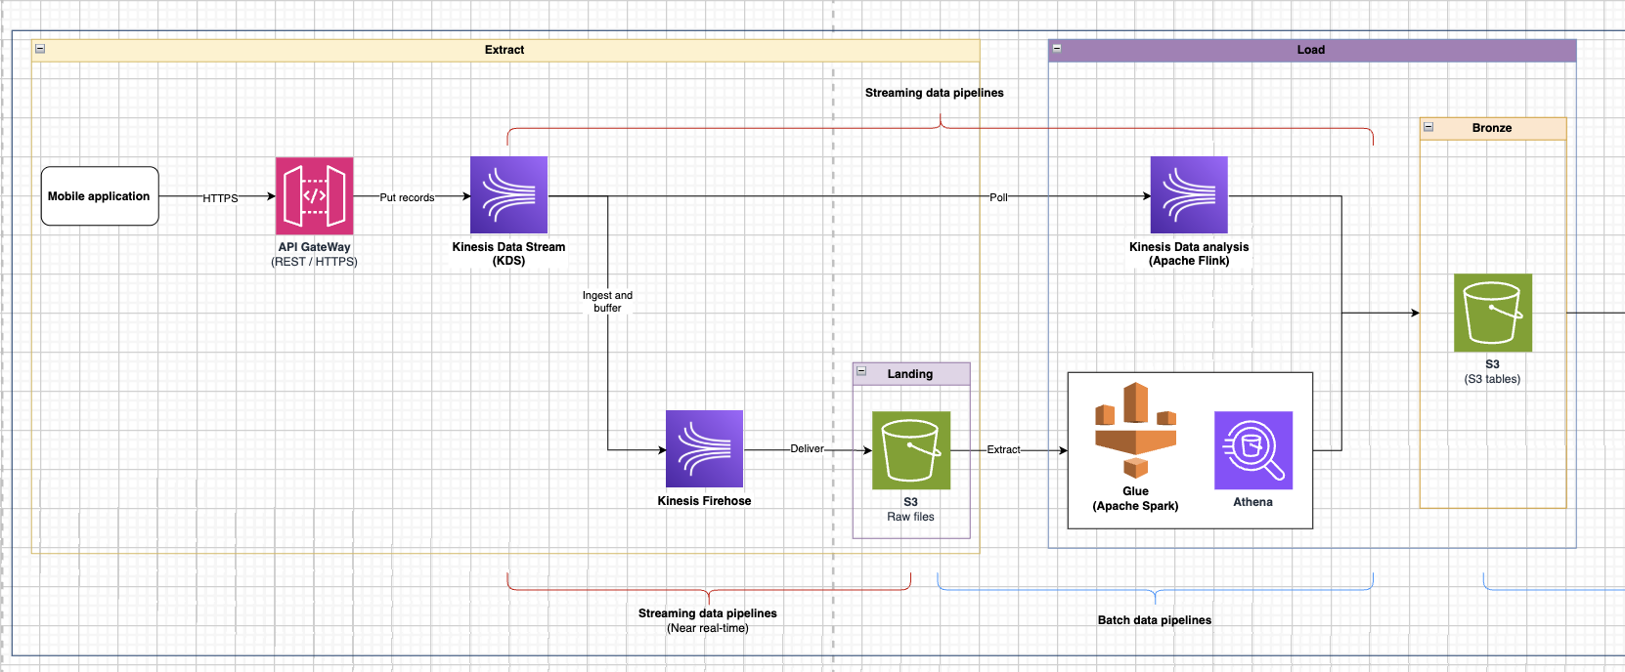

*Figure1. Extract to Load stage*

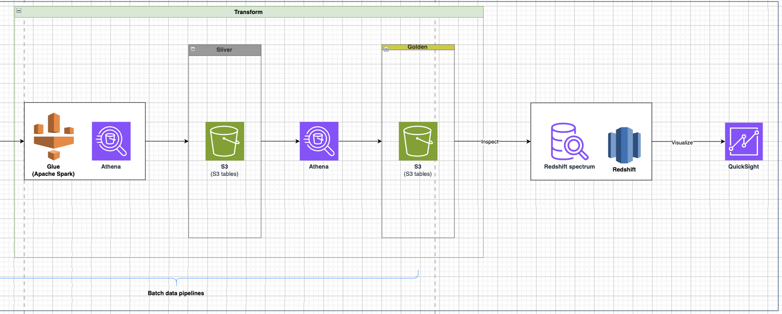

Figure 2. Load to Transform and BI application

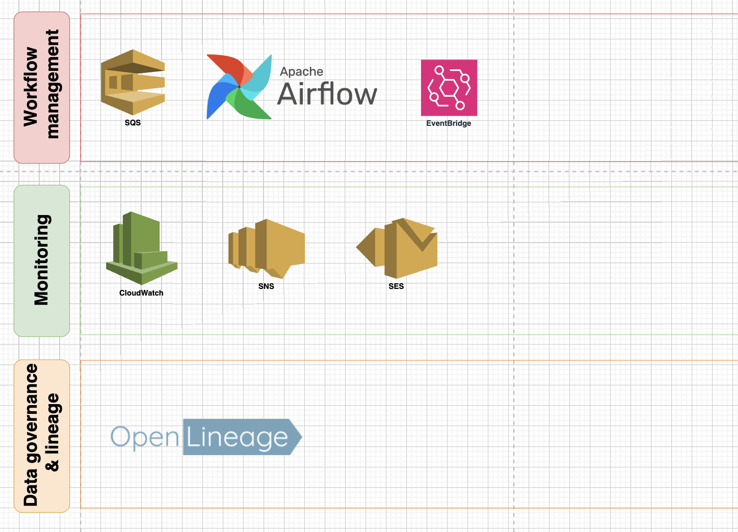

*Figure 3. Other layers*

### **Streaming Ingestion**

* **Amazon API Gateway + Kinesis Data Streams (KDS):** Enables ingestion of real-time inspection metadata from mobile apps via secure HTTPS. KDS buffers the records for downstream processing.
* **Kinesis Data Firehose:** Used to persist real-time stream data into S3 (Landing zone) for raw archival and batch processing.
* **Kinesis Data Analytics (Apache Flink):** Performs real-time stream analysis to enrich or filter metadata before it is delivered to the lake.

### **Batch Processing**

* **AWS Glue (Apache Spark):** Used for scalable ETL across all data zones (Landing → Bronze → Silver → Gold). Handles large volumes of inspection metadata using PySpark.
* **Amazon Athena:** Serverless SQL analytics engine that enables fast querying of data in S3 tables across lake zones.

### **Lakehouse Storage**

* **Amazon S3:** Stores inspection metadata in structured zones:  
  + **Landing:** Raw files from Firehose
  + **Bronze:** Cleaned and labeled metadata
  + **Silver:** Enriched, joined datasets
  + **Golden:** Business-ready datasets for BI tools

### **Analytics & BI**

* **Redshift Spectrum + Redshift:** Redshift Spectrum enables querying data directly from S3; Redshift hosts aggregated, highly-performant tables for dashboards.
* **Amazon QuickSight:** Visualizes insights like inspector performance, inspection trends, or geographic damage patterns.

# **2. Data Flow: From Raw to Processed**

### **Ingestion**:

* Inspection **metadata and image files** are sent from the mobile app via **API Gateway** into **Kinesis Data Stream**.
* KDS distributes data to:  
  + **Kinesis Data Analytics (Flink)** for enriching metadata in-flight (e.g., geolocation tagging, damage scoring).
  + **Kinesis Firehose**, which delivers:  
    - **Metadata + image references** to **Landing (S3)**
    - **Images themselves** (base64 or presigned URL payloads) to a designated S3 bucket for **raw image storage**

### **Storage Zones**:

* **Landing**: Contains both raw metadata and associated image files (stored via Firehose)
* **Bronze**: Metadata is parsed, validated, and linked to image paths
* **Silver**: Joins metadata with inspection context (e.g., inspector info)
* **Golden**: Ready-to-query tables for analytics, each record linked to image files in S3

### **Query & BI**:

* + Athena supports ad hoc queries across all lake zones.
  + Redshift Spectrum reads from Golden zone for efficient joins.
  + QuickSight dashboards visualize insights using Redshift.

## **3. Handling of Image Metadata**

* This pipeline handles **image metadata and image delivery**:
  + **Image metadata** includes: file name, capture timestamp, GPS, device info, damage labels, and inspector ID.
  + **Actual images** are **delivered via Kinesis Firehose** to **S3 (Landing Zone)** and are **not processed or transformed** in this pipeline.
  + Image files are **referenced** (e.g., via S3 URI) in downstream tables (Bronze/Silver/Golden), enabling efficient querying and downstream access without heavy storage in databases.

## **4. Scalability Considerations**

* **Streaming**:
  + Kinesis can scale to handle thousands of PUTs/sec.
  + Flink + Firehose scale horizontally for both real-time and bulk ingestion.
* **Storage**:
  + S3 provides infinite, cost-effective scalability for raw and curated data layers.  
    Lakehouse zone structure (Landing → Bronze → Silver → Golden) ensures scalable, modular data growth.
* **Processing**:
  + AWS Glue auto-scales Spark jobs based on input size.
  + Athena and Redshift Spectrum enable querying large datasets without overloading compute.
* **Monitoring & Workflow**:
  + **CloudWatch**, **SNS**, **SES** handle alerting and monitoring.  
    **Apache Airflow**, **EventBridge**, and **SQS** manage pipeline orchestration.
  + **OpenLineage** provides metadata tracking and data lineage governance.

## **5. Key Highlights**

* Hybrid architecture supports both **streaming** and **batch** pipelines.
* Modular **Lakehouse zones** for data lifecycle management.
* Focus on **metadata processing** enables high throughput without heavy image compute.
* Built-in **governance and observability** with OpenLineage and CloudWatch.
* Designed to handle **1M+ inspections/month** with elasticity across AWS services.