RATES GADGET WRITE-UP

The Rate Gadget calculates a ratio, one value over another where the values for numerator and denominator can be selected, filtered, filtered with compound select statements, and aggregated using aggregate functions. Examples: attack rates, morbidity rates, mortality rates, mosquitoes per household in selected regions, etc.

### Example One: Get the rate of mosquitoes present per household in a region as a percent.

Resource: MosquitoesPresentTrue_per_HouseInRegion.xlsx

Open the Excel file, MosquitoesPresentTrue_per_HouseInRegion.xlsx, in Visual Dashboard and add a Line list gadget for all of the data fields. (…for discussion and as a reference. You don’t need to create a Line List to create a Rate.) You’ll end up with a Line List like the one shown below. With the Region sorted, notice that there are five distinct houses in region A and there is only one case where MosquitoesPresent is true – 20%. In Region B there are only two distinct houses and both of those houses have at least one MosquitoesPresent equal to true – 100%. Region C has a rate of 66% MosquitoesPresent per household. Notice that the numerator and denominators are *counts* of *distinct* values of HouseID, and the numerator is the *count* of *distinct* values where the value is equal to true. The group setting would have to be set to Region on the properties panel (image inset).

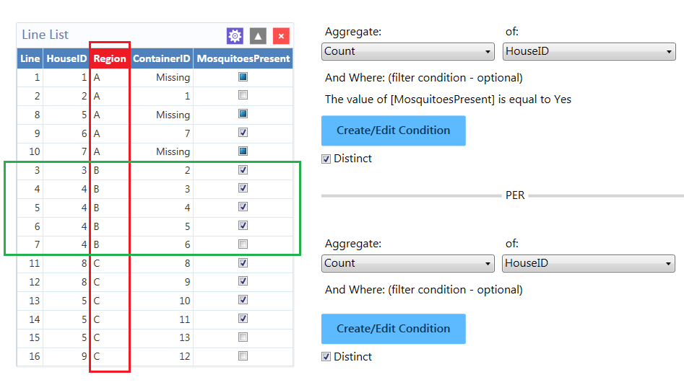

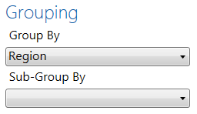

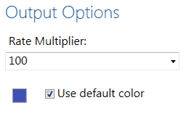 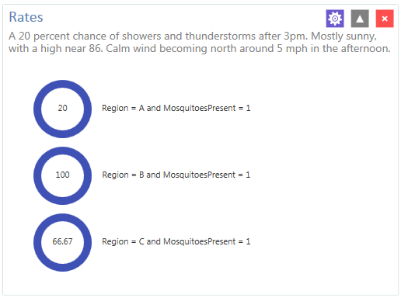

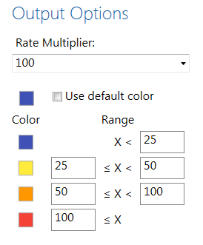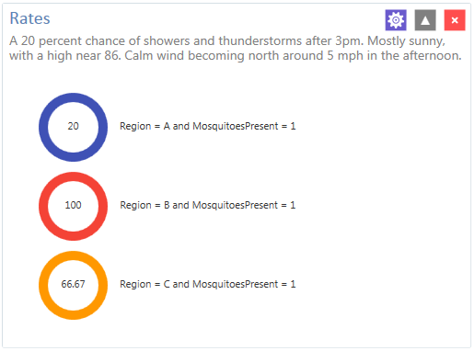

### Example Two: Mortality rates - deaths reported per population (1/100,000) in a region.

Resource: DeathsReported_per_Region.xlsx

Open the Excel file, DeathsReported_per_Region.xlsx and using the *Add related data source…* feature, join the two sheets in the file on Region and ReportingRegion. A Line List of the data is shown below. Note that the numerator would have to be all the DeathsReported using the aggregate Sum. Because the Population was brought over as related data, the data is repeated. Selecting Distinct limits one Population to each region.

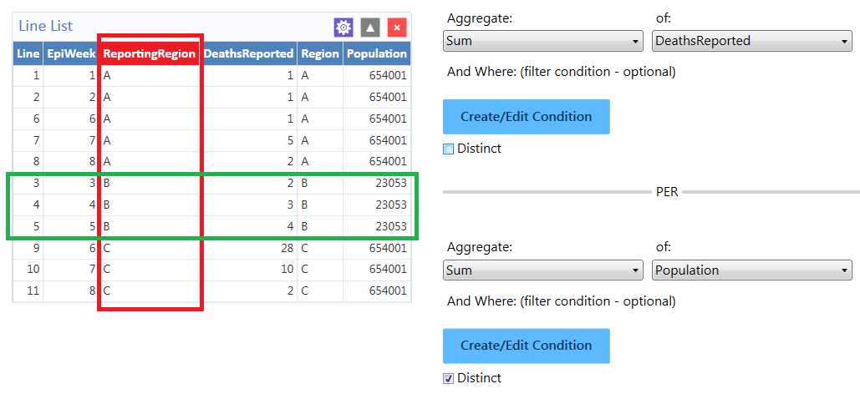

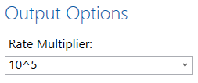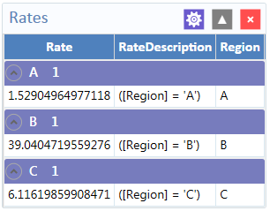

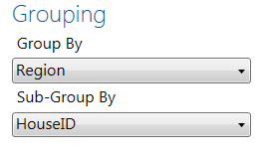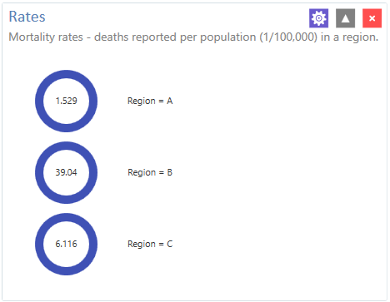

Bottom of Form