Financial Collapse & Unit Economics
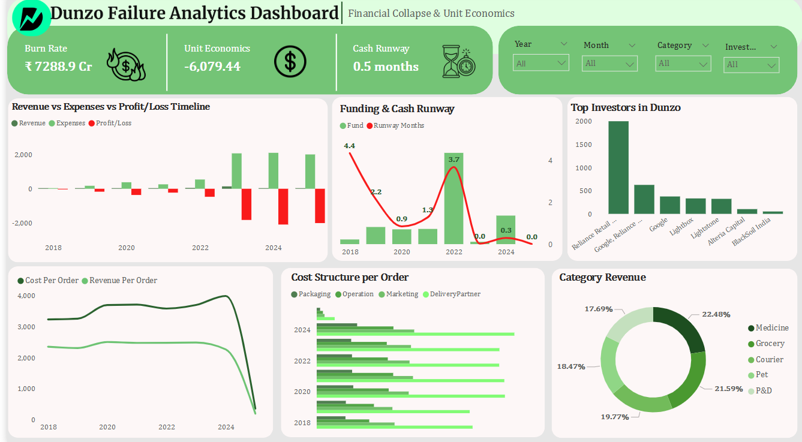

Operation & Competitive Position
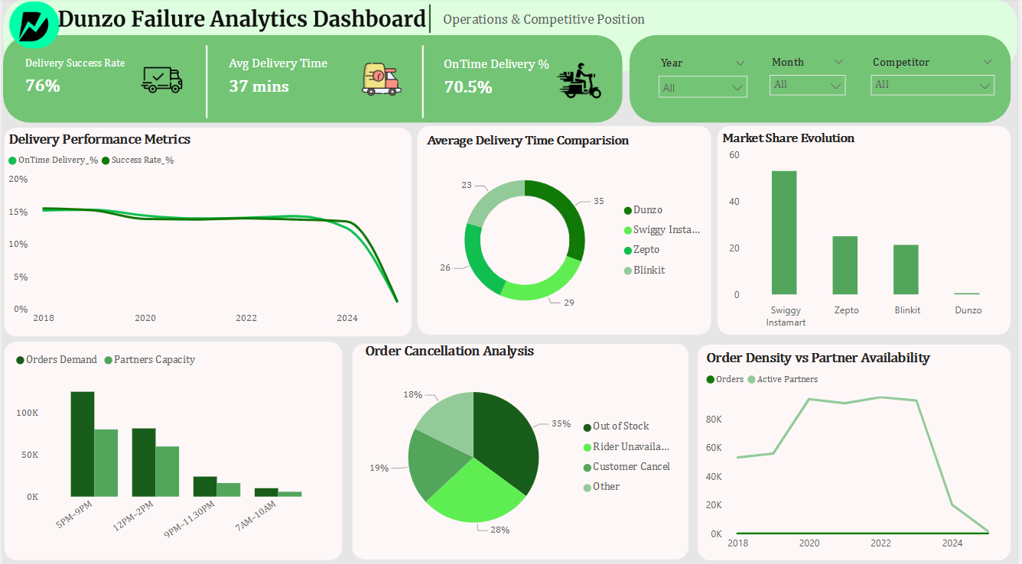

Customer Behaviour & Market Dynamics
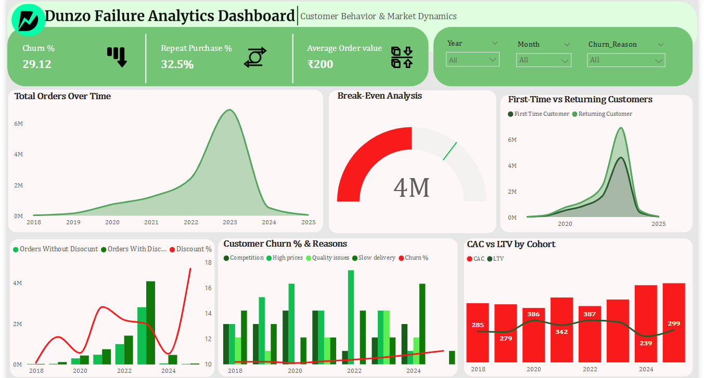

Workforce Stability & Operational Efficiency
