**CAPSTONE 2 MILESTONE REPORT**

**Problem Statement**

Foreign exchange rate forecasting is essential for managing foreign exchange risk. Financial institutions and businesses with exposure to exposure to foreign currency transactions, should constantly seek to manage this risk. Foreign exchange forecasting is also essential for currency traders both at an institutional level and at the individual level.

Predicting foreign exchange rate has been a challenging task for traders and practitioners in financial markets, and this project attempts to examine and compare the effectiveness and performance of ARIMA and Neural Networks in predicting Foreign Exchange rate.

**Methodology**

Using foreign exchange rates from 2000 to 2019, this project attempts to predict EUR/USD exchange rate for the next 10 years, using SARIMAX Time series forecasting method and the LSTM model of Neural networks.

**SARIMA**

Time series forecasting models support the assumption that past patterns in data can be used to forecast the future. The Autoregressive Integrated Moving Average, is one of the most widely used forecasting methods for univariate analysis, but it does not support time series with seasonal component, as a result, I have used the SARIMA extension of the ARIMA model, that explicitly models the seasonal element in univariate data.

ARIMA consists of three parts namely:

* Autoregressive denoted by ‘p’ : defined by the autocorrelation function (ACF)
* Integrated denoted by ‘d’ : defined by the stationary test of a time-series. We will be using the Dickey-fuller test for this.
* Moving average denoted by ‘q’: Defined by the partial correlation function (PACF).

LSTM: The task here will be to predict values for a time series given the history of eurusd daily closing exchange rate between year 2000 and 2019. I will be using the multi-layered LSTM recurrent neural network to predict the last couple of years of exchange rate

**Dataset**

Consists of daily closing exchange rate of eurusd downloaded from barchart.com

**Data Cleaning**

Data supplied from website is clean and complete and in the required format. I carried out the following checks to determine data quality:

I examined completeness and data types. I also examined the summary statistics of the dataset. All checks revealed that the dataset is clean and is in the required format to be used in my models.

**Exploratory Data Analysis**

**Hypothesis 1:**

**p-value > 0.05: Accept the null hypothesis (H0), the data has a unit root and is non-stationary.**[**¶**](http://localhost:8889/notebooks/Desktop/springboard/Capstone_2/CAPSTONE_2_FOREIGN_EXCHANGE_PREDICTION_RNN_EURUSD.ipynb#p-value->-0.05:-Accept-the-null-hypothesis-(H0),-the-data-has-a-unit-root-and-is-non-stationary.)

**p-value <= 0.05: Reject the null hypothesis (H0), the data does not have a unit root and is stationary.**

**Result of hypothesis:**

From the above results, it is clear that the Standard deviation is stationary, while the mean is not. We will reject the null hypothesis H0, the data does not have a unit root and is stationary.

**Stationarity**[**¶**](http://localhost:8889/notebooks/Desktop/springboard/Capstone_2/CAPSTONE_2_FOREIGN_EXCHANGE_PREDICTION_RNN_EURUSD.ipynb#Stationarity)

I used the Dickey–Fuller test to test the null hypothesis that a unit root is present in an autoregressive model. Stationary series has constant mean and variance over time. Rolling average and the rolling standard deviation of time series do not change over time.

Dickey-Fuller test Null Hypothesis (H0): Time series has a unit root, meaning it is non-stationary. Alternate Hypothesis (H1): Suggests the time series does not have a unit root, meaning it is stationary.

I decomposed the eurusd into its different components as shown below”

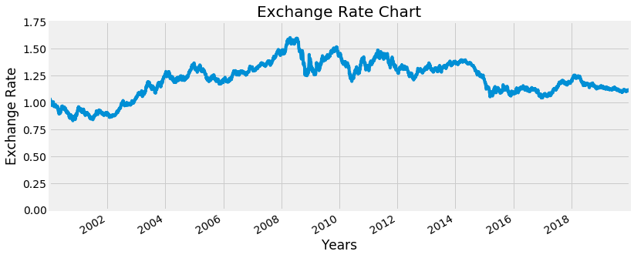

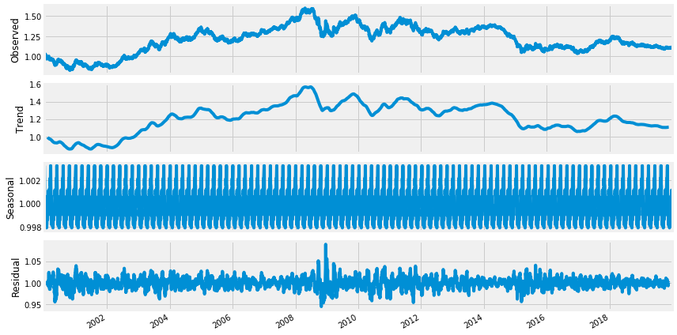

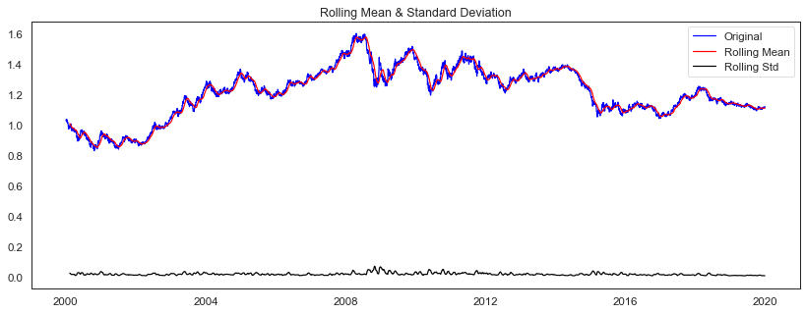

Results of Dickey-Fuller Test

Test Statistic -1.7338

p-value 0.4138

#Lags Used 0.0000

Number of Observations Used 5186.0000

Critical Value (1%) -3.4316

Critical Value (5%) -2.8621

Critical Value (10%) -2.5671

dtype: float64

For a timeseries to be considered stationary, it is expected that the mean and standard deviation should be constant which means the data should not have trend and seasonality. As mentioned earlier, I used ADF to determine the stationarity of my time series and to determine the order of differencing.

**Statistical Normality Test**

I used the statistical normality test to quantify whether data looks as though it was drawn from a Gaussian distribution, using the D’Agostino’s K² Test.

**Hypothesis 2:**

**p <= alpha: reject H0, not normal.**[**¶**](http://localhost:8889/notebooks/Desktop/springboard/Capstone_2/CAPSTONE_2_FOREIGN_EXCHANGE_PREDICTION_RNN_EURUSD.ipynb#p-<=-alpha:-reject-H0,-not-normal.)

**p > alpha: fail to reject H0, normal**

**Result of hypothesis:**

From the statistics below it is clear that the data does not look Gaussian, we will therefore reject the null hypothesis H0.

Statistics=137.136, p=0.000

Kurtosis of normal distribution: -0.43668157335097213

Skewness of normal distribution: -0.28722463936355497

The kurtosis of the distribution above is less than zero and is light tailed. The distribution is fairly symmetrical, as seen below:

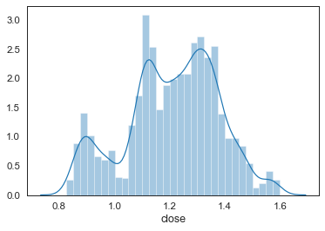

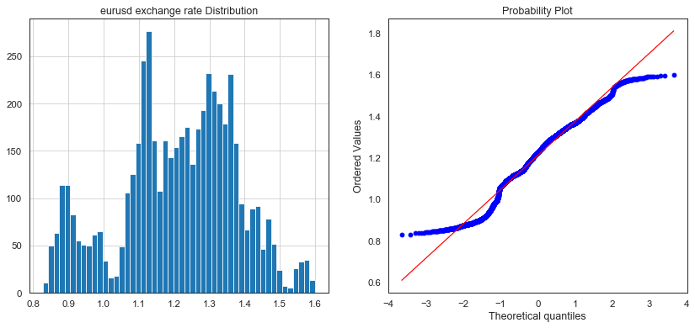

The table below shows the summary statistics of the eurusd time series:

| **count** | **mean** | **std** | **min** | **25%** | **50%** | **75%** | **max** |
| --- | --- | --- | --- | --- | --- | --- | --- |
| Open | 5187.0000 | 1.2093 | 0.1666 | 0.8266 | 1.1103 | 1.2258 | 1.3315 | 1.5991 |
| High | 5187.0000 | 1.2147 | 0.1672 | 0.8322 | 1.1149 | 1.2313 | 1.3372 | 1.6038 |
| Low | 5187.0000 | 1.2039 | 0.1658 | 0.8230 | 1.1067 | 1.2196 | 1.3254 | 1.5866 |
| close | 5187.0000 | 1.2093 | 0.1666 | 0.8271 | 1.1105 | 1.2259 | 1.3314 | 1.5990 |
| Change | 5187.0000 | 0.0000 | 0.0074 | -0.0348 | -0.0041 | 0.0001 | 0.0041 | 0.0467 |
| Volume | 5187.0000 | 119833.2103 | 155557.6128 | 0.0000 | 0.0000 | 0.0000 | 229402.5000 | 763921.0000 |