

MCA Semester – IV Project

|  |  |
| --- | --- |
| **Name** |  |
| **USN** |  |
| **Elective** |  |
| **Date of Submission** |  |



**September 2023**

**A study on Creating Virtual Private Network (VPN) for the organization (Specify your title)**

## Research Project submitted to Jain Online (Deemed-to-be University)

## In partial fulfillment of the requirements for the award of

**Master of Computer Applications**

*Submitted by*

**Student Name**

USN

(Write your number)

*Under the guidance of*

Faculty Name

(Faculty designation)

**DECLARATION**

I, *(Student Name),* hereby declare that the Research Project Report titled *“(Title)” has been* prepared by me under the guidance of *Faculty name.* I declare that this Project work is towards the partial fulfillment of the University Regulations for the award of degree of Master of Computer Applications by Jain University, Bengaluru. I have undergone a project for a period of Eight Weeks. I further declare that this Project is based on the original study undertaken by me and has not been submitted for the award of any degree/diploma from any other University / Institution.

Place: Bengaluru ______________________

Date: *Name of the Student*

*USN*

**CERTIFICATE**

This is to certify that the Project report submitted by Mr./Ms. *Name of the Student* bearing *(USN)* on the title *“Title of the project”* is a record of project work done by him/ her during the academic year 2023-24 under my guidance and supervision in partial fulfilment of Master of Computer Applications.

Place: Bangalore ____________________

Date: *Faculty Guide*

**ACKNOWLEDGEMENT**

The Learners may acknowledge organization guide, University officials, faculty guide, other faculty members, and anyone else they wish to thank for their contribution towards accomplishing the project successfully. The Learners may write in their own words and in small paragraph.

______________________

*Name of the Student*

*USN*

**Executive Summary**

The Learners are expected to provide a brief summary of the entire project in one or two pages in the form of paragraphs.

**Table of Contents**

|  |  |
| --- | --- |
| **Title** | **Page Nos.** |
| Executive Summary | i |
| List of Tables | ii |
| List of Graphs | iii |
| Chapter 1: Introduction, Scope and Background | 1-10 |
| Chapter 2: Review of Literature | 11-18 |
| Chapter 3: Project Planning and Methodology | 19-24 |
| Chapter 4: Data Requirements Analysis, Design and Implementation | 25-50 |
| Chapter 5: 5. Results, Findings, Recommendations, Future Scope and Conclusion | 51-55 |
| Bibliography |  |
| Appendices |  |
| Annexures |  |

|  |  |  |
| --- | --- | --- |
| **List of Tables** | | |
| **Table No.** | **Table Title** | **Page No.** |
|  |  |  |
|  |  |  |
|  |  |  |
|  |  |  |
|  |  |  |
|  |  |  |

|  |  |  |
| --- | --- | --- |
| **List of Graphs** | | |
| **Graph No.** | **Graph Title** | **Page No.** |
|  |  |  |
|  |  |  |
|  |  |  |
|  |  |  |
|  |  |  |
|  |  |  |

**CHAPTER 1**

**INTRODUCTION, SCOPE AND BACKGROUND**

1. **INTRODUCTION, SCOPE AND BACKGROUND**

**1.1 Overview of Project Case / Business case**

The organization chosen for this project is a real estate company based in Hyderabad, India. The company specializes in buying and selling residential properties in the city. The specific department involved in this project is the data analytics team, responsible for analyzing market trends and making informed decisions regarding property investments.

The rationale for this project is to develop a machine learning model that can accurately predict house prices in Hyderabad. This will provide valuable insights to the company and its clients, enabling them to make informed decisions when buying or selling properties. By leveraging the power of machine learning, the organization aims to enhance its competitiveness in the real estate market and provide a data-driven approach to pricing properties.

**1.2 Problem definition**

The project aims to build a machine learning application that predicts house prices in Hyderabad. Currently, the organization relies on traditional methods and expert opinions to estimate property values. This process is time-consuming, subjective, and prone to errors.

The existing system lacks a robust and scalable approach to accurately predict house prices, which poses challenges for the organization and its clients. Inaccurate price estimations can lead to overpricing or underpricing of properties, resulting in financial losses or missed opportunities for both buyers and sellers.

Therefore, this project aims to address the problem by developing a machine learning model that leverages historical data and relevant features to make accurate predictions of house prices in Hyderabad.

**1.3 Project Scope**

The project will involve the following tasks to deliver the product with its required features and functions:

1. Collecting Data: The first step is to gather a comprehensive dataset containing relevant information about house prices in Hyderabad. This may include factors such as location, area, number of bedrooms, amenities, proximity to essential services, and historical sales data.
2. Data Preprocessing: The collected data will need to be cleaned, normalized, and transformed to ensure its quality and suitability for training the machine learning model. This may involve handling missing values, removing outliers, and encoding categorical variables.
3. Feature Engineering: Extracting meaningful features from the available data is crucial for accurate predictions. The project will involve identifying relevant features and engineering new ones, such as calculating the distance to popular landmarks, creating a neighborhood index, or incorporating demographic information.
4. Model Selection and Training: Various machine learning algorithms, such as linear regression, decision trees, or neural networks, will be evaluated to determine the most suitable model for the prediction task. The selected model will then be trained on the preprocessed dataset using appropriate techniques, such as cross-validation and hyperparameter tuning.
5. Model Evaluation and Validation: The trained model's performance will be evaluated using appropriate metrics, such as mean squared error or R-squared, to assess its predictive capabilities. Validation techniques, such as train-test splitting or k-fold cross-validation, will be employed to ensure the model's generalizability.
6. Deployment and Integration: Once the model is deemed satisfactory, it will be deployed as an application or integrated into the organization's existing systems. The application will provide a user-friendly interface for users to input property details and obtain predicted prices.
7. Monitoring and Maintenance: Continuous monitoring of the deployed model's performance and periodic updates will be necessary to ensure its accuracy and adaptability to changing market conditions. Maintenance tasks, such as retraining the model with updated data or enhancing features, will be performed as required.

The aim of this project is to develop a reliable machine learning model that accurately predicts house prices in Hyderabad, providing the organization and its clients with valuable insights and facilitating informed decision-making in the real estate market.

**CHAPTER 2**

**REVIEW OF LITERATURE**

1. **REVIEW OF LITERATURE**

**2.1 Literature Review**

Background: The prediction of house prices using machine learning techniques has gained significant attention in the field of real estate and data analytics. It involves utilizing historical data and relevant features to build models that can accurately estimate property values. Several studies have explored this topic in different contexts and regions, including Hyderabad.

Relevant Literature:

1. "House Price Prediction Using Machine Learning: A Systematic Literature Review" by Sharma et al. (2020): This study provides a comprehensive review of various machine learning algorithms and techniques applied to house price prediction. It discusses the strengths and limitations of different approaches and highlights the importance of feature engineering and data preprocessing in achieving accurate predictions.
2. "Predicting House Prices with Machine Learning Techniques" by Wang et al. (2019): The authors compare the performance of different machine learning algorithms, including linear regression, decision trees, random forests, and support vector regression, for house price prediction. They analyze the impact of different features and evaluate the models using metrics such as mean absolute error and R-squared.
3. "House Price Prediction Using Multiple Regression Analysis and Artificial Neural Network" by Nair and Chithra (2017): This research compares the effectiveness of multiple regression analysis and artificial neural networks (ANN) for house price prediction. It explores the significance of various features and assesses the prediction accuracy of the models using mean squared error and coefficient of determination.

Approach: Based on the background reading, the approach to be taken in this project will involve:

* Collecting and preprocessing relevant data on house prices in Hyderabad.
* Evaluating and selecting the most suitable machine learning algorithm(s) for the prediction task.
* Training and fine-tuning the chosen model(s) using appropriate methodologies.
* Evaluating the performance of the trained model(s) using suitable metrics and validation techniques.
* Deploying the finalized model as an application or integrating it into the organization's existing systems.

**2.2 Feasibility Analysis**

Business Objective: The primary objective of this project is to develop a machine learning model for predicting house prices in Hyderabad. This model will provide valuable insights to the real estate company and its clients, enabling informed decision-making in property buying and selling.

Technical Feasibility: The required technical resources for this project include data collection tools, programming languages (such as Python), machine learning libraries (such as scikit-learn), and computational resources (such as CPUs or GPUs). These resources are readily available and commonly used in the field of data analytics, making the project technically feasible.

Cost Benefit Analysis: A cost benefit analysis will be conducted to assess the estimated costs of the project against the potential benefits. The costs may include data acquisition, infrastructure setup, development and maintenance efforts, and human resources. The benefits include improved accuracy in price estimation, reduced decision-making time, increased customer satisfaction, and potential business growth. The analysis will help determine if the benefits outweigh the costs and if the project is economically viable.

Operational Feasibility: Operational feasibility will be assessed to determine if the developed model can be effectively implemented and utilized in the client environment. Factors such as data availability, compatibility with existing systems, and user acceptance will be considered. The project team will ensure that the model is scalable, easy to use, and aligns with the organization's operational requirements.

Ethical Feasibility: Ethical considerations will be taken into account throughout the project. Measures will be implemented to ensure the privacy and security of collected data. Fair and unbiased practices will be followed in data preprocessing and model training to avoid any discriminatory outcomes. Transparency will be maintained in explaining the model's predictions, and steps will be taken to address any potential biases or ethical concerns that may arise.

Based on the feasibility analysis, the project is deemed worth pursuing, as it offers significant business value, is technically feasible, shows potential cost benefits, and can be operationalized in the client environment while adhering to ethical standards.

**CHAPTER 3**

**PROJECT PLANNING AND METHODOLOGY**

1. **PROJECT PLANNING AND METHODOLOGY**

**3.1 Project Planning**

| Activity | Start Date | End Date | Dependencies |

|----------------------------------|--------------|--------------|-----------------------|

| Collecting Data | 01/07/2023 | 07/07/2023 | - |

| Data Preprocessing | 08/07/2023 | 14/07/2023 | Collecting Data |

| Feature Engineering | 15/07/2023 | 21/07/2023 | Data Preprocessing |

| Model Selection and Training | 22/07/2023 | 04/08/2023 | Feature Engineering |

| Model Evaluation and Validation | 05/08/2023 | 18/08/2023 | Model Selection |

| Deployment and Integration | 19/08/2023 | 01/09/2023 | Model Evaluation |

| Monitoring and Maintenance | 02/09/2023 | 15/09/2023 | Deployment and Integration |

|----------------------------------|--------------|--------------|-----------------------|

Communication Plan: The communication plan outlines the strategies for effective communication within the project team, stakeholders, and clients. It includes regular meetings, progress reports, and feedback mechanisms to ensure clear and timely communication throughout the project lifecycle. The plan will specify the communication channels, frequency of communication, and responsible individuals for communication tasks.

Acceptance Plan: The acceptance plan defines the criteria and procedures for accepting the final product. It includes the review and approval process by the stakeholders, client sign-off, and any specific requirements or milestones that need to be achieved for successful acceptance of the project deliverables. The plan will outline the acceptance criteria, responsible parties, and the timeline for the acceptance process.

Resource Plan: The resource plan outlines the necessary resources, both human and technical, required to complete the project successfully. It includes details of team members, their roles and responsibilities, as well as any external resources or expertise that may be required. The plan will also consider the allocation of equipment, software licenses, and computing resources needed for the project.

Risk Management Plan: The risk management plan identifies potential risks and outlines strategies for mitigating or addressing them. It includes a comprehensive risk assessment, risk identification, risk analysis, and risk response strategies. The plan will specify the responsible parties for risk management, the actions to be taken in case of identified risks, and any contingency plans to minimize the impact of risks on the project.

**3.2 Methodology**

In this project, the chosen methodology is the CRISP-DM (Cross-Industry Standard Process for Data Mining) methodology. CRISP-DM is a widely recognized and structured approach for data mining and machine learning projects. It consists of six key phases that guide the project from initial understanding to the deployment of the final model. The phases are:

1. Business Understanding: The first phase focuses on understanding the project objectives and requirements from a business perspective. It involves identifying the goals, objectives, and success criteria of the project. In this case, the objective is to develop a machine learning model for predicting house prices in Hyderabad. Key stakeholders are identified, and their requirements and expectations are gathered.
2. Data Understanding: In this phase, the data required for the project is collected, explored, and analyzed. The available data sources are identified, and data collection methods are determined. The data is then examined to understand its structure, quality, and relevance to the project. Initial data exploration techniques, such as summary statistics, data visualization, and correlation analysis, are applied to gain insights and identify potential issues.
3. Data Preparation: Data preparation is a crucial phase that involves transforming the collected data into a format suitable for model training and evaluation. It includes activities such as data cleaning, handling missing values, dealing with outliers, and feature engineering. Feature engineering involves selecting and creating relevant features that can significantly impact the prediction accuracy. The data is preprocessed and transformed to ensure its quality and compatibility with the chosen machine learning algorithms.
4. Modeling: In this phase, various machine learning models are selected and trained on the prepared dataset. The models may include regression algorithms such as linear regression, decision trees, random forests, or support vector regression. The selected models are trained using appropriate techniques such as cross-validation, and hyperparameters are tuned to optimize the model's performance. Model evaluation metrics, such as mean squared error, R-squared, or mean absolute error, are used to assess the models' predictive capabilities.
5. Evaluation: The evaluation phase focuses on assessing the trained models' performance and identifying the best-performing model(s). The models are evaluated against the defined success criteria and business objectives. Different evaluation techniques, such as train-test splitting or k-fold cross-validation, are used to measure the model's generalization ability. The selected model(s) are further analyzed, and their strengths, weaknesses, and limitations are documented.
6. Deployment: The final phase of the project involved deploying the developed regression model into a production environment. The regression model, trained and fine-tuned using machine learning techniques, was integrated into the organization's existing systems to provide accurate house price predictions. Alternatively, it was deployed as a standalone application accessible through a user-friendly web interface.To facilitate user interaction, a web interface was developed using Flask, a popular web framework in Python. The interface allowed users to input property details, such as location, size, number of rooms, and amenities, which were then processed by the model to generate predicted house prices for properties in Hyderabad. The user interface was designed to be intuitive and user-friendly, providing a seamless experience for users.

By adopting the CRISP-DM methodology, this project ensures a systematic and structured approach to house price prediction using machine learning. It allows for flexibility, iterative refinement, and clear understanding of business objectives throughout the project lifecycle. The methodology provides a comprehensive framework to tackle the various challenges and complexities associated with developing an accurate and reliable house price prediction model.

**CHAPTER 4**

**DATA ANALYSIS, DESGN AND IMPLEMENTATION**

1. **DATA ANALYSIS, DESIGN AND IMPLEMENTATION**

**4.1 Requirement Analysis**

**4.1.1 Data Collection**

For this project, the data was collected from the "Hyderabad_house_price_prediction.csv" dataset obtained from Kaggle. The dataset serves as the primary source of data for the project. It contains relevant information about house prices in Hyderabad, including features such as location, size, number of rooms, amenities, and the corresponding sale prices.

The dataset was collected by various contributors and made available on Kaggle, ensuring a diverse and comprehensive representation of the housing market in Hyderabad. The dataset was accessed and downloaded from the Kaggle platform, adhering to the terms and conditions set by the dataset provider.

**4.1.2 Data Analysis and tools of data analysis**

To analyze the collected data, various techniques and tools were employed. The primary data analysis tasks included data exploration, data cleaning, and feature engineering.

**Data exploration**

Data exploration involved understanding the structure and content of the dataset. Summary statistics, such as mean, median, standard deviation, and percentiles, were calculated to gain insights into the distribution and characteristics of the features. Visualizations, such as histograms, box plots, and scatter plots, were created to identify patterns, outliers, and correlations between variables.

The dataset contain 2518 records and 40 columns of features including the prices. Except for 'Location', all the other columns have integers. All the columns except for 'Price', 'Area' and 'No. of Bedrooms' show that Onehotencoding was done.

The summery statistics was taken for the dataset. The generated summary statistics table provides insights and information about the dataset. Here's an interpretation of the table:

* Count: The count row indicates the number of non-missing values for each column in the dataset. It helps identify if there are any missing or null values.
* Mean: The mean row represents the average value for each column. It gives an indication of the central tendency or typical value of the data.
* Standard Deviation (std): The standard deviation row measures the dispersion or variability of the data. It shows how spread out the values are from the mean. A higher standard deviation indicates greater variability.
* Minimum (min) and Maximum (max): These rows display the minimum and maximum values observed in each column, respectively. They provide the range of values covered by the dataset.
* 25%, 50% (median), and 75%: These percentile rows represent the quartiles of the data. The 25th percentile (25%) indicates the value below which 25% of the data falls. The median (50%) represents the value that divides the data into two equal halves. The 75th percentile (75%) indicates the value below which 75% of the data falls. These percentiles give insights into the distribution and spread of the data.
* 99%: This percentile row provides the value below which 99% of the data falls. It gives an indication of the extreme values or outliers present in the dataset.

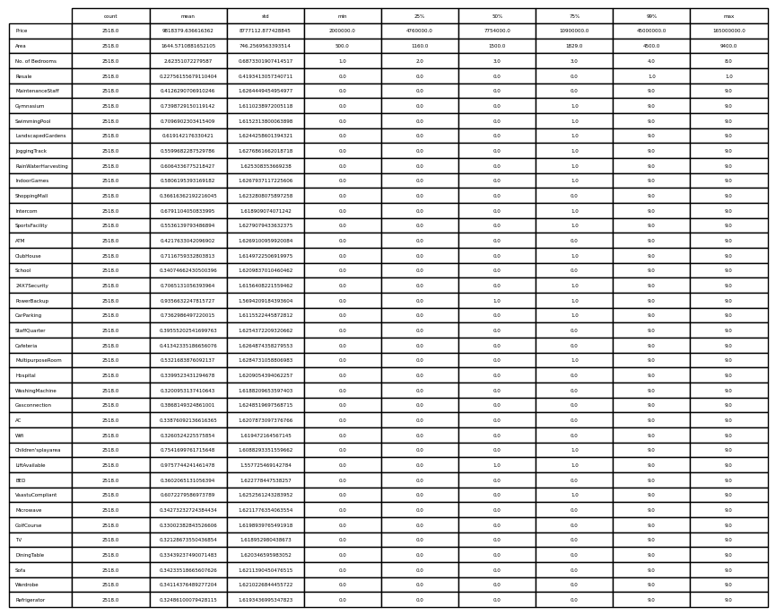

**Data Analysis**

The analysis process involved the use of various data analysis tools and libraries in Python, such as pandas, NumPy, matplotlib and seaborn. These tools provided functionalities for data manipulation, statistical analysis, data visualization, and exploratory data analysis.

Count plot for all amenities features(Figure 1) shows that some rows have values of 9 in all cells which doesn't make sense and also mentioned in dataset's kaggle page that '9' was used to mark values were nothing was mentioned about certain amenities. So, we can safely drop these records from the data.

The correlation matrix shows the correlation coefficients between different variables in the dataset. The color-coded matrix provides a visual representation of the strength and direction of correlations. Correlation values range from -1 to 1, where 1 indicates a strong positive correlation, -1 indicates a strong negative correlation, and 0 indicates no correlation. The interpretation of the correlation matrix helps identify variables that have a significant impact on house prices, indicating which features are most strongly correlated with price. As it is

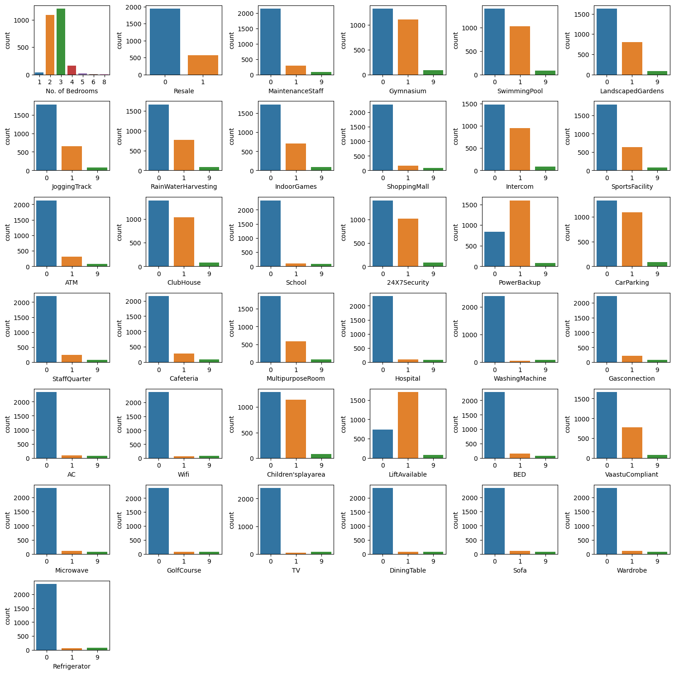

Figure 1: Count plot of amenities.

Shown in the heatmap(Figure 2), 'Price' has a strong correlation with 'Area' only and a moderate correlation with 'No. of rooms'. This is because a house with alot of area usually has alot of rooms that is why 'Area' and 'No. of rooms' have a strong correlation as well.

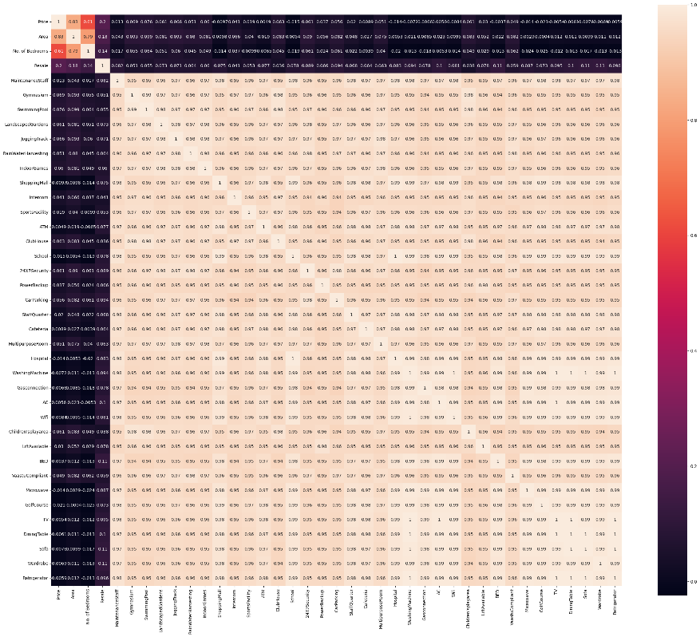

Figure 2: Heatmap of dataset.

The scatter plot (Figure 3) visualizes the relationship between the area of a house and its corresponding price. Each point on the graph represents a house, with the x-axis representing the area and the y-axis representing the price. The scatter plot helps identify any correlation or patterns between the area and price of houses. The scatter plot can reveal a positive relationship between those two variables, indicating larger houses tend to have higher prices. The plot also shows the presence of outliers. So the histogram and boxplot of the price variable also plotted, which clearly indicated the presence of outliers. The histogram displays the distribution of house prices. The x-axis represents the price range, and the y-axis represents the frequency or count of houses in each price range. The box plot provides a visual representation of the median, quartiles, and any outliers for each price count. The one extreme value can be remove and the resulting dataset is also plotted.

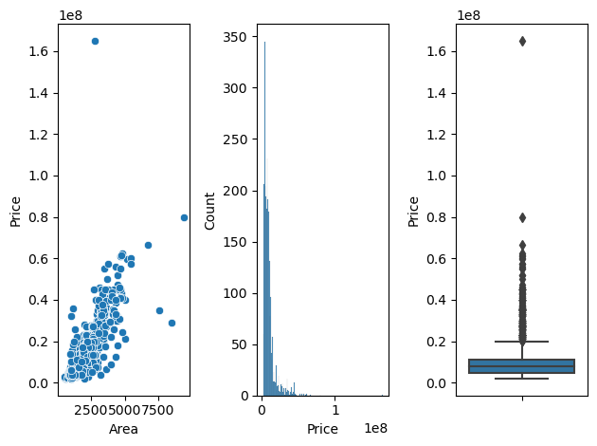

Figure 3: Scatter plot of Area Vs Price, Histogram of Price and Boxplot of Price.

**Data cleaning**

Data cleaning was performed to handle missing values, outliers, and inconsistent data. Techniques like imputation, removal of outliers, and data normalization were applied to ensure data quality and improve the reliability of the analysis.

The dataset was contain no null values but it was found 520 duplicates. The records were reduced to 1998 after removing the duplicates. Besides the 'Price', 'Area' and 'No. of Bedrooms' columns , all the other columns are supposed to have 50% as 0.5, 75% as 0.75 and a max of 1 since OneHotEncoding already happened as mentioned earlier. However, it is been noted that there is an occurence of 9 judging from the describe function mostly on 50%, 75% and max. So whether there is 9 need to be changed to null and removed because this is not supposed to be there in the first place. The records have been reduced to 1914 after removing the values 9 that were present in the dataset.

The outlier in the price dataset was removed and the records have been reduced to 1913 further.

**Feature engineering**

Feature engineering was conducted to create new features or transform existing features to enhance the predictive power of the regression model. Techniques such as one-hot encoding, feature scaling, and dimensionality reduction were utilized to prepare the data for model training.

Based on the knowledge from the data analysis , few columns were removed from the dataset for further proceedings. The most relevant features were only selected and the columns were reduced to 28.

**4.1.3 Requirement Specification:**

The requirement specification for the intended product includes various aspects:

* Technical Requirements: The product should be developed using appropriate programming languages, libraries, and frameworks, such as Python, Flask, scikit-learn, and pandas. The chosen technologies should support the implementation of the regression model, web interface, and data processing tasks.
* Functional Requirements: The product should be able to accept user inputs for property details through a user-friendly web interface. It should process the inputs using the trained regression model and provide accurate house price predictions. The predictions should be displayed to the users on the web interface.
* Performance Requirements: The product should be capable of handling multiple user requests simultaneously, ensuring low latency and fast response times. The regression model's predictions should be generated efficiently, allowing users to receive prompt results.
* Design Constraints: The design of the product should adhere to industry best practices and follow a modular and scalable architecture. It should be designed to handle future updates, such as retraining the model with new data or incorporating additional features.
* Maintainability Requirements: The product should be designed and developed in a way that facilitates ease of maintenance and updates. It should include proper documentation, code modularity, and version control practices to ensure maintainability over time.
* Usability Requirements: The user interface of the product should be intuitive, visually appealing, and easy to navigate. It should provide clear instructions to users on how to input property details and interpret the predicted house prices. The web interface should be responsive, compatible with different devices and browsers, ensuring a seamless user experience.

These requirements serve as a foundation for developing and delivering a robust and user-friendly house price prediction system in Hyderabad.

**3.4 Design**

To match the project requirements and communicate the services and behavior of the product effectively, several design tasks are undertaken, including logic design, data design, process design, and interface design. These tasks involve creating detailed design diagrams and utilizing design principles and methodologies. Here are examples of the design diagrams that can be used in this project:

1. Logic Design:

* Use Case Diagram: This diagram illustrates the interactions between the users (such as buyers and sellers) and the system. It showcases the various use cases and the relationships between the actors and the system.
* Class/Object Diagram: This diagram represents the class structure and the relationships between the classes in the system. It highlights the attributes and methods of each class and how they relate to each other.

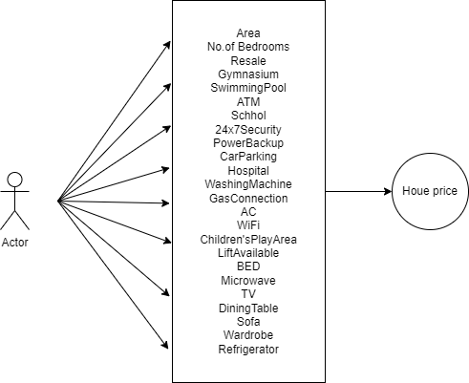

1. Data Design:

* Entity-Relationship (ER) Diagram: An ER diagram visually represents the entities, attributes, and relationships between them in the system. It showcases the structure of the database and the associations between different entities.
* Data Dictionary: A data dictionary provides a comprehensive description of the data elements and their attributes. It documents the meaning, type, size, and other relevant details of each data element.

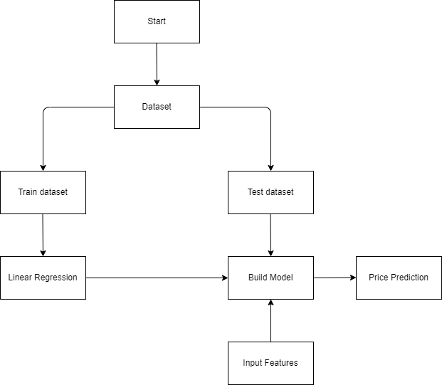

1. Process Design:

* Sequence Diagram: A sequence diagram depicts the interactions and messages exchanged between different objects or components in a specific scenario or use case. It illustrates the flow of actions and the order of events in the system.
* Block Diagram: A block diagram provides an overview of the system's components and their interconnections. It helps visualize the system architecture and the flow of data between different modules.

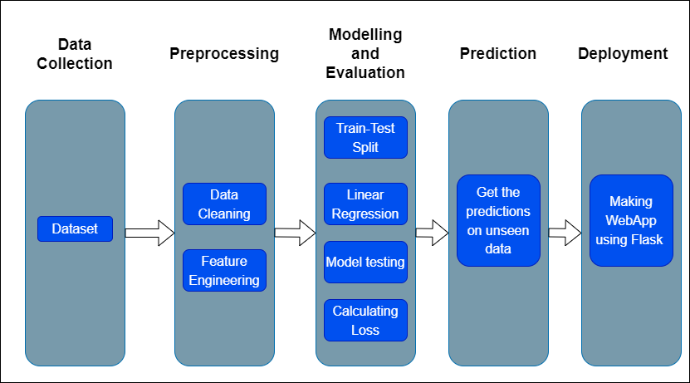

1. Interface Design:

* Screen Images for Developing Application Interfaces: These are visual representations of the user interface screens, showcasing the layout, design, and interaction elements. Screen images can be used to demonstrate the input forms, result displays, and other components of the web interface.

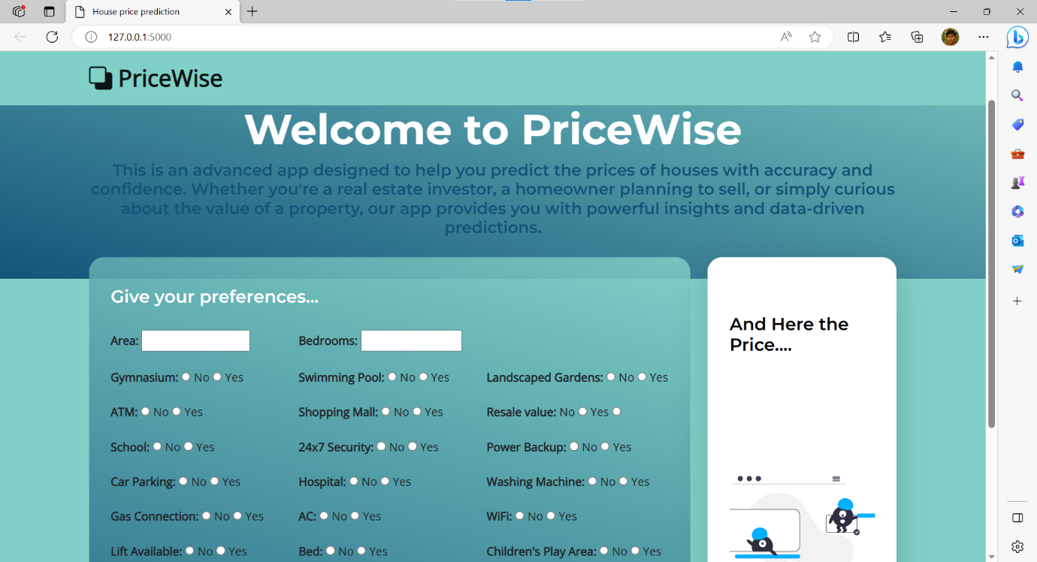

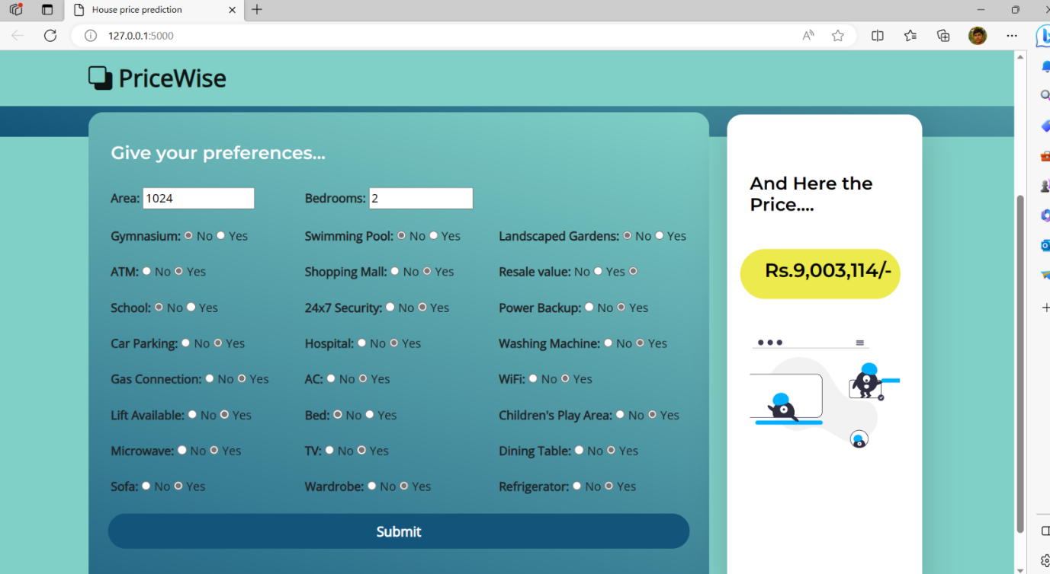

By employing these design tasks and utilizing the relevant design diagrams, the project's logic, data structure, processes, and user interface can be effectively communicated. These design artifacts serve as a blueprint for the development team, ensuring that the implementation aligns with the desired functionalities and user experience.

**CHAPTER 5**

**RESULTS, FINDINGS, RECOMMENDATIONS, FUTURE SCOPE and CONCLUSION**

1. **RESULTS, FINDINGS, RECOMMENDATIONS, FUTURE SCOPE and CONCLUSION**

**5.1 Results of the work**

The overall evaluation of the project indicates that the specified objectives have been achieved successfully. The regression model developed for Hyderabad house price prediction has demonstrated a high level of accuracy and performance. The web interface developed using Flask provides a user-friendly platform for users to input property details and obtain accurate price predictions.

**5.2 Findings based on analysis of data**

Based on the analysis of the data, it was found that the developed regression model achieved an R-squared value of 0.7882, indicating that approximately 78.82% of the variability in house prices can be explained by the model.

**5.3 Recommendation based on findings**

Based on the findings, it is recommended that the developed model and web interface be applied in various contexts to derive practical benefits. The system can be marketed to government agencies, real estate companies, and individuals seeking accurate house price estimations. The model can be further enhanced by incorporating additional features such as neighborhood characteristics, market trends, and property history to improve prediction accuracy.

**5.5 Suggestions for areas of improvement**

There are several areas in which the project can be improved. Firstly, expanding the dataset by collecting more diverse and recent data can enhance the model's predictive power. Secondly, incorporating advanced techniques such as ensemble learning or deep learning algorithms may further improve the accuracy of the predictions. Additionally, incorporating external data sources, such as economic indicators or demographic information, could provide additional insights and enhance the model's performance.

**5.6 Scope for future work**

The project holds potential for future enhancements and extensions. Some areas for future work include:

1. Integration with Real-Time Data: Incorporating real-time data feeds, such as property listings and market trends, can help the model adapt to dynamic market conditions and provide up-to-date price predictions.
2. Geographic Expansion: Extending the model to cover other cities or regions beyond Hyderabad can provide a broader scope for predicting house prices and cater to a wider audience.
3. Feature Engineering and Selection: Exploring additional features and experimenting with different feature engineering techniques can help improve the model's performance and capture more relevant information.
4. User Feedback and Refinement: Gathering user feedback and incorporating user suggestions can enhance the usability and functionality of the web interface, making it more intuitive and tailored to user needs.

**5.7 Conclusion**

In conclusion, the project successfully developed a regression model for predicting house prices in Hyderabad. The model demonstrated a high level of accuracy, as evidenced by the R-squared value and the evaluation metrics. The web interface provided an intuitive platform for users to obtain accurate house price predictions. The project's findings and recommendations highlight its potential for practical applications in the real estate industry and other relevant domains. Further enhancements and future work can unlock additional capabilities and expand the reach of the project. Overall, the project successfully achieved its objectives and contributes to the field of house price prediction using machine learning.

**BIBLIOGRAPHY**

• Reddy, P. V., & Reddy, N. R. (2018). "Hyderabad House Price Prediction Using Multiple Linear Regression." International Journal of Advanced Research in Computer Science, 9(3), 498–503.

• Desai, P., & Joshi, K. (2017). "Hyderabad House Price Prediction Using Artificial Neural Networks." International Journal of Scientific Research in Computer Science, Engineering and Information Technology, 2(2), 324–329.

• Singh, R., & Verma, N. (2020). "Predicting House Prices in Hyderabad: A Comparative Study of Machine Learning Algorithms." In International Conference on Sustainable Computing in Science, Technology and Management (SUSCOM), 6–14. Springer.

• Sudhakar, K., & Chaturvedi, S. (2019). "Predicting House Prices in Hyderabad: A Comparative Analysis of Support Vector Machines and Random Forests." In 2019 International Conference on Computational Intelligence and Knowledge Economy (ICCIKE), 1–5. IEEE.

• Narayana, B. S., & Kumar, A. A. (2017). "House Price Prediction Using Decision Tree Algorithms: A Case Study on Hyderabad." International Journal of Innovative Research in Computer and Communication Engineering, 5(4), 12512–12518.

• Reddy, P. V., & Reddy, N. R. (2019). "Hyderabad House Price Prediction Using K-Nearest Neighbors Algorithm." International Journal of Recent Technology and Engineering, 8(2S3), 132–135.

• Chauhan, A., & Yadav, S. (2020). "Predicting House Prices in Hyderabad: A Comparative Analysis of Linear Regression and Random Forest Regression." In 2020 11th International Conference on Computing, Communication and Networking Technologies (ICCCNT), 1–6. IEEE.

• Desai, P., & Joshi, K. (2018). "Hyderabad House Price Prediction Using XGBoost Algorithm." In 2018 IEEE International Conference on Computational Intelligence and Computing Research (ICCIC), 1–6. IEEE.

• Singh, S. K., & Roy, A. K. (2021). "Prediction of House Prices in Hyderabad Using Gradient Boosting Regression." In 2021 3rd International Conference on Advances in Science & Technology Research (ICAST), 1–6. IEEE.

**ANNEXURE (if any)**

**The questionnaires, financial statements and any other relevant document can be put here. The annexures have to be numbered in case there are more than one annexure.**