**Presence**

* Only 5 articles written about the designer collection
* Instagram – 3162, Twitter – 441 Followers Google Reviews – 1
* General perception is pretty things at a pretty place
* Resort wear -> lifestyle -> sipping margaritas at a lounge

**Basic Problem**

* Not recognized as a brand, it’s a collection.
* What separates them is their design, prints and colors. But their brand value doesn’t attract the elite.
* “…..Collections of le sirenuse”
* Matchesfashion.com uses Le sirenuse as the brand name for online selling
* 5 articles over 5 years
* 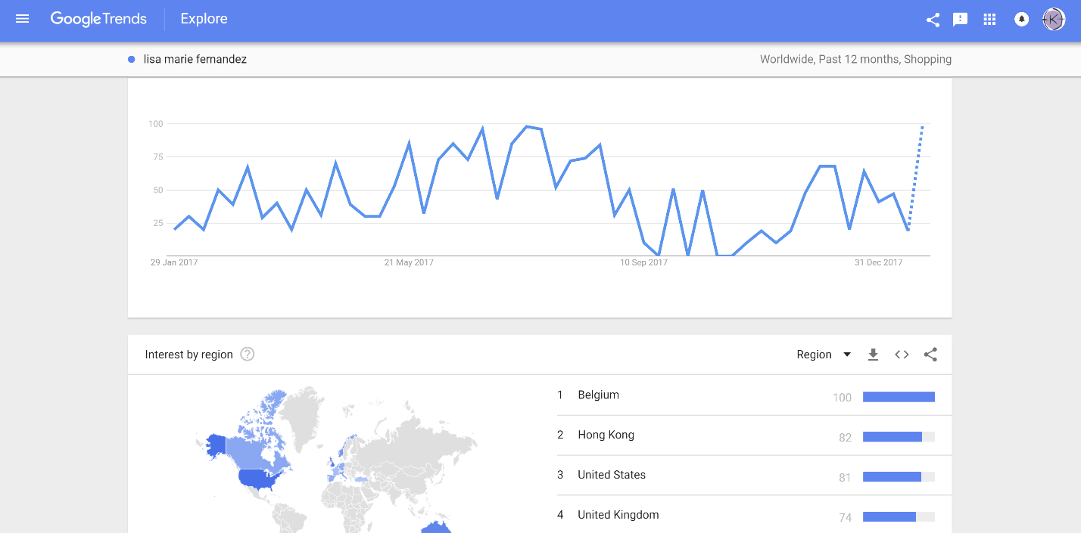
* 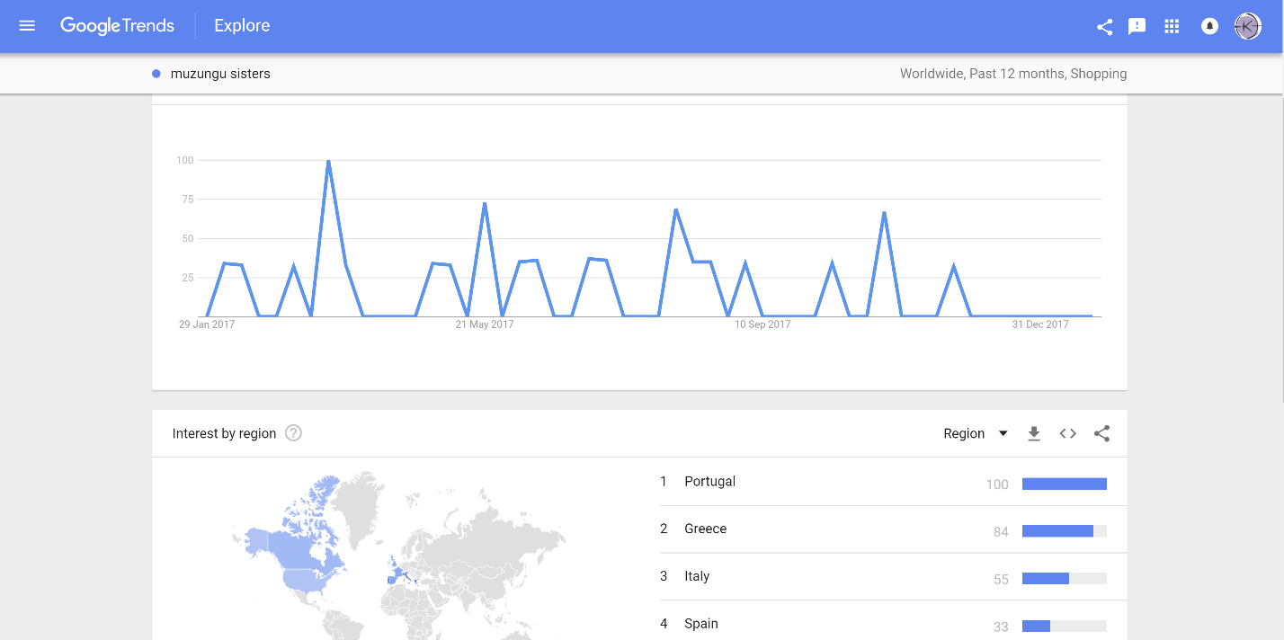
* 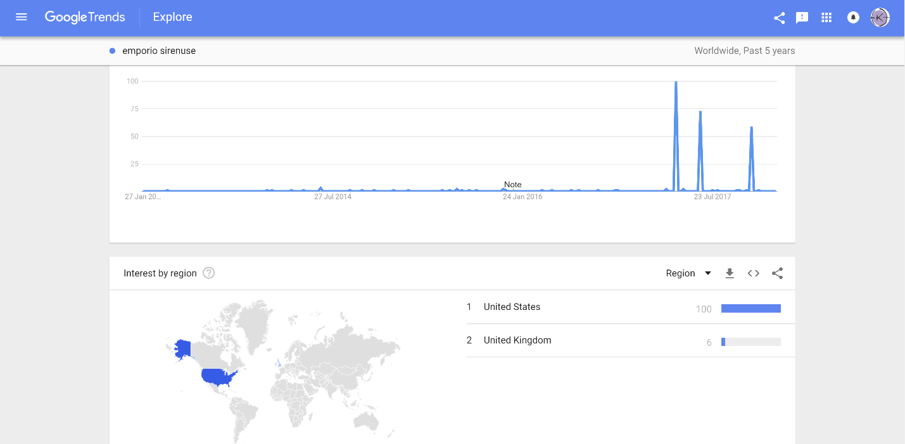

**Social Media Engagement**

Elite Ecommerce Channelizing

Personalized Email Marketing

Reengagement Solutions

Time series analysis

*Prospects, Campaign activity, Sales*

*Create a advertising roadmap for customers*

*Post Scheduling*

*Social Mention Widget*

*Tweetdeck widget – Activity, Mentions and Search*

* Attract (Outbound – better Emails/website, Inbound-create blogs and add value, Push content, analyse *GA to see problems*), Capture (High value content behind contact information), Nurture, Nurture, Convert and Expand

**Solutions for brand value/ social media activity increase**

Increasing interaction on a website (establish a dialogue with the audience)

Breakdown the 4th wall, speak to the designer, show her passion and her work, design process

Regular and Scheduled Content – Timed to the demographic timezone

Demographic reason to scroll social media

Humor Marketing

Respond to Responses

Talk about the field not just the brand

How to dress/ summer colors, sessions, tutorials

**Solutions for conversion of activity to sales**

Call to action : Feedback, tune in, live stream, early review.

Promo code -discount reference

60/40 rule, latest fashion trends, you should be a fashion blog with a product

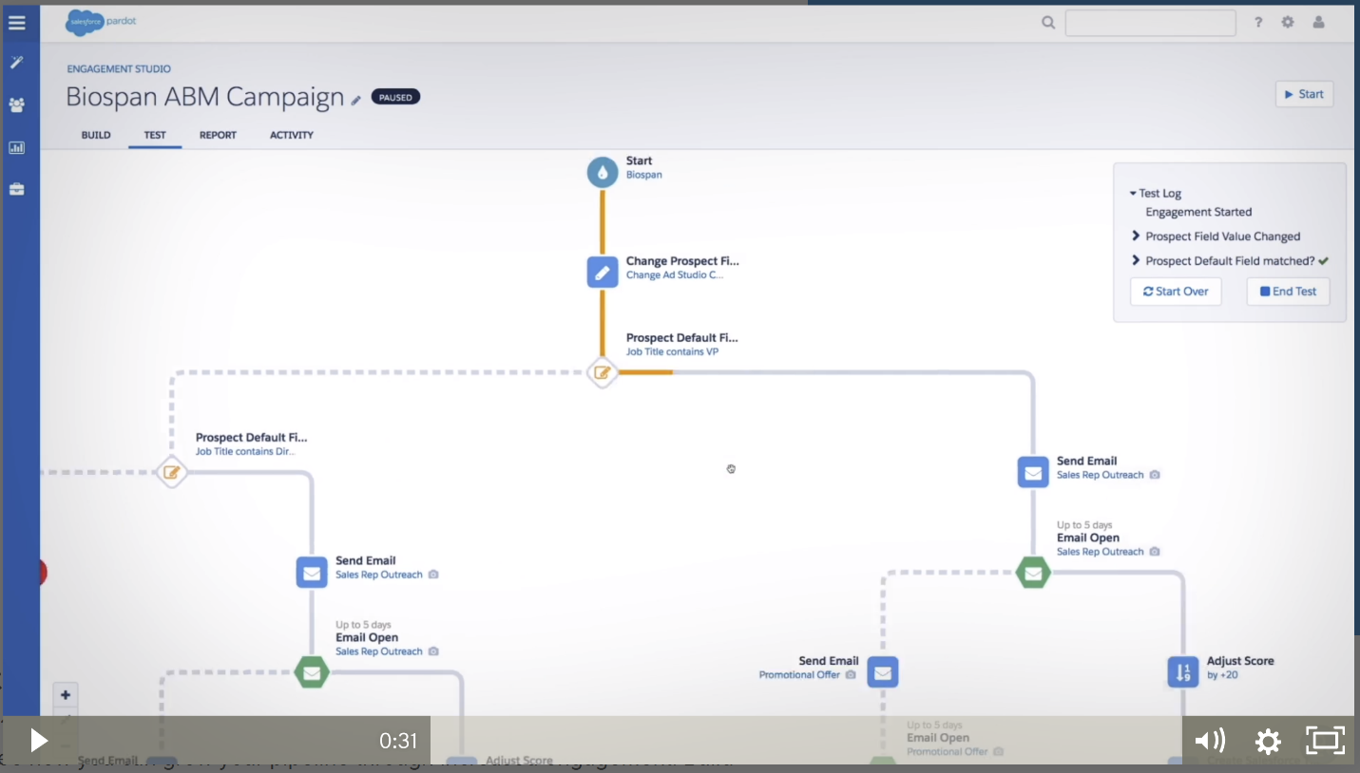

**Measuring the response**

* Google Analytics

**Step 1 : Determine your brand’s target audience.**

The foundation for building your brand, is to determine the targeted audience that you’ll be focusing on.

*You can’t be everything to everyone, right?*

When brand building, keep in mind who exactly you are trying to reach. You’ll tailor your mission and message to meet their specific needs.

**Get specific.** Figure out detailed behaviors and lifestyle of your consumers.

I’ll explain with a few brief examples:

* single moms who work from home
* tech-savvy early adopters
* college students studying abroad
* executive recruiting professionals

Solidify a picture of your consumers, then create a brand identity that **they** **can understand and relate to**.

[When brand building, keep in mind who exactly you are trying to reach. You'll tailor your mission and message to meet their specific needs.**CLICK TO TWEET**](https://twitter.com/share?text=When+brand+building%2C+keep+in+mind+who+exactly+you+are+trying+to+reach.+%23branding+%23smallbiz&url=http://bit.ly/2CjtVLv&via=FreshSparks)

**Step 2 : Define a branding mission statement.**

Before you can build a brand that your target audience trusts, you need to know what value your business provides.

The mission statement basically defines a purpose for existing. It will inform every other aspect of your brand building.

[What's your mission? Craft a clear expression of what your company is most passionate about.](https://twitter.com/share?text=What%27s+your+mission%3F+Craft+a+clear+expression+of+what+your+%23smallbiz+is+passionate+about.+%23branding&url=http://bit.ly/2CjtVLv&via=FreshSparks)

Everything from your logo to your tagline, voice, message and personality should reflect that mission.

We all know the Nike tagline: ***Just Do It***. But do you know their mission statement?

[**Nike’s mission**](http://about.nike.com/) is: “***To bring inspiration and innovation to every athlete in the world***“.

You can see the Nike mission everywhere. They focus on all types of athletes using Nike products to be their best self.

Nike goes even further with their mission, by adding a footnote to the statement: “*If you have a body, you are an athlete*“. Think about how wide their target audience becomes with a disclaimer like that!

The company has built up such a reputation and brand following, that they are able to increase their target to accommodate every “body”.

[Start small with your branding, and remember to focus on your target niche audience first.](https://twitter.com/share?text=Start+small+with+your+%23branding+%26+remember+to+focus+on+your+target+niche+audience+first.+%23smallbiz&url=http://bit.ly/2CjtVLv&via=FreshSparks)

With time, your brand loyalty may grow enough to expand your reach.

**Step 3 : Research brands within your industry niche.**

You should never imitate exactly what the big brands are doing in your industry.

But, you should be aware of what they do well (or where they fail).

[The goal is to differentiate from the competition. Convince a customer to purchase from you over them.](https://twitter.com/share?text=When+brand+building%2C+the+goal+is+to+differentiate+from+the+competition.+%23branding+%23smallbiz&url=http://bit.ly/2CjtVLv&via=FreshSparks)

Research your main competitors or benchmarks. Study how they have effectively, and ineffectively built their brand.

* Are they consistent with their message and visual identity across channels?
* What is the quality of their products or services?
* Do they have customer reviews you can read, or social mentions about them?

**Step 4 : Outline the key qualities & benefits your brand offers.**

There will always be brands with bigger budgets and more resources to command their industry.

*Your products, services, and benefits belong solely to you.*

You have to delve down deep and figure out what you offer, that no one else is offering.

[Focus on the qualities and benefits that make your company unique.](https://twitter.com/share?text=Focus+on+the+qualities+and+benefits+that+make+your+company+unique.+%23branding+%23smallbiz&url=http://bit.ly/2CjtVLv&via=FreshSparks)

It could be more authentic and transparent customer service, a better way to support productivity, or helping save money with a more affordable option.

Assuming you know exactly who your target audience is (see Step 1), give them a reason to choose your brand over another.

[**Apple**](https://www.apple.com/) is obviously not just another computer company. One of their key qualities is **clean design**, and a key benefit is**ease of use**.

From unique packaging to their announcement events, Apple always reminds customers that its products can be used right out of the box.

Do you remember Apple’s slogan back in 1997-2002? It was “*Think Different*“. This notion continues to exist, today.

Bottom of Form

**Step 5 : Create a great brand logo & tagline.**

The most basic (and arguably the most important piece) of brand building, is the creation of your company logo and tagline.

This graphic will appear on everything that relates to your small business. It will become your calling card, and the visual recognition of your promise.

**Be willing to invest the time and money to create something exceptional.**You’ll be putting the logo on everything, to reinforce visual identity of your brand.

[Hire a professional designer or creative agency with branding and identity design experience, to help you build your brand.**T**](https://twitter.com/share?text=Hire+pro+designer+or+creative+agency+with+%23branding+experience+to+help+build+your+brand.+%23smallbiz&url=http://bit.ly/2CjtVLv&via=FreshSparks)

Their expertise will ensure that you get a unique and timeless mark for your business.

A designer can also [**develop brand guidelines**](https://designschool.canva.com/blog/your-brand-needs-a-visual-style-guide/), to ensure consistency for any future application of the logo and associated color palette.

**Step 6 : Form your brand’s business voice.**

Your voice is dependent on your company mission, audience, and industry.

It’s how you communicate with your customers, and how they respond to you.

A business voice could be:

* professional
* friendly
* service-oriented
* promotional
* conversational
* informative, etc.

There are endless adjectives and possibilities.

[Choose a brand voice that makes sense and resonates with your target customers.**T**](https://twitter.com/share?text=Choose+a+%23branding+voice+that+makes+sense+and+resonates+with+your+target+customers.+%23smallbiz&url=http://bit.ly/2CjtVLv&via=FreshSparks)

[**Virgin America**](https://www.virginamerica.com/) is known for its friendly and reliable customer service, and their voice constantly builds that brand.

On Twitter, notice their personable style–using location-based humor in this instance. They also reinforce the value that they bring to their customers–guaranteeing power outlets on every flight.

Fish sticks will fly at Pike Place before we ever offer a flight without power outlets. [**#FleetWide**](https://twitter.com/hashtag/FleetWide?src=hash) [**pic.twitter.com/eQLLsUfXmz**](http://t.co/eQLLsUfXmz)

— Virgin America (@VirginAmerica) [**August 4, 2015**](https://twitter.com/VirginAmerica/status/628706988294316032)

**Step 7 : Build a brand message and elevator pitch.**

When brand building, tell customers succinctly who you are.

*Use the business voice you have chosen.*

Your message should be intricately associated with your brand, and conveyed in 1-2 sentences.

It goes beyond your logo and tagline to define the key aspects of who you are, what you offer, and why people should care.

[A brand message is an opportunity to communicate on a human level, making a direct emotional connection with your consumers.**CLICK TO TWEET**](https://twitter.com/share?text=A+%23branding+message+is+an+opportunity+to+communicate+on+a+human+level+with+your+consumer.+%23smallbiz&url=http://bit.ly/2CjtVLv&via=FreshSparks)

What this means, is that the language you use should be understood immediately while striking an emotional chord.

*Make it simple and clear.*

Most importantly: when crafting a message, address not what your product can do…but why it is important to your customer.

[**TOMS Shoes**](http://www.toms.com/) has built a huge social following, and overwhelming positive brand perception.

They clearly define their message front and center on their website: “*Improving lives. With every product you purchase, TOMS will help a person in need. One for One.*”

**Step 8 : Let your brand personality shine.**

Customers aren’t looking for another cookie-cutter company who offers the same thing as everyone else.

They are looking for an experience tailored to their needs, backed by genuine personal interaction.

[Make your personality stand out in every aspect of your brand building.**CLICK TO TWEET**](https://twitter.com/share?text=Make+your+personality+stand+out+in+every+aspect+of+your+brand+building.+%23branding+%23smallbiz&url=http://bit.ly/2CjtVLv&via=FreshSparks)

**Be consistent with this brand personality across all points of contact.**

It can be as simple as:

* a conversational voice in communication (using “I”, and “you”)
* sharing behind-the-scenes content
* telling stories about real experiences
* describing your products/services in a quirky manner

**Step 9 : Integrate your brand into every aspect of your business.**

*Brand building never stops.*

Your brand should be visible and reflected in everything that your customer sees (and doesn’t see).

If a client walks into your office, your brand should be on display both in the environment and with personal interactions.

Anything tangible–from business cards, to advertisements, to packaging–needs the stamp of your logo.

When you design your website: incorporate your voice, message, and personality into content.

Profile pages for social media networks should be branded visually, and with your chosen voice for engagement.

**Step 10 : Stay true to your brand.**

Unless you decide to change your brand into something that is more effective based on measured consumer response, **consistency is key**.

[Once you’ve chosen a voice, use it for every piece of content you create.**CLICK TO TWEET**](https://twitter.com/share?text=Once+you+choose+a+brand+voice%2C+use+it+for+every+piece+of+content+you+create.+%23branding+%23smallbiz&url=http://bit.ly/2CjtVLv&via=FreshSparks)

Don’t constantly change your branding,  The inconsistency will confuse your customers, and make long-term brand building more difficult.

[**Starbucks**](http://www.starbucks.com/) is the world’s leading specialty coffee retailer, and their brand has always promised to bring people together.

The Starbucks mission? “*To inspire and nurture the human spirit – one person, one cup and one neighborhood at a time.*”

That’s why at every store you’ll find free Wi-Fi, large tables, and soothing music to make conversing easy. They always write your name on your coffee for an extra personal touch.

Even despite a [**logo change in 2011**](http://www.csmonitor.com/Business/new-economy/2011/0106/Starbucks-logo-change-No-name.-More-mermaid.-Will-it-sell-more-coffee) (removing the company name!), the Starbucks brand perception remains strong. When you see that simplified green mermaid logo, what do you feel? I guarantee it’s something.

**Step 11 : Be your brand’s biggest advocate.**

Once you have built a brand that works for your small business, you (and your employees) are the best advocates to market your brand.

[No one knows your brand better than you, so it’s up to you to spread the word.**T**](https://twitter.com/share?text=No+one+knows+your+brand+better+than+you%2C+so+it%E2%80%99s+up+to+you+to+spread+the+word.+%23branding+%23smallbiz&url=http://bit.ly/2CjtVLv&via=FreshSparks)

When hiring employees, ensure that they are a culture fit–aligning with the mission, vision, and values of your brand.

Encourage employees to [**establish a personal brand**](http://www.quicksprout.com/the-complete-guide-to-building-your-personal-brand/) that aligns with your company’s, further strengthening reach.

Give your loyal customers a voice. Encourage them to post reviews, or share your content.

**Conclusion**

A solid brand building process can transform your business from a small player into a successful competitor.

You’ll discover that your customers will develop a deeper level of trust for your brand, and be more likely to purchase what you are selling.

Develop a consistent message and visual identity to reinforce your mission.

Integrate your brand into every aspect of customer experience: from your storefront, to your website, to your personal interactions!