Software Engineering Practical Course
Quality Analysis of User Stories
Documentation

Version: 1.0
Date: 30.04.2025
Team: SP25_Gruppe1_Dateng_Hammudi_Stechert_Alshaabi
Supervisor: Prof. Gabriele Taentzer, Lukas Hofmann
Institution: Philipps-Universität Marburg

1. Introduction
This documentation outlines the development of a Java-based application for analyzing the quality of User Stories (USs) in agile software development. The tool reads USs from .txt or .json files, extracts annotations (roles, actions, entities), performs quality checks, and generates reports.

1.1 Objectives
- Extract structured annotations (roles, actions, entities) from natural-language User Stories.
- Analyze USs based on quality criteria (e.g., well-formedness, atomicity, uniformity).
- Provide a graphical user interface (GUI) for configuration and visualization.
- Export analysis results in JSON format.

1.2 Technologies
- Programming Language: Java
- NLP Tools: OpenNLP / Stanford CoreNLP (for text processing)
- Build Tool: Maven
- Version Control: Git (GitLab)
- GUI Framework: JavaFX or Swing

2. Setup & Repository Structure
2.1 Git Repository Setup
- Repository Name: SP25_Gruppe1_Dateng_Hammudi_Stechert_Alshaabi
- Access: Private, with team members, tutors, and professors @hofman6v, @taentzer added as Reporters.
- Branch Strategy:
- main (stable releases)
- dev (development branch)

2.2 Project Structure
src/
main/
java/
code/
Analysis.java #Quality checks
Gui.java #Graphical Interface
Main.java #Entry point
Model,java #Data classes (UserStory, Annotation)
NLP.java #NLP processing (extract roles/actions/entities)
resources/ #Sample files, JSON templates
tests/ #JUnit Tests

3. Functional Requirements
3.1 Input/Output
Read User Stories
Parse .txt or .json files containing USs in the format: "As a <Role>, I want <Goal>, [so that <Benefit>]."
Extract Annotations
Identify and tag: Roles, Actions (Goal/Benefit), Entities, and relationships (trigger, targets, contains).
Export Annotations
Save extracted data in JSON format for later reuse.
Example structure:
json
{
"PID": "#G03#",
"Text": "As a UI designer, I want to modify webpage content.",
"Persona": ["UI designer"],
"Action.Goal": ["modify"],
"Entity.Goal": ["webpage content"]
}

3.2 Quality Analysis

- Well-formedness: US must contain at least a role and a goal “As an Administrator I want to distribute …” Reject for example “The system needs a server”
- Atomicity: US must describe only one action “As an Administrator I want to distribute …” Reject for example “As an Administrator I want to distribute and locate…”
- Uniformity: US must follow “As a <Role>, I want <Goal>…” format
- Redundancy-free: No two USs should have identical/similar Goals etc.
- Conflict-free: No USs should contradict each other

3.3 GUI Features
- Load USs from files
- Select Quality checks to perform
- Visualize Results
- Filter/Sort by criteria
- Export reports to JSON

4. Development Process
4.1 Workflow
- Sprints in iterations (Weeks 2-4, 5-9, 10-12 and 13)
- Meetings: Weekly progress reviews with Tutors
- Tools: Gitlab for version control

4.2 Milestones
Week 1: Setup repo, project structure, Gantt chart
Week 2-4: Implement US parsing and annotation extraction
Week 5: Milestone, Basic NLP functionality
Week 5-9: Implement quality checks
Week 10: Full quality analysis
Week 10-12: Develop GUI
Week 13: Final presentation and code submission

5. Preliminary Class Diagram
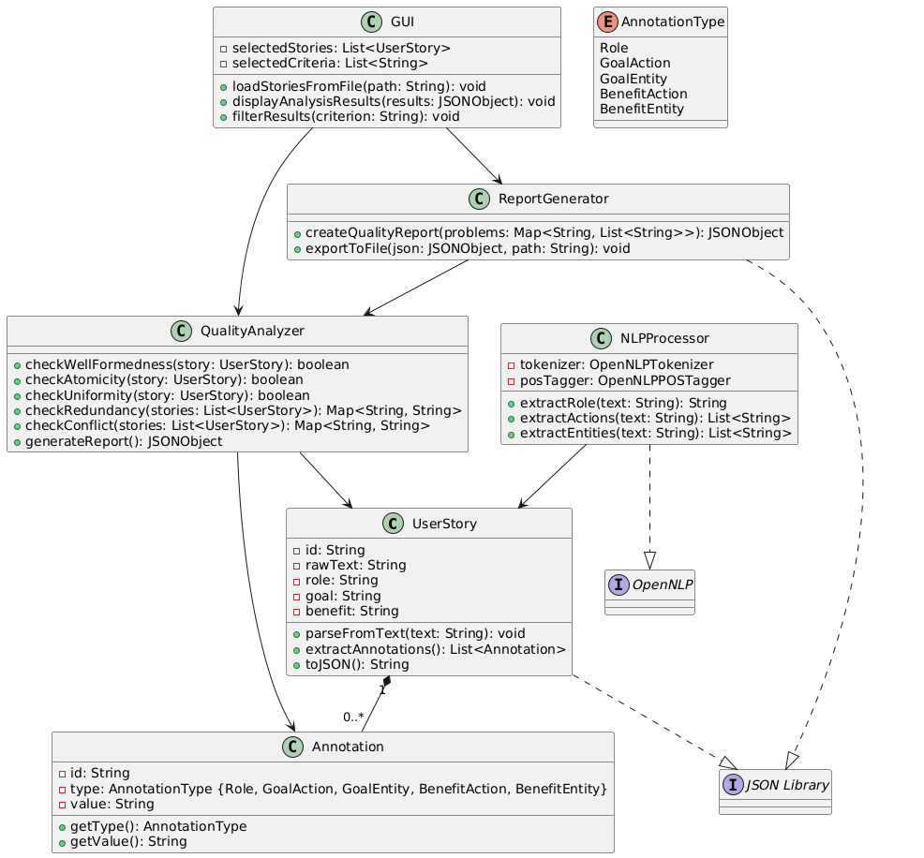

6. Deliverables
Code: Fully functional Java application
Documentation:
- Gantt Chart (PDF)
- Class diagram (PDF)
- Manual (How to use GUI)
3. Reports
- Quality analysis outputs (JSON)
- Test cases (JUnit)

Repository:
https://gitlab.uni-marburg.de/stechert/sp25_gruppe1_dateng_hammudi_stechert_alshaabi.git

