SIMATS ENGINEERING (SAVEETHA SCHOOL OF ENGINEERING)
Department of Computer Science & Engineering
CO2 - ASSESSMENT TOOL - 1
Scenario-Based Assessment

Course Code | CSA3717 | Course Title | Software Testing
CO Assessed | CO2 | Assessment | Assessment Tool 1: Scenario Based Assessment
Weightage | 50% of CIA | Total Marks | 100
CO2 Statement | Apply software testing principles to enhance the effectiveness of software quality assurance and improve defect detection strategies. (BL3)
Student Name | M.Dathu | Reg. No. | 192311158
Section/Batch | Slot A / | Date | 30-10-2026

M.DATHU
Code of Conduct:
I M.DATHU 192311158 certify that this submission is my original work and that I have adhered to the guidelines specified for this assessment. I understand that any violation of academic integrity rules will result in disciplinary action.
Signature of the student:

Question:
A mobile food delivery app features a "Real-time Tracker" that transitions through various states (Ordered, Preparing, Out for Delivery, Delivered). Users reported the app getting stuck when a driver cancels mid-delivery. Evaluate the current black-box strategy and apply State Transition Testing to redesign the scenarios. Justify how this technique addresses the logic gaps that ECP and BVA might miss in dynamic workflows.

Solution

State Transition Testing for the Real-Time Order Tracker

1. Executive Summary
The food delivery app's Real-time Tracker moves an order through four visible states: Ordered, Preparing, Out for Delivery, Delivered. Users report that the tracker gets stuck when a driver cancels mid-delivery. The screen keeps showing "Out for Delivery", the ETA stops updating, the map pin freezes, and the customer has no way to act.
This report makes four contributions:
- It evaluates the black-box strategy that most likely produced this gap. The strategy appears to rely on Equivalence Class Partitioning (ECP) and Boundary Value Analysis (BVA) applied to individual inputs and screens.
- It models the tracker as a finite state machine and shows that the specification is incomplete: the driver-cancel event is not defined for the Out for Delivery state, and the model has no states for recovery.
- It applies State Transition Testing (STT) to produce a redesigned scenario set: a state transition table, a full set of valid and invalid transitions, and N-switch sequences for the cancellation workflow.
- It justifies why STT finds defects that ECP and BVA structurally cannot, and explains how the three techniques should be combined.
Core finding. The defect is not a bad value or a bad boundary. It is a missing transition: a legal real-world event arriving in a state where the system has no defined response. ECP and BVA partition and probe data. They do not model behaviour over time, so they cannot see this class of defect. STT can.
Assumptions. The team's actual test suite was not available for this analysis. The evaluation in Section 3 is therefore an inference from the symptoms, from common practice and from the structure of the four-state tracker. Where the real suite differs, the reasoning still holds, and the redesigned scenarios in Sections 6 to 8 do not depend on the evaluation being exactly right.

2. Background and Problem Statement

2.1 The system under test
The Real-time Tracker is a mobile UI component fed by backend events, typically over WebSocket or push notifications, with polling as a fallback. Each event changes what the customer sees: a status label, a progress bar, an ETA and a map. Four states are visible to the user:
State | What the customer sees | Typical trigger into the state
Ordered | "Order placed", waiting for the restaurant | Payment confirmed
Preparing | "Restaurant is preparing your food" | Restaurant accepts
Out for Delivery | Driver name, live map, ETA | Driver picks up the order
Delivered | "Enjoy your meal", rating prompt | Driver marks delivery complete
This is the happy path. It is a straight line: Ordered → Preparing → Out for Delivery → Delivered.

2.2 The reported failure
When a driver cancels after pickup, the backend must do something: find a new driver, escalate to support, refund the customer, or all three. Users report that the tracker simply stays on Out for Delivery. Plausible technical causes include:
- The client only handles forward transitions, so a "driver cancelled" event is received and silently ignored.
- The backend emits an event type the client does not recognise, and the client discards unknown events.
- The backend emits no event at all, because the cancellation is handled in a separate driver-side service that does not notify the order service.
- The client receives a "reassigning" event but has no screen for it, so the UI never re-renders.
Every one of these is a state-machine defect. In each case an event occurs in a state where the designed behaviour is undefined, or defined only for the happy path.

2.3 Why this matters
A frozen tracker is worse than an error message. The customer cannot tell whether the food is coming, cannot cancel with confidence, and typically contacts support or disputes the charge. The cost is support load, refunds, lost trust and app-store reviews. The defect also sits on the most emotionally charged moment of the user journey, when the customer is hungry and waiting.

3. Evaluation of the Current Black-Box Strategy

3.1 What the current strategy most likely contains
A typical black-box plan for a feature like this, written without a state model, looks like the following:
- ECP on inputs. Valid and invalid order IDs, valid and invalid statuses, logged-in versus guest users, orders with one item versus many.
- BVA on numeric values. ETA of 0, 1, 59, 60 and 61 minutes, a driver rating of 1 and 5, a cart total at the minimum order value.
- One test per state. Confirm that each of the four screens renders correctly when the order is in that state.
- One happy-path end-to-end test. Place an order and watch it advance to Delivered.
- A small number of negative tests. For example, the user cancels before the restaurant accepts.
This suite looks thorough on a coverage report. Every screen is visited, every field is validated, every boundary is probed. It would also pass, and it did pass, with the cancellation defect present.

3.2 Strengths of the current strategy
The strategy is not wrong. It is incomplete, and it is good at what it does:
- It is cheap to write and easy to review.
- It catches input-validation defects and rendering defects.
- It gives wide coverage of static properties such as layout, formatting and field limits.
- It is technique-neutral and works without access to the code.

3.3 Gaps in the current strategy
# | Gap | Consequence
G1 | No behavioural model. Tests are derived from screens and fields, not from a model of states and events. | Nobody asks "what can happen in this state?"
G2 | State treated as data. The order status is handled as an input partition ("valid status") rather than as the context that decides how an event is interpreted. | The same event is tested once, not once per state.
G3 | Events are under-specified. Backend events such as driver-cancel, driver-reassign and connection-lost are not first-class test inputs. | The scenarios that fail in production are never created.
G4 | Only forward paths are tested. The suite follows the arrow from Ordered to Delivered. | Backward, lateral and looping transitions go unexercised.
G5 | No invalid-transition testing. There are no tests for events that should be ignored or rejected, such as "delivered" arriving while the order is still Preparing. | Out-of-order and duplicate events corrupt the UI.
G6 | Recovery states are absent from the specification. There is no Reassigning, Cancelled or Escalated state. | Testers have nothing to design against, and the product gap goes unnoticed in review.
G7 | No sequence coverage. Each test starts fresh and checks one step. | Defects that only appear after two or three transitions, such as a second driver cancelling, are invisible.
G8 | Coverage metric is misleading. Screen coverage and boundary coverage read as 100% while transition coverage is roughly 3 of at least 15. | The team believes the feature is well tested.

3.4 Root-cause analysis of the escape
The defect escaped for a single structural reason: the test design technique had no place to put the missing requirement. ECP asks "which input classes exist?" BVA asks "where do values change behaviour?" Neither asks "what events can occur in each state, and what must happen next?" Because the question was never asked, the absence of a response to driver cancels in Out for Delivery was never noticed.
Two secondary causes made things worse:
- Requirements gap. The product specification probably describes the happy path in detail and failure handling in a sentence. A black-box tester working from that specification inherits the gap.
- Environment gap. Real driver cancellations are hard to trigger in a test environment, so testers avoid them. A mockable event feed is needed to make them cheap (Section 9).

3.5 Verdict
The current strategy is adequate for static validation and inadequate for dynamic workflow behaviour. It should be kept for what it does well and supplemented, not replaced.

4. State Transition Testing: Technique Overview

4.1 Core concepts
State Transition Testing is a black-box technique that models the system as a finite state machine. Its elements are:
- State: a stable condition of the system in which it waits for an event, such as Preparing.
- Event: something that happens, from the user, the backend or the environment, such as driver_cancels.
- Transition: a change from one state to another caused by an event, written State --event [guard] / action--> NextState.
- Guard: a condition that must hold for the transition to fire, such as food already picked up.
- Action: what the system does on the transition, such as showing a banner or sending a notification.
Tests are derived by choosing paths through the model according to a coverage criterion.

4.2 Coverage criteria
Level | Criterion | What it guarantees
1 | All states | Every state is reached at least once.
2 | All valid transitions (0-switch) | Every defined arrow is exercised at least once.
3 | All invalid transitions | Every (state, event) pair not defined is tried, and the system rejects or ignores it safely.
4 | 1-switch (all pairs of consecutive transitions) | Every two-step sequence is covered, which catches defects that depend on history.
5 | N-switch / selected long paths | Chosen long sequences, such as repeated cancellations or reconnects.
Levels 1 and 2 are the minimum. Level 3 is what exposes missing handling. Levels 4 and 5 are risk-based and should be targeted at the cancellation workflow.

4.3 The state table
Two representations are used together. A state diagram gives a picture, which is good for review. A state transition table lists every state against every event and records either the resulting state or "invalid". The table is the more important artefact for testing, because a blank cell is a visible, countable gap. A diagram hides missing arrows. A table does not.

5. Modelling the Real-Time Tracker

5.1 Revised state set
The four visible states are not enough to describe the system. Modelling the cancellation exposes the need for extra states. These are proposed as part of the redesign, and the product team should confirm them.
ID | State | Description
S1 | Ordered | Payment confirmed, awaiting restaurant acceptance.
S2 | Preparing | Restaurant accepted and is cooking. A driver may or may not yet be assigned.
S3 | Out for Delivery | A driver has picked up the food and is en route.
S4 | Delivered | Terminal. Delivery confirmed.
S5 | Reassigning Driver | New. The assigned driver cancelled after pickup, and the system is finding a replacement.
S6 | Needs Attention | New. Automatic recovery failed. A support agent or the customer must decide: refund, wait, or contact the restaurant.
S7 | Cancelled | New. Terminal. The order was cancelled by the customer, the restaurant or the system, with a refund as applicable.
The central design decision is that S5 and S6 must exist. A mid-delivery cancellation cannot be modelled as a transition from S3 to S3, because the customer's situation has genuinely changed and the UI must say so.

5.2 Event set
ID | Event | Source
E1 | restaurant_accepts | Restaurant
E2 | restaurant_rejects | Restaurant
E3 | driver_picks_up | Driver
E4 | driver_delivers | Driver
E5 | driver_cancels | Driver
E6 | reassign_success | Dispatch system
E7 | reassign_timeout (no driver within the time limit) | Dispatch system
E8 | customer_cancels | Customer
E9 | support_resolves (refund or redelivery) | Support agent
E10 | connection_lost / reconnected | Network
E11 | duplicate or out-of-order event | Backend or network

5.3 State diagram
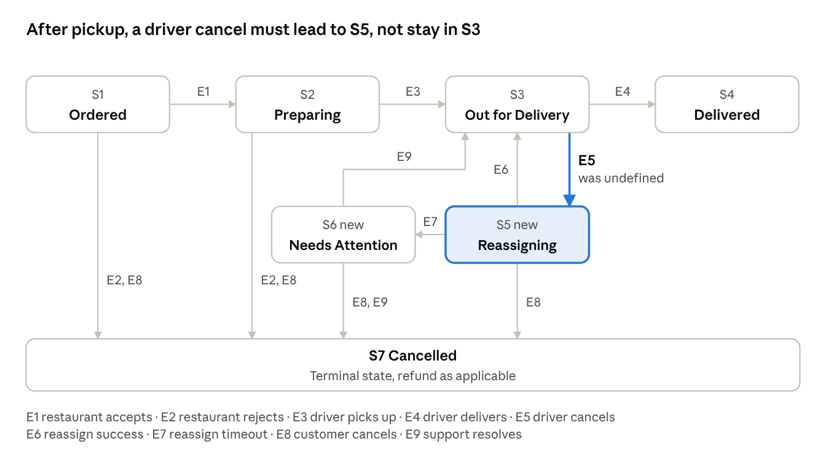
order tracker states · 7 states, 9 events
The highlighted path is the reported failure: a driver cancel in S3 (E5) must move the order to S5. A cancel before pickup (E5 in S2) keeps the order in S2.

5.4 State transition table
Cells show the next state. INV means the event is invalid in that state and must be ignored or rejected safely without changing state. ? marks a cell where the current specification is silent and a product decision is needed. The cell for S3 and E5 is the one that failed in production.
State \ Event | E1 accepts | E2 rejects | E3 pickup | E4 delivers | E5 driver cancels | E6 reassigned | E7 timeout | E8 customer cancels | E9 support resolves
S1 Ordered | S2 | S7 | INV | INV | INV | INV | INV | S7 | INV
S2 Preparing | INV | S7 | S3 | INV | S2 (driver slot reopened) | INV | INV | S7 (fee rules apply) | INV
S3 Out for Delivery | INV | INV | INV | S4 | S5 (defect: currently undefined) | INV | INV | ? (S7 with partial refund, or blocked) | INV
S4 Delivered | INV | INV | INV | INV | INV | INV | INV | INV | INV
S5 Reassigning | INV | INV | INV | INV | INV (already unassigned) | S3 | S6 | S7 | INV
S6 Needs Attention | INV | INV | INV | INV | INV | INV | INV | S7 | S3 or S7
S7 Cancelled | INV | INV | INV | INV | INV | INV | INV | INV | INV
Reading the table. There are 7 states and 9 events, so 63 (state, event) pairs. Roughly 16 are valid transitions and 47 are invalid or open. A suite built from screens and boundaries exercises perhaps 3 of the 63. That ratio is the quantitative form of gap G8.

5.5 Guards and special cases
- E5 in S2 (driver cancels before pickup) is benign: the order stays in Preparing and the system silently looks for a new driver. A banner is optional.
- E5 in S3 (driver cancels after pickup) is critical. The food has left the restaurant, so a replacement driver may need to collect it from the first driver, or the order may be unrecoverable. The UI must enter S5 immediately.
- E8 in S3 needs a product decision, shown as ? above. Customer cancellation after pickup is usually blocked or partially refunded. Whichever rule is chosen, it must be written down and tested.
- E6 after E5 should return to S3 with a new driver name, new ETA and a new map pin. A stale driver name here is a common secondary defect.

6. Test Design

6.1 Derivation approach
The scenarios are derived in four passes:
- Valid transitions (0-switch): one test for every defined arrow in the table.
- Invalid transitions: one test for every INV cell that is realistic. Unrealistic cells are grouped and sampled.
- 1-switch sequences: two-step paths that cross the cancellation workflow.
- N-switch sequences: long paths with repeated or interleaved events.
Each test records start state, event or event sequence, expected end state, and expected observable behaviour. The last item matters because state-based tests should check the UI as well as the internal status: label, ETA, map, buttons and notification.

6.2 Pass 1: valid transitions
ID | Start | Event | Expected state | Expected observable behaviour
TC-01 | S1 Ordered | E1 restaurant_accepts | S2 Preparing | Label changes. Progress bar advances to step 2.
TC-02 | S1 Ordered | E2 restaurant_rejects | S7 Cancelled | Cancellation reason is shown. Refund notice is displayed.
TC-03 | S1 Ordered | E8 customer_cancels | S7 Cancelled | Order is removed from active orders. Full refund notice.
TC-04 | S2 Preparing | E3 driver_picks_up | S3 Out for Delivery | Driver name, live map and ETA appear.
TC-05 | S2 Preparing | E5 driver_cancels | S2 Preparing | Label unchanged. Driver slot reopened. No error shown.
TC-06 | S2 Preparing | E2 restaurant_rejects | S7 Cancelled | Refund notice. Reason shown.
TC-07 | S2 Preparing | E8 customer_cancels | S7 Cancelled | Cancellation fee shown if applicable.
TC-08 | S3 Out for Delivery | E4 driver_delivers | S4 Delivered | Rating prompt. Map and ETA removed.
TC-09 | S3 Out for Delivery | E5 driver_cancels | S5 Reassigning | Banner: "Finding you a new driver." Map pin greyed. ETA replaced by "Updating".
TC-10 | S5 Reassigning | E6 reassign_success | S3 Out for Delivery | New driver name, new ETA, new pin.
TC-11 | S5 Reassigning | E7 reassign_timeout | S6 Needs Attention | Options shown: contact support, wait, request refund.
TC-12 | S5 Reassigning | E8 customer_cancels | S7 Cancelled | Refund processed according to policy.
TC-13 | S6 Needs Attention | E9 support_resolves (redelivery) | S3 Out for Delivery | Tracker resumes with a new ETA.
TC-14 | S6 Needs Attention | E9 support_resolves (refund) | S7 Cancelled | Refund confirmation.
TC-15 | S6 Needs Attention | E8 customer_cancels | S7 Cancelled | Refund processed.
TC-09 is the regression test for the reported bug. Before the fix it fails by remaining in S3. After the fix it passes only if the tracker visibly enters Reassigning.

6.3 Pass 2: invalid transitions
The purpose of these tests is to prove that out-of-order, duplicate or impossible events are ignored safely and do not corrupt the state or the UI.
ID | Start | Event | Expected result
TC-16 | S1 Ordered | E4 driver_delivers | Ignored. Stays in S1. Event logged. No "Delivered" screen.
TC-17 | S2 Preparing | E4 driver_delivers | Ignored. Stays in S2. No rating prompt.
TC-18 | S3 Out for Delivery | E1 restaurant_accepts (late duplicate) | Ignored. Stays in S3. Driver and ETA unchanged.
TC-19 | S4 Delivered | E5 driver_cancels (late) | Ignored. Terminal state preserved. No banner.
TC-20 | S4 Delivered | E8 customer_cancels | Rejected with a clear message. State unchanged.
TC-21 | S7 Cancelled | E3 driver_picks_up (stale event) | Ignored. Stays in S7. No map appears.
TC-22 | S5 Reassigning | E5 driver_cancels (duplicate) | Ignored. Stays in S5. Banner shown once only.
TC-23 | S5 Reassigning | E4 driver_delivers | Ignored. Stays in S5.
TC-24 | S6 Needs Attention | E6 reassign_success (late) | Product decision needed. Recommended: accept and return to S3.
TC-24 is deliberately a judgement case. Invalid-transition testing often reveals requirement ambiguities, and recording these is as valuable as recording defects.

6.4 Pass 3: 1-switch sequences
These test two-step histories, which is where state-dependent defects such as stale data hide.
ID | Sequence | Expected final state | What it targets
TC-25 | S3 → E5 → S5 → E6 → S3 | S3 | Driver name, ETA and map are all refreshed after reassignment, and nothing from driver 1 remains.
TC-26 | S3 → E5 → S5 → E7 → S6 | S6 | Timer starts on entering S5 and fires correctly. UI shows the options screen.
TC-27 | S3 → E5 → S5 → E8 → S7 | S7 | Customer cancellation during reassignment triggers the right refund path.
TC-28 | S2 → E5 → S2 → E3 → S3 | S3 | A pre-pickup cancellation followed by a new pickup does not leave a stale "driver cancelled" flag.

6.5 Pass 4: N-switch and environment sequences
ID | Sequence | Expected final state | What it targets
TC-29 | S3 → E5 → S5 → E6 → S3 → E5 → S5 → E7 → S6 | S6 | Repeated cancellation. The reassign timer resets on the second entry to S5 and counters do not carry over.
TC-30 | S3 → E5 (app backgrounded) → resume app | S5 | The client reconciles with the server on resume, and the user does not see a stale S3.
TC-31 | S3 → connection lost → E5 occurs server-side → reconnect | S5 | Missed-event recovery. On reconnect the client fetches the current status rather than relying on the event stream alone.
TC-32 | S3 → E5 and E4 arrive out of order | Depends on the server's authoritative order | The client uses server timestamps or sequence numbers, not arrival order.
TC-33 | S3 → E5 → S5 → E9 arrives while in S5 | INV | Support events must not skip S6.

6.6 Coverage summary
Metric | Before | After redesign
States covered | 4 of 4 visible | 7 of 7
Valid transitions covered | about 3 of 16 | 16 of 16
Invalid (state, event) pairs exercised | 0 of about 47 | about 10 directly, remainder grouped and sampled
1-switch sequences | 0 | 4 targeted
N-switch / environment sequences | 0 | 5 targeted

7. Deep Dive: The Driver-Cancellation Workflow
The reported bug lives in a small region of the model: S3, S5, S6 and their exits. This section lists the sub-scenarios that the redesigned suite must keep separate, because each one fails for a different reason.
Sub-scenario | Variation | Why it needs its own test
Timing of cancellation | Immediately after pickup, mid-route, within the last few minutes of the ETA | The ETA, the map and the "arriving" banner behave differently at each point.
Food custody | Driver still holds the food, or the food was handed back | This decides whether reassignment is possible or whether the order must go straight to S6.
Dispatch outcome | Replacement found quickly, found slowly, or not found | Exercises E6, the timer and E7.
Customer behaviour during recovery | Waits, cancels, contacts support, closes the app | Exercises E8 in S5 and S6, plus resume behaviour.
Repetition | Second or third driver also cancels | Counters, timers and stale data.
Delivery of the signal | Event arrives instantly, late, twice, or not at all | Exercises reconnect and reconciliation logic.

7.1 Expected UI contract for S5 and S6
Testers need an unambiguous oracle, so the redesign defines what the customer must see:
- Reassigning (S5): a clear status line, a note that the previous driver is no longer assigned, the ETA replaced by an "updating" indicator, a greyed or removed map pin, and a way to contact support. No driver name or photo from the cancelled driver may remain.
- Needs Attention (S6): an explanation in plain language, at least two actions (wait or request a refund, plus contact support), and a visible timestamp of when the problem began.
- Return to S3 (E6): a new driver identity, a new ETA and a new pin, with a short notice that the driver changed.
If the product team prefers different wording or actions, the tests change but the structure does not. The key requirement is that the tracker must never remain in a state that no longer describes reality.

8. Why STT Closes the Gaps That ECP and BVA Miss

8.1 What each technique actually models
Technique | Models | Question it asks | Unit of test
ECP | Input data | "Which groups of values behave the same?" | One value per class
BVA | Input data at the edges | "Where does behaviour change as a value crosses a limit?" | Values on and around each boundary
STT | System behaviour over time | "In this state, what must happen when this event occurs?" | A (state, event) pair, or a path of them
ECP and BVA treat the system as a function: input in, output out, with no memory. STT treats it as a machine with memory: the output depends on the input and on the history that put the system in its current state. A delivery tracker is the second kind of system.

8.2 Five structural reasons ECP and BVA miss the bug
1. The defect is a missing behaviour, not a wrong value. ECP and BVA can only select from values that someone has already identified as inputs. "Driver cancelled" is not an input value in the current model. It is an event that the specification does not mention for this state. A technique that begins from the specification's inputs cannot generate a test for something the specification omits. STT begins from the full grid of states and events, so the missing cell is visible by construction.
2. The same input must produce different outputs depending on state. E5 (driver cancels) does nothing visible in S2, moves the order to Reassigning in S3, and is invalid in S4 and S7. ECP would place "driver cancels" in a single class and test it once, probably in the easiest state. That one test cannot reveal that the behaviour in the other state is wrong. STT forces one test per state for the same event.
3. Boundaries on values do not exist for events. There is no meaningful boundary between "driver cancels" and "driver cancels slightly more". BVA has nothing to grip. The nearest analogue in a workflow, such as a timeout threshold, is a timing boundary and is covered in Section 9 by combining BVA with STT.
4. History-dependent defects need sequences. Some defects appear only after S3 → S5 → S3 → S5, for example a reassign timer that is never reset, or a driver name cached from the first assignment. ECP and BVA tests are single-step and stateless. They have no mechanism for saying "do this, then this, then this, then check." STT's N-switch coverage does.
5. Invalid events are first-class tests. ECP does include invalid input classes, but these are invalid values such as a malformed order ID. It does not cover valid events delivered at the wrong time, such as a "delivered" signal for an order still in Preparing. These are common in real distributed systems, where messages arrive late, twice or out of order. STT's invalid-transition pass tests them directly.

8.3 Worked comparison on the reported defect
Suppose the team wants to test the tracker thoroughly using ECP and BVA only.
- ECP on order status: classes are Ordered, Preparing, Out for Delivery, Delivered, and an invalid status. Five tests. All pass, because each screen renders when the status is set directly.
- BVA on ETA: values 0, 1, 59, 60 and 61 minutes. All pass, because the ETA formats correctly.
- ECP on driver rating, order size, payment method: all pass.
The suite is green, and the bug is still present. Now apply STT:
- The state table for S3 has a blank cell under E5.
- The tester writes TC-09: put the order in S3, inject E5, observe the screen.
- The test fails immediately. The defect is found in a single targeted test, without any change to the input data.
The point is not that STT is cleverer. It is that STT's derivation process asks the question that exposes the defect, while the other two techniques' derivation processes do not.

8.4 What STT does not replace
STT does not validate data. It will not tell you that an ETA of 61 minutes renders badly, or that an empty driver name crashes the card. Those are the strengths of ECP and BVA. The three techniques answer different questions, and a complete strategy uses all of them.

9. A Combined, Layered Strategy

9.1 Layer model
Layer | Technique | Purpose | Examples in this feature
1 | STT | Behaviour over time | TC-01 to TC-33
2 | ECP | Data classes within a state | Driver name length, missing photo, many items versus one
3 | BVA | Edges of values and timers | ETA 0 and 1 minute, reassign timeout at limit minus one, at limit and at limit plus one
4 | Exploratory and environmental | Unknown unknowns | Poor network, app kill, OS notification settings, low battery mode

9.2 Where ECP and BVA slot into the state model
The layers combine multiplicatively. For example, TC-26 (S5 to S6 on timeout) gains BVA variants:
- Timeout minus one second: the tracker is still in S5.
- Timeout exactly: the tracker moves to S6.
- Timeout plus one second: the tracker is in S6, with no flicker back to S5.
Similarly, TC-10 (S5 to S3 on reassignment) gains ECP variants: a replacement driver with a long name, with no photo, with a rating of 5.0, and with a rating of 1.0. Each is a data class tested inside the state-based scenario.

9.3 Prioritisation
Not all 33 scenarios are equal. A risk-based order is recommended:
- Critical: TC-09, 10, 11, 25, 26, 27, 29, 31. These are the cancellation path and the recovery path.
- High: TC-04, 05, 08, 12 to 15, 22, 30, 32. These are core transitions and state corruption risks.
- Medium: TC-01 to 03, 06, 07, 16 to 21, 23, 24, 28, 33. These are remaining valid transitions and invalid transitions.

10. Execution and Automation

10.1 Making events testable
The reason driver cancellations were never tested is probably that they are hard to cause in a real environment. The fix is a controllable event source:
- A mock or staging endpoint that lets a tester inject any event for a given order ID.
- A way to set an order directly into any starting state, so that TC-09 does not need ten minutes of setup.
- Server-side logging of the authoritative order status, so tests can compare the UI against the truth.

10.2 Table-driven automation
Because the state table is data, the tests can be too. A single parameterised test reads each row and checks the outcome. The pseudocode below is illustrative:
const transitions = [
{ start: 'OUT_FOR_DELIVERY', event: 'DRIVER_CANCELS', expected: 'REASSIGNING',
ui: { banner: /finding you a new driver/i, etaText: /updating/i } },
{ start: 'REASSIGNING', event: 'REASSIGN_SUCCESS', expected: 'OUT_FOR_DELIVERY',
ui: { driverChanged: true } },
{ start: 'DELIVERED', event: 'DRIVER_CANCELS', expected: 'DELIVERED',
ui: { banner: null } },
];
test.each(transitions)('$start + $event -> $expected', async (t) => {
const orderId = await seedOrderInState(t.start);
await openTracker(orderId);
await injectEvent(orderId, t.event);
await expectState(orderId, t.expected); // server truth
await expectUi(t.ui); // what the customer sees
});
This structure has two benefits. New rows are cheap to add when the product team defines a new state. And a blank or changed cell in the specification translates directly into a test failure or a new test.

10.3 Oracles
Every state-based test needs two checks: the internal state (from the server or the app's state store) and the visible result (label, ETA, map, buttons). A common failure mode is a correct internal state with a stale screen, which is precisely the reported symptom.

11. Metrics and Exit Criteria
Metric | Target for release
State coverage | 100% of 7 states
Valid transition coverage | 100% of defined transitions
Invalid transition coverage | 100% of realistic invalid pairs, with the remainder justified
1-switch coverage on the cancellation region | 100% of pairs among S3, S5, S6 and S7
Open "?" cells in the state table | 0. Each resolved by a product decision and a test.
Critical-priority scenarios passing | 100%
Time from event to UI update (S3 to S5) | Within the agreed service level, for example under 3 seconds on a normal connection
Defect-based metric. After release, track "stuck tracker" support tickets and compare with the pre-fix baseline. A drop in these tickets is the ultimate validation of the redesign.

12. Risks and Limitations
- State explosion. Real apps have more states than this model (payment failure, address change, partial refunds, multi-restaurant orders). The mitigation is hierarchical state machines: model the tracker separately from payment and dispatch, and test interactions selectively.
- Model accuracy. Tests are only as good as the model. If the model omits a real state, the suite omits it too. Review the model with developers and product owners, and compare it against production event logs.
- Specification gaps are not test gaps. Cells marked "?" require product decisions. Testers can find these gaps, but should not silently invent the answer.
- Asynchrony. Events from the network are not instantaneous. Tests must wait on conditions rather than fixed delays, or they become flaky.
- Not a complete strategy. STT does not cover performance, security, accessibility or usability on its own.

13. Recommendations and Roadmap
- Adopt the extended state model (S1 to S7) and review it with product and engineering. Resolve every "?" cell.
- Fix the defect by implementing S5 and S6 and the E5 handler in S3, then use TC-09 as the regression test.
- Build the event-injection and state-seeding tools so that all transitions can be tested cheaply.
- Automate the table-driven suite (TC-01 to TC-33) in the CI pipeline, with the critical set running on every build.
- Retain ECP and BVA inside each state for data and timing edges.
- Add client reconciliation: on app resume and reconnect, fetch the authoritative status instead of relying only on the event stream.
- Review the model quarterly and whenever a new status is added to the backend.
- Monitor production for transitions that the model does not contain. An unknown event type is a signal that the model needs to grow.
Phase | Activities | Outcome
1. Model | Workshop to agree states, events and the table | Signed-off state model
2. Design | Derive scenarios and add ECP/BVA variants | Reviewed test set
3. Enable | Event injection and state seeding | Cheap, repeatable setup
4. Automate | Table-driven tests in CI | Regression safety net
5. Monitor | Production event and ticket tracking | Feedback into the model

14. Conclusion
The tracker froze because the system had no defined behaviour for a legitimate event in a particular state, and the test strategy had no technique capable of noticing that absence. Equivalence Class Partitioning and Boundary Value Analysis are valuable, but they describe data. The order tracker is a workflow, and workflows fail at the joins between states.
State Transition Testing supplies what was missing. It forces every state to be examined against every event, turns blank cells into visible gaps, tests invalid and out-of-order events, and extends to sequences where history matters. Applied here, it yields 33 targeted scenarios, exposes a design gap that requires two new states, and provides a single regression test (TC-09) for the reported defect.
The best result comes from layering: STT for behaviour, ECP and BVA for data and timing within each state, and exploratory testing for what no model anticipates. With that structure, a mid-delivery driver cancellation becomes an ordinary, well-tested path rather than a production surprise.

Appendix A: Traceability Summary
Gap from Section 3.3 | Addressed by
G1 No behavioural model | Sections 5.1 to 5.4
G2 State treated as data | State and event as separate axes of the table
G3 Events under-specified | Event set E1 to E11, injection tooling in Section 10
G4 Only forward paths | TC-05, 09 to 15 and backward or lateral transitions
G5 No invalid-transition tests | TC-16 to TC-24, TC-33
G6 Missing recovery states | S5, S6 and S7 added
G7 No sequence coverage | TC-25 to TC-33
G8 Misleading coverage metric | Section 6.6 and Section 11

Appendix B: Glossary
- ECP: Equivalence Class Partitioning. Inputs are grouped into classes expected to behave alike, and one value per class is tested.
- BVA: Boundary Value Analysis. Values at and around the edges of equivalence classes are tested.
- STT: State Transition Testing. Tests are derived from a finite state machine of states, events and transitions.
- 0-switch, 1-switch, N-switch: Coverage of single transitions, pairs of consecutive transitions, and sequences of N+1 consecutive transitions.
- Guard: A condition that must be true for a transition to occur.
- Oracle: The source of truth used to decide whether a test passed.

15. CO2 Extension: Black-Box, White-Box and Control-Flow Test Design
This section adds white-box and control-flow test design to the black-box work above. No source code was supplied, so the event handler below is an assumed reconstruction that reproduces the reported bug.

15.1 Techniques used
Technique | Type | Where applied | What it finds
Equivalence partitioning | Black-box | Section 3 gaps, input classes | Wrong handling of invalid values
Boundary value analysis | Black-box | Timeout limit, Section 9.2 | Defects at the edges of a limit
State transition testing | Black-box | Sections 5 and 6 | Missing, invalid and wrong transitions
Decision table (state by event) | Black-box | Section 5.4 | Combinations nobody specified
Statement coverage | White-box | 15.4 | Code never executed
Branch coverage | White-box | 15.4 | Decision outcomes never taken
Condition and MC/DC coverage | White-box | 15.4 | Weak or dead parts of compound conditions
Basis path testing | White-box | 15.3 | One test per independent path
Control flow graph and cyclomatic complexity | White-box | 15.3 | Complexity and the minimum number of path tests

15.2 Assumed handler before the fix
1 function onEvent(order, e):
2 if e.orderId != order.id: return
3 if e.seq <= order.lastSeq: return
4 order.lastSeq = e.seq
5 switch order.state:
6 case ORDERED:
7 if e.type == ACCEPTS: order.state = PREPARING
8 elif e.type in (REJECTS, CUSTOMER_CANCELS): order.state = CANCELLED
9 case PREPARING:
10 if e.type == PICKUP: order.state = OUT_FOR_DELIVERY
11 elif e.type == DRIVER_CANCELS: order.driver = null
12 elif e.type in (REJECTS, CUSTOMER_CANCELS): order.state = CANCELLED
13 case OUT_FOR_DELIVERY:
14 if e.type == DELIVERS: order.state = DELIVERED
15 render(order)
There is no branch for a driver cancel inside OUT_FOR_DELIVERY. The event falls through, the state does not change, and the screen is redrawn unchanged. That is the "stuck tracker".

15.3 Control flow graph and cyclomatic complexity
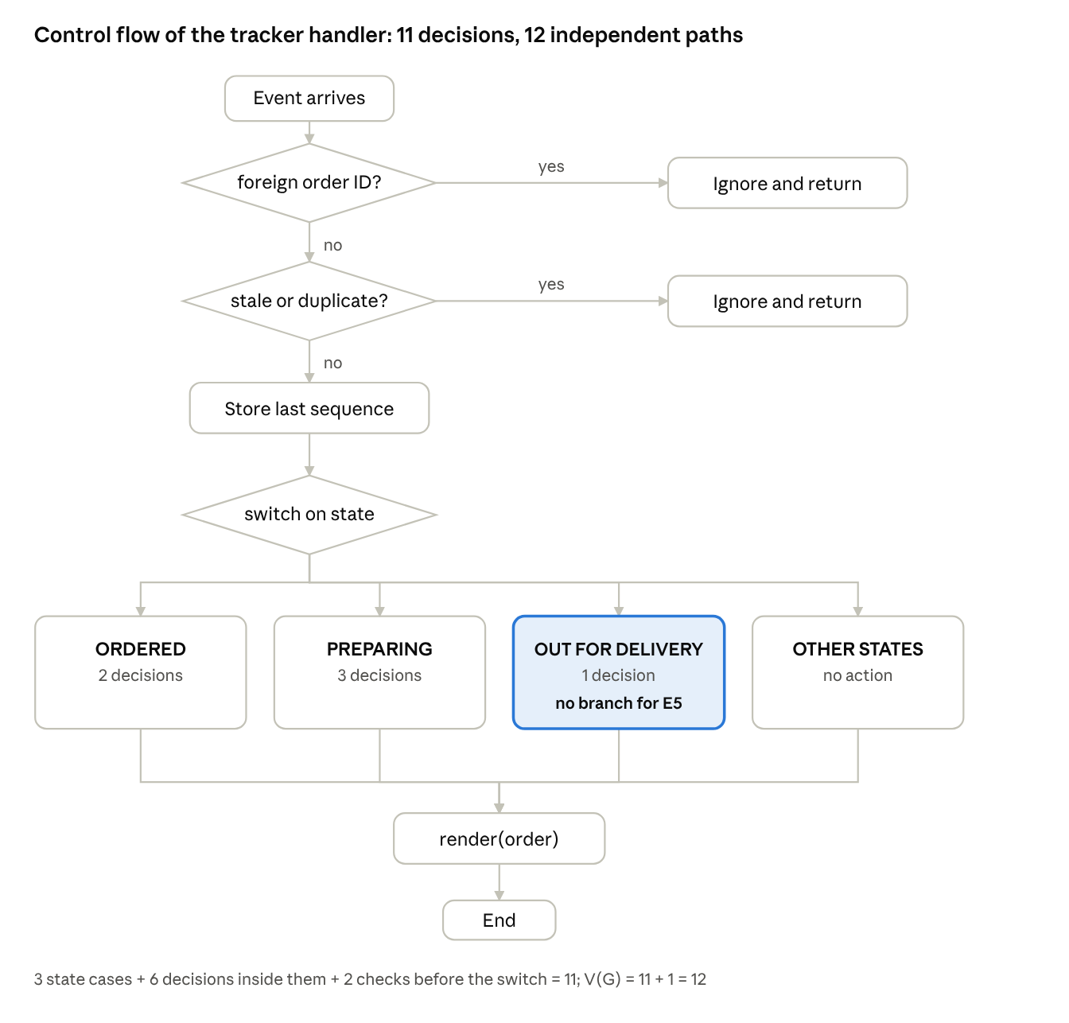
control flow graph of the assumed tracker handler · 11 decisions
Each decision in the handler is one predicate: two checks before the switch (lines 2 and 3), three state cases (lines 6, 9, 13) and six decisions inside them (lines 7, 8, 10, 11, 12, 14). Cyclomatic complexity is V(G) = 11 + 1 = 12, so at least 12 tests are needed to exercise every independent path.
Path | Decisions taken | Input (state, event) | Expected result | Black-box test
BP1 | Line 2 true | Event for another order | Ignored | add TC-34
BP2 | Line 2 false, line 3 true | Duplicate or old sequence number | Ignored | TC-22, TC-32
BP3 | State ORDERED, line 7 true | S1 and E1 | S2 | TC-01
BP4 | State ORDERED, line 8 true | S1 and E2 or E8 | S7 | TC-02, TC-03
BP5 | State ORDERED, no match | S1 and E4 | No change | TC-16
BP6 | State PREPARING, line 10 true | S2 and E3 | S3 | TC-04
BP7 | State PREPARING, line 11 true | S2 and E5 | S2, driver cleared | TC-05
BP8 | State PREPARING, line 12 true | S2 and E2 or E8 | S7 | TC-06, TC-07
BP9 | State PREPARING, no match | S2 and E4 | No change | TC-17
BP10 | State OUT_FOR_DELIVERY, line 14 true | S3 and E4 | S4 | TC-08
BP11 | State OUT_FOR_DELIVERY, line 14 false | S3 and any other event, including E5 | No change (defect for E5) | TC-09
BP12 | No case matches | S4 or S7 and any event | No change | TC-19, TC-20, TC-21

15.4 Coverage criteria applied
Criterion | Requirement | Minimum tests | Result on this handler
Statement | Every statement runs at least once | 8: BP1, BP2, BP3, BP4, BP6, BP7, BP8, BP10 | 100% reached, and the bug is not found
Branch | Every decision takes both outcomes | The 12 basis paths cover all of them | 100% reached, and the bug is not found
Condition | Every condition is true and false | Same as branch (no compound conditions yet) | Same result
Path | Every route from start to end | 12 paths in total, because decisions are nested, not in sequence | All 12 can be run; still no failing test on the code as written
MC/DC | Each condition alone changes the decision | 3 tests for one compound guard (see 15.5) | Applies to the fixed code only
Why 100% coverage still misses the bug. BP11 is already executed by any event other than a delivery, for example a pickup arriving in S3. The false outcome of line 14 is therefore covered, yet nothing checks that a driver cancel is handled. The defect is missing code, and coverage tools only measure code that exists. The blank cell in the state table (Section 5.4) is what exposes it, which is why black-box state testing is needed alongside white-box coverage.

15.5 Fixed handler and added coverage
13 case OUT_FOR_DELIVERY:
14 if e.type == DELIVERS: order.state = DELIVERED
15 elif e.type == DRIVER_CANCELS and order.pickedUp:
16 order.state = REASSIGNING; startTimer(REASSIGN_LIMIT)
17 case REASSIGNING:
18 if e.type == REASSIGN_SUCCESS: order.state = OUT_FOR_DELIVERY
19 elif e.type == REASSIGN_TIMEOUT: order.state = NEEDS_ATTENTION
20 elif e.type == CUSTOMER_CANCELS: order.state = CANCELLED
21 case NEEDS_ATTENTION:
22 if e.type == SUPPORT_RESOLVES: order.state = resolveTarget(e)
23 elif e.type == CUSTOMER_CANCELS: order.state = CANCELLED
The fix adds nine decisions: two in the driver-cancel branch (the event and the pickedUp guard), four for REASSIGNING (one case plus three events) and three for NEEDS_ATTENTION. Complexity rises from 12 to V(G) = 21, so the basis set grows to 21 paths. The new paths map to TC-09 to TC-15, TC-22 to TC-24 and TC-25 to TC-33.
MC/DC for the guard DRIVER_CANCELS and pickedUp in S3:
Test | Event is E5 | pickedUp | Decision | Expected
M1 | True | True | True | S5 (TC-09)
M2 | False | True | False | Stays in S3 (TC-18 style)
M3 | True | False | False | Not reachable: an order in S3 has always been picked up
M3 shows that the second condition may be dead code. Either the guard should be removed or the specification should say what happens when a driver cancels before pickup inside S3.

15.6 What each technique detects for this defect
Technique | Finds the stuck tracker? | Reason
Equivalence partitioning | No | The failing input is an event, not a data value
Boundary value analysis | No | No numeric limit is involved
Statement, branch, condition and path coverage | No | The defect is missing code
Basis path testing | Only if the tester adds an E5 case to BP11 | The path exists, but its expected result is only known from the specification
State transition testing | Yes | The blank cell for S3 and E5 is visible in the table
Control flow review of the handler | Yes | A reviewer comparing line 13 to 14 with the state table sees no E5 branch
The combined approach is therefore: derive tests from the state model first (black-box), then measure branch and path coverage on the fixed code (white-box) to confirm that every written branch has been executed.

Criteria | Weightage | Level 4 – Exemplary | Level 3 – Proficient | Level 2 – Developing | Level 1 – Beginning | Marks
Problem Understanding & Context Analysis | 25 | Thoroughly understands the scenario with accurate interpretation of all requirements | Clearly understands the scenario with minor gaps | Basic understanding; some aspects of the scenario unclear | Poor understanding or misinterpretation of the scenario
Application of Concepts | 30 | Applies appropriate concepts effectively to solve complex real-world problems | Applies relevant concepts correctly with minor errors | Applies basic concepts but with limited accuracy | Fails to apply appropriate concepts
Analytical & Decision-Making Skills | 20 | Demonstrates strong analysis and selects optimal solutions with justification | Good analysis with reasonable solutions | Limited analysis; solutions lack justification | Poor or no analysis; incorrect decisions
Solution Design & Approach | 15 | Well-structured, innovative, and feasible solution approach | Logical and structured solution with minor gaps | Basic solution with limited structure or feasibility | Unclear or incorrect solution approach
Clarity, Justification & Presentation | 10 | Clear, well-justified explanation with strong reasoning | Clear explanation with some justification | Limited clarity and weak justification | Poorly explained with no justification

