Topology of Neural-Network Layers for Out-of-Distribution Detection
Dat Bui · October 2026 · code and full results: github.com/Datquangbui1011/Research
At a glance
Task: find a model used in the six papers of the literature report, implement all six approaches on it, use them to detect out-of-distribution (OOD) inputs, and compare how well each works.
Model: the Bayesian MLP 784→64→16→10 from the pTU paper [3], trained on MNIST (97.2 % test accuracy, close to the paper’s 97.4 %).
Test: can each method tell MNIST digits apart from 7 kinds of unfamiliar images? Every result is averaged over 3 independently trained models.
Main result: 5 of the 6 topological approaches beat the standard confidence baseline. The best one, [5], reaches 96.5 / 100 AUROC versus 74.1 for confidence. Neural Persistence [1] cannot detect OOD inputs at all.
1. The shared model
- Why this model: papers [1], [2] and [3] all study small fully connected networks (MLPs) on MNIST, and [3] gives the exact architecture, prior and training rule, so the setup can be reproduced.
- What it is: 784 inputs (28×28 pixels) → 64 → 16 → 10 classes, ReLU, trained as a Bayesian network (Bayes-by-Backprop) with [3]’s scale-mixture prior (σ₁ = 1, σ₂ = 0.007) and early stopping (patience 25), so each weight has a distribution, not a single value.
- How it is used: methods [1], [2], [4], [5], [6] use the posterior-mean weights; [3] (pTU) uses 30 posterior weight samples, as in the paper.
- One change from the paper: the KL term of the loss is scaled by 0.1. With the full term, accuracy stalls at 94.5 %, and [3] does not say how it weighted this term.
2. The six approaches
All six turn a layer of the network into a shape (a graph or a cloud of points), track how that shape connects up as a threshold changes (persistent homology), and summarize it with numbers. An input whose numbers look unusual compared with training data is flagged as OOD.
Paper | Object built from the network | OOD score used here
[1] Neural Persistence (Rieck et al. 2019) | Bipartite layer graph of |W| (weights only); 0-dim superlevel persistence diagram = maximum spanning tree (MST) weights. | Original NP is input-independent (AUROC = 50 by construction). Adaptation: NP of each input’s activation graph, z-scored per predicted class.
[2] Topological Uncertainty (Lacombe et al. 2021) | Activation graph |W(j,i)·x(i)| per layer; persistence diagram = its MST weights. | Mean over layers of the 2-Wasserstein distance to the class-mean diagram of training data (predicted class).
[3] pTU (Yeh & Yang 2025) | The same activation-graph diagrams under 30 posterior weight samples. | Fréchet variance of the 30 diagrams, averaged over layers; plus the paper’s permutation test (Alg. 2) on groups of images.
[4] Persistent Laplacian (Wolf et al. 2025; PETLS) | In dim 0 with all vertices born first, the persistent Laplacian of Kₛ ⊆ Kₜ equals the graph Laplacian of Kₜ. | Number of zero eigenvalues (β₀) and nonzero-spectrum features at 3 thresholds, z-scored per predicted class.
[5] Data manifold (Magai & Ayzenberg 2022) | Point cloud of layer activations (input, 2 hidden, logits); Vietoris–Rips persistent homology. | Groups: H0/H1 total persistence + TwoNN intrinsic dimension. Single image (adaptation): change in H0/H1 of its 20 nearest training neighbours when it is added.
[6] CNN activations (Purvine et al. 2023) | The same point clouds (an MLP already gives one vector per image); Rips diagrams. | Groups: sliced-Wasserstein distance to reference diagrams; and the layer-to-layer SW profile.
3. How the methods were tested
- Normal data: 2000 MNIST test digits; reference statistics from MNIST training images.
- OOD data (2000 each, all 28×28 grayscale in [0, 1]): Fashion-MNIST (clothes), KMNIST (Japanese characters), CIFAR-10 (photos), SVHN (house numbers), Gaussian noise, uniform noise, and MNIST-flip (digits with 100 pixels inverted).
- Score: AUROC = how well a method ranks OOD images above normal ones; 50 = random guessing, 100 = perfect. FPR95 (lower is better) = % of OOD images missed when 95 % of normal images are accepted.
- Two settings: one image at a time (the usual OOD task) and groups of images (is this whole batch from a different source?), which is how papers [3], [5], [6] use topology.
- Baselines: softmax confidence (MSP, the baseline in [2]), Bayesian mutual information, and distance to the nearest training images (k-NN).
- Repeats: every number is mean ± std over 3 independently trained models; † = evaluated on 1000 images per set.
4. Results
4a. One image at a time — average over the 7 OOD sets, mean ± std over 3 trained models, ranked from best to worst. Grey rows are baselines.
# | Method | AUROC ↑ | FPR95 ↓ | Verdict
1 | [5] Data manifold, single-image version † | 96.5 ± 0.4 | 16.9 ± 2.3 | Best — but it mainly measures distance to the training data
2 | k-NN distance (baseline) † | 88.4 ± 0.9 | 46.4 ± 1.9 | Strong baseline
3 | [2] TU with layers rescaled (my fix) | 87.4 ± 0.6 | 60.1 ± 1.6 | Good — +8 points over the paper’s version
4 | [4] Persistent Laplacian, zero eigenvalues only (β₀) † | 85.8 ± 0.1 | 50.3 ± 1.6 | Good — very stable
5 | [3] pTU | 83.0 ± 5.2 | 39.4 ± 7.0 | Good but unstable — misses Gaussian noise
6 | [4] Persistent Laplacian, full spectrum † | 82.6 ± 0.8 | 59.3 ± 1.5 | OK — extra eigenvalues make it worse
7 | Bayesian mutual information (baseline) | 81.4 ± 4.8 | 60.2 ± 9.0 | Baseline
8 | [2] TU (paper version) | 79.1 ± 0.8 | 73.1 ± 3.1 | OK — beats confidence
9 | Softmax confidence, MSP (baseline) | 74.1 ± 4.8 | 74.1 ± 3.0 | Weak baseline — fooled by confident mistakes
10 | [1] Neural Persistence (per input) | 55.4 ± 5.0 | 89.2 ± 4.9 | Fails — near random guessing
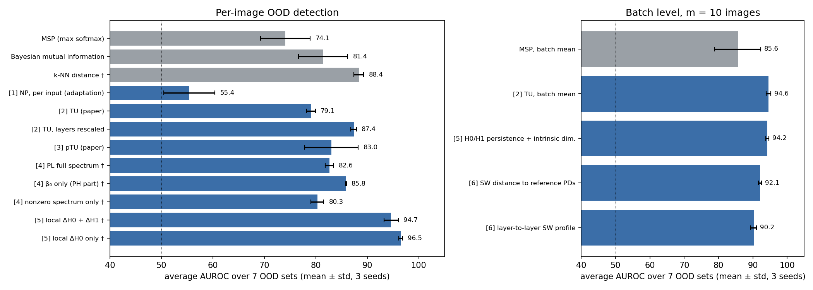
Figure 1. Average AUROC (mean ± std over 3 models). Grey = baselines, blue = topological approaches; † = evaluated on 1000 images per set. Dotted line = random guessing.
4b. Groups of images — is a whole batch of m images from a different source? (average AUROC, 3 models)
Method | 10 images | 20 images | Comment
[2] TU, averaged over the batch | 94.6 ± 0.7 | 96.8 ± 0.5 | Best with very small batches
[5] Cloud topology + intrinsic dimension | 94.2 ± 0.5 | 98.9 ± 0.0 | Ties TU at 10 images, ahead from 20
[6] Distance between persistence diagrams | 92.1 ± 0.4 | 99.0 ± 0.2 | Near perfect from 20 images
[6] Layer-to-layer distance profile | 90.2 ± 0.9 | 94.6 ± 1.6 | Paper’s main tool; weaker for OOD
Softmax confidence, averaged (baseline) | 85.6 ± 6.7 | 89.0 ± 8.3 | Lowest and least stable
[3] pTU statistical test (the paper’s own test on groups of images): with 50 images it flags every OOD set in 96–100 % of trials, while flagging normal MNIST only 3–5 % of the time (the intended 5 % false-alarm rate). All group methods reach about 100 AUROC with 50 images.
5. Main takeaways
- Topology catches what confidence misses. The network is 94–100 % confident on SVHN, CIFAR-10 and uniform noise, so the confidence score fails there (AUROC 60–69). TU, pTU and β₀ still detect them (78–100), and their results barely change between trained models.
- A method must look at the input. Neural Persistence [1] describes the trained weights, which are the same for every input, so it cannot tell normal and unusual inputs apart.
- Simple summaries beat complicated ones. Counting connected pieces (β₀) works better than the full persistent-Laplacian spectrum and TU’s distance; the extra eigenvalues and loop (H1) features add noise.
- How layers are combined matters. The first layer is the most informative in [2], [3] and [4], but those papers average all layers equally. Rescaling each layer before averaging lifts TU from 79 to 87.
- The best single-image score is mostly a distance. [5]’s top result measures how far an image is from its nearest training images; its loop-based part alone is worse than guessing.
- For groups of images, everything works. All group methods reach about 100 AUROC with 50 images; pTU’s test is the only one with a controlled false-alarm rate.
6. Limitations and next steps
- Scope: one small MLP on MNIST (the setting of [1]–[3]; [5] and [6] studied CNNs); 3 trained models.
- My adaptations (labelled above): single-image versions of [1] and [5], the MLP version of [6], rescaled TU, and β₀-only; plus the 0.1 KL scaling.
- Next: repeat on a CNN (CIFAR-10), test layer-weighted TU/pTU, and use a two-sided pTU score so low-variance inputs such as Gaussian noise are caught.
References: [1] Rieck et al., ICLR 2019. [2] Lacombe et al., IJCAI 2021. [3] Yeh & Yang, arXiv:2511.18813. [4] Wolf et al., arXiv:2509.20220; Jones & Wei (PETLS); Botnan & Dong, arXiv:2408.16741. [5] Magai & Ayzenberg, arXiv:2204.08624. [6] Purvine et al., AAAI 2023.

